 | OFFICE OF THE POLICE & CRIME COMMISSIONER FOR THAMES VALLEY

Report for Decision: PCC 2022-P-019

Title: Cost of Living and Employee retention Package

Executive Summary:

The operation and performance of the force is dependent on a full complement of Officers and staff including recruiting our final year of Police Uplift Programme (PUP) officers and the additional staff required to deliver our transformation projects and programmes. Therefore, attracting and retaining officers and staff is our key priority. Current conditions are making this extremely difficult and we currently have over 400 police staff vacancies and a PUP target of 244 additional officers in addition to maintaining existing numbers.

The Covid pandemic and the outcome of Brexit have led to staff shortages in the UK economy which, in turn, is driving private industry to increase salary levels to attract sufficient staff.

To add to the national pressures, the Metropolitan Police Service (MPS) are also targeting officers with a £5,000 transfer bonus. Partly in response to the MPS announcements, other forces in the South East are also expected to review the level of South East Allowance they currently pay their officers.

On top of the labour market supply and demand issues there are large, very well reported, inflationary pressures caused by the war in Ukraine and broader supply chain shortages. This “Cost of Living Crisis” is having a real impact on many families and impacting their confidence levels.

To help mitigate some of these issues, to pre-empt any increase in the outward flow of officers and staff, at the same time as attracting additional officers and staff, it is vital that as an employer we look at how we can support our staff though these inflationary pressures.

Recommendation:

The Police and Crime Commissioner is invited to endorse the Chief Constable’s recommendation to:

- Increase the South East Allowance for police officers from £2,000 to £3,000 with effect from 1st September 2022;
- Make a one-off payment to all staff (not officers) of £500, prorated for part time staff, to be paid as soon as possible;
- Pay a Bonus Payment for Milton Keynes Incident and Crime Response (ICR) officers of £2,000 per annum with effect from 1st September until the end of the 2023/24 financial year;
- Pay a Bonus Payment of £1,250 to all detectives in investigative roles, and those in hard to fill roles having their existing Bonus increased from £1,250 to £2,000 per annum with effect from 1st September;
- Set aside £0.250m for the purchase/lease of parking spaces to support areas where parking is sparse and or expensive.

This package, which will cost circa £17.237m over the 3 year period 2022/23 to 2024/25, will be funded by a combination of the following:

Police and Crime Commissioner
I hereby approve the recommendation above.
Signature  Date: 22 July 2022
PART I – NOT CONFIDENTIAL

- Introduction and background

  - The operation and performance of the force is dependent on a full complement of Officers and staff including recruiting our final year of Police Uplift Programme (PUP) officers and the additional staff required to deliver our transformation projects and programmes. Therefore, attracting and retaining officers and staff is our key priority. Current conditions are making this extremely difficult and we currently have over 400 staff vacancies and a PUP target of 244 additional officers in addition to maintaining existing numbers.

  - The Covid pandemic and the outcome of Brexit have led to staff shortages in the UK economy which, in turn is driving private industry to increase salary levels to attract sufficient staff.

  - To add to the national pressures, the MPS are also targeting officers with a £5,000 transfer bonus. Partly in response to the MPS announcements, other forces in the South East are also expected to review the level of South East Allowance they currently pay their officers.

  - On top of the labour market supply and demand issues there are large, very well reported, inflationary pressures caused by the war in Ukraine and broader supply chain shortages. This “Cost of Living Crisis” is having a real impact on many families and impacting their confidence levels.

  - To help mitigate some of these issues, to pre-empt any increase in the outward flow of officers and staff, at the same time as attracting additional officers and staff, it is vital that as an employer we look at how we can support our staff though these inflationary pressures.

- Issues for consideration

  - The proposal takes into consideration the following key principles:

  - Long Term Affordability
  - Transparency to officers and staff
  - Implementation – avoid bureaucracy for both the individual and organisation
  - Legality of payment mechanism

  - The following measures have been discussed and agreed between the Chief Constable and the PCC, and represent the best “offer” to our staff and officers which is affordable to the Force.

- Increase the South East Allowance for police officers from £2,000 to £3,000 (maximum permissible amount) with effect from 1st September 2022;
- Make a one-off payment to all police staff (not officers) of £500, prorated for part time staff, to be paid as soon as possible;
- Pay a Bonus Payment for Milton Keynes ICR officers of £2,000 per annum with effect from 1st September until the end of the 2023/24 financial year;
- Pay a Bonus Payment of £1,250 to all detectives in investigative roles, and those in hard to fill roles having their existing Bonus increased from £1,250 to £2,000 per annum with effect from 1st September;
- Set aside £0.250m for the purchase/lease of parking spaces to support areas where parking is sparse and or expensive.

  - The implementation of a Bonus Payment for Milton Keynes ICR officers is supported by the fact that the Milton Keynes ICR team are exposed to constant risk, potential trauma, extraordinary demand and high investigative workloads. More so than any other LPA in TVP. For a long period, it has been difficult to retain a fully established ICR team within Milton Keynes. There is therefore a need to break this cycle and address the resource challenge in Milton Keynes so that they are better equipped to meet the demand.

  - The extension of the Detective Bonus payment to all detectives in an investigative role, will reflect that these posts still remain difficult to fill with a shortage of trained detectives both nationally and in TVP. This together with an increase in the Bonus for those detectives in ‘hard to fill’ positions will hopefully allow us to retain and attract new officers into these roles

- Financial comments

  - The estimated cost over the three-year period 2022/23 to 2024/25 is £17.237m as set out below.

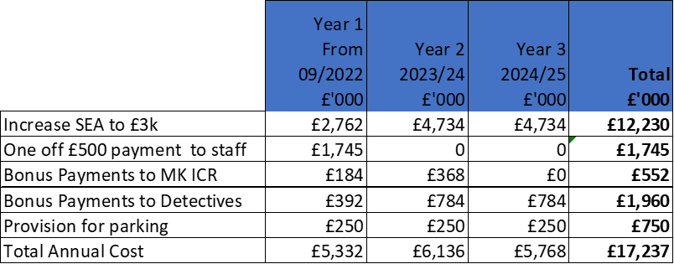

  - Long term these additional costs will have to be addressed through additional savings and/or efficiencies. These will be delivered through a number of Force programmes such as:

- Smart working,
- The Estates strategy,
- As well as our Technology programmes.

  - It is anticipated that the conditions and restrictions on police officer numbers will cease at the end of 2023/24 allowing the force the flexibility to utilise the most effective workforce mix.

  - Within 12 –18 months we will have a clear strategy to deliver the required savings.

  - To mitigate against any unforeseen delays in delivering our savings’ strategies we have identified potential funding of £20.7m to cover the period 2022/23 to 2024/25, which exceeds the estimated funding requirement of £17.2m.

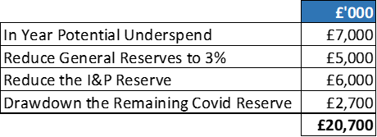

  - The actual split between General Reserves, I+P Reserves, additional savings and in-year underspends can be determined as we progress this year and next but the above illustrates that sufficient funding is available up until the end of 2024/25.

- Police Officer Pay Settlement

  - The announcement on 19 July 2022 is a 5% package for officers but distributed towards the lower paid officers with a flat £1,900 pay rise for all officers. This equates to 7.7% for an officer on £24,780 (PC), 3.3% for an officer on £58,332 (Chief Inspector) or 2.2% for an officer £86,970 (Chief Supt).

  - Any officer currently paid above £54,500 will receive less than 3.5% pay award. Currently we have 186 officers (including regional) who earn over £54,500.

  - The overall package equates to c.5% whereas we had budgeted for 3.5%. The additional cost is:

  - The Home Office is providing additional funding of £70m in the current year and £140m for the next two years. TVP currently receives approx. 3.1% of national total so we should receive circa £2.1m in 2022/23 and £4.2m in 23/24 and 25/26 so the settlement will be fully funded without the requirement to find any additional savings.

- Support Staff

  - We previously agreed a 3.5% pay award for all police staff with effect from 1 July 2022.

  - In addition, we have improved the starting salary for new joiners and introduced increments between the starting salary and the Market Median. Existing staff have been moved to an increment appropriate to their length of service. These changes were in addition to the 3.5% pay award and equate to 1.5 – 2% bringing the overall package to above 5%. Those staff who were on or above the Market Median will only receive the 3.5% increase. This means we have 1,555 staff who have received less than a 5% award.

- Legal comments

  - The PCC and Chief Constable have the legal powers to make these awards

- Equality comments

  - There are no specific issues with regard to Equality & Diversity with this award. All police officers and police staff are being treated fairly and equitably.

- Background papers
n/a

Public access to information
Information in this form is subject to the Freedom of Information Act 2000 (FOIA) and other legislation. Part 1 of this form will be made available on the website within 1 working day of approval. Any facts and advice that should not be automatically available on request should not be included in Part 1 but instead on a separate Part 2 form. Deferment of publication is only applicable where release before that date would compromise the implementation of the decision being approved.
Is there a Part 2 form? No

Name & Role | Officer
Head of People | Christine Kirby
Financial Advice | Linda Waters

PCC’S STATUTORY OFFICERS’ APPROVAL
We have been consulted about the proposal and confirm that financial and legal advice have been taken into account in the preparation of this report.

We are satisfied that this is an appropriate request to be submitted to the Police and Crime Commissioner.

Head of Compliance & Governance Date: 22 July 2022

Chief Finance Officer Date 22 July 2022

