 | OFFICE OF THE POLICE & CRIME COMMISSIONER  FOR THAMES VALLEY

PCC DECISION REPORT - SECTION A - SUMMARY

Report for Decision

Report Reference Number: | PCC 2022-P-022

Report Title: Community Fund grant awards September 2022

Executive Summary:
The Community Fund (previously called the Police Property Act Fund) is created from the proceeds of sale of goods recovered by the police that cannot be returned to their original owner. In accordance with the Police Property Act Regulations (1997) all awards from the fund must be for charitable purposes.

The latest round of this funding launched on 22nd August 2022 with £100,000 allocated to the pot. It closed on 12th September and received 111 applications, totaling approximately £800k. An evaluation panel of four members of staff from the OPCC, including the PCC, sat to consider all applications.

Due diligence checks were made, as needed, and the list proposed to the Chief Constable who offered his input and approved the final shortlist. The recommendations were then approved by the PCC, and award letters (and unsuccessful letters) were sent out by email on 29th September 2022.

In total, the final grant awards will support 25 organisations with total funding of £100,073.

Community Fund Grant Awards – September 2022
Name | Amount
Abingdon Street Pastors | £2,000
Adventure Plus | £5,000
African Diaspora Foundation | £5,000
Aylesbury Town Chaplaincy | £5,000
BACO | £5,000
Barton Community Association | £1,000
Britwell Youth and Community Project (BYCP) | £1,000
EMBS Community College Ltd | £3,945
Employment 4 All CIC | £6,000
First Stop | £5,000
Hope and Vision Communities | £5,000
Leys Community Development Initiative | £1,000
Milton Keynes Somali Community Association | £3,000
MK Act | £7,000
One Eighty | £5,000
Oxford City Angels | £4,628
Prison Fellowship | £2,700
Reading Street pastors | £5,000
Thatcham Youth | £1,000
The Inside Out Trust | £5,000
The Mustard Tree Foundation (Rahab) | £6,000
The Pump House Project | £1,000
The SPORTS Collective CIC* | £4,800
TRIYBE | £5,000
Youth Concern | £5,000
Total Awarded | £100,073

Recipients are required to submit information about how grants are spent and the outcomes achieved. Any recipients who received funding previously will need to submit acceptable reports on that expenditure before receiving further amounts in this round.

Funding awarded is for the purpose outlined in the submitted bids and if the funding has not been spent within 12 calendar months of the grant, the PCC reserves the right to request the funding be returned.

Note that the initial decision included a grant to Transitions UK for £8,127, but the charity had declared insolvency since submitting their application. The initial allocation to the SPORTS Collective was £3,600, but this was increased to £4,800, ensuring a total allocation of £100k, and reflecting the importance of their work in the Slough area.

Recommendations:
- To approve the above grant proposals for this round of the Community Fund

Decision of Police and Crime Commissioner
I hereby approve the recommendation(s) above.
Signature:  Date: 04/10/2022

GOVERNANCE CHECKS (Name & Role) | Officer Signature
Originating Officer / Head of Unit  Cath Marriott (Head of Partnerships & Community Safety) | 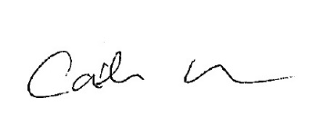
Legal Advice
Vicki Waskett (Head of Governance & Compliance)
Financial Advice  Martin Thornley (Chief Finance Officer & Dep. Chief of Staff) | 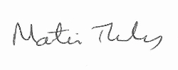
Equalities and Diversity  Gillian Ormston (Chief of Staff) | 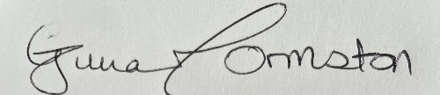

PCC’s STATUTORY CHIEF OFFICERS’ APPROVAL

We have been consulted about the proposal(s) contained in this Decision Report and confirm that financial and legal advice have been taken into account in the preparation of this report.

We are satisfied that this is an appropriate request to be submitted to the Police and Crime Commissioner for decision.

Chief of Staff (Monitoring Officer) Date: 04/10/22

Chief Finance Officer Date: 04/10/22

