

Charlotte Roberts
Tel: No. 01865 541948
Date: 26 May 2022 Email: Charlie.roberts@thamesvalley.police.uk

Dear Chief Constable

Performance & Accountability Meeting (PAM)
You are requested to attend a PAM meeting on 30 May 2022 in the CCMT meeting room or MS Teams for those who are unable to attend at 1400hrs.
Microsoft Teams meeting
Join on your computer or mobile app
Click here to join the meeting
Or call in (audio only)
+44 20 7660 8499,,103289151# United Kingdom, London Phone Conference ID: 103 289 151#


Yours sincerely

Paul Hammond Chief Executive

Agenda Item Page No.

1. | Apologies | -
2. | Minutes of the PAM meeting held on 31 March 2022 | 3 - 8
3. | HMICFRS PEEL Inspection Report 2021/22 & Overview | 9 - 56
4. | TVP Strategic Plan 2021/22 | 57 - 68
5. | OPCC Strategic Delivery Plan 2021-2025 | 69 - 83
6. | AOB | -

Date of next PAM meeting: 21 July 2022 at 1030hrs in the CCMT Meeting Room HQ South/MS Teams

2
AGENDA ITEM 2

3



POLICE & CRIME COMMISSIONER FOR THAMES VALLEY MINUTES OF THE PERFORMANCE AND ACCOUNTABILITY MEETING

HELD IN THE CCMT MEETING ROOM AND/OR VIA MS TEAMS ON 31 MARCH 2022 COMMENCING AT 10:30HRS

Present:
M Barber (Police & Crime Commissioner) (OPCC) J Campbell (Chief Constable) (TVP)
L Waters (Director of Finance) (TVP)
I Thompson (Chief Finance Officer & Deputy Chief Executive) (OPCC)
J Kidman (Chief Supt. Head of Governance & Service Improvement) (TVP)
C Widdison (Corporate Governance Officer, Strategic Governance Unit) (TVP) H Wake (Head of Victims Services) (OPCC)
M Butler (Service Improvement Manager) (TVP)
C Roberts (Executive Assistant to the PCC) - Minutes (OPCC)
G Evans (Policy Development Officer, Policing & Performance) (OPCC)

Apologies:
J Hogg (Deputy Chief Constable) (TVP) P Hammond (Chief Executive) (OPCC)
V Waskett (Head of Governance) (OPCC)
D Simmonds (Service Improvement Manager) (TVP)

Agenda Item

Apologies

The Police & Crime Commissioner (PCC) welcomed attendees to the meeting noting apologies received.

Minutes of the PAM meeting held on 19 January 2022

The Minutes of the meeting held on 19 January 2022 were confirmed as accurate.

Action: The Chief Constable (CC) to update the PCC as to the increase in the number of disruptions and successful prosecutions for serious organised crime ensuring focus on serious organised crime groups involved with acquisitive crime and exploitation.

(CC) confirmed that Det.Supt. Kelly Gardner (KG) would attend the next PAM meeting in July 2022 to discuss the present charges and charging decisions made

4

HMICFRS Recommendation Monitoring

Claire Widdison (CW) referred to the Phase 2 inspection which was led by Det. Supt. Stuart Bosley (SB) and focused on examining cases from point of charge through to conclusion. It was noted that Gary Evans (GE) from the OPCC would link in with this information. Phase 1 had been rolled out in the Autumn last year and examined cases from initial reporting through to a decision to take no further action. The findings set out that communication with the victim was often inconsistent after charge and that victim services could vary by area including access to independent sexual violence advisers (ISVAs) and changes to investigators and prosecutors throughout the process. The issues were resulting in victims not feeling supported. Overall, the report stated that whilst there were individuals who were working throughout the criminal justice system to provide the best possible service and outcome to victims of rape, the criminal justice system were failing victims.

The (PCC) wished that this continued to be monitored and to be kept updated as to progress.

The (PCC) asked if there was a system in place of ‘recommendation progress’. (CW) confirmed that TVP were just waiting on the final HMICFRS recommendations report and (CW) would be in a position to consolidate the work which would hopefully be in the next month to 6 weeks.

Action: The (PCC) required an updated from (CW) as to HMICFRS’ recommendations once this had been finalised.

Action: The (CC) noted that HMICFRS would be discussing matters with TVP next week at a meeting as to the appeal letter and an update would be provided to the (PCC) in due course.

The PCC NOTED the update as appropriate in order to provide a response to HMICFRS.

OPCC Strategic Delivery Plan 2021/22

Ian Thompson (IT) presented the OPCC Strategic Delivery Plan 2021/22 and referred to the summary position set out on page 18. It was noted that a lot of work for developing strategies had not as yet started.

With regard to ensuring compliance with reporting to the Home Office as to ‘National Crime & Policing Measures’ and the Government’s ‘Beating Crime Plan’ set out on page 23 of the plan, the OPCC lead officer (GE) had had a discussion with (CW) and David Simmonds (DS), who were on board with the model and this would progress over the next 12 months. The new model gave more information and would be able to publish this.

Action: The (PCC) asked if an update on the model could be produced at today’s meeting as to where the Force were now in going forwards. (CW) confirmed that this would need to be aligned at the next Force Performance Group meeting as to the full year and would be in a position at the end of April to provide the (PCC) with an update.

The PCC NOTED the progress on the delivery of the actions contained within the OPCC Strategic Delivery Plan 2021/22.

5

PESP Annual Assurance Report

The PESP Annual Assurance Report was a joint report to the PCC and Chief Constable of TVP. The (PCC) noted that reference was made for the Panel Members to be invited to Service Improvement Review meetings (SIR) and so was trying to assess the benefit of this in terms of the Panel attending internal meetings. He wanted assurance that the Panel were there to look at the ethical angles of policing, rather than operational angles, and to target where the OPCC and TVP wished to task PESP in addressing such matters.

Action: The PCC felt that one thing to consider would be an approach to the Panel to assist in CCTV and to task them with this.

The PCC and Chief Constable NOTED the PESP Annual Assurance Report.

Joint Corporate Governance Framework

The Joint Corporate Governance Framework culminated in a few months of work during which it had been reviewed by the Governance Advisory Group. The changes that had been made were summarised on page 40 for each of the four components of the framework. This had been presented to the Joint Independent Audit Committee who confirmed they were content with the changes made. Once the framework had been approved by the (PCC) and the Chief Constable, this would be uploaded on to the OPCC website. The (PCC) and (CC) both confirmed they were content with the changes made although the only point from the (PCC) to note was the paper that (PH) had prepared for major projects around governance. This paper would be presented to the Police & Crime Panel meeting for the purposes of clarity. Linda Waters (LW) indicated there were guidelines but agreed that there needed to be a reference included as to what actually applied.

Action – The (PCC) required an update at the next PAM meeting in July 2022 after a review had been considered and where the information would sit within the Joint Corporate Governance Framework noting any amendments or additions made.

The PCC and Chief Constable APPROVED the Joint Corporate Governance Framework for 2022/23.

TVP Strategic Plan 2021/22

The (CC) reported on the Crime Overview where TVP’s national position was 14th out of 43 with was good. Recorded crime levels had now increased to levels observed before the pandemic which was partly due to significant improvements in crime recording and fewer Covid related restrictions on the activities of the public.

Action: The (CC) would cross-reference various parts of the data to analyse within LPAs etc. and to look at the link between LPAs and victim based crimes and ASB incidents. The (PCC) felt that Cath Marriott (CM) from the OPCC should attend a future PAM meeting to present to the (PCC) as to where the organisation stood and how to link in with the Force.

The PCC noted that the good measures of success set out on page 161 that showed reductions in serious violence, personal robbery and residential burglary dwellings compared to the 5 year average.

6

The (CC) went through the National Outcomes Framework metrics. The national outcomes framework was measured at a national level. The data was not broken down or available on an individual Force basis, but all Forces were developing proxy measures to understand the local context of these national measures, although there were still data gaps within the document. The (PCC) asked why the gaps had not been filled by the Home Office. Mattias Butler (MB) shared his view on how quickly the gaps would be filled to hold TVP to account in relation to the data. (MB) had covered these areas with proxy data. The last two performance groups had linked into the VRU and this would be discussed at the next meeting. Not all gaps have been filled albeit the organisation was doing their best to get proxy data included.

The (PCC) asked if there was a similar reduction in possession of a firearm. (MB) would ask his team to look at the strategic portal to provide an update to the (PCC) at the end of today’s meeting.

As to improving 101 calls and contact services, the (CC) viewed his concerns although the target had in fact been achieved and had seen a reduction. The (CC) had asked ACC Catherine Akehurst (CA) to look at this in managing the discretionary calls that came in from the public. The (PCC) pointed out that he had in fact called 101 at 08:00hrs on a Monday morning and managed to get straight through but resilience needed to be looked into. On 21 March 2022 a member of the public had written to the (PCC) to note they had contacted 101 and had been cut off. (CC) confirmed that this was due to a fire alarm going off twice in one day but would ascertain an update as to the circumstances.

Action: The (CC) would contact Chief Insp. Matt Bullivant as to the circumstances on 21 March 2022 and the resilience in the control room to understand what actually happened and would update the (PCC) accordingly.

The (CC) went through the Serious Organised Crime on page 164 of the report as to the increasing number of disruptions and successful prosecutions for serious organised crime (SOC) groups involved with acquisitive crime and exploitation. There were currently 53 OCGs in TVP of which 73% have a primary criminality of drugs.

As to fighting cyber crime and fraud, a fraud dashboard had been created to increase visibility of the data provided by NFIB and recorded on Niche.

TVP were working with other criminal justice agencies to improve performance in dealing with crimes such a domestic abuse, rapes and serious sexual assaults. There had been a small drop in numbers from the previous period.

Action: The area of concern for the (CC) was the sexual offences figures and would arrange for Det. Supt. Stuart Bosley (SB) to come to a future PAM meeting to discuss the charges rates for rapes and serious assaults (RASA).

(CC) went through the measures of success in relation to Domestic Abuse. There was a 14% reduction in the volume of domestic abuse crimes that led to formal action being taken. The charges had dropped but this would be discussed at a meeting with the Chief Prosecutor Jaswant Naswal. In relation to knife carrying, the (PCC) had discussed this with D/Supt Craig Kirby (CK) as to charges and bringing offenders to justice. In Domestic Abuse cases, the issue was around evidence and threshold tests but there were many other offence types where the importance was for early charging decisions and to be held in remand.

Chief Supt Joe Kidman (JK) pointed out that this went back to CPS if an offender was held in custody and was not a remandable case. There was a challenge around the culture of police charging and

7

CPS charging decisions. This should be pushed and additional resources allocated and put into a project to put experts in but was down to the CPS if evidence had already been provided.

The (CC) went through the successful outcomes through the criminal justice system for Thames Valley.

The (PCC) also took an interest in the levels of importance of mental health and wellbeing of staff and officers.

In terms of violent arrest and assaults on officers, there were a lot of arrests that were not recorded. The Outreach team were looking into the assault figures and making sure that these were tidied up and recorded accurately when assaults took place, as they had decreased by 1.5%.

Unauthorised encampments showed a 4% reduction over a 1 year change but had also seen a 15% reduction over a 2 year change. In terms of this, there is greater clarity needed in getting robust action from officers but also awareness and having sight of when an encampment pops up in the Thames Valley area. There was now a 24 hour Public Order Silver Commander in place and the organisation now had a much better and more robust system to discuss unauthorised encampments and the impacts on the Force.

Action: In terms of reporting unauthorised encampments, the (CC) would speak to Det. Chief Supt. Jim Weems (JW) as to the numbers of unauthorised encampments to add on to the DMM to have organisational awareness and would update the (PCC).

The (CC) went through the key indicators for organisational performance. The Strategic Plan measure number 2 on page 70 as to maintenance of reduced levels of avoidable attrition Force- wide with a focus on front line officers and staff should be colour coded red instead of green and needed to be updated.

The (PCC) provided an update to the (CC) as to the quarterly Joint Collaboration Governance Board meetings. Currently, there were four meetings per year but the scale of JOU and joint ICT did not get the level of scrutiny required. The (PCC) suggested that rather than having 4 meetings per year, there would be 6 meetings and this was currently being discussed between EAs to ascertain dates. Each meeting would alternate a presentation by Joint Operations Unit and Contact Management and the usual agenda items followed by an ICT update at the following meeting and so on. The (CC) noted the proposed changes from the (PCC).

The PCC NOTED the TVP Strategic Delivery Plan 2021/22.

Decisions under the Scheme of Governance

(LW) presented the Decisions under the Scheme of Governance and the only matter to highlight to the (PCC) was extracting the legal delegations for this period. The next report in July would include legal delegations.

The PCC NOTED the decisions taken by Chief Officers during the period 1 January to 28 February 2022.

8

Income Charging Rates 2022/23 and Sponsorship received 2021/22

(LW) presented the annual report, with virtually nothing to bring to the (PCC’s) attention due to the recent pandemic during which sponsorship had not taken place. The (PCC) enquired whether it would be worth looking into sponsorship around car parking spaces and capacity in the Thames Valley area as there must be other organisations to tap into that have availability in car parking spaces especially around High Wycombe for officers to park their patrol vehicles.

As to events, the PCC asked if there were any plans for TVP to hold their ‘Open Day’. At this stage, the (CC) indicated there would not be an Open Day for 2022. This would be looked at in 2023 and possibly scaled back at Sulhamstead. The Open Days had always been very popular, positive and an enjoyable day out. A smaller Berkshire Open Day could still be held at Sulhamstead but the Force would need to look at sponsorship.

The proposed charges for next year (2022/23) were based on a standard variable rate which had been set nationally. The charges for special police services and the formula was set out as per the paper but the intention was for all Forces to use the same rate per hour as per the NPCC Guidance which had been clarified, although there was not much flexibility in the real world.

The PCC NOTED the current fees and chargeable rates for 2022/23 and NOTED the Sponsorship received in 2021/22.

AOB

(JK) noted that in relation to ‘possession of a firearm figure’ that the (PCC) had asked (MB) to provide earlier on in the meeting, it had been confirmed there had been a 33% reduction in the possession of a firearm and the PCC thanked (MB) and (JK) for providing a swift response to the request.

The meeting concluded at 11:50hrs

Date of next PAM meeting: 30 May 2022 at 14:00hrs in the CCMT meeting room, HQ South or via MS Teams
9 AGENDA ITEM 3



PEEL 2021/22
Police effectiveness, efficiency and legitimacy

An inspection of Thames Valley Police

10

Contents

Overall summary 1
Our judgments 1
Important changes to PEEL 1
HM Inspector’s observations 2
Reducing crime assessment 4
Providing a service to the victims of crime 5
Victim service assessment 5
Crime data integrity 7
Area for improvement 8
Main findings 8
Engaging with and treating the public with fairness and respect 10
Area for improvement 10
Main findings 10
Preventing crime and anti-social behaviour 13
Areas for improvement 13
Innovative practice 14
Main findings 14
Responding to the public 17
Areas for improvement 17
Innovative practice 18
Main findings 18
Investigating crime 21
Areas for improvement 21
Innovative practice 22
Main findings 22
Protecting vulnerable people 25

11

Area for improvement 25
Main findings 25
Managing offenders and suspects 28
Innovative practice 28
Main findings 28
Disrupting serious organised crime 31
Building, supporting and protecting the workforce 32
Areas for improvement 32
Innovative practice 33
Main findings 34
Vetting and counter corruption 36
Strategic planning, organisational management and value for money 37
Areas for improvement 37
Innovative practice 39
Main findings 39

12

Overall summary

Our judgments
Our inspection assessed how good Thames Valley Police is in ten areas of policing. We make graded judgments in nine of these ten as follows:

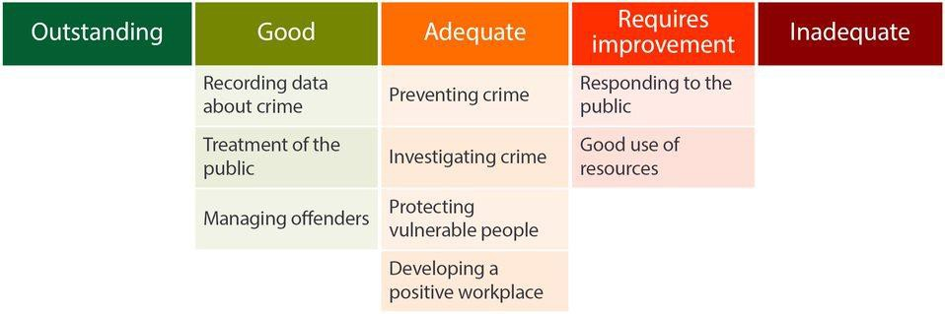
We also inspected how effective a service Thames Valley Police gives to victims of crime. We don’t make a graded judgment in this overall area.
We set out our detailed findings about things the force is doing well and where the force should improve in the rest of this report.

Data in this report
For more information, please view this report on our website and select the ‘About the data’ section.

Important changes to PEEL
In 2014, we introduced our police effectiveness, efficiency and legitimacy (PEEL) inspections, which assess the performance of all 43 police forces in England
and Wales. Since then, we have been continuously adapting our approach and this year has seen the most significant changes yet.
We are moving to a more intelligence-led, continual assessment approach, rather than the annual PEEL inspections we used in previous years. For instance, we have integrated our rolling crime data integrity inspections into these PEEL assessments.
Our PEEL victim service assessment will now include a crime data integrity element in at least every other assessment. We have also changed our approach to graded judgments. We now assess forces against the characteristics of good performance, set out in the PEEL Assessment Framework 2021/22, and we more clearly link our

13

judgments to causes of concern and areas for improvement. We have also expanded our previous four-tier system of judgments to five tiers. As a result, we can state more precisely where we consider improvement is needed and highlight more effectively the best ways of doing things.
However, these changes mean that it isn’t possible to make direct comparisons between the grades awarded this year with those from previous PEEL inspections. A reduction in grade, particularly from good to adequate, doesn’t necessarily mean that there has been a reduction in performance, unless we say so in the report.

HM Inspector’s observations
Since our last inspection in 2019 Thames Valley has been through a demanding 18 months. Like all forces, it has been affected by the pandemic. It has dealt with a serious terrorist incident, multiple public protests and increased levels of homicide.
Despite these pressures, I am satisfied with some aspects of Thames Valley Police’s performance in keeping people safe and reducing crime. Yet, there are areas where the force needs to improve.
These are the findings I consider most important from our assessments of the force over the last year.
Thames Valley Police has made some improvements since our previous inspection in 2019. We now rate its crime recording as good and as a consequence it now records more crime. It has got better in some other areas we identified as requiring
improvement. These include aspects of its response to victims of domestic abuse and the speed with which it answers calls in the control room.
We are encouraged to see the efforts it is making to make sure that it is treating people both inside and outside the force fairly. The work it is doing in communities to attract people from ethnic minority backgrounds to join the force is noteworthy.
There is a greater focus on the wellbeing of the workforce, with a more proactive approach to supporting staff.
But, despite these positive elements, we found that the force is struggling to meet some of the demand in a timely way. It now records more crime than before.
Combined with recent changes to the way cases are prepared, this means officers are busier than they were. In addition, some aspects of policing have become more complex, particularly in respect of gathering evidence from digital devices. At the same time, the force is bringing through new, inexperienced staff, who require greater time in respect to training and supervision.
The force has introduced some notable innovations, looked for more efficient ways of working and moved additional staff into some areas. Nonetheless, this inspection found that a lack of resource is affecting the timeliness of its response to the public, the investigation of crimes and the assessment of risk to vulnerable people or by potentially dangerous offenders. The work pressure on some staff is also undermining the steps that the force has taken to improve the wellbeing of its workforce.

14

Thames Valley Police isn’t blind to this and it was reassuring to see that it had already identified some of the issues we found during our fieldwork. It is to its credit that it had not only completed this work, but shared it with the inspectorate. This gives me confidence that the force is aware of the problem, but it must now move forward to fully understand and address the matters identified. We will review its progress as part of our continuing assessment of the force.



Roy Wilsher
HM Inspector of Constabulary

15

Reducing crime assessment

We have identified seven themes underpinning a force’s ability to reduce crime effectively which, taken together, allow an assessment of the extent to which the force is doing all it can to reduce crime. This is a narrative assessment, as police recorded crime figures can be affected by variations and changes in recording policy and practice, making it difficult to make comparisons over time.
Thames Valley Police uses analysis well to identify and tackle crime, anti-social behaviour and to protect the vulnerable. It works well with other organisations and generally tackles crime and anti-social behaviour in its communities through a structured approach, although this needs to be more consistently recorded.
Effective recording of crime is a vital component of this process and I am pleased to see the improvement it has made in crime recording and data integrity.
Other factors contributing to the force’s ability to reduce crime are:
  - effective identification and management of repeat offenders;
  - clear operational priorities with effective oversight and performance management;
  - good use of measures outside court proceedings, such as cautions, to obtain justice for victims and divert offenders; and
  - a strategic focus on protecting vulnerable people.
I am pleased that the force is addressing the right areas of policing to reduce crime.
But the following areas may negatively affect the force’s ability to reduce crime:
  - It needs need to build sufficient capacity in its response and investigations to maximise opportunities to collect evidence, properly support victims and bring offenders to justice.
  - The force doesn’t always identify repeat or vulnerable victims at the first point of contact.
  - It isn’t consistently supervising crime investigations to a good standard, resulting in some offenders not being brought to justice.
  - It doesn’t have a comprehensive understanding of how allocating local policing teams to other work is inhibiting its preventative work.
Until the force improves the most important factors from this assessment it won’t be able to effectively reduce crime.

16

Providing a service to the victims of crime

Victim service assessment
This section describes our assessment of the service victims receive from Thames Valley Police, from the point of reporting a crime through to the end result. As part of this assessment, we reviewed 130 case files as well as 20 cautions, community resolutions and cases where but the victim does not support or has withdrawn support for police action. While this assessment is ungraded, it influences graded judgments in the other areas we have inspected.

The force has improved the time it takes to answer emergency and non-emergency calls but vulnerable victims aren’t always identified
When a victim contacts the police, it is important that their call is answered quickly and that the right information is recorded accurately on police systems. The caller should be spoken to in a professional manner. The information should be assessed, taking into consideration threat, harm, risk and vulnerability. And the victim should get appropriate safeguarding advice.
Emergency and non-emergency call waiting times have got better, but the force is still not quite meeting national standards. When calls are answered, the victim’s vulnerability isn’t assessed using a structured process. Repeat victims aren’t
always identified, which means this isn’t taken into account when the force considers its response. Victims aren’t always given crime prevention advice or advice on the preservation of evidence.

The force doesn’t always respond to calls for service in a timely way
A force should aim to respond to calls for service within its published time frames, based on the prioritisation given to the call. It should change call priority only if the original prioritisation is deemed inappropriate, or if further information suggests a change is needed. The response should take into consideration risk and victim vulnerability, including information obtained after the call.
In too many cases attendance was outside recognised force timescales and the victim’s expectations weren’t met. This may cause victims to lose confidence
and disengage. Despite the difficulties, appropriate staff were allocated to respond to incidents.

17

The force is good at recording reported crime
The force’s crime recording should be trustworthy. It should be effective at recording reported crime in line with national standards and have effective systems and processes, supported by the necessary leadership and culture.
The force has effective crime recording processes to make sure crimes reported to the force are recorded correctly. We set out more details about the force’s crime recording in the ‘Crime data integrity’ section below.

The force allocates crimes to appropriate staff, but victims aren’t always informed if their crime isn’t going to be investigated further
Police forces should have a policy to make sure crimes are allocated to appropriately trained officers or staff for investigation or, if appropriate, not investigated further.
The policy should be applied consistently. The victim of the crime should be kept informed of the allocation and whether the crime is to be further investigated.
The arrangements for allocating recorded crimes for investigation were in accordance with the force’s policy. In nearly all the cases we reviewed, the crime was allocated to the most appropriate department for further investigation, yet victims weren’t always informed that their crime report wouldn’t be investigated further. This is important to provide victims with an appropriate level of service and to manage expectations.

Investigations aren’t always effective and timely
Police forces should investigate reported crimes quickly, proportionately and thoroughly. Victims should be kept updated about the investigation and the force should have effective governance arrangements to make sure investigation standards are high.
In some of the cases we reviewed, investigations weren’t carried out in a timely manner and relevant lines of inquiry weren’t completed. In some there was a lack of effective supervision of investigations and investigation plans. This resulted in some ineffective investigations. Victims weren’t always kept updated about the progress of the investigation. This means some victims are being let down and offenders aren’t being brought to justice.
When domestic abuse victims withdrew their support for a prosecution, the force didn’t always consider prosecuting offenders without the victim’s support or using measures designed to protect victims, such as a domestic violence protection notice or domestic violence protection order. These measures are an important method of protecting the victim from further abuse.
Under the Code of Practice for Victims of Crime (the Victims Code) there is a requirement to conduct a needs assessment at an early stage to decide whether victims require additional support. The result of the assessment and the request for additional support should be recorded. The force isn’t always completing this assessment, which means not all victims will get the appropriate level of service.

18

The force properly finalises reports of crimes but sometimes fails to consult the victims for their views or record them
The force should make sure it follows national guidance and rules for deciding the outcome of each report of crime. In deciding the outcome, the force should consider the nature of the crime, the offender and the victim. And the force should show the necessary leadership and culture to make sure the use of outcomes is appropriate.
In appropriate cases, those offenders who are brought to justice can be dealt with by means of a caution or community resolution. To be correctly applied and recorded, it must be appropriate for the offender and the views of the victim to be taken into consideration.
In nearly all of the cautions and community resolutions we reviewed, the offender met the national criteria for their use, but the victim’s views weren’t always sought or considered. Where a suspect is identified but the victim doesn’t support or withdraws support for police action, the force should have an auditable record to confirm the victim’s decision so that it can close the investigation. Evidence of the victim’s decision was absent in most cases we reviewed. This represents a risk that victims’ wishes may not be fully represented and considered before the crime is finalised.

Crime data integrity


Thames Valley Police is good at recording crime.
We estimate that Thames Valley Police is recording 94.9 percent (with a confidence interval of +/- 2.1 percent) of all reported crime (excluding fraud). This is a statistically significant improvement compared to the findings of our 2019 inspection. We estimate that compared to the findings of our 2019 inspection, this improvement meant that
the force recorded an additional 11,500 crimes for the year covered by our inspection. We estimate that this means the force still didn’t record over 8,300 crimes for the year covered by our inspection.
Its performance is worse for offences of violence against the person. We estimate that
92.5 percent (with a confidence interval of +/- 3.9 percent) of violent offences are being recorded. The force performance for recording sexual offences is better, with
95.2 percent (with a confidence interval of +/- 3.5 percent) of sexual offences reported to the force being recorded.

19

Area for improvement

The force needs to improve the recording of equality data
The force’s data for victims of crime shows that age and gender are well recorded, ethnicity is less well recorded and other protected characteristics are not well recorded. The force should be collecting this information to understand the extent to which each protected group is affected by crime, how this differs from those without the protected characteristics, and whether a different response is needed for these victims.

Main findings
In this section we set out our main findings that relate to how well the force provides a service to the victims of crime.

Crime recording is well supervised and scrutinised by chief officers
The force has focused on improving crime recording. It carries out regular in-depth audits, the results of which are reviewed by chief officers. Any errors found during audits are corrected and then circulated to relevant staff so that they learn from
the correction. There is a crime recording action plan, which is reviewed and updated with progress against actions.

The force has improved its recording of violent crime
The force has made statistically significant improvements in how it records violent crime. We estimate that compared to the findings of our 2019 inspection, this improvement means that the force recorded an additional 8,200 violent crimes for the year covered by our inspection.

The force records crimes against vulnerable people well
The force records crimes against vulnerable victims well. It is important crimes against vulnerable victims are recorded to safeguard the victims from further offences and identify perpetrators.

The force is good at recording most sexual offences but isn’t always recording rape offences correctly
The force correctly records most sexual offences, yet reports of rape weren’t always recorded properly. Rape is one of the most serious crimes a victim can experience. Therefore, it is especially important that crimes are recorded accurately so that victims receive the service and support they expect and deserve.

20

The force should improve its workforce’s understanding of anti-social behaviour and how it records anti-social behaviour crimes and incidents
The force isn’t always correctly recording crimes that occur as a result of incidents of anti-social behaviour. Harassments were particularly poorly recorded. Anti-social behaviour can have a significant effect on victims, especially if the behaviour is prolonged. Failure to record crimes results in victims not receiving the support they need and offenders escaping judicial proceedings.

21

Engaging with and treating the public with fairness and respect

Thames Valley Police is good at treating people fairly and with respect.

Area for improvement

The force should improve how it records and understands the use of force by officers
Compared to most other police forces in England and Wales, Thames Valley Police records a low number of incidents where it has used force. We estimate that during 2019/20 it failed to record 27,441 occasions when force was used.
Systems used to record when force has been used are seen as time-consuming, so staff don’t always submit the required form. A new system is being implemented, which will improve recording, but at the moment any analysis about how force is used is based on an incomplete data set. This prevents the force from being able to fully identify and understand disproportionality.

Main findings
In this section we set out our main findings that relate to treating people fairly and with respect.

The force hasn’t yet published analysis to demonstrate that it has a comprehensive knowledge of all causes of disproportionality in its use of powers of stop and search
In our 2017 report on the use of stop and search powers nationally we made recommendations about how forces should look for its disproportionate use on people from ethnic groups, or based on age and gender. We said that if identified, forces should establish why this occurred and publish the analysis with an action plan to address it.

22

Thames Valley Police isn’t fully meeting this recommendation. There is oversight and scrutiny of the use of stop and search at both a force and local level. The more sophisticated stop and search database it has developed helps it recognise the disproportionate use of the powers. Despite this, the force hasn’t yet published
any analysis of the causes of disproportionality or action plan that satisfies our 2017 recommendation.

The force treats people fairly
Treating people fairly and without bias is included in many training courses in the force. This is reinforced by senior leaders, who give clear guidance on topics such as the correct use of stop and search powers and the abuse of authority.
Our review of body-worn video showed officers dealing with the public politely, respectfully and fairly.
There is an early intervention scheme for officers who receive three or more low-level complaints in a 12-month period. This gives line managers the opportunity to review the officer’s interactions with the public and help them reflect on and improve their approach.

The force works with diverse communities to understand what matters to them
Each local policing area has a neighbourhood policing plan outlining work with their communities to ensure that important issues are addressed.
The force uses a range of methods to communicate with communities face-to-face and digitally. The force, working with other organisations such as local authorities, has worked intensely with its communities making it more likely to understand
their concerns. Neighbourhood teams regularly meet them at local meetings, surgeries and events. Police community support officers (PCSOs) work with groups who have less contact with the police.
An online and social media presence plays an important role in the force’s work with communities. It has over 800,000 followers across four social media platforms.
Social media messages are posted in other languages when targeted at those whose first language isn’t English. Live-streamed Facebook events, including an interview with the chief constable, have reached a quarter of a million viewers, giving the public insight into different areas of policing.
This isn’t a one-way information feed. Responses to posts are monitored and responded to by the force. There are also 111,000 people signed up to the Thames Valley Alert two-way information sharing website.
Each policing area has a community engagement officer and socially media trained PCSOs. Their role includes advising neighbourhood teams on the best way to develop interactive campaigns with the public.

23

The workforce understands how to use stop and search powers fairly and respectfully
We reviewed a sample of 205 stop and search records from 1 January to 31 December 2020. Based on this sample, we estimate that 88.3 percent (with a confidence interval of +/- 4.2 percent) of all stop and searches by the force during this period had reasonable grounds. This is a marginal improvement since our review the previous year when we found that an estimated 84.0 percent (with a confidence interval of 4.2 percent) of stop and searches had reasonable grounds. We found 58 of the 67 stop and searches on people from ethnic minority backgrounds that we reviewed had reasonable grounds recorded. The use of body-worn video is mandated when police use stop and search powers and we found an improved level of compliance with this.
All officers receive initial training on stop and search and several mandatory courses feature training in unconscious bias. Yet, no structured refresher training, including the College of Policing’s authorised professional practice for stop and search, has taken place for several years.

The use of stop and search powers is scrutinised by external organisations and the arrangement is being extended to include the use of force
The force has developed several methods of external scrutiny of stop and search, including reviews by independent advisory groups. The force applies less stringent vetting requirements for membership of community scrutiny panels that also review stop and search activity. It has extended the remit of these groups to include reviews of the police’s use of force. This means that more people with relevant lived experience can provide feedback to the force.

The workforce understands how to use force fairly and properly
Personal safety, tactical communication and use-of-force training is provided during the officers’ initial learning phase. Operational officers complete mandatory annual refresher training on the use of force.

24

Preventing crime and anti-social behaviour


Thames Valley Police is adequate at prevention and deterrence.

Areas for improvement

The force should make sure that its approach to solving community problems of crime and anti-social behaviour is consistent and recorded well
The force uses a recognised model to develop its response to community problems, such as anti-social behaviour, based on the principles of objective, scanning, response and assessment (OSARA). It has also developed a simpler version, OSARA light, for staff to use for less complex problems.
We found that the force doesn’t use these models consistently. Some neighbourhood officers don’t always use these structured models while others don’t record what they have done to solve a problem. This reduces the opportunity for evaluation and the sharing of good working methods.

The force should make sure it fully understands the impact of the allocation of neighbourhood officers to other duties
Neighbourhood police officers told us they are frequently taken away from their normal duties to support other teams, which they find frustrating. This was a particular issue where it prevented them from working on problems in their community, attending planned meetings or working with other organisations tackling crime and anti-social behaviour.
The force can monitor the frequency of this when it takes place in a planned way but not when it takes place as the result of an urgent need due to the lack of availability of officers in other teams. This means that the force doesn’t have a full picture of the cost or overall impact of the removal of neighbourhood officers to support with other duties.
The effective monitoring of the deployment of neighbourhood officers away from their core duties will become even more important over the next 12 months as the force commences a structured programme of secondments of neighbourhood officers to address shortfalls on incident response teams.

25

Innovative practice

The force works with other organisations to prevent crime and protect vulnerable people
The force has collaborated with Roehampton University to recognise the signs and language associated with romance fraud, where people who believe that they are in a relationship are duped into sending money to criminals.
This work sets out the techniques used by fraudsters in clearly understandable and highly informative steps. It has been publicised across both social media and traditional media with an online guide produced in the form of an e-booklet.
Its content is a blend of operational and academic work presented in format that is easy to digest and download and which signposts victims to support.

Main findings
In this section we set out our main findings that relate to prevention and deterrence.

The force prioritises the prevention of crime, anti-social behaviour and vulnerability
We are pleased to see the force’s commitment to preventing crime, anti-social behaviour and protecting vulnerable people. It follows College of Policing guidelines for neighbourhood policing, which is overseen by a dedicated board. It is laying the foundations of an effective model.
In our fieldwork we saw neighbourhood teams working well with other organisations such as councils. They use data, including information shared by these organisations, to target areas of high demand and individuals.
The force has developed an innovative range of IT systems that identify the areas that are vulnerable to crime and individuals who are at increased risk, or who are a risk to others.
There is effective work to determine the needs of the force’s different communities. Some officers have built links with BAME or LGBTQ+ communities, which puts the force in a better position to understand their needs. It is disappointing to find that these networks weren’t always mapped and documented. If an individual officer moved, those relationships may be lost.

The force works effectively with a wide range of other organisations, with positive results and reductions in demand
The force works well with other organisations and can demonstrate positive results and reduction in demand. At a neighbourhood level we observed work with
partners, such as local authorities, to tackle and eliminate problems such as persistent anti-social behaviour and low-level criminality.

26

Despite the inconsistent approach identified as an area for improvement above, we saw evidence that some staff use the OSARA model well. There are oversight arrangements to evaluate the quality of plans to solve community problems and an IT network increasingly used to share information about good professional procedures. The force is putting neighbourhood intelligence analysts in place, which will help it more fully evaluate the effectiveness of this work.
There are a range of forums where the force works with organisations to tackle anti-social behaviour and protect vulnerable people. For example, in Operation Guardian a specialist from a domestic abuse charity is on duty at identified peak
demand times to attend domestic abuse incidents with a police officer. This gives the victim early access to support and advice. In other cases, we learnt how the force works with charities supporting homeless people and drug users, to determine how they can reduce their vulnerability to harm.

The force should reassure itself that it has a full understanding of levels of anti-social behaviour
In the year ending 31 March 2021, Thames Valley Police recorded 11.9 anti-social behaviour incidents per 1,000 population. This is the lowest of all forces throughout England and Wales and much lower than the average throughout forces in England and Wales, which was 31.9 incidents per 1,000 population.

Anti-social behaviour incidents recorded per 1,000 population for forces in England and Wales in the year ending 31 March 2021

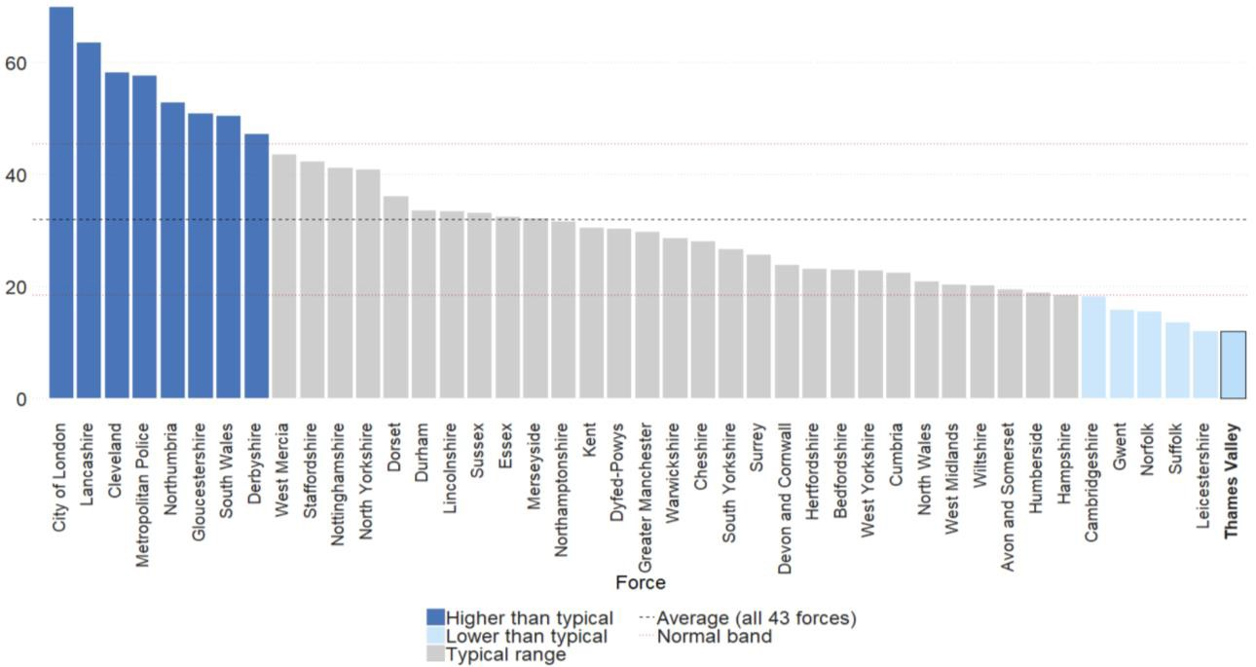
In the year ending 31 March 2020, the Crime Survey for England and Wales estimated that 36.6 percent of the population of the Thames Valley Police force area experienced or witnessed anti-social behaviour. This is similar to the average throughout force areas in England and Wales, which was 37.9 percent.

27

Estimated proportion of people that experienced or witnessed anti-social behaviour for force areas in England and Wales in the year ending 31 March 2020

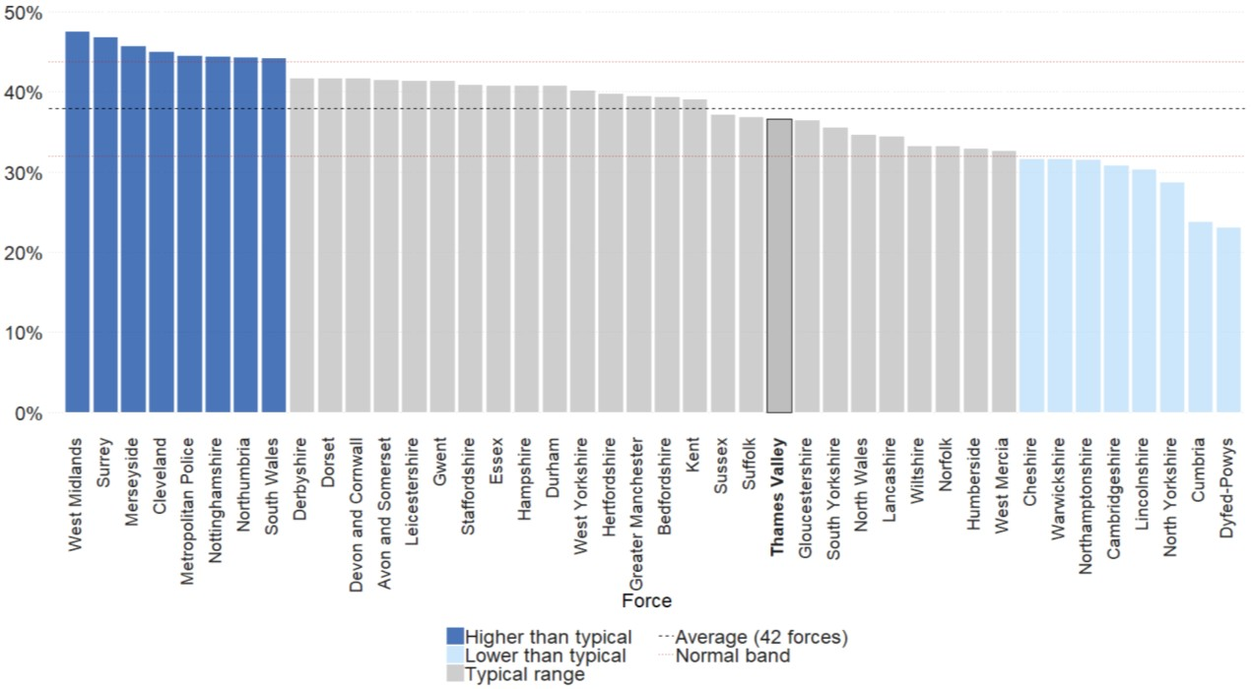

Note: the data included in this graph are estimates from the Crime Survey for England and Wales. Within this data, the City of London has been combined with the Metropolitan Police to provide an estimate for London as a whole.
It isn’t clear why Thames Valley Police records lower levels of anti-social behaviour. It may suggest that there are fewer incidents in the area where Thames Valley Police operates, that anti-social behaviour isn’t being reported or that it is being inaccurately recorded by the force.
The force should reassure itself that the community is confident in reporting incidents of anti-social behaviour and that any reports made are correctly identified and recorded.

28

Responding to the public


Thames Valley Police requires improvement at responding to the public.

Areas for improvement

The force should make sure that repeat callers and vulnerable people are routinely identified
Thames Valley Police records a lower proportion of callers with mental health concerns than most other forces in England and Wales. Our observations of the forces call handling centre highlighted that checks for repeat callers or other vulnerable people connected to the incident weren’t always completed at the first point of contact. On some occasions where a vulnerable person was identified, insufficient details were recorded on the incident log.
Failure to identify repeat or vulnerable callers means that the risk to the victim isn’t always accurately assessed and, as a result, the victim may not always receive the correct response.
In the year ending 31 March 2021, the force recorded 4.1 mental health incidents per 1,000 population. This is lower than the rate in England and Wales, which was 9.1 mental health incidents per 1,000 population in the same period.
Thames Valley Police was unable to tell us how many incidents it had received relating to repeat callers.

The force should make sure that call handlers assess risk effectively so that people receive an appropriate response
Contact management staff are trained to use a structured risk assessment known as THOR (Threat, Harm, Opportunity, Risk). This helps establish how urgent a call is and what type of response is needed. This process isn’t completed well enough on too many occasions. Failure to consistently complete and record a thorough risk assessment can lead to an inappropriate prioritisation or response.

29

The force needs to make sure that call takers give appropriate advice on the preservation of evidence and crime prevention
On several occasions crime prevention or scene preservation advice wasn’t given when required. Giving crime prevention advice can protect victims from repeat abuse and scene preservation advice will greatly assist investigations.

Innovative practice

Officers have received additional training to help them work better with victims in crisis
Some 200 members of incident and crime response teams have received training from police negotiators on how to communicate with victims of crime. The training raises awareness that a victim of any crime could be in crisis and how that may feel. This is explored further through explaining the different stages of grief and how a victim may respond differently to the expectations of the
attending officers. This provides the teams with skills to help them better work with victims and leave the victim feeling they have had a good service.

Main findings
In this section we set out our main findings that relate to how well the force responds to the public.

The force doesn’t always have the capacity to provide an appropriate and timely response to incidents, including those involving vulnerable people
Response officers investigate certain types of crime, complete case papers and respond to calls for service. They are clear on their responsibilities to safeguard vulnerable people. They have good knowledge of what initial enquiries need to be made at crime scenes to secure and preserve evidence.
There has been increased demand on response officers, for example they have more work to complete to prepare prosecution files. Officers also look after people detained under the Mental Health Act. Frequently there are difficulties finding a place of safety so they spend unacceptably long periods of time waiting with officers. This is an additional demand on the force which, at this time, it isn’t able to fully quantify.
We found that the numbers of officers responding to incidents is insufficient to meet demand. As a result, the force doesn’t consistently respond to calls for service within its own target times. There are often backlogs of incidents waiting for officers to attend.
Data from the force for the 12 months ending in July 2021 indicates that it is only meeting its 15-minute target to attend incidents requiring an immediate response on 54 percent of occasions. People requiring an urgent response – within one hour – only receive it on 38 percent of occasions. The need to respond to new calls for service

30

prevents response officers from giving a consistent, timely service to victims of the crimes they are already investigating.

Workloads in the control room and for response officers aren’t always manageable
Response and control room staff receive good levels of welfare support through structured debriefing after traumatic incidents, access to free and confidential mental health support from the Blue Light Network, and the availability of counselling through the employee assistance programme.
Line managers are responsive to welfare needs and the chief officer team has taken steps to improve officer safety. Enhanced support is given to any officers and staff who are assaulted. The success of prosecutions for these assaults are monitored at a chief officer level.
Despite this, all too often we heard from control room and response staff that workload pressure was unmanageable. Figures from the force indicate that many of the response teams are working excessive overtime, which indicates that the pressures are a problem.
Call handlers in the control room, who are getting used to a new contact management computer system, were concerned they might overlook something important due to the amount of calls they deal with.

The public can report crimes and incidents through a range of channels
The force is an early adopter of the new national contact platform for police forces, police.uk, providing digital reporting services and information.
There has been a marked shift towards using this platform partly because the force encouraged callers to use online reporting during COVID-19 lockdowns. A change in messaging has contributed to 50 percent of non-emergency calls moving online at its peak.
It is also rolling out the Good Sam app, which allows the global positioning signal of a caller’s phone to be pinpointed on the force system. With the caller’s consent it gives access to the caller’s mobile phone video app. The footage and GPS in turn can be shared with ambulance and fire and rescue services.

Officers attending calls don’t always receive relevant information in a timely way
The force has implemented a new, advanced IT system to manage its response to calls for service from the public. It can access other IT systems within the force holding relevant information about callers. This helps to assess the risk to the caller and provide information to attending officers.
Although this is positive, not all contact management staff fully understand how to use the system effectively. They told us that sometimes they found it difficult to quickly gather all relevant information. This could mean they have an incomplete picture of

31

what resources are available for deployment and fail to pass all relevant information to attending officers in a timely way.
The force has recently made changes to how information is displayed by the system. We will review their effectiveness as part of our continuing work with the force.

The force’s understanding of the demands for emergency response informs its decision-making on deploying resources to meet them
Prior to our inspection, the force had already comprehensively reviewed its capacity to respond to calls from the public and shared this work with us. It discerned that often there weren’t enough deployable incident response staff to meet demand in a timely way and developed a plan to increase the number available. This includes reducing the frequency with which response officers are used to support other parts of the force and seconding neighbourhood policing officers to the response role. Progress against this plan is overseen by a group of senior officers.
We identified the same issues and will monitor the force’s progress in implementing its plan to address them.

32

Investigating crime

Thames Valley Police is adequate at investigating crime.

Areas for improvement

The force needs to make sure it complies with the requirements of the Victims Code
Under the Code of Practice for Victims of Crime, there is a requirement to conduct a needs assessment at an early stage to decide whether victims fall into one of the three priority categories: victims of the most serious crimes; persistently targeted victims; and vulnerable or intimidated victims. If victims fall into these categories, special measures can be used to support them to give the best evidence in court and these should be explained.
The outcome of the assessment and the request for special measures should be recorded.
In the initial stage of our inspection of Thames Valley Police we found no structure to ensure that victim needs assessments were completed, which made it unclear whether this support had been fully considered. While we are pleased to see the force promptly improved its training and processes in this area, the new system is not yet understood by everyone nor effective enough.
We also found that victims’ personal statements were often not considered. This means that they are not always given the opportunity for their voices to be heard.
Victims are inconsistently updated about the progress of their case.
We acknowledge the force’s efforts to address this since our 2019 inspection. Response officers have time allocated in their shift pattern to update victims, and oversight and monitoring arrangements are in place. Despite this progress, this still needs to improve.

33

The force should ensure it records the reasons why victims withdraw their support from investigations and considers evidence-led prosecutions
When a victim decides to withdraw support for an investigation, known as outcome 16, or wishes for it to be dealt with by an out-of-court disposal or a caution, an auditable record of the victim’s wishes, such as a signed statement, needs to be obtained. This is important as it gives a record of the victim’s wishes and the reasons why they don’t wish to support a prosecution.
In many cases these wishes are not recorded. In some cases, such as domestic abuse incidents, it would have been appropriate for the police to continue an investigation through an evidence-led prosecution, but this wasn’t considered by the investigating officer.

Innovative practice

Victims of serious sexual assault are given information that encourages them to see criminal justice proceedings through to completion
Victims of rape and serious sexual assault may wait for some time for the investigation to be completed. This can lead to the victim feeling that the police don’t take the matter seriously and disengaging from the investigation.
To prevent this, Thames Valley Police provides a timeline explaining what to expect during the investigation and when significant events are likely to
take place. This gives victims an understanding of the process and the time that it will take.
Evaluation shows that victims who have received this are less likely to withdraw from the criminal justice process.

Main findings
In this section we set out our main findings that relate to how well the force investigates crime.

The force has effective governance in place to improve the quality of investigations
The force has put in place a comprehensive programme known as Endeavour to improve the quality of investigations. Embedding crime investigation skills is an important part of this work. Additional training and resources, such as aide memoirs and learning bulletins, are provided to front line officers and their supervisors.

34

The force has successfully encouraged officers to pursue a detective career but it should reassure itself that it understands the number of detectives it needs to meet demand
Encouraging officers to pursue a detective career is also part of the Endeavour programme. The force was an early adopter of the external direct entry route for detectives, a fast track from recruit to detective. It promotes the role of a detective through enhanced recognition, such as requiring experience of crime investigation for promotion. There is support for those who choose this career pathway. This includes a dedicated crime academy offering continuing professional development.
As of 31 March 2021, Thames Valley Police had 100 percent of posts that require officers to be at level 2 of the professionalising investigation programme (PIP2) filled with accredited investigators or trainee investigators. This means the force has no shortfall of investigators. This is higher than the average throughout forces in England and Wales, which was 89 percent.

Percentage of PIP2 accredited investigators and trainees (total staff) in post compared to those who should be in post throughout forces in England and Wales as at 31 March 2021

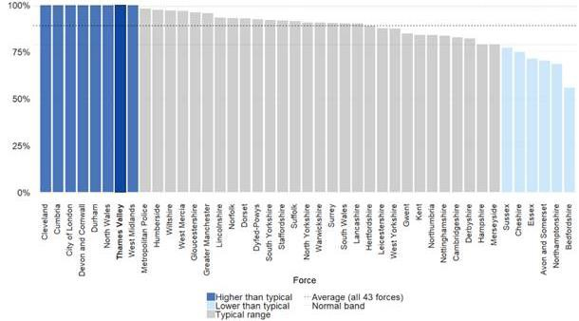

Note: In total, 558 of the 792 PIP2 investigator roles (70 percent) were filled with accredited investigators while the remaining 263 posts were filled with trainee investigators. Including the number of trainee investigators has led to the force to have no shortfall in investigative capacity.
Despite this, many investigators carry high workloads that they describe as unmanageable.
The force now records more crime than previously. Procedural changes mean that it takes longer to prepare case files, comply with disclosure rules and gather evidence from electronic devices. This extra work has been absorbed within existing teams.

35

We found there is an over reliance on the use of overtime. We were told that staff in some units consistently work 30 hours’ overtime each month. On occasions
officers are working unpaid on laptops at home, which may mask the level of demand on them. This can affect the ability of officers to relax when away from work and take uninterrupted time for rest and recovery.
Despite these efforts, some staff still need to prioritise investigations based on risk, which means that other victims will wait longer for their investigations to be progressed. Delays mean that there is a greater probability that victims disengage from the justice process and offenders aren’t brought to justice.

The supervision of investigations isn’t always effective and appropriate
The force has clear processes and expectations about the supervision of investigations. Despite this, some supervisors told us that the numbers of inexperienced staff made this more time-consuming. This extra demand added to other pressures of work may explain why supervisor reviews aren’t always taking place.
Consequently, not all investigations are effectively supervised. This lack of oversight adversely affected the quality and timeliness of some of the investigations we reviewed.

Provision of forensic evidence for lower-risk cases isn’t always timely
The force has a service level agreement with its scientific support department in respect of the provision of forensic evidence such as fingerprints or mobile
phone examination. The speed of examinations will be determined by the risk or urgency of the case. Service in respect of serious cases is good. The force has invested in additional equipment to examine mobile phones and where necessary has outsourced this work.
It recognises that in some non-urgent cases the speed of examinations isn’t
quick enough. There is now a forensic improvement plan with an allocated budget designed to improve performance in this area.

The force makes good use of out-of-court disposals to secure justice for victims
When appropriate a force can use measures outside court proceedings to achieve justice for victims, such as a caution, apology or other forms of reparation. While work needs to be done to record the wishes of victims, Thames Valley Police makes frequent and proper use of these resolutions. This means that victims are satisfied, offenders diverted and pressure on the court system reduced.

36

Protecting vulnerable people

Thames Valley Police is adequate at protecting vulnerable people.

Area for improvement

The force should make sure that it actively considers the use of measures to protect people from domestic abuse in all appropriate cases
Our 2019 inspection said that the force should reassure itself that it was making proper use of tools such as domestic violence protection orders and the domestic violence disclosure scheme, also known as Clare’s Law.
In this inspection we found that domestic abuse protection orders were still not considered in all applicable cases. The force also makes less use of the domestic violence disclosure scheme than almost all other forces in England and Wales.
This may mean that opportunities to prevent further harm to victims of domestic abuse are being missed.
Main findings
In this section we set out our main findings that relate to how well the force protects vulnerable people.

The force’s governance of the service delivered to vulnerable people is effective
Each category of vulnerability, such as domestic abuse or modern slavery, has an individual action plan led by a senior officer. These follow categories set out in the National Vulnerability Action Plan as examples of good ways of working.
Progress against these plans is monitored by the vulnerabilities strategic group chaired by a chief officer. The force could be more confident in the success of these plans if it reassures itself that it accurately identifies all types of vulnerability when victims first contact the force.
Where the board identifies a problem that requires further work to improve its service in a particular area it commissions a service improvement review. These reviews are used frequently by the force and consist of a detailed analysis drawing out conclusions and recommendations with an associated improvement plan.

37

The force doesn’t always have sufficient capacity to meet the needs of vulnerable victims
Staff and supervisors in units dedicated to dealing with vulnerable victims, such as the domestic abuse investigation teams, told us that workloads were often unmanageable. Overtime was used routinely to keep up with demand and there was evidence of staff working from home to complete tasks. Not all this extra work received overtime payments, meaning that this demand on officers’ time may be hidden from the force.
Cases with the highest risk or approaching some sort of time limit such as a court date are prioritised. Yet, cases such as an allegation of a historic domestic rape or investigations awaiting a charging decision would be left until officers had time to attend to them. These delays increase the risk that victims may withdraw from the investigation and make it difficult to secure a magistrate’s extension to bail conditions imposed by the police. This can then lead to conditions designed to protect domestic abuse victims lapsing.

The force has improved its initial response to victims of domestic abuse but there is still work to do
In our 2019 inspection, we identified that the force used a system of appointments to see victims of domestic abuse where an immediate response wasn’t required. It could be some days before a victim was seen. This delay all too often meant that the victim had disengaged from the investigation and making an arrest was more difficult.
The force now attends nearly all domestic abuse reports in person and prioritises them. It makes a much higher proportion of arrests for domestic abuse than previously and brings more domestic abuse perpetrators to justice than in the past. The most recent data provided by the force shows that it made 9,250 arrests between 1 April 2021 and 30 September 2021, compared to 4,097 in the previous six months.
Despite this, it takes officers on average 12 hours to attend an incident that isn’t classed as immediate. This is too long.

The force works effectively and proactively with other organisations to reduce vulnerability and repeat victimisation
Working with other organisations is a notable strength for Thames Valley Police and is woven through its approach to protecting vulnerable people. It actively works within multi-agency strategic boards such as the safeguarding children’s board.
It contributes well to the work of meetings that support victims of domestic abuse, such as multi-agency risk assessment conferences (MARACs) and multi-agency tasking and co-ordination meetings (MATACs).
It makes good use of data from other organisations to identify and protect those at most risk of harm or of becoming repeat victims. This includes young people who are in danger of harm by frequently going missing or others involved with drugs supply or other forms of exploitation.
It adopts good professional procedures such as using the Philomena protocol to encourage other organisations to note relevant information that might be helpful in

38

locating a young person at risk from frequently going missing. It also uses the Herbert protocol, which is a similar approach for older people in care settings.
The force was an early adopter of Operation Signature, which supports elderly victims of fraud and prevents them becoming victims a second time.
The force has multi-agency safeguarding hubs (MASHs) that receive all referrals created about vulnerable people. The hub assesses the risk attached to each referral and starts work with other organisations to provide appropriate support. As a result of a backlog of assessments, the force put additional staff into the hub and reviewed how it could work more efficiently. As a result, the backlogs have been reduced.
Although positive, some backlogs remain and the problem may persist without further investment or the implementation of more efficient ways of working.

The force supports detained children and young people and women
Children and young people detained by Thames Valley Police or who attend a police station voluntarily as a suspect are seen by a worker from the liaison and diversion service. This is to seek opportunities to put diversionary activities in place and address any needs, such as mental ill-health, where the young person may benefit from support. The force also works with Reading Football Club to offer life coaching and other diversion activities for 18 to 25-year-olds.
Women are seen by the custody nurse, who assesses any underlying needs that may be leading to their offending. This discussion with someone outside policing has sometimes highlighted hidden harm, such as domestic abuse. This helps ensure the woman has access to specialist support.

39

Managing offenders and suspects

Thames Valley Police is good at managing offenders and suspects.

Innovative practice

The force takes effective measures to reduce re-offending and change behaviour
Violence reduction units (VRUs) are partnerships initially funded by central Government to promote a public health approach to knife crime. The work of the VRU in Thames Valley demonstrates innovative approaches.
VRU data has improved the targeting of offenders and locations connected to knife crime leading to a reduction in these crimes. Interventions at ‘teachable moments’ in accident and emergency departments and custody divert young people from committing further violent crimes.
The use of community resolutions has been expanded to some drug offences. Those found in possession of class A drugs, irrespective of a previous conviction, can take part in a diversion scheme that provides assessment, education and tailored intervention. The force told us that 95 percent of adults and 88 percent of young people participating complete the programme.
Data sharing has been significantly improved through the development of the Thames Valley Together Project. This gives over 1,000 people working across allied organisations access to data on a cloud-based shared system and uses analytics to better understand the issues that may be driving crime.
Main findings
In this section we set out our main findings that relate to how well the force manages offenders and suspects.

40

The force doesn’t always have the resources within its MOSOVO (management of sex and violent offenders) and POLIT (police online intelligence) teams to manage demand in a timely way
Individuals suspected of viewing indecent images of children online are dealt with promptly where the risk is assessed as high or very high. But the force doesn’t deal promptly with investigations that are assessed as low or medium risk.
There are also delays in intelligence gathering for referrals to police linked to indecent images of children. At the time of our inspection, there was a backlog of nearly 300 cases waiting for a full risk assessment. This leads to delays in arrest and investigation and affects the force’s ability to prevent further offending.
The team responsible for the management of sex and violent offenders (MOSOVO team) also has a backlog of visits. These visits help establish whether or not a sex offender is reoffending or if the risk they pose has changed. This can be identified by examining phones and laptops but staff expressed concerns that equipment and technical assistance isn’t always available. This may affect the force’s ability to accurately assess the risk the offender poses and therefore its ability to prevent further offending.
The force recognises the risks in this area and has approved the allocation of 12 further staff to the MOSOVO team. The force should monitor the effect of this increase to ensure that it is sufficient to manage demand and risk.

The force has effective arrangements to monitor and scrutinise pre-charge bail and the release of suspects under investigation
Officers were clear about when it was appropriate to grant suspects pre-charge bail (PCB) or release them under investigation (RUI) and supervisors record the justification for these decisions. This increases the effective management of suspects and protects victims. Systems remind investigating officers and their supervisors when suspects on bail are due to return. Supervisors record why decisions about the use of or any changes to PCB or RUI are justified. The appropriate use of PCB and RUI is monitored quarterly by senior officers through the bail custody group.

The force has provided officers with guidance for dealing with foreign nationals who have been detained
Frontline officers understand what actions need to be taken in respect of a detained foreign national. A document offers guidance about how to establish the identity of the individual and prevent any risk they may pose. It includes information about acceptable forms of identity and how to carry out immigration and Interpol checks.
Explanatory notes and any contact details that may be needed are provided.

Public protection and neighbourhood policing teams work together to manage registered sex offenders
Staff and supervisors in the public protection unit (PPU) are trained to use nationally recognised risk assessment techniques. This helps to correctly determine the risk posed by registered sex offenders.

41

The PPU and neighbourhood policing teams work together to ensure awareness of sex offenders in the community. Details of all registered sex offenders and where they live are held on the force computer system and new offenders are included in neighbourhood briefings. A guide has been produced for neighbourhood officers explaining what they should look for if they attend a sex offender’s address and there are clear processes for them to record any intelligence they gather. This helps the force understand any increase in risk or likelihood of further offending.

The force identifies and manages repeat offenders well and takes effective measures to change their behaviour
Repeat offenders are identified through the risk, frequency and gravity dashboard created by the force intelligence bureau. It combines sources of information and intelligence, including information provided by other organisations, to determine the most serious risks in each policing area. Local tasking and co-ordination processes direct appropriate actions to reduce offending.
There is an effective multi-agency integrated offender management (IOM) programme. Themed subgroups, such as housing or mental health, develop bespoke support systems for offenders.
IOM staff work alongside probation and analytical staff to reduce offending by removing some of the drivers of it, such as homelessness or drug use. They use nationally approved models to assess the initial and changing risk posed by offenders. The force breaks down results by offender and has calculated the cost of crime throughout all organisations to give an understanding of whole costs. Data provided by the force shows a 23 percent reduction in offending by participants during the first six months they are on the scheme. This data has been used to justify additional investment to increase the size of the IOM cohort to 500 as the force moves to expand the scheme to work with types of offenders not usually eligible. This will make it more responsive to local patterns of offending.

42

Disrupting serious organised crime

We now inspect serious and organised crime (SOC) on a regional basis, rather than inspecting each force individually in this area. This is so we can be more effective and efficient in how we inspect the whole SOC system, as set out in HM Government’s SOC strategy.
SOC is tackled by each force working with regional organised crime units (ROCUs). These units lead the regional response to SOC by providing access to specialist resources and assets to disrupt organised crime groups (OCGs) that pose the highest harm.
Through our new inspections we seek to understand how well forces and ROCUs work in partnership. As a result, we now inspect ROCUs and their forces together and report on regional performance. Forces and ROCUs are now graded and reported on in regional SOC reports.
Our SOC inspection of Thames Valley Police hasn’t yet been completed. It is due to conclude in 2023. We will update our website with our findings (including the force’s grade) and a link to the regional report once the inspection is complete.

43

Building, supporting and protecting the workforce

Thames Valley Police is adequate at building and developing its workforce.

Areas for improvement

The force needs to better understand all data relating to wellbeing and improve its evaluation of the services it provides to staff
The force does not fully use data from occupational health and psychological screening referrals to understand wellbeing issues throughout the force. There is also only limited evaluation of the extent to which its wellbeing provision addresses its workforce’s needs. This means it may not be fully identifying issues or using the best means to tackle them.
The force should ensure its that officers and staff have manageable workloads
The most significant wellbeing effect on staff across the force was unmanageable workloads. Overtime is used to address daily demand and too often staff are not taking the full allocated meal break when on duty.
As a result, officers are sometimes unable to provide victims with the service they deserve, which further affects their wellbeing. High workloads are also preventing some staff from accessing initiatives designed to support them.

44

Innovative practice

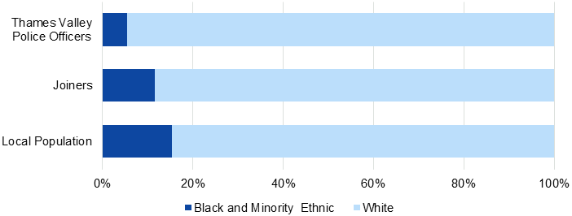
There is good work to recruit and retain more officers from minority ethnic backgrounds
The force has a positive action engagement team (PAET) who encourage and support prospective officers from minority ethnic backgrounds to join Thames Valley Police.
Applicants from minority ethnic backgrounds who meet the eligibility criteria for police constable are offered support through the recruitment process. The PAET uses a private Facebook account to provide information and a Q&A session with a human resources representative on how to complete the application process.
Those successful at this stage are provided with guidance and advice in interactive sessions that help them relate their experiences to the areas tested in the selection centre. Applicants offered an interview are again provided with advice and support for this part of the process.
The PAET maintains contact with the applicants to ensure any barriers or concerns are addressed. If successful, the student officer is assigned a mentor from their policing area to offer advice and support during their probationary period.
In the year ending 31 March 2021, 11.6 percent of police officer joiners to Thames Valley Police self-identified as Black, Asian or minority ethnic (BAME). This is lower than the BAME proportion in the local population (15.4 percent) but higher than the total proportion of BAME officers in the force at 31 March 2021 (5.5 percent). This suggests that the force is moving in a positive direction but is still not fully representative of its local community.

Proportion of full-time equivalent Thames Valley Police officers and officer joiners that self-identify as Black, Asian or minority ethnic at 31 March 2021 compared to the local population

Note: calculations exclude ethnicities that haven’t been stated, which represented 0.8 percent of police officers and 0.3 percent of police officer joiners

45

Main findings
In this section we set out our main findings that relate to how well the force builds and develops its workforce.

The force has an ethical and inclusive culture
Staff are proud to work for Thames Valley Police and a feeling of belonging exists in the organisation.
Ethical behaviour is part of the training and development courses and is promoted strongly by senior leaders. There are ethics champions throughout the force and an ethics committee chaired by an independent academic ethics adviser. The committee has published ethical dilemmas, such as disparity in stop and search use and officers participating in protests, through a dedicated intranet page. The force could do more to promote this good work among frontline staff and encourage them to submit ethical dilemmas.

Wellbeing initiatives are available to staff but some struggle to find time to participate
The force is following the national framework to promote staff wellbeing and there is support for those experiencing trauma, mental health issues or other welfare challenges.
The Emergency Services Trauma Intervention Programme (ESTIP) is widely used to support incident response officers effectively, although we found that this was applied less systematically for specialist investigators. Supervisors are trained in decompression techniques to support colleagues affected by traumatic experiences.
Advice is available for staff with financial difficulties, wellbeing dogs visit stations and quiet wellbeing rooms are provided for staff. The employee assistance programme provides access to support and counselling services. Gyms are provided throughout the force area and health surveillance nurses monitor trends in wellbeing.
There are 180 Blue Light Champions raising awareness of mental health issues and challenging the stigma that surrounds them and over 30 peer supporters that the force has trained to support colleagues. The force leadership has encouraged ‘buddy networks’ for staff to support each other, including a network for staff with cancer, a men’s forum and a maternity group.
Overall, the force offers good wellbeing provision and the workforce knows it is available, but on many occasions they told us that they were too busy to use it. This undermines the efforts the force is taking to improve wellbeing.

The force is good at managing performance
Leaders encourage a learning approach to improve performance. Reflective methods are used to manage low-level performance. This demonstrates that the force addresses poor performance in an ethical and proportionate way.

46

The force makes good use of the unsatisfactory performance procedures. In the year ending 31 March 2021, 1.25 percent of Thames Valley Police’s officers were subject to these procedures. This is much higher than the average throughout forces in England and Wales, which was 0.36 percent.

Percentage of police officers who have been through unsatisfactory performance procedures for forces in England and Wales in the year ending 31 March 2021

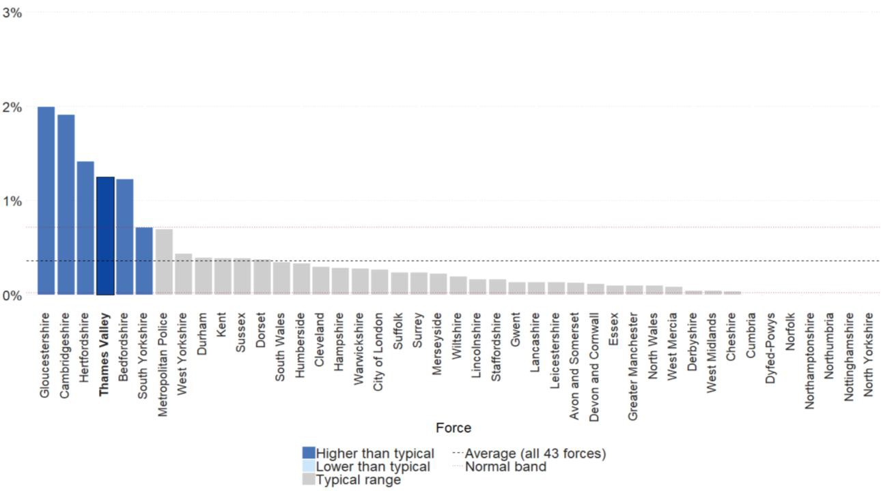

Support to staff in high risk roles isn’t seen as wholly effective
Officers and staff in roles identified by the force as carrying a higher risk of trauma undergo regular psychological screening through an online questionnaire. This is to determine and address wellbeing issues at an early stage. If concerns are identified, it is followed by an occupational health appointment. At the time of our inspection, referred staff were waiting on average 25 days for this to take place.
Staff taking part in the screening aren’t confident that it always identifies those experiencing difficulties. The online form makes it easier for participants to avoid disclosing information that they feel could lead to an unwanted change of role or adversely affect promotion prospects. As there is less consistent use of decompression techniques among specialist staff, early signs of welfare issues may be missed.

The force is building its workforce for the future
The force has an excellent recruitment website called TVP Careers, offering a good insight into policing for prospective applicants through extensive details on officer and staff roles. Information on recruitment and training processes are supplemented with videos about the experience of officers and staff in Thames Valley Police.

47

The force knows the diversity of its workforce
The force knows the make-up of the workforce through its diversity monitoring questionnaire, which the force told us had been completed by over 80 percent of staff. This high return demonstrates that staff with protected characteristics feel comfortable disclosing them and it helps the force to support people better and to determine areas of the organisation where under-representation exists.

The force understands factors that influence retention
The force has analysed data from leavers’ interviews to discover the main reasons why officers and staff leave the force. It found that non-pay benefits such as flexible working act as incentives to stay with the force. Analysis of changes it made as a result showed more positive feelings towards the force. This means that people are less likely to leave the organisation.

Development programmes provide officers and staff with the opportunity to progress their careers
The two-year Developing Potential Programme takes 30 police officers and staff each year to explore their self-awareness and self-development. A course tailored to Black, Asian and minority ethnic officers and staff has so far been completed by 60 people, which has improved diversity in leadership roles. Likewise, the Women’s Development Programme supports female sergeants in moving into more senior positions.

Vetting and counter corruption
We now inspect how forces deal with vetting and counter corruption differently. This is so we can be more effective and efficient in how we inspect this high-risk area of police business.
Corruption in forces is tackled by specialist units, designed to proactively target corruption threats. Police corruption is corrosive and poses a significant risk to public trust and confidence. There is a national expectation of standards and how they should use specialist resources and assets to target and arrest those that pose the highest threat.
Through our new inspections, we seek to understand how well forces apply these standards. As a result, we now inspect forces and report on national risks and performance in this area. We now grade and report on forces’ performance separately.
Thames Valley Police’s vetting and counter corruption inspection hasn’t yet
been completed. We will update our website with our findings and the separate report once the inspection is complete.

48

Strategic planning, organisational management and value for money

Thames Valley Police requires improvement at operating efficiently.

Areas for improvement

The force needs to develop a comprehensive understanding of demand
The force demonstrates that it has a good awareness of current demand for service and it flexes resources to meet the challenges it is experiencing.
However, it needs to better understand how its approach affects the overall quality of service to the public and the impact on its staff.
We were told that staff have unmanageable workloads in most areas.
New requirements, that include greater complexity in investigating crime and with file preparation, combined with the fact that the force now records crime more accurately, are adding pressure. Officers are taking work home to manage excess work demand.
Officers are often pulled away from their normal duties to supervise people
in crisis. The pressures other services face in providing suitable accommodation for people detained under the Mental Health Act are increasing demand for Thames Valley Police. This is adding to the demand the force has to manage.
The force should reassure itself that it is able to understand and quantify how these pressures are affecting its ability to manage demand across the entire organisation.

The force needs to make sure it has the capability and capacity it needs to meet and manage current demands efficiently
The force needs the right people in the right place to support the changes it has planned and to make sure that calls for service and investigations are not subject to undue delay.

49

Initiatives to help manage incoming demand, for example the incident and crime response teams, are not resourced effectively and do not have enough capacity or capability. The work pressure on supervisors is preventing them from overseeing and leading their teams as they feel they should.
The investigation of crimes and the assessment of risk to vulnerable people or by potentially dangerous offenders are adversely affected by a lack of sufficient staff with the right skills.

The force should ensure that new IT systems are implemented effectively
In September 2020, Thames Valley Police introduced a new contact management system that records calls for service from the public, can access relevant information about the call from other force systems, and records actions taken.
This introduction of this system has caused frustration for some staff who have been unable to use it in the way that it was envisaged. For example, during the inspection we were told by control room staff that they were not confident they could always provide important situation updates relevant to the safety of officers attending calls. This was reinforced by incident response officers who had experienced this.
Some control room staff told us that they did not trust the new system to identify all the relevant information and consequently were also carrying manual searches on other systems. Other staff reported that screen displays lacked clarity, making it difficult for them to identify the location or availability of officers. As a result, they were recording some information on paper.
As part of the implementation of this system, the force has carried out a review and identified many of these issues already. In some cases, it puts problems down to staff not understanding how to use the system correctly despite receiving guidance. In other cases, where the review has raised the need for minor adjustments, such as a different screen layout, that has been progressed.
Despite these efforts, not all contact management staff understand standard operating procedures and how to make best use of the system 13 months after the system went live. This is leading to inefficiencies and, critically, these staff losing faith in the system. The force must make sure these issues are fully addressed and that new IT systems deliver what was envisaged and provide the benefits identified.
Generally, the force should reassure itself that the implementation of new systems is closely monitored to make sure that all staff are supported, and that feedback is both sought and seen to have been acted upon. This will help improve changes in the future. It will also enable the force to ensure the systems provide what was promised and that the impact of change does not affect staff confidence or the service provided to the public.

50

Innovative practice

The force improves productivity by developing its use of robotic process automation
In several policing areas, the force is using robotic process automation (RPA) for mundane administrative tasks, helping staff to focus on high-level, value-adding tasks. RPA works by using software to mimic human actions and follow policing processes. The force has developed its use of RPA to process firearms applications, process road traffic collision reports submitted online, check data within the records management system and generate automated letters to victims.
The force is looking for further opportunities to develop automated processes to focus staff time elsewhere.
Main findings
In this section we set out our main findings that relate to how well the force operates efficiently.

The force understands future demand and has plans to make sure it can meet it
The force has initially responded well to the national, central Government-funded programme to increase police numbers. The force focused its first year of funding on increasing the numbers in its incident and crime response teams and in fact recruited an additional 61 officers over the target of 183 by 31 March 2021. It is planning to use its second year of funding to support other areas throughout the force. This plan includes replacing some police staff with police officers in some roles, such as in the control room and as investigators. The force should reassure itself that these plans will improve results and provide value for money.

The force makes the best use of the finance it has available, and has a robust and effective plan to meet its savings challenge
It is evident that the chief officer group takes control of finance, which is managed within a good governance structure. The force's financial plans are clearly aligned to the force management statement, the force's strategic plan and the police and crime commissioner’s police and crime plan.
The force anticipates that it needs to make savings of £18m over the course of its mid-term financial plan. It has an established savings board and there are rigorous processes in place with regular reviews to make sure that the force is on track to achieve them. For example, the force initially forecasted a requirement of £16m in savings over the life of the medium term financial plan, but through regular reviews and assessments this figure changed to £18m. It was able to respond effectively to this challenge and realign its plans to accommodate the difference. While it still has a gap of £3.25m in its final year of planning 2024/25, there is good governance and focus on driving efficiencies to achieve savings.

51

The problem facing the force is that it needs to ensure savings are aligned with promoting effective and efficient policing. But the force recognises that further changes in funding will present it with difficult decisions and this could affect how it manages its workforce mix in future years.

The force actively seeks opportunities to improve services through collaboration
The force has a good track record for entering into collaboration agreements. These include local, regional and national arrangements covering IT, counter terrorism, forensics and automatic number pate recognition. Of note is the joint IT
strategy with Hampshire Constabulary, which reduces duplication while meeting joint priorities and objectives. Clearly linking to the national Policing Vision 2025, it sets out a timetable of improvements for both forces.


52

April 2022 | © HMICFRS 2022
www.justiceinspectorates.gov.uk/hmicfrs
53 AGENDA ITEM 3

HMICFRS PEEL Overview 2022 – TVP

All AFIs and improvement activities are reviewed through the DCC’s Improvement & Innovation Board to provide assurance on activities.

Section | AFI | Grading | Governance & Activities
Victim Services Assessment | N/A | No grading | All relevant points covered in below sections
CDI | The force needs to improve the recording of equality data | Good | Governed through CDI strategic group.  Organisational decision paper due to go to CCMT in June/July.
Public Treatment | The force should improve how it records and understands the use of force by officers | Good | Governed through the Legitimacy Board.  - Advancements already made in data analysis.  - Move to Pronto in July.  - Data will also be published externally.
Preventing Crime & ASB | The force should make sure that its approach to solving community problems of crime and anti‐social  behaviour is consistent and recorded well. | Adequate | Governed through NH Programme board. Improvement plan in place.
Preventing Crime & ASB | The force should make sure it fully understands the impact of the allocation of neighbourhood officers to other duties | Adequate | Reported into Tier 2 every 2 months, and to the NH Programme Board monthly.  Improvements in data on‐going.
Responding to the Public | The force should make sure that repeat callers and vulnerable people are routinely identified | Requires Improvement | Governed through DCC Collaboration Board.

54

 | The force should make sure that call handlers assess risk effectively so that people receive an appropriate response |  | Contact Management continual improvement plan in place across both TVP and Hampshire.
 | The force needs to make sure that call takers give appropriate advice on the preservation of evidence and crime prevention
Investigating Crime | The force needs to make sure it complies with the requirements of the Victims Code | Adequate | Governed through Victim Satisfaction Gold group.  Strategic lead in place for Victims Code and Victim Satisfaction with DCC as Chief Officer lead.  Improvement plan and activities underway.
Investigating Crime | The force should ensure it records the reasons why victims withdraw their support from investigations and considers evidence‐led prosecutions |  | Being governed by Crime Standards Board.  Work ongoing to bring together various workstreams.
PVP | The force should make sure that it actively considers the use of measures to protect people from domestic abuse in all appropriate cases | Adequate | Being governed by Crime Standards Board.  Comprehensive DVPN/DVPO Improvement Action plan in place.  Comprehensive Clare’s Law Improvement Action plan in place.
Managing Offenders | None | Good | N/A
Workforce | The force needs to better understand all data relating to wellbeing and improve its evaluation of the services it provides to staff | Adequate | Being governed by Workforce Board.  Improvement activities include:  - A Force Health, Safety Wellbeing Plan  - Enhanced data analysis.

55

 | The force should ensure its that officers and staff have manageable workloads |  | To be governed under the Managing Frontline Demand Programme.  Demand reduction opportunities being identified at the moment with first set of options to be taken to CCMT at the end of June.
Strategic Planning | The force needs to develop a comprehensive understanding of demand | Requires Improvement | To be governed under the Managing Frontline Demand Programme.  Overarching objective: Strategic oversight, direction and co‐ ordination of a programme of work to develop and implement interventions to reduce internal demand and increase capacity for the frontline.  Demand reduction opportunities being identified at the moment with first set of options to be taken to CCMT at the end of June.  Work on FMS 5 will be starting in June‐September which is focused on understanding demand, capacity and capability.
Strategic Planning | The force needs to make sure it has the capability and capacity it needs to meet and manage current demands efficiently | Requires Improvement | To be coordinated by G&SI and governed under the three demand programmes of work.  - Managing Frontline Demand programme  - Service Delivery & Crime Management Review programme  - Force Review  Work on FMS 5 will be starting in June‐September which is focused on understanding demand, capacity and capability.

56

 |  |  | Tier 1 will also feed into this.
 | The force should ensure that new IT systems are implemented effectively |  | Being governed through Transformation Board and CMP actions through Contact Management improvement plan.  TVP have already ensured that robust lessons learnt from CMP have been conducted and have been considered in our programme management practice since then. (Specific details included in the factual accuracy template)

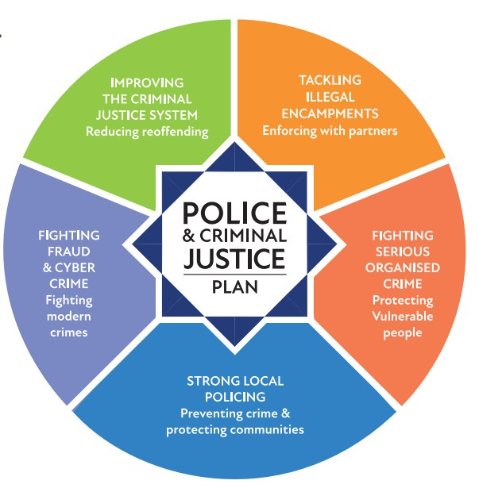
Police and Criminal Justice Plan Level 2 Meeting Data Review
57
AGENDA ITEM 4



1


All Victim Based Crime – Longitudinal Data
58
All Crime Overview
A Focus on Crime Prevention, Reducing Levels of Neighbourhood Crime and Antisocial Behaviour


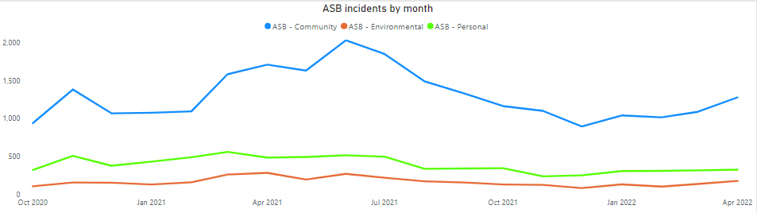
National position* |  | MSG position*
11th of 43 |  | 3rd of 8
There was a +19% increase in the volume of crime recorded in 2021/22 compared with the previous 12 months, however this was predominantly due to the impact of Covid-19 lockdowns on crime levels in 2020/21. Crime volumes in 2021/22 increased +4% compared with 2019/20.

March 2022 saw the highest monthly volume of crime in the last 4 years. Violence without Injury and Public Order accounted for 29% and 13% of crime recorded in March respectively, with both seeing notable increases on levels recorded in January and February 2022.

Longitudinal data for ASB is not comparable due to the change of recording system between Command and Control and CMP, however the monthly volumes since October 2020 are consistent with seasonal patterns.
*crimes per 1000 population 12 months to Mar 2022

59
All Crime Overview
A Focus on Crime Prevention, Reducing Levels of Neighbourhood Crime and Antisocial Behaviour

Recorded crime in Thames Valley
1st April 2021 to 22nd May 2022
Strategic Plan Aim | Measure of Success | 2021/22 | 2022/23 | Thames Valley  Change | National position* | MSG position*
1 | A 5% reduction in the volume of Violence with Injury (including DA but excluding knife crime) | 2,197 | 2,632 | 20% | 3rd of 43** | 2nd of 8**
2 | A reduction in homicide levels against the 5 year average | 2  (5 year average excluding 2020/21) | 5 | 67% | 21st of 43 | 6th of 8
3 | A 5% reduction in the level of knife enabled crime, as defined by the Home Office (excluding possession) | 155 | 153 | -1%

*crimes per 1000 population 12 months to March 2022
** Violence with injury (ONS)

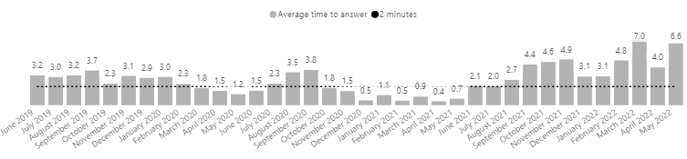
60
Call Handling: 101
Average time taken to answer 101 calls / proportion of callers waiting over 10 minutes for their call to be answered.
Each of the last 9 months has averaged over 3
minutes to answer 101 calls. The year-to-date figure sits at:
5 minutes 7 seconds

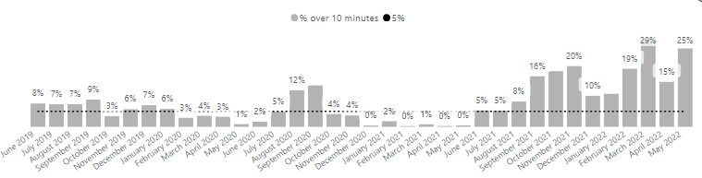
Each of the last 9 months has seen the proportion of callers waiting over 10 minutes for their call to be answered at over 10%. The year-to-date figure sits at:
19%

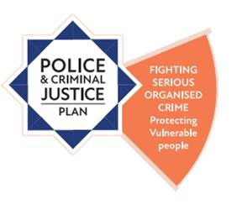
61
Serious Organised Crime - OCGs
Increasing the number of disruptions and successful prosecutions for serious organised
crime (SOC), Ensuring focus on SOC groups involved with acquisitive crime and exploitation

Number of Disruptions
2022/23 Strategic Plan
OCGs and CDLs remain an area of focus for improvement in the 2022/23 plan, with the strategic aim being: Disrupt organised crime groups and county drugs lines, including a focus on drug activity in public spaces.

At the end of 2021/22 there were 52 OCGs
and 33 county drugs lines.

Recorded disruptions have significantly increased in 2021/22 compared with 2020/21. This is partly due to recording practices within FIB, including recording of disruptions attributed to LPAs.

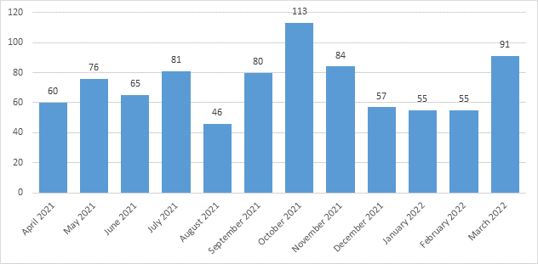

Source: APMIS
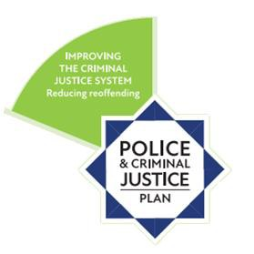
62
Rape and Sexual Offences
Working with other criminal justice agencies to improve performance in dealing
with crimes such as domestic abuse, rapes and serious sexual assaults

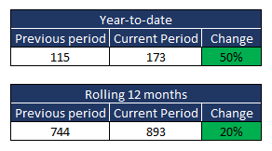
Strategic Aim 11: Increase the volume of formal action taken in rape & other sexual offences
Other sexual offences

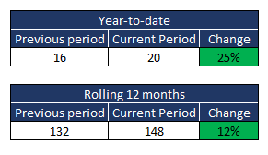
National position*
17th of 43
MSG position*
2nd of 8
Rape

*positive outcome rate 12 months to March 2022
National position*
27th of 43
MSG position*
6th of 8


63
Domestic Abuse

Working with other criminal justice agencies to improve performance in dealing
with crimes such as domestic abuse, rapes and serious sexual assaults

Strategic Plan Aim | Measure of Success | Last updated | Thames Valley
10 | A 10% increase in the volume of DA cases where formal action is taken | 22/05/2022 | 29%
12 | Increase the volume of formal action taken in stalking & harassment offences | 22/05/2022 | 40%
13 | Monitor overall volume of VAWG offences & FAT rate | 22/05/2022 | Offences +21%  FAT rate +1%
Monitoring | Arrest rate in DA related crimes that resulted in  attendance | 22/05/2022 | 46%

64
Bringing offenders to justice
Increasing successful outcomes through the criminal justice system

Strategic Plan Aim | Measure of Success | Last updated | Thames Valley | National position* | MSG position*
8 | Achieve an increase in FAT  volumes in rural crime | 22/05/2022 | 40% | Not available at national level
9 | A 8% increase in overall volume of  cases where formal action taken |  | 11% | 14th of 43 | 2nd of 8

*Positive outcome rate 12 months to March 2022

65
Unauthorised Encampments

*

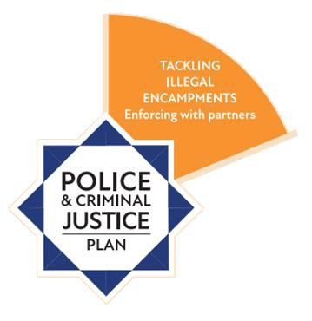
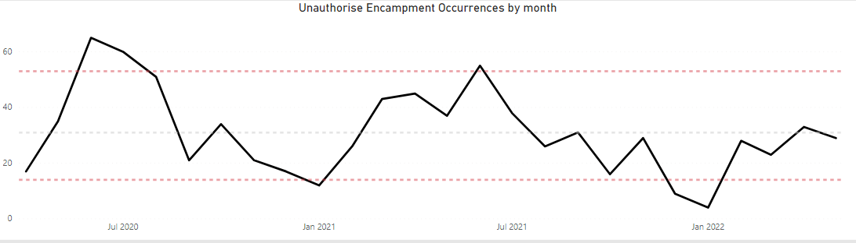
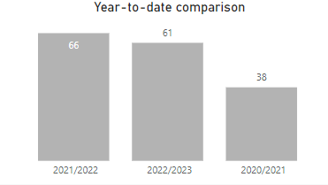
Data Source: Thames Valley Police Crime Recording System: NICHE RMS Date Extracted: 23/05/2022
Note: The table/chart is representative of those occurrences where the occurrence type matched 'Unauthorised Encampment'.
*Year-to-date up to 22nd May 2022

66
National Crime and Policing Measures

Measured at a national level using national metrics such as CSEW minimises any administrative burden on forces and respects forces’ operational autonomy.

Priority Measure | National Metrics | Baseline  (Jul-18 to Jun-19) | Latest 12 months (May-21 to Apr-22) | % Change compared to baseline
Reduce Murder and other Homicides | Homicides | 13 | 22 | +69%
Reduce Serious  Violence | Hospital admissions of u25s for assault with a sharp object | NHS data
Reduce Serious  Violence | Offences involving a discharge of a firearm | 39 | 15 | -61%
Disrupt drugs supply and county lines | Drug-related homicides | 1 | 4 | +300%
Disrupt drugs supply and county lines | Police referrals into drug treatment | Public Health England data
Reduce Neighbourhood Crime | Burglary, robbery, theft of and from a vehicle, theft from a person | CSEW
Improve satisfaction among victims, with a particular focus of domestic abuse | Satisfaction with the police among victims of domestic abuse
 | Victim satisfaction with the police
Tackle cyber crime | Confidence in the law enforcement response to cyber crime | Cyber Aware Tracker
Tackle cyber crime | Percentage of businesses experiencing a cyber breach or attack | Department for Digital, Culture, Media and Sport survey

The National Outcomes framework is national and measured at a national level, the data is not broken down to, or available on an individual force basis.

All forces are developing proxy measures to understand local context of the national measures.

TVP are working with regional colleagues to align proxy measures.


67
Organisational Performance – key indicators
SP
We value our workforce, make best use of resources and maximise the benefits of digital developments

Strategic Plan Measure | Measure of Success | Last updated | Thames Valley
1 | Recruitment and establishment levels, with a particular focus on maintaining sustainable levels of staffing in ICR. | 24/5/2022 | Currently a -5.16% vacancy factor regarding overall Police Officer Establishment.
2 | Reduced levels of avoidable attrition | 24/5/2022 | Total avoidable TVP leavers for Q1 22/23 is  240. This remains relatively stable compared to Q4 21/22 (243).
3 | Increased retention and representation for BAME officers and staff forcewide | 24/5/2022 | YTD successful police officer applicants  remains at 14%.
5 | Reduce overall sickness levels | 24/5/2022 | Overall hours lost in Q4 21/22 is 138,256. A 14% decrease from Q3 2021 (161,220 hours).
7 | Reduction in spending of overtime | 24/5/2022 | The force overspend for 2021/22 was  £1,487,021 (13%)
12 | Reduction in backlogs of digital forensic examination | 24/5/2022 | Backlogged cases have decreased 5% (633 to 603), however exhibits have increased by 1% (1365 to 1378). This indicates a small increase in the number of exhibits per case.
17 | Continued low rates of ICT P1 and P2 incidents | 24/5/2022 | The overall number of incidents continued to drop this quarter by 15%. All P1 incidents were resolved within the SLA timeframe. All four of the P1 incidents impacted Contact Management.

68
69 AGENDA ITEM 5


OFFICE OF THE POLICE & CRIME COMMISSIONER FOR THAMES VALLEY

Report for Information: PCC’s Performance and Accountability Meeting, 30th May 2022

Title: OPCC Strategic Delivery Plan 2021-2025

Executive Summary:

The PCC’s Police and Criminal Justice Plan 2021-2025 presents a combination of policing and non-policing strategic priorities, objectives and planned activities.

The PCC’s Chief Executive, Chief Finance Officer and other members of his Office of the PCC (OPCC) Strategic Management Group are responsible for ensuring that all non-operational policing strategic priorities and objectives within the Police and Criminal Justice Plan are monitored and delivered on a timely basis.

The key activities and actions underpinning the delivery of the PCC’s strategic priorities and objectives are captured within the OPCC’s internal ‘Strategic Delivery Plan’, and update reports are presented to the PCC on a regular basis throughout each year to enable the PCC to monitor progress on their delivery.

Attached is a copy of the OPCC Strategic Delivery Plan for 2021-2025. Appendix 1 lists all ‘Project & Annual’ ad hoc actions’.
Appendix 2 lists all ‘Business as Usual & Cyclical’ ongoing actions.

This OPCC Strategic Delivery Plan is a ‘live’ internal management document which will be reviewed and refreshed regularly throughout each year of the Plan, providing a rolling update of progress.

For information, the Chief Constable will be held to account for delivering the long- term strategic policing priorities and objectives within the PCC’s Police and Criminal Justice Plan, and year-on-year progress will be measured against the Force’s own ‘Annual Strategic Plan’.

Recommendation:

1. That the PCC notes progress on the delivery of the actions contained within the OPCC Strategic Delivery Plan 2021-2025.

Police and Crime Commissioner
I hereby approve the recommendation above.

SignatureDate

70

PART 1 – NON-CONFIDENTIAL

- Introduction and background

  - The PCC published his four-year Police and Criminal Justice Plan 2021–2025 in June 2021.

  - Within the Office of the PCC (OPCC), the PCC holds his Chief Executive, Chief Finance Officer and other members of his Strategic Management Group to account for delivery of the non-operational strategic policing priorities and objectives set out within the Police and Criminal Justice Plan. This includes those service activities to be delivered by external partners and commissioned service providers, such as community safety partnerships and victims’ service providers, who receive funding from the PCC to do so.

  - Attached is a copy of the OPCC Strategic Delivery Plan (SDP) for 2021-2025. The SDP presents key activities and ‘Actions’ underpinning the delivery of the PCC’s strategic priorities and objectives, as set out in the Police and Criminal Justice Plan, as follows:

    - Improving the criminal justice system
    - Fighting fraud and cybercrime
    - Tackling illegal encampments
    - Strong local policing
    - Fighting serious organised crime
    - Governance and accountability
    - Other

  - Appendix 1 lists all ‘Project & Annual’ ad hoc actions (57) whereas Appendix 2 lists all ‘Business as Usual & Cyclical’ ongoing actions (55), comprising 112 actions in total.

  - Progress on the delivery of the 112 actions contained in the attached appendices is summarised below:

Progress | Appendix 1  (Projects) | Appendix 2  (BAU) | Total
Completed | 15 | 24 | 39
On Track | 18 | 23 | 41
At Risk | 0 | 0 | 0
Significant Risk | 0 | 0 | 0
Not Commenced | 24 | 8 | 32
Total | 57 | 55 | 112

  - For information, the PCC separately holds the Chief Constable to account for the efficient and effective performance of the Force in delivering the relevant operational ‘policing’ objectives and planned outcomes contained within the Plan.

71

- Issues for consideration

  - This SDP document is used throughout each financial year covered by the SDP to inform the PCC as to the performance of the OPCC in terms of whether scheduled activities and actions are being adequately progressed, and planned outcomes are being successfully delivered.

- Financial comments

  - There are no specific financial implications arising from this report.

- Legal comments

  - There are no specific legal implications arising from this report.

- Equality and Diversity comments

  - There are no equality and diversity implications arising from this report.

- Background papers
Police and Criminal Justice Plan 2021-2025

Public access to information
Information in this report is subject to the Freedom of Information Act 2000 (FOIA) and other legislation. Part 1 of this form will be made available on the website within 1 working day of approval. Any facts and advice that should not be automatically available on request should not be included in Part 1 but instead on a separate Part 2 form. Deferment of publication is only applicable where release before that date
would compromise the implementation of the decision being approved.
Is the publication of this form to be deferred? No
Is there a Part 2 form? No

Name & Role | Officer
Head of Unit  The annual Strategic Delivery Plan explains how the OPCC will implement and monitor delivery of the non-operational policing activities, actions and outcomes, as set out in the Police and Criminal Justice Plan 2021-2025, during 2021/22. | OPCC Chief Executive
Legal Advice  There is no statutory requirement to produce a strategic delivery plan to oversee delivery of the Police and Criminal Justice Plan. | OPCC Head of Governance & Compliance
Financial Advice  There are no financial implications arising from this report. | OPCC Chief Finance Officer
Equalities and Diversity  No issues arising from this report. | OPCC Chief Executive

72

PCC STATUTORY CHIEF OFFICERS’ APPROVAL


We have been consulted about the report and confirm that appropriate financial
and legal advice has been taken into account.
We are satisfied that this is an appropriate report to be submitted to the Police
and Crime Commissioner.
Chief Executive
Date 23rd May 2022
Chief Finance Officer
Date 23rd May 2022

73


OPCC Strategic Delivery Plan 2021-2025
15 APPENDIX 1
18
Completed
On track
At risk
Significant risk
Not commenced

0
0
24
57

PROJECT & ANNUAL ACTIONS PAM 30.05.2022

Business Area | Ref | Action | Strategic Priority | Start Date | Due Date | SMG Sponsor | Lead Officer | RAG | Progress
Community Safety | 001 | Project manage the TV Prison Leavers programme of work including:  - Whole system review  - Develop partnership model through RRO board  - Engage with Bullingdon on prison based services  - Enhance community based provision | Criminal justice | Jun-21 | Jun-23 | Cath Marriott | Cath Marriott | On track | Rachel Batts on board and picking up tasks. Restart Team 9 of 10 recruited.  Delay remains on ISA, awaiting Probation approval for Ndelius data
Community Safety | 002 | Develop and publish Reducing Reoffending Strategy | Criminal justice | Dec-21 | May-22 | Matthew Barber | Cath Marriott | On track | Data gathering mostly complete from LCJB and YJB (YOTs) to add to Prison Leaver's work.  Paused for handover to new LCJB programme manager. Whole Systems Review due to be released in May 2022 which will form a large part of strategy content.
Community Safety | 003 | Support the new Probation Service arrangements to reduce re-offending (e.g. in relation to accommodation, employment, restorative justice, substance misuse) including through:  - Developing governance structures with Hampshire and the National Probation Service (NPS)  - Seeking co-commissioning opportunities for wrap- around services | Criminal justice | May-21 | Ongoing | Cath Marriott | Cath Marriott | Completed | PCC has representation on the Commissioning Panel and regular meetings with the Head of Commissioning for Probation South Central
Community Safety | 004 | Develop and publish Cyber Crime & Fraud Prevention Strategy | Cyber & fraud | May-22 | Sep-22 | Matthew Barber | Cath Marriott | On track | Currently designing structure, high level content and identifying key contributors. Proposal to separate Fraud from Cyber Crime as Fraud is a significant issue on its own.
Community Safety | 005 | Develop and publish Illegal Encampment Strategy  - including the use of a transit site(s) | Illegal Encampments | Jan-22 | Sep-22 | Matthew Barber | Cath Marriott | Not commenced
Community Safety | 006 | Implement the InterAct data sharing and visualisation project to include police and partnership data | Local Policing | May-21 | May-22 | Cath Marriott | Aaron Cheung | Completed | InterACT now live. CSPs signing ISA forms for access. Niche data uploaded with dashboards drafted.  YouGov data purchase in progress, due to commence 1st June 2022
Victims | 007 | Develop process for sharing learning from Domestic Homicide Reviews | Local Policing | Dec-22 | Jun-23 | Helen Wake | Candy Heinrich  & Wendy Walker | Not commenced

74

Community Safety | 008 | Community Speedwatch:  - Support the roll out of CSWO to existing groups  - Recruit new groups to take part in speedwatch  - Provide starter kits to new groups  - Ongoing support for volunteers | Local Policing | Nov-21 | Mar-23 | Cath Marriott | Jacob Nurdan | On track | Kits being distributed via Lee T with support from Jim.  800 volunteers as at mid-May 2022. Scheme proving very popular. Managing expectations needed.
Community Safety | 009 | Drive improvements in analysis and evidence-based decision making across CSPs, through analytical capacity building, upskilling, provision of tools and support | Local Policing | May-21 | Ongoing | Cath Marriott | Aaron Cheung | On track | Collaboration taking place with Oxon and all Berkshire CSPs for the OPCC to host 2 additional local analysts, enabling consistency of acess to data and quality of analytical product. OPCC analyst supporting multiple CSPs with their strategic assessment and other analysis work such as Safer Streets.
Community Safety | 010 | Implement a peer-assessment / health check process for CSPs to support development and peer-to-peer mentoring. | Local Policing | Jan-22 | Oct-22 | Cath Marriott | TBC | On track | CSP review published and shared. Wokingham review complete. West Berkshire and Bracknell scheduled in year (2022)
Community Safety | 011 | Develop and publish Neighbourhood Policing Strategy | Local Policing |  |  | Matthew Barber | Cath Marriott | Not commenced
Community Safety | 012 | Develop and publish Road Safety Strategy | Local Policing | Feb-22 | tbc | Matthew Barber | Cath Marriott | On track | Currently designing structure, high level content and identifying key contributors.
Community Safety | 013 | Seek and apply for appropriate funding opportunities such as 'Safer Streets' and' Local Leadership & Integration Fund' (LLIF) | OPCC  Governance | May-21 | Jun-22 | Cath Marriott | Cath Marriott | Completed | OPCC successful with 5 bids (2 x VRU, 2 x OPCC, 1 x PSD) to the NPCC STAR fund (science, technology and research). SI arranging monthly catch ups for all projects.  4 bids submitted for Safer Streets 4th round, results due June.
Community Safety | 014 | Support the implementation of Safer Streets 2 (Reading) including documenting learning for future opportunities and decision making on tackling acquisitive crime | OPCC  Governance | Jun-21 | Apr-22 | Cath Marriott | Cath Marriott | Completed
Community Safety | 022 | Develop and publish Serious Violence and Knife Crime Strategy | Organised Crime | Nov-21 | Sep-22 | Matthew Barber | Cath Marriott | On track | Supporting CSPs in their local strategies and Needs Assessments and propose that the PCC Strategy incorporates key elements that run through multiple CSPs
Community Safety | 023 | Implement fly-tipping reduction scheme in partnership with local authorities  - Launch pilot with West Oxfordshire District Council | Other | Oct-21 | Ongoing | Cath Marriott | TBC | Not commenced
Community Safety | 024 | Seek business cooperation and sponsorship opportunities | Other | Apr-22 | Ongoing | Cath Marriott | Cath Marriott | On track | Meetings started with National Lottery, Heart of Bucks and Grenham Trust to take a regional approach to identifying external investment opportunities.  Jan 2022 update - new conversation beginning with "The Good Exchange" along the same lines.
Community Safety | 025 | Develop and publish Fly-Tipping and Environmental Crime Strategy | Other |  |  | Matthew Barber | Cath Marriott | Not commenced

75

Finance | 031 | Review the structure of the Police Property Act Fund (PPAF) – implement new structure and awards ceremony | OPCC  Governance | Jul-21 | Aug-21 | Cath Marriott | Cath Marriott | Completed
Finance | 050 | Develop policy for determining and allocating staff costs to external grant funding, particularly MoJ funding | OPCC  Governance | Dec-21 | Jan-22 | Paul Hammond | Ian Thompson | Completed
Governance | 051 | Review the need for OPCC intervention in Appropriate Adult provision | Criminal justice | Mar-22 | May-22 | Vicki Waskett |  | On track | Meeting with other South East area Governance Departments to understand how they are managing the provision within their LPAs. A meeting with the Head of Custody at TVP has been arranged to establish initial weaknesses within the current arrangements and to consider what remedial action may be required.
Governance | 052 | Develop and publish Mental Health Strategy | Criminal justice |  |  | Matthew Barber | TBC | Not commenced | Purpose, Scope and Timetable still to be determined
Governance | 053 | Develop and publish Cyber Crime & Fraud Reporting Strategy | Cyber & fraud |  |  | Matthew Barber | TBC | Not commenced | Purpose, Scope and Timetable still to be determined
Governance | 054 | Develop and publish Digital Investigations Strategy | Cyber & fraud |  |  | Matthew Barber | TBC | Not commenced | Purpose, Scope and Timetable still to be determined
Governance | 058 | Draft and adopt Police & Criminal Justice Plan 2021-2025 | Force Governance | May-21 | Jun-21 | Matthew Barber | Gary Evans | Completed
Governance | 060 | Develop and publish Staff/Officer Recruitment and Retention Strategy | Force Governance |  |  | Matthew Barber | TBC | Not commenced | Purpose, Scope and Timetable still to be determined
Governance | 061 | Develop and publish Contact Management Strategy | Force Governance |  |  | Matthew Barber | TBC | Not commenced | Purpose, Scope and Timetable still to be determined
Governance | 062 | Develop and publish Specialist Capabilities Strategy | Force Governance |  |  | Matthew Barber | TBC | Not commenced | Purpose, Scope and Timetable still to be determined
Governance | 063 | Develop and publish Officer Welfare Strategy | Force Governance |  |  | Matthew Barber | TBC | Not commenced | Purpose, Scope and Timetable still to be determined
Governance | 064 | Develop and publish ANPR Strategy | Force Governance |  |  | Matthew Barber | TBC | Not commenced | Purpose, Scope and Timetable still to be determined
Governance | 068 | Develop and publish Rural Crime Strategy | Local Policing |  |  | Matthew Barber | TBC | Not commenced | Purpose, Scope and Timetable still to be determined
Governance | 069 | Develop and publish Business Crime Strategy | Local Policing |  |  | Matthew Barber | TBC | Not commenced | Purpose, Scope and Timetable still to be determined
Governance | 070 | Develop and publish Pet Theft Strategy | Local Policing |  |  | Matthew Barber | TBC | Not commenced | Purpose, Scope and Timetable still to be determined
Governance | 073 | Procure and implement new PCC casework management system | OPCC  Governance | Jul-21 | Sep-22 | Matthew Barber | Vicki Waskett | Completed
Governance | 080 | Review and update the TVP/PCC Joint Corporate Governance Framework (JCGF) in readiness for 2022/23. | OPCC  Governance | Dec-21 | Mar-22 | Paul Hammond | Vicki Waskett | Completed | Updated 2022/23 JCGF approved at Performance  & Accountability Meeting on 31.03.2022.
Governance | 081 | Process for the appointment of a future Deputy PCC | OPCC  Governance | Nov-21 | Dec-21 | Matthew Barber | Paul Hammond | Completed | Indicative outline recruitment and selection process produced by PCC - to be submitted to Police and Crime Panel for consultation.  Intention is for recruitment plan to be in place in readiness for when Government mandate the appointment of a Deputy PCC.
Governance | 087 | Develop and publish Emergency Services Collaboration Strategy | OPCC  Governance |  |  | Matthew Barber |  | Not commenced | Purpose, Scope and Timetable still to be determined
Victims | 089 | Develop and publish Sexual Exploitation and Child Abuse Strategy | Organised Crime |  |  | Helen Wake | TBC | Not commenced | Purpose, Scope and Timetable still to be determined
Governance | 090 | Develop and publish Serious Organised Acquisitive Crime Strategy | Organised Crime |  |  | Matthew Barber | TBC | Not commenced | Purpose, Scope and Timetable still to be determined

76

Governance | 091 | Develop and publish Tackling Illegal Drugs Strategy | Organised Crime | 33 |  | Matthew Barber | TBC | Not commenced | Purpose, Scope and Timetable still to be determined
Victims | 092 | Undertake end-to-end review of Victims First sevice model (including commissioned  services), including alternative delivery models | Criminal justice | Jan-22 | May-22 | Helen Wake | TBC | Completed | Review, including findings and recommendations, presented to and endorsed by SMG on 23.05.2022
Victims | 093 | Develop partnership governance structure of Rape & Sexual Assault (RASA) service landscape | Criminal justice | Sep-22 | Oct-22 | Helen Wake | Candy Heinrich | Not commenced | New post holders have now started in key roles in this work area. Discussions are underway about structure of meetings/agreed governance processes. Future commissioning work will also help to determine key priorities
Victims | 094 | Review complex needs and domestic abuse (DA) provision | Criminal justice | Aug-21 | May-22 | Helen Wake | Candy Heinrich | On track | Funding has been agreed for a further 12 months for the complex needs services.  Further consideration in regards to longer term complex needs provision will be covered as part of the Review of Victims Services.
Victims | 095 | Develop and publish Support for Victims in Criminal Justice Strategy including:  - The Victims Law  - Victims Code of Practice (VCoP) compliance framework | Criminal justice | Dec-21 | Oct-22 | Helen Wake | Candy Heinrich | Not commenced | Victims Law is currently in consultation. Outcomes of this will help determine this strategy.
Victims | 096 | Develop and publish Support for Victims outside of Criminal Justice Strategy | Criminal justice | Dec-21 | Oct-22 | Helen Wake | Wendy Walker | Not commenced
Victims | 097 | Develop and publish Domestic Abuse Strategy | Criminal justice |  | Jun-22 | Helen Wake | Candy Heinrich | On track | Work has started on this and consultation with partners and stakeholders will start shortly.
Victims | 098 | Develop and publish 'Rape and Sexual Offending' (RASO) Strategy | Criminal justice |  | Jun-22 | Helen Wake | Candy Heinrich | On track | This work will be completed in conjunction with the Victims Services Review.
Victims | 099 | Implement Victims First Connect to raise awareness of Victims First services and facilitate signposting to support:  - Continue to recruit Tier 1 and Tier 2 Connect points, developing communications and promotion opportunities  - Roll out online training, expanding training opportunities with partners where needed  - Ensure geographical spread of Connect points including targeting areas under-represented in victims services (e.g. rural areas) | Criminal justice | May-21 | Mar-22 | Helen Wake | Sarah Stokes | Completed | Continuing to engage organisations on Tier 1 of the programme in displaying Victims First materials to help signpost people to support.  Tier 2 training began in July 2021. Training is now taking place online every month with approx. 10 - 15 individuals trained from a range of organisations  including Family Centres, Community Centres, Sexual Health Clinics, Citizens' Advice Bureaus and Housing Associations.  Connect points have been mapped to identify geographical gaps.
Victims | 100 | Provide quarterly and standardised victim services framework data to promote the work and outcomes associated with Victims First via the Victims First website. | Criminal justice | Dec-21 | Ongoing | Helen Wake | Wendy Walker / Sarah Stokes | On track | Work is underway and new reporting mechanisms/data collection will be in place for April 2022
Victims | 101 | Implement and evaluate new model for provision of Medium Risk Safety Planning (MRSP) to better manage demand and appropriately allocate resources according to risk. | Criminal justice | Apr-21 | Mar-22 | Helen Wake | Wendy Walker | Completed

77

Victims | 102 | Visit all VF delivery providers and conduct one annual themed audit of part of their services to inform action plans for service improvement. | Criminal justice | Dec-21 | Mar-22 | Helen Wake | Wendy Walker | On track | Audit plans have been drawn up and audits began in Feb 2022.
Victims | 103 | To attract, recruit and retain appropriate counsellors into the counselling service by improving recruitment processes  (e.g. JD, interview process, treatment room audit, etc.) | Criminal justice | Dec-21 | Ongoing | Helen Wake | Candy Heinrich | On track | Work is ongoing with the Clinical Psychologist to create a job description and associated recruitment material. Draft JD has been completed.
Victims | 104 | To improve quality standards of interventions offered by the counselling service and reduce attrition rate:  - Improve therapeutic trauma provision for children  - Improve evidence-based therapeutic interventions for adults  - review access into service and implement an assessment process | Criminal justice | Oct-21 | Mar-22 | Helen Wake | Candy Heinrich | On track | A draft new assessment and evaluation process has been created and currently being reviewed by stakeholders. A recommendation on the assessment and assessor post will be included in the victim services review.
Victims | 105 | Improve referral pathways between Victims First Services and mental health providers and services. | Criminal justice | Dec-22 | Dec-22 | Helen Wake | Candy Heinrich | Not commenced | This work will be started as part of the Victims Services Review and development of commissioned services.
Victims | 109 | Develop, implement and review improved performance monitoring and reporting processes | Criminal justice | Nov-21 | May-22 | Helen Wake | ddie Fitzpatric | Completed | Review of the Apricot system is underway with a focus on the recording of VFO activity, with new robust processes being developed to ensure all the work & activity of the Hub is being captured effectively.
Victims | 111 | Explore options for developing a victims’ needs assessment, and implement preferred option, to provide evidence base to support future commissioning decisions. | Criminal justice | Nov-21 | May-22 | Helen Wake | Wendy Walker | On track | Previous needs assessments have been reviewed and being updated internally
Victims | 112 | Evaluate Domestic Violence (DV) Perpetrators Programmes in Thames Valley, including:  - Reviewing available programme options and costs  - Seeking joint funding arrangements  - Implement if appropriate programme identified | Criminal justice | Aug-21 | May-22 | Helen Wake | Wendy Walker | Completed | Project CARA has been implemented.

78


OPCC Strategic Delivery Plan 2021-2025
24 APPENDIX 2
23
Completed
On track
At risk
Significant risk
Not commenced

0
0
8
55

'BUSINESS AS USUAL' & CYCLICAL ACTIONS PAM 30.05.2022

Business Area | Ref. | Action | Strategic Priority | Start Date | Due Date | SMG Sponsor | Lead Officer | RAG | Progress
Community Safety | 015 | Review Community Safety Fund grant allocations and implement changes ahead of the next financial year. | OPCC Governance | Aug-21 | Sep-21 | Cath Marriott | Cath Marriott | Completed
Community Safety | 016 | Manage the existing Community Safety Fund that is granted to CSPs through regular monitoring and scrutiny | OPCC Governance | May-21 | Oct-22 | Cath Marriott | Cath Marriott | Completed
Community Safety | 017 | Ensure auditable due diligence and proportionate regular monitoring of CSF grants to external organisations through grant and service level agreements | OPCC Governance | May-21 | Ongoing | Cath Marriott | Cath Marriott | Completed
Community Safety | 018 | Develop forward commissioning options for the deployment of non-CSP Community Safety Fund monies, aligned to the P&CJ Plan | OPCC Governance | Sep-21 | Dec-21 | Cath Marriott | Cath Marriott | Completed
Community Safety | 019 | Implement a new OPCC Communications Strategy | OPCC Governance | May-21 | Ongoing | Cath Marriott | Heather Sherkunov | On track | Ongoing development of the overarching Communications Strategy – continually updated and being delivered.
Community Safety | 020 | Review OPCC and Victims First websites and implement changes | OPCC Governance | Sep-21 | Apr-22 | Cath Marriott | Heather Sherkunov  & Sarah Stokes | On track | Website provider has been selected through procurement process. Development beginning.
Community Safety | 021 | Continue to support the work of the Violence Reduction Unit | Organised Crime | May-21 | Ongoing | Matthew Barber | Cath Marriott | On track | Monthly touchdown meetings taking place
Finance | 026 | Strategic review of all OPCC draft budgets for 2023/24, including Ministry of Justice (MoJ) grant funding, to ensure the most effective use of resources. | Criminal justice | Oct-22 | Nov-22 | Ian Thompson | Ian Thompson | Not commenced
Finance | 027 | Review Force and OPCC budgets including ongoing review of police officer and staff numbers | Force Governance | Oct-22 | Ongoing | Ian Thompson | TBC | Not commenced
Finance | 028 | Work with TVP Corporate Finance to prepare and publish the 3 year medium term financial plan (MTFP) 2023/24 to 2025/26. | Force Governance | Jul-22 | Feb-23 | Ian Thompson | TBC | Not commenced
Finance | 029 | Agree 2022/23 revenue budget and issue the council tax precept to billing authorities. | Force Governance | Dec-21 | Feb-22 | Matthew Barber | Ian Thompson | Completed
Finance | 030 | Manage corporate property matters through Strategic Estates Group and work to deliver a future estates strategy | Force Governance | May-21 | Ongoing | Matthew Barber | Ian Thompson | On track
Finance | 032 | Launch Autumn 2021 PPAF funding round | OPCC Governance | Sep-21 | Dec-21 | Cath Marriott | Cath Marriott | Completed
Finance | 033 | Launch Spring 2022 PPAF funding round | OPCC Governance | Feb-22 | Apr-22 | Cath Marriott | Cath Marriott | Completed

79

Finance | 034 | Close the 2021/22 accounts in accordance with best practice and submit to Ernst & Young external auditors (EY) by 30 May 2022. | OPCC Governance | Apr-22 | Jun-21 | Ian Thompson | TBC | On track
Finance | 035 | Liaise with external audit and then present the audited accounts to the Joint Independent Audit Committee (JIAC) prior to publication on the PCC’s website. | OPCC Governance | Jun-22 | Sep-22 | Ian Thompson | TBC | On track
Finance | 036 | Complete the 2020/21 and 2021/22 ‘Whole of Government Accounts’ (WGA) return and submit to HM Treasury. | OPCC Governance | 01/14/  2022 | Dec-22 | Ian Thompson | Colin Simpson | Not commenced | 2021/22 Return not yet available (expected Autumn 2022). [NB 2020/21 submission tool still not available]
Finance | 037 | Update specific OPCC controlled budget allocations (e.g. OPCC, capital financing) and ensure they are reflected in the updated 2023/24-2025/26 Medium Term Financial Plan (MTFP). | OPCC Governance | Oct-22 | Nov-22 | Ian Thompson | Ian Thompson | Not commenced
Finance | 038 | Complete and submit all statutory returns and Government grant returns in accordance with required timescales. | OPCC Governance | Apr-22 | Mar-23 | Ian Thompson | Ian Thompson | On track
Finance | 039 | Undertake the VAT partial exemption calculation for 2021/22. | OPCC Governance | May-22 | Mar-23 | Ian Thompson | TBC | Not commenced
Finance | 040 | Work with external advisors to explore VAT opportunities as appropriate. | OPCC Governance | May-22 | Mar-23 | Ian Thompson | TBC | Not commenced | Withdrawn from the Royal Mail claim
Finance | 041 | Ensure all treasury management activity is conducted in accordance with agreed treasury management strategy. | OPCC Governance | Apr-22 | Mar-23 | Ian Thompson | TBC | On track
Finance | 042 | Respond appropriately to any recommendations from HMRC’s compliance inspection in Jan 2020 | OPCC Governance | May-21 | Mar-22 | Ian Thompson | TBC | Completed
Finance | 043 | Prepare for stage 2 of "Making Tax Digital" in April 2022. Apply for deferral. | OPCC Governance | Apr-22 | May-22 | Ian Thompson | TBC | Completed | March 2022 VAT claim submitted online through Aptos
Finance | 044 | Prepare for new financial reporting standard IFRS 16 on 'Leasing'. Set up project group to identify all leases captured by the standard that will be brought onto the balance sheet and prepare all appropriate lease calculations and accounting entries | OPCC Governance | May-22 | Mar-24 | Ian Thompson | TBC | On track | IFRS 16 has been deferred for 2 years. New implementation date is April 2023
Finance | 045 | Produce and present the 2021/22 Internal Audit Annual Report to the Joint Independent Audit Committee (JIAC) meeting in June 2022. | OPCC Governance | Jun-22 | Jun-22 | Ian Thompson | Neil Shovell | On track | Report to be submitted to and endorsed by the JIAC at its meeting on 17 Jun 2022.
Finance | 046 | Produce regular JIAC update reports on:  - Progress of 2022/23 Internal Audit Plan delivery and summary of matters arising from completed audits; and  - Progress of delivery of agreed actions in internal audit reports. | OPCC Governance | May-22 | Mar-23 | Ian Thompson | Neil Shovell | On track | Progress update reports to be issued to the 17 Jun, 7 Oct and 16 Dec 2022 and 17 Mar 2023 JIAC meetings.
Finance | 047 | Update the Internal Audit team’s self- assessment in complying with the Public Sector Internal Audit Standards (PSIAS). | OPCC Governance | May-22 | Mar-23 | Ian Thompson | Neil Shovell | Completed | The Team's PSIAS self assessment has been completed with the outcome being reported to the JIAC and Internal Audit Oversight Group.  No issues or actions have been identified.

80

Finance | 048 | Implement the Internal Audit team’s Quality Assurance and Improvement Programme (QAIP) Action Plan.  This will include any areas raised as part of the team’s External PSIAS Assessment and recommendations from the recent CIPFA Internal Audit: Untapped Potential national review. | OPCC Governance | May-22 | Mar-23 | Ian Thompson | Neil Shovell | On track | The team’s QAIP was developed for 2022/23 and has been implemented. Updates have been provided to the JIAC and Internal Audit Oversight Group.  The outcome of the team's External PSIAS Assessment is due in Jun 2022, which will be reported to the JIAC and Internal Audit Oversight Group. Any actions will be noted in the QAIP.  The CIPFA Internal Audit: Untapped Potential report will be reviewed with any actions being noted in the QAIP.
Finance | 049 | Publish the approved Joint Annual Internal Audit Plan for 2022/23, following formal consultation with stakeholders. | OPCC Governance | Apr-22 | Apr-22 | Ian Thompson | Neil Shovell | Completed | The 2022/23 Joint Internal Audit Plan was submitted to and endorsed by the JIAC at its meeting held on 18 Mar 2022.
Governance | 055 | Establish a framework for monitoring Force performance against the Police & Criminal Justice Plan | Force Governance | Jul-21 | Ongoing | Paul Hammond | Gary Evans | Completed | TVP 2021/22 performance report submitted to PAM in Nov 2021, Jan & Mar 2022 (links to Ref 067)
Governance | 056 | Establish monitoring system and ensure responses to HMICFRS inspections | Force Governance | Aug-21 | Ongoing | Paul Hammond | Gary Evans | Completed | GE now attending Force Improvement & Innovation meetings to monitor wider implementation of HMICFRS recommendations. Imminent release of the PEEL inspection report will require an update to the Force recommendations spreadsheet, before being shared with the PCC.
Governance | 057 | Establish complaints handling monitoring system and ensure responses to IOPC recommendations | Force Governance | Aug-21 | Ongoing | Vicki Waskett | Sierra Reid | Completed | Liaison with IOPC Oversight Officer in order to confirm that the OPCC receive all IOPC recommendations, and system put in place to record recommendations and monitor their implementation by the Force and OPCC. IOPC complaints data now published on PCC's website together with accompanying narrative (linked to reference 067).
Governance | 059 | Operate an efficient and effective Independent Custody Visiting Scheme | Force Governance | May-21 | Ongoing | Vicki Waskett | Jim Katouzian | Completed | Service currently 'business as usual' incorporating appropriate Covid pandemic health & safety risk mitigation arrangements.
Governance | 065 | Review of existing governance arrangements and develop new governance framework for oversight of major Force projects | Force Governance | Sep-21 | Mar-22 | Matthew Barber | Paul Hammond | On track | Internal Audit brief agreed with NS. A Grimley to act as TVP liaison point. Proposed new Major Project Governance framework presented to and endorsed by Police & Crime Panel on 8 Apr 2022.  Next stage - to develop Project Management Performance & Progress reporting templates (in consultation with AG) and implement framework.
Governance | 066 | Ensure the OPCC complies with additional or changed responsibilities regarding police complaints system resulting from the Policing and Crime Act 2017 reforms. | Force Governance | May-21 | Ongoing | Vicki Waskett | Sierra Reid | Completed | New Complaints Review Manager in post and backlog of reviews has reduced by about 70%.

81

Governance | 067 | Ensure compliance with reporting to Home Office regarding 'National Crime & Policing Measures' and compliance with the Government's 'Beating Crime Plan' | Force Governance | May-21 | Ongoing | Paul Hammond | Gary Evans | On track | The lack of available (and publishable) national comparative performance data sets and the knock-on effect at a local level remains unchanged – this is a wider national issue affecting all PCCs.  We are also working closely with APACE and APCC to identify good practices in developing a PCC Statement. Notwithstanding the data issue, the OPCC is working to improve the contextual narrative that informs TVP’s progress against the National Measures in the current PAM performance report. Avon & Somerset’s PCC Statement has been identified as an emerging model of good practice, and it was recently agreed by the OPCC and Force that this model be adopted for Thames Valley. This approach will enhance the current performance reporting arrangements and ensure a greater degree of compliance with Home Office regulations.  A Specified Information Order webpage has been created on the PCC’s website and the requirements to report on the other two elements of the regulations (IOPC complaints data and publishing the last PEEL report) are being met.
Governance | 071 | Support for the Special Constabulary:  - Pursuing internal rewards options with Force  - Lobbying HMG for changes to HMRC regulations  - Support for training of Specials  - Membership of the Police Federation | Local Policing | Jul-21 | Ongoing | Matthew Barber | TBC | On track
Governance | 072 | Develop, maintain and monitor an effective management information dashboard within the OPCC | OPCC Governance | Aug-21 | Ongoing | Paul Hammond | Gary Evans | Not commenced | PH to arrange meeting with GE and relevant SMG members (VW, HW & CM).
Governance | 074 | Produce and publish the PCC’s Annual Report 2020-21 | OPCC Governance | May-21 | Jun-21 | Paul Hammond | Gary Evans | Completed
Governance | 075 | Produce and publish the PCC’s Annual Report 2021-22 | OPCC Governance | May-22 | Jun-22 | Paul Hammond | Gary Evans | On track | TV OPCC internal deadline for publication: 30 June 2022. GE compiling content. First draft to be made available by end of May 2022
Governance | 076 | Maintain a regular ‘environment scanning’ regime to highlight relevant policy and service initiatives and sources of intelligence on emerging threats, risks or opportunities relevant to:  - informing the development and ongoing annual review of strategic priorities to be presented and delivered in the PCC’s Police & Criminal Justice Plan  - informing & updating action tasks to be included in the OPCC Risk Register and Strategic Delivery Plan | OPCC Governance | May-21 | Ongoing | Vicki Waskett | Gary Evans | On track | Briefings currently prepared and circulated on a weekly basis

82

Governance | 077 | Draft the 2022/23 OPCC Strategic Delivery Plan, including review of staff capability, capacity and development needs. | OPCC Governance | Feb-22 | Mar-22 | Paul Hammond | TBC | Completed | Process - 2021/22 SDP rolled-over, updated & re- configured as a 4 year rolling Plan (2021-2025) to align with PCC's Police & Criminal Justice Plan, splitting presentation and reporting between ad hoc 'Project & Annual' actions, and ongoing 'Business as Usual & Cyclical' actions. SDP to be reviewed and updated on an ongoing basis, i.e. to be maintained as a 'dynamic' performance management tool.
Governance | 078 | Develop, agree and publish the 2020/21 Annual Governance Statement (AGS). | OPCC Governance | May-21 | Jun-21 | Paul Hammond | Vicky Waskett Ian Thompson | Completed | AGS submitted to and endorsed by the JIAC at its meeting held on 18 June 2021
Governance | 079 | Oversee implementation of agreed actions contained in the 2020/21 AGS Action Plan. | OPCC Governance | May-21 | Mar-22 | Paul Hammond | Vicki Waskett | Completed | No actions identified
Governance | 082 | Support PCC's role as Joint APCC Lead for Policing Performance Portfolio, including APCC representation on the national Crime and Policing Performance Board | OPCC Governance | Jul-21 | Ongoing | Paul Hammond | Gary Evans | Completed | GE support role confirmed
Governance | 083 | Support PCC's role as APCC Lead for Digital, Data & Technology Portfolio, including APCC representation on the national Strategic Change and Investment Board | OPCC Governance | Jul-21 | Mar-22 | Paul Hammond | Gary Evans | Completed | GE support role confirmed [NB PCC Matthew Barber has now relinquished this role]
Governance | 084 | Identify needs and provide appropriate training for OPCC staff including through the PDR process | OPCC Governance | Oct-21 | Ongoing | Paul Hammond | TBC | Completed | Ongoing review of needs via annual PDR process and 'as & when' relevant training courses / seminars, etc. are identified
Governance | 085 | Support ongoing emergency services collaboration and prepare for fire governance changes if mandated by HMG | OPCC Governance | Jun-21 | Ongoing | Matthew Barber | Paul Hammond | On track | Meetings held between PH and 3 TV chief fire officers (CFOs) to consider potential respective work programme implications in event of any change in Fire & Rescue Services governance arrangements. As at 18 May 2022, Home Office released a consultation document to seek views on future FRS governance options prior to publication of White Paper.
Governance | 086 | Implement and maintain improved recording of OPCC decision making | OPCC Governance | May-21 | Ongoing | Paul Hammond | Vicki Waskett | Completed
Governance | 088 | Review and maintain OPCC compliance with the Data Protection Act 2018 and General Data Protection Regulation (GDPR) requirements. | OPCC Governance | May-21 | Ongoing | Vicki Waskett | Sierra Reid | On track | GDPR compliance is continually monitored with any new projects being subjected to screening questionnaires followed by Data Protection Impact Assessments where appropriate. The Chief Constable and the PCC have both signed an updated Information Sharing Agreement and Data Processing Agreement which regulates the flow of data between the Force and the PCC providing a high level of GDPR compliance. The breach register is regularly updated and staff are reminded at staff meetings about data breach procedures and GDPR processes to maintain awareness.

83

Victims | 106 | Provide management oversight to the Victims First Hub to ensure effective and consistent service is delivered to victims | Criminal justice | Nov-21 | Ongoing | Helen Wake | Eddie Fitzpatrick | On track | Ongoing via: weekly VFH Manager (VFHM) & VFH Team Leader (VFHTL) meetings, weekly data quality review & feedback, monthly performance review (VFHM, VFHTL & Data Quality Officer (DQO)). A Wider Review is underway to redefine VF Hub processes and develop a range of outcome measurements to support quality provision.
Victims | 107 | Develop and maintain a Business Continuity Plan to support resilience of Victims First Hub under a range of supply/demand pressures | Criminal justice | Nov-21 | May-22 | Helen Wake | Eddie Fitzpatrick | On track | Hub Resilience Plan has been developed in response to COVID and which is subject to ongoing review and update as the situation evolves. The plan is currently being updated to add VFH response to Major Incidents
Victims | 108 | Develop and maintain Victims First Hub risk register | Criminal justice | Nov-21 | May-22 | Helen Wake | Eddie Fitzpatrick | On track | In progress - currently being updated and will be reviewed at next Performance meeting.
Victims | 110 | Learning & Development Plan to ensure Victims First Hub maintains a sufficient level of training and all staff have the skills, experience and support to undertake their role effectively | Criminal justice | Nov-21 | May-22 | Helen Wake | Eddie Fitzpatrick | On track | Training & Development Plan for Hub staff at all levels currently being finalised which includes core training competencies

