

PST014 V3 OP22003

OPCC Report for Decision PCC 2022-P-026

Taser T7 Project – Issue 9

Submitted By: Richard Fowles

Date Submitted: 17th November 2022

Procurement Services Team

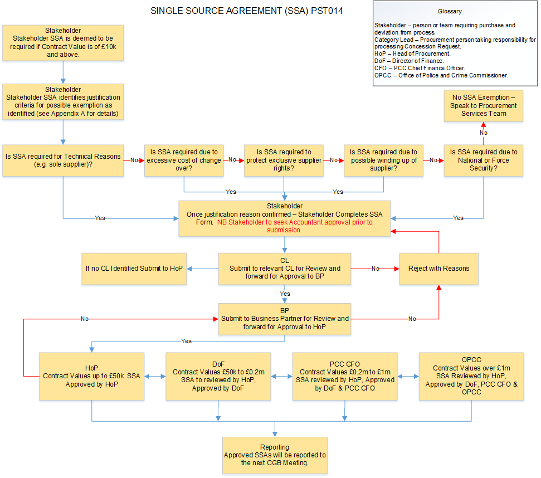

Procurement Services Team
Single Source Agreement Request Form

To be read in conjunction with the Single Source Agreement (SSA) Guidance Notes at Appendix A. Please attach all additional information in support of your request e.g. quote, specification.
Title of Purchase Project | OP22003 Taser T7 Project
Stakeholder | Operational Policing – TVP Non Firearms Roles (Including TVP Protection Group)
Value of purchase (£) | £7,889,320.00
Proposed Supplier | Axon
Contract Duration | 5 Years
Please state Contract start and end dates that this SSA is applicable to. | Contract Start 2023

In completing this form there is an explicit understanding that no person involved in the creation of the document or within the process has a personal or financial interest in the outcome of the decision.
Background – (Brief explanation on the background of the requirement)
The current Taser X2 model has a 5 year warranty with Axon which will ensure the forces capability until 2023 when a number will come to the end of their warranty and Useful Life Recommendation

Technological products and electronic components wear out over time and may not operate as expected increasing the risk of the device (Taser) failing. The risk increases as devices get older especially around the five-year mark. Axon have issued a five year Useful Life Recommendation for Taser weapons.

The Useful Life Recommendations should not be interpreted as an expiration date. However, from a risk management standpoint, it is best practice to replace units over 5 years to avoid the increased of failure in the field where an officer could be seriously injured by an assailant.

The Home Office are due to award a new national contract for CEDs in March 2023. This paper seeks commercial and financial approval for a longer term plan (T60) to fix pricing from 2023 onwards via a commitment by TVP from December 2022.

The Home Office have supported this project.

Axon have put three options forward to TVP for continued supply of the new model T7 from 2023 onwards to support TVPs commitment to Taser roll-out. Axon require a commitment by TVP in December 2022 to secure pricing for 2023 onwards, although delivery and payment is not required at that point.

The Home Office have given reassurance that the Axon product – Taser T7 will be supported after March 2023.

TVP will be increasing the number of Taser licensed Officers over the coming years.

Section 1a - Reason(s) for exemption (To be completed by the requester):
Reason | Please put X those that are relevant
Technical Compatibility | X | As per TVPs current technical systems and governance
High cost of changeover | X | Costs are minimised due to the options being presented by Axon.
Protection of exclusive rights | X | Home Office exclusive contract
Winding up of a supplier |  | Only to be used if we are getting especially advantageous terms
National/Force Security |  | Please provide some information in the 1b – Technical Justification section

Section 1b – Technical Justification (To be completed by the requester):
Rationale for this being an SSA (Please base it upon the box you ticked in section 1a

The supply of CED’s (Taser) is led and authorised by the Home Office. A licence to supply CEDs to UK police forces is awarded by the Home Secretary. This is a sole supply licence.

Section 2 – Value For Money (To be completed by requestor):
- Value For Money
TVP is committed to achieving Value For Money (VFM) in the procurement process of any goods, services or works contracts. It is therefore a key driver in any procurement engagement. VFM needs to be considered at the front end of the procurement process during your spend analysis, category identification, complexity assessment and supply market analysis. This identifies the key VFM drivers that give context to subsequent stages of the procurement process.
Considering VFM during the market analysis stage can identify opportunities to leverage competition and market dynamics, promote productivity and take advantage of innovations in the market. It is also worth considering VFM at later stages of the procurement process, such as contract management to drive continuous improvement during the contract period.
VFM is undoubtedly best achieved through a competitive procurement process using a fit for purpose specification that can be understood by competing bidders and measured against both cost and deliverable and technical objectives. Where a generic requirement is being purchased, that mostly meets TVP needs, a competitive process should always be utilised.
However, there are times when a competitive process is not easy to achieve due to unique and unavoidable situations. In these circumstances we need to understand and demonstrate where the value or money is derived in procuring from a specific source that has benefits that are both measurable and deliverable.
Where due to lack of a competitive process, VFM cannot easily be demonstrated in the actual purchase activity but through other areas such as Total Cost of Ownership, TVP Vulnerability (Risk), Contract Management / performance. The following table aims to aid the decision making process in justification of non-competitive VFM procurements.
PROCESS STAGE | VFM DRIVER | RESPONSE Y/N | PLEASE CLARIFY RESPONSE
Planning | How did you identify this supplier? | Y | Axon are the only supplier of CED’s (Taser) in the UK. A licence is issued and authorised by the Home Office. A licence to supply CEDs to UK police forces is awarded by the Home Secretary. This is a sole supply licence
Planning | When did you first identify the need of this requirement? | Y | A replacement programme was identified in 2021
Planning | Has the performance history of prospective supplier(s) been considered? | N | N/A
Total Cost of Ownership | Are there any ongoing financial considerations including whole life costs that mean competing this requirement is not appropriate? | Y | The supply based is restricted to one supplier (Axon). Axon have put forward 3 Options. Option 1 being the best value for money.  Goods provided include accessories such as holsters; batteries; cartridges and warranties  Cost are guaranteed for the whole contract subject to TVP committing to Option 1. This protects from price rises over that period especially on cartridge costs.  - Commit via contract to a phased purchase and delivery of T7 T60 Plans before the close of 2022  - Delivery and payment scheduled from 2023 onwards  - Leverage £300 trade in against 465 T7 devices totalling £139,500.00  - Pricing frozen at 2022 point for duration of phased contract  COMMERCIAL IN CONFIDENCE – ATTACHMENTS NOT FOR PUBLIC VIEW – to be removed or redacted if published  TVP Non-Firearms Pricing £7,482,196.00  TVP Protection Group Pricing £407,124.00  Total Value £7,889,320.00
Total Cost of Ownership | Is the good/service procured the only product/service fit for purpose? | Y | Goods provided include accessories such as holsters; batteries; cartridges and warranties
Total Cost of Ownership | Will this requirement have any implications for stock holding or requiring minimum order quantities? | N | N/A
Non-Financial | How does the procurement seek to achieve/advance TVP policy objectives? | Y | The ongoing use of and training in CEDs meets with and complies to TVPs strategic plan and objectives. We are equipping our Officers with the resources they need to keep themselves and our communities safe.  The Terms and Conditions of this Procurement are in accordance with current Home Office Terms and Conditions Agreement. . Note: This sourcing exercise leverages the terms and conditions within Home Office contract HO/CPPP/10
Non-Financial | Have the end-user(s) been consulted? | Y | This replacement plan/project is headed up by senior leaders within TVP
Non-Financial | How have resources been used efficiently so as to maximise customer service levels, minimise lead times, and optimise inventory levels? | Y | By committing to a long-term replacement programme TVP are ensuring that resources are being used efficiently; lead times are minimised and supply chain is profiled and stocked.
Non-Financial | To what extent has the procurement addressed environmental and sustainability aspects? | N | N/A
Quality of Delivery | Is there an adequate level of quality of service? | Y | By committing to a long-term replacement programme TVP are ensuring that resources are being used efficiently; lead times are minimised and supply chain is profiled and stocked.
Quality of Delivery | Is there an adequate level of support? | Y | Axon will provide on-going “in-life” support requirements such as maintenance. The specification meet the requirements of TVP.
Contract Management and Performance | What are the agreed services level \ goods warranties offered with this contract and are they acceptable? | N | N/A
Contract Management and Performance | Are there any other added value opportunities covered in this contract that is not covered above? | N | N/A

Section 3 – Justifications for exemptions (To be completed by Procurement):
(Please refer to points for consideration in the guidance notes)
Technical Criteria | As per TVPs current technical systems and governance
Costs for changeover | Costs are minimised due to the options being presented by Axon.
Protection of exclusive rights | Home Office exclusive contract
Winding up of a supplier
National/Force Security

 | Name: | Department | Date
Requested By | Signature / Shoulder Number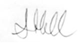Supt 1170 Ade Hall | Joint Operations Unit  Operations | 1/11/2022
NB. The requestor has to seek Accountant budgetary approval prior to submission to Procurement. Procurement will
reject any SSA request with no budgetary approval below.
 | Name: | Financial Account for  OPERATIONS Category | Date
Approved by Finance Accountant to confirm available budget | H.BROOKES C2942  Signature / Shoulder Number | Financial Account for  OPERATIONS Category | 02/11/2022

 | Name:R. Fowles c3179 | Head of Procurement | Date
Approved On behalf of CGB By | Signature / Shoulder Number | Head of Procurement | 3.11.22

 | Name: | Director of Finance | Date
Approved On behalf of CGB By | Signature / Shoulder Number  Linda Waters | Director of Finance | 04.11.22

 | Name: | Chief Financial Officer –  OPCC | Date
Approved On behalf of CGB By | Signature / Shoulder Number  Martin Thornley | Chief Financial Officer –  OPCC | 09.11.22

 | Name: | Chief Executive Officer - OPCC | Date
Approved On behalf of CGB By | Signature / Shoulder Number  Gillian Ormston | Chief Executive Officer - OPCC | 14.11.22

 | Name: | Police & Crime Commissioner | Date
Final Approval | Signature / Shoulder Number  Matthew Barber | Police & Crime Commissioner | 16.11.22

Once approved this SSA will be reported to the next Commercial Governance Board Meeting.

Document Template History

Document Ref | Status | Author | Approver | Date
PST014 – Issue 1 Feb 2017 | Obsolete | D Dockerill | R Fowles | 10-02-17
Change recorded | Approval recording information added
PST014 – Issue 2 July 2017 | Obsolete | R Fowles | A Hughes | 31-07-17
PST014 – Issue 3 July 2017 | Obsolete | L Sammons | R Fowles | 10.11.2017
Change recorded | Procedure removed from application form, rejection process included.
PST014 – Issue 4. August 2018 | Obsolete | D Dockerill | R Fowles | 28-08-2018
Change Recorded | Form Re-design with flowchart
PST014 – Issue 5. October 2019 | Obsolete | D Dockerill | R Fowles | 30-10-2019
Change Recorded | Process updated to reflect new Approval levels as detailed within CCFIs
PST014 – Issue 6. 25th November 2020 | Obsolete | D Dockerill | R Fowles | 24/03/2022
Change Recorded | Value For Money requirement included.
PST014 – Issue 7 24th March 2022 | Obsolete | D Dockerill | R Fowles | 24/03/2022
Change Recorded | Inclusion of contract start and end dates to be stated by requestor.
PST014 – Issue 8 31/08/2022 | Live | D Dockerill | R Fowles | 31/08/2022
Change Recorded | Re format of Header Table and addition of reporting requirement
PST014 – Issue 9 | Live | D Dockerill | R Fowles | 14/09/2022
Change Recorded | Additional Section for Finance Accountant Approval Added.

Appendix A – Regulations and Guidance
Where an SSA is permitted, authorities must still publish a contract award notice (CAN) in the OJEU following award of a contract that is above threshold. The CAN must set out the justification for using an SSA.
Additionally, PCR Regulation 112 requires publication of a CAN on Contracts Finder even for below threshold procurements, where they are above the £25k.
Completion of SSA Form
SSA requests must be made in writing using the SSA Request form.

The customer prepares Section 1 (providing details of the background and rationale for the request).

Procurement prepares Section 2 (identifying the potential justification and recommendation to approve) in consultation with the customer identifying all perceived risks associated with the SSA and appends a risk register to support the SSA. This allows an informed choice to be made by any additional approvers as well as providing an auditable record.

In completing Section 2 of the Form, the TVP Procurement Manager/ Business Partner is required to test the requirement against the SSA criteria and any exemptions sought (set out below). Sufficient evidence and assurance will be provided that a SSA is justified before seeking level 2 and 3 approval, as applicable to the opportunity.
Where the TVP Sourcing & Contracts Specialist, Procurement Manager and/or Business Partner believe the requirement is justified, the completed form must be signed off/approved in accordance with relevant TVP delegated letter of authority limits.
Delegated authority within TVP for SSA decisions are set by the TVP line management structure based upon an individual’s demonstrable capability.

On final approval of the SSA, Procurement enter details on the Contracts Database on BLPD as an SSA.

The details of both approved and rejected applications should be entered on the SSA register with the link to the approval or rejection e-mail.

If the value of the request is in excess of the thresholds, TVP is required to publish a contract award notice (CAN), utilising the negotiated procedure without prior publication of a contract notice, citing in Annex D the derogation relied on for justifying the procedure (reg 50 & reg 108).

Requirement not justified
Where Procurement believes the requirement is not justified the application must not be signed detailing the reason in the signatory boxes at 3.1 and advising the most appropriate procurement route. The reasons for rejection must be detailed at 3.2 and retained for audit purposes. The PM/BP must inform the customer of the decision.

Escalation
If the customer does not agree with the advice provided by Procurement, the customer should raise the matter with the Head of Procurement.

 | Types of contract | Mandatory criteria | Other considerations
  Ground
Defence & Security PCR 2015, Regulation 15 (1) and 15 (2) | Where the goods and/or services being purchased or the adherence to the normal process for award of contract could result in a detrimental impact upon the protection of the essential security interests of the United Kingdom or another member State. This may be by the disclosure of information which it considers contrary to the essential interests of its security.  Where the procurement and performance of the public contract or design contest are classified as secret or must be accompanied by special security measures in accordance with the laws, regulations or administrative | Other means such as Non Disclosure Agreements and other confidentiality arrangement must have been considered but cannot be guarantee to provide the level of security required. | Works, goods and services
No suitable tenders received  PCR 2015, Regulation 32(2)(a) and 32(3) | • No tenders (or no suitable tenders) or no requests to participate (or no suitable requests to participate) in an open procedure or restricted procedure; AND  • The initial conditions of the contract are not substantially altered; AND  • The authority sends to the European Commission a report if requested | • A tender is not "suitable" if it is irrelevant to the contract and manifestly incapable of meeting the Authority's needs, as specified in the procurement documents, without substantial changes.  • A request to participate (such as a PQQ response) is not "suitable" where the mandatory or discretionary exclusion grounds apply to the bidder or the bidder does not meet the selection criteria.  • Case law suggests that minor non-compliances in tenders do not justify use of regulation 32(2)(a)1. | Works, goods and services
For technical reasons, competition is absent  PCR 2015, Regulation 32(2)(b)(ii) | Only one provider can deliver the contract for technical reasons, competition is absent; AND  • There is no reasonable alternative or substitute; AND  • The absence of competition is not the result of an artificial narrowing of the parameters of the procurement. (By manipulating the specification). | Interoperability with existing products or fleets will not necessarily be adequate justification for an SSA. The authority must at least show incompatibility will cause "disproportionate technical difficulties"2.  • The authority must produce evidence of a serious study into the availability of suppliers in Europe3. | Works, goods and services
Exclusive rights, including intellectual property rights  PCR 2015, Regulation 32(2)(b)(iii) | Only one provider can deliver the contract due to the protection of exclusive rights, including intellectual property rights; AND  • There is no reasonable alternative or substitute; AND  • The absence of competition is not the result of an artificial narrowing of the parameters of the procurement. |  | Works, goods and services
The aim of the procurement is the creation or acquisition of a unique work of art or artistic performance  PCR 2015, Regulation 32(2)(b)(i) | The aim of the procurement is the creation or acquisition of a unique work of art or artistic performance. |  | Works, goods and services
Extreme urgency  PCR 2015, Regulation 32(2)(c) and 32(4) | Extreme urgency brought about by events unforeseeable by the contracting authority; AND  • The urgency is not brought about by events attributable to the authority; AND  • The time limits for the open and restricted procedures or the competitive procedure with negotiation cannot be complied with. | Time limits for open and restricted procedure: this refers to the shorter (10 or 15 day) time limits permitted by Regulation 27(5) and 28(10) for open and restricted procedures.  • The event giving rise to the urgency must be unforeseeable. It is not enough that the authority did not in fact foresee the event.  • The Court of Justice has taken the view that 3 months is more than enough to run  a competitive process under the PCR4.  • The extreme urgency must be caused by the unforeseeable event5.  • To comply with transparency and equal treatment, the authority should run some form of competitive process. The extent of this process will depend on the urgency of the matter. | Works, goods and services
Research, experimentation, study or development  PCR 2015, Regulation 32(5)(a) | Products are manufactured purely for the purpose of research, experimentation, study or development; AND  • Contract does not include quantity production to establish commercial viability or to recover R&D costs. |  | Goods
Additional deliveries  PCR 2015, Regulation 32(5)(b) and 32(6) | Additional deliveries by original supplier; AND  • these are EITHER a partial replacement of supplies or installations, OR the extension of existing supplies or installations; AND  • A change of supplier would oblige the authority to acquire supplies having different technical characteristics which would result in incompatibility or disproportionate technical difficulties in  operation and maintenance; AND  • Total duration of the contracts is no more than 3 years. |  | Goods
Commodity market  PCR 2015, Regulation 32(5)(c) | Supplies quoted and supplied on a commodity market. | As for all uses of SSAs, the authority must act transparently and in a non-discriminatory manner. In practice for commodity markets this means the authority should buy at the best price available and without regard to the nationality of the supplier. | Goods
Particularly advantageous terms on insolvency or winding up  PCR 2015, Regulation 32(5)(d) | Purchase on particularly advantageous terms; AND  • The purchase is from a supplier which is definitively winding up its business activities, or the liquidator in an insolvency procedure, an arrangement with creditors or a similar procedure under national laws or regulations. | The authority should ensure it can show what the "normal" best price would be. This is necessary so that it can prove the terms are particularly advantageous | Goods
Services contract following a design contest  PCR 2015, Regulation 32(7) | Following a design contest under the PCR 2015; AND  • Where it is awarded under the rules provided for in the design contest to the winner of the design contest. |  | Services
Repetition of similar works or services  PCR 2015, Regulation 32(9) | New works / services that are a repetition of similar works / services; AND  • The original contract was awarded under a competitive process under the PCR;  AND  • The original procurement disclosed the possible purchase of repeat works or services; AND  • The original project agreement indicated the extent of possible additional works / services and the conditions under which they will be awarded; AND  • The value of the extension was taken into account for the purpose of valuing the original project; AND  • The procedure can only be used for 3 years after conclusion of the original project agreement. |  | Works and services

Reliance upon exemptions
It is essential that any reliance upon seeking either an SSA or an exemption to the regulations through an SSA, that the grounds for doing so are robust and bona fide.
All risks associated with the SSA should be understood and captured in an associated risk register that appends the SSA, with owners for each risk clearly identified.
It may be necessary in certain circumstances to seek legal opinion as to the legitimacy of an exemption sought and this opinion shall also append the SSA.
All SSAs and associated documentation are still subject to the overarching EU Directive principles, publication, financial reporting and the Freedom of Information Act, depending upon the value, category, and current circumstances at the time the SSA is sought.

