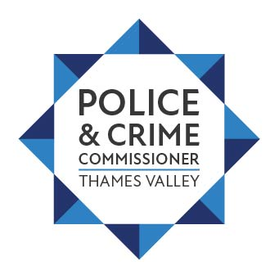

Thank you for your email dated 17 March 2022, received at the Office of the Police and Crime Commissioner.

With regard to your request for information concerning the Council Tax Survey, I can advise the following:

2,050 members of the public responded to the survey question (Would you support an increase of up to 83p per month in council tax (based on a Band D property) to improve local policing in the Thames Valley?) of which:

- 1,424 (69.5%) supported an increase of £10 per year for a band D property
- 513 (25.0%) said no
- 113 (5.5%) answered don’t know.

Further information can be found on the Council Tax Leaflets webpage.

I am sorry to read of your dissatisfaction with the increase in Council Tax, I will ensure your comments are forward to the Police and Crime Commissioner, Mr Matthew Barber.

