Council Tax 2021/22
Berkshire, Buckinghamshire and Oxfordshire

Foreword
Since the Government pledged to recruit 20,000 police officers nationally, Thames Valley Police has already increased officer numbers having received funding for 183 police officers in 2020/21 and the Home Office has now announced an increase in funding from central government of a further £12.6m for 2021/22. The additional investment will help to fund some of Thames Valley’s core support functions that allow the police to focus on driving down crime and will fund the recruitment of 179 more police officers in the second tranche of the national uplift programme.

By increasing council tax by less than 29p a week for a Band D property, which is in-line with Government recommendations and other PCC decisions, we are able to invest in frontline improvements that will better enable the police to reduce crime and keep us all safe.
In difficult economic times with so much uncertainty it is important that the police continue to deliver an efficient as well as effective service for the public. This year’s budget includes savings of £16 million over the next for four years – on top of the £109 million of savings already made since 2010.
The change in council tax precept this year will raise more than
£13m to help fund key improvements to fight crime, bring more criminals to justice and protect our communities. This additional funding will enable Thames Valley Police to:
- Ensure that neighbourhood policing is strengthened, not just through police officer recruitment but by ensuring PCSOs
remain at the heart of local policing at a time when many Forces have cut back on neighbourhood policing
- Support dedicated teams to fight County Drugs Line (CDL) that exploit children and supply drugs on our streets
- Ensuring increased visibility in our major urban areas
- Increase the Force’s capacity to deal with domestic abuse and protect victims and their families
- Invest in prevention and investigation of fraud and cyber-crime which is a threat to us all
- Establish a Rural Crime Task Force to improve visibility and bring more offenders to justice
- Improve service delivery by investing in key areas such as forensic services and digital investigations, safeguarding
and operational end-user devices (such as better storage for body worn video).

Foreword (continued)

The last year has been challenging for the entire country and the police are no exception.
Thames Valley Police have risen to that challenge and the officers
and staff across the Force have continued to serve the public with bravery and dedication in the most difficult of circumstances.
I will be standing down as PCC Thames Valley Police in May this year after nearly 9 years in the role. I am confident that I am handing over to my successor a police force that is well led, and highly competent. Thames Valley is consistently one of the best performing large police forces, and I am confident that this will continue into the future. It has been a difficult time to be a PCC with constant cuts to the police budget. However this year we will see a real investment into policing with more officers, better equipment, and a greater ability to combat crime in all its forms.
Our priorities will remain to reduce crime, keep the public safe, and to secure justice for victims.
Further information on the budget is provided on the website.

Anthony Stansfeld
Police & Crime Commissioner for Thames Valley

Matthew Barber
Deputy Police & Crime Commissioner for Thames Valley

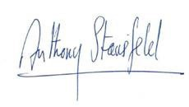

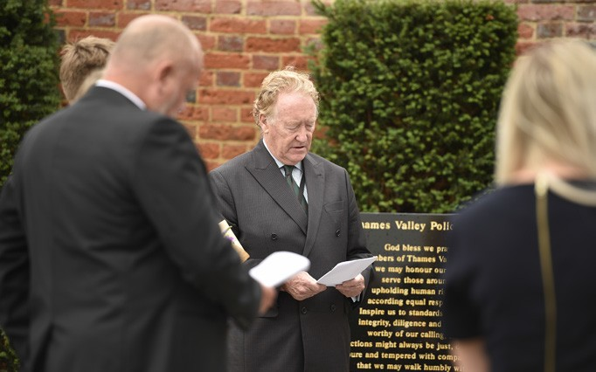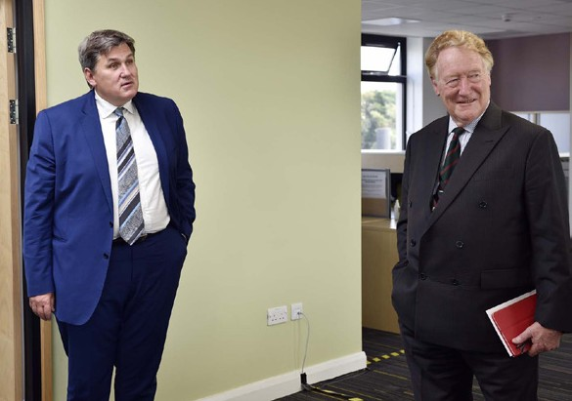

Anthony Stansfeld Police & Crime Commissioner for Thames Valley 2012 – 2021

Budget 2021/22
2020/21 |  |  | 2021/22
Total  £m | per head  £ |  | Total  £m | per head  £
500.70 | 205.01 | Gross expenditure | 531.99 | 217.64
-49.98 | -20.46 | Income | -55.41 | -22.67
-1.79 | -0.73 | Contribution | -0.69 | -0.28
 |  | from reserves
448.93 | 183.82 | Net expenditure | 475.89 | 194.69
 |  | Less:
-79.32 | -32.48 | CLG Formula grant | -83.48 | -34.15
-153.44 | -62.83 | Police grant | -163.95 | -67.08
-15.28 | -6.26 | Legacy council | -15.28 | -6.25
 |  | tax grants
-2.05 | -0.84 | Collection | -0.38 | -0.15
 |  | fund surplus
198.84 | 81.41 | Council tax | 212.80 | 87.06

The net revenue budget for 2021/22 is £475.9 million, representing an annual increase of £27.0 million or 6.0%.
In accordance with Government recommendations, the Police and Crime Commissioner has increased his element of council tax by £15 a year or £1.25 per month for a band D household for the year.
This equates to 6.9%. This increase will enable
the PCC to recruit additional police officers together with supporting infrastructure and also invest in other high priority policing services.
The budget for 2021/22 incorporates £4 million of
cashable efficiency savings. The police precept for each council tax band is:

Band | 2021/22  £ | Band | 2021/22  £
A | 154.19 | E | 282.68
B | 179.88 | F | 334.07
C | 205.58 | G | 385.47
D | 231.28 | H | 462.56

The police funding settlement enables us to invest for the medium-term to expand our capabilities in those areas of most concern to ourselves and the public as a whole, including:

POLICE
COMMUNITY
SUPPORT OFFICER
101

Neighbourhood policing & PCSOs
We remain committed to Neighbourhood Policing in philosophy, strategy and dedicated resources. At the heart of our approach is the role of the PCSO, dedicated familiar, accessible officers, known by their community and at the heart of local community safety and engagement. They are
well regarded by stakeholders and public alike. This additional funding will allow us to maintain our popular establishment of PCSOs and deploy additional police officers elsewhere.
Rural Crime Task Force
Our current Neighbourhood Teams work hard in this area but having the scale to respond to patterns of criminality and be visible to the many, can be difficult. We will create a dedicated Task Force to provide increased visibility, enforcement and prosecution in relation to crimes affecting the rural community in particular. The Task Force made up of Uniform and CID, would be highly visible and deployable to locations across the Force. The public would see and feel the difference.

County Drugs Line (CDL) Enforcement
The disruption of CDLs is a Force priority and is clearly a priority for Government. They are quick to establish and significant damage follows. The current team is modest but using a combination of covert and overt tactics, recent results have been positive. Increased funding will enable the Force to ‘industrialise’ its approach and resource a central capability as well as developing and increasing numbers within LPA based Stronghold/Tasking teams.

Domestic Abuse (DA) Capability
We have had some success over the last 18 months with increased attendance and arrest rates and outcomes now up by some 38%; that’s an additional 650 offenders brought to some form of justice. However domestic reports are also rising with an increase of 23% compared to this time last year.
That’s an extra 3,000 crimes. Moreover experience suggests that during economic downturns and increased unemployment domestic abuse will further increase, so having increased capability in this area is very important. Increased funding will protect more vulnerable members of the community and bring more offenders to justice.

+

Cyber/Fraud
Fraud is significantly under reported and national processes lack credibility. The Force has a capable Economic Crime Unit which works closely with the Regional Organised Crime Unit and their cyber capability. The Force assesses that 80% of Fraud is preventable. Increased funding will prevent more members of the public becoming victims of crime.

Improved service delivery
The additional police officers are key to developing the above capabilities but we also need to ensure the infrastructure, technology and supporting services are there to complete the overarching improvement in service provision. We need to understand our demand to ensure we respond appropriately to each incident, we need to make sure we are maximising the effectiveness of our officers’ time by providing them with access to technology. As such we will invest:
  - Forensic services and digital investigations
  - Effective demand management
  - Safeguarding and vulnerability
  - End-to-end investigation processes
  - Operational end user devices, such as better storage for body worn video

Savings
Thames Valley Police has a long history of delivering productivity savings and using these to balance annual budgets or reinvesting them in frontline policing, a strategy that has been widely scrutinised and praised by Her Majesty’s Inspectorate of Constabulary and Fire & Rescue Services (HMICFRS) during various inspections and reports.

The financial and operational demands facing the Force mean that it is more important than ever that we continue to review, challenge and improve our services to ensure we focus our resources on priority areas.

£109 million has already been removed from the base revenue budget since 2010/11 and plans are in place to remove at least another £16 million over the next four years (2021/22 to 2024/25), including £4 million in 2021/22.

2021/22 savings identified include:
  - Contract renewals for telecoms
  - ICT Contract savings
  - Savings from force wide smarter ways of working
  - Delivery of the People Directorate operating model
  - Changing the opening times and locations of our front counters

  - Savings from printing contracts
  - Reduction in ICT spend on software licences
  - Reduced flying time demands on the National Police Air Support unit

Further details of all productivity savings can be found in the Budget Book for 2021/22 which is posted on the website.

About us

For further information about the PCC’s Police and Crime Plan 2017-21 or finances, please visit our website at www.thamesvalley-pcc.gov.uk

In respect of the 2021/22 council tax increase, you will fi
- Revenue Budget and Capital Programme 2021/22
- List of FAQs in respect of the 2021/22 Budget
For further information about the PCC, his plan, the budget or how you can get involved, get in touch using the contact details below:

Office of the Police and Crime Commissioner, The Farmhouse,
Force Headquarters Oxford Road, Kidlington,
Oxon, OX5 2NX

Tel: 01865 541957
@
Email: pcc@thamesvalley.pnn.police.uk
Facebook: https://www.facebook.com/tvopcc LinkedIn: https://www.linkedin.com/company/tvopcc/ Twitter: https://twitter.com/TV_PCC

If you would like this publication in any other format please email: pcc@thamesvalley.pnn.police.uk
Designed by Corporate Communications CC5715

© Thames Valley Police 2021 (02/21).

