

Charlotte Roberts
Tel: No. 01865 541948
Date: 4 August 2023 Email:Charlie.roberts@thamesvalley.police.uk

Dear Chief Constable

Performance & Accountability Meeting (PAM)

You are requested to attend a PAM meeting on Wednesday 9 August 2023 at 10:30–12:30hrs in the Farmhouse Meeting Room or via MS Teams for those unable to attend in person.

Microsoft Teams meeting
Join on your computer, mobile app or room device
Click here to join the meeting
Meeting ID: 319 399 001 12
Passcode: Gwtgp8
Download Teams | Join on the web
Or call in (audio only)
+44 20 7660 8499,,910751527# United Kingdom, London
Phone Conference ID: 910 751 527#

Yours sincerely

Gillian Ormston
Gillian Ormston
Chief of Staff (OPCC)

Agenda Item Page No. Timings

1. | Apologies – Martin Thornley, Chief Supt Joe Kidman  (PCC) | - | 10:30-10:35hrs
2. | Minutes of the PAM meeting held on 14 July 2023  (PCC) | 3 - 6 | 10:35-10:45hrs

3. | HMICFRS update  - An inspection of how effective police forces are in the deployment of firearms  - Police Performance – Getting a Grip | 7 - 22 | 10:45-11:15hrs
4. | TVP Demand & Performance (August 2023)  (Matthias Butler) | 23 - 40 | 11:15-11:45hrs
5. | TVP Organisational Performance  (Ali Nicholls) | 41 | 11:45-12:15hrs
6. | AOB  (PCC) | - | 12:15-12:30hrs

Date of next PAM meeting: Tuesday 12 September 2023 at 1030hrs-1230hrs CCMT Meeting Room/MS Teams for Generic Items



POLICE & CRIME COMMISSIONER FOR THAMES VALLEY MINUTES OF THE PERFORMANCE AND ACCOUNTABILITY MEETING
HELD IN THE CCMT MEETING ROOM AND/OR VIA MS TEAMS ON 14 JULY 2023 COMMENCING AT 10:30-12:30 HRS

Present:
M Barber (Police & Crime Commissioner) (OPCC) J Hogg (Chief Constable) (TVP)
L Waters (Director of Finance) (TVP)
M Butler (Lead Advisor, Service Improvement) (TVP) A Nicholls (People Services Manager) (TVP)
G Ormston (Chief of Staff) (OPCC)
M Thornley (Chief Finance Officer) (OPCC)
C Roberts (Executive Assistant to the PCC & Chief of Staff) (OPCC)

Apologies:
B Snuggs (Deputy Chief Constable) (TVP)
J Kidman (Chief Supt. Head of Governance & Service Improvement) (TVP) C Widdison (Head of Strategic Governance) (TVP)

Agenda Item

Apologies

The Police & Crime Commissioner (PCC) welcomed attendees to the meeting and received apologies from DCC Ben Snuggs (BS), Chief Supt. Joe Kidman (JK) and Claire Widdison (CW).

Minutes of the PAM meeting held on 18 May 2023

The (PCC) went through the minutes of the meeting from 18 May 2023 and confirmed these were accurate and complete. All actions had been carried out by TVP and reported back to the PCC.

The PCC APPROVED the Minutes of the Meeting held on 18 May 2023.

TVP Demand & Performance (July 2023)

Matthias Butler (MB) presented a different paper from last year as this was a paper which went to CCMT and covered the same points and summary. The intention was that the pack would be brought into this forum at future meetings. Force Performance would be discussed monthly instead of bi- monthly and changes to these meetings would be updated. This was the first draft provided to the PCC today and the PCC was content with what had been provided.

The main areas going forwards and keen for the PCC to look at was around charge rates for certain offences and formal outcomes. This was an area going forwards where improvements were needed. (MB) bought charges into the street plan with the aim of improvements. The Force Performance pack would have a very similar visual to identify key points about accountability.

Action: At the next PAM meeting the pack would set out the charge rates.

(MB) went through the highlights from the presentation pack where TVP were seeing a 5% increase in crime. TVP were 37th nationally for charge rates but were now 34th. The biggest driver was the violence profile which was a big volume area and while it was without injury, this had been a big driver which had seen an increase just shy of 2000 crimes in the area. On the welcome page there was a page for a demand summary option.

There was some positive signs within the serving victim’s pillar of the plan earlier in the year and a big drive around the use of Pronto to complete the codes of practice.

The PCC noted the previous HMICFRS recommendations and to note that TVP were not going to follow the recommendations as some of the consequences were not a priority for TVP, where violence was one area where it was difficult to control. The PCC noted the Force had done really well in managing the number of harm cases caused by another and the recording of these offences but to also distinguish between where the increases were.

Chief Constable Jason Hogg (JH) noted there may be more challenges around attending crime but there was an opportunity to build relationships with communities and awaited the outcome of the survey. In terms of the quality of the survey, the PCC asked how confident were TVP that they were getting responses from a broad cross-section. Gillian Ormston (GO) asked whether an IAG could attend and carry out a dip sample of victims and to have conversations. (GO) would pick this up with ACC Dennis Murray (DM) in terms of how the Force could use the IAGs to provide the advice and guidance.

Call handling times remained a challenge sitting at 21.8% waiting over 10 minutes. There had been an increase in mistaken calls and had some offset from Hampshire when their system was upgraded, but this would have had a small impact. More work was needed for the 101 programme.

Data sets to be agreed during the SMG meeting to discuss performance and sales force and (MB) confirmed that he would be attending this meeting in July 2023.

Thames Valley Together was a different piece of work than SIPO. The aspiration was the underlying data and was the same for everything. Thames Valley Together was currently working on the data visualisation. TVT was putting data out on serious violence with a specific definition under serious violence data and the two were not necessarily going to match up and this was where TVT had come under a lot of criticism. ACC Christian Bunt was currently talking to DCC Ben Snuggs where TVT sat in the long term but this needed ICT support and support from Performance. Building Trust and Confidence monitoring was being reviewed and (GO) and (DM) were currently discussing this.

The final key point to note was context around community engagement of the increase of visibility and engagement with communities.

Action: (GO) asked who she would need to speak to in SIPO as to the techniques and attending a meeting. (MB) confirmed he would arrange a meeting for (GO) to attend.
Action: The PCC felt it would be helpful to see measures in place around 101 especially around members of the public using 101 and 999 call at a future meeting and taking a close look at attendance times and grade one calls at a future PAM meeting.

The PCC NOTED the TVP Demand & Performance for July 2023.

OPCC Strategic Delivery Plan 2023/24

(GO) provided an update and review of the OPCC Strategic Delivery Plan (SDP) for 2023-2024.

The PCC had reviewed the SDP prior to the meeting and (GO) provided key points. There would be some additions to the SDP as to the decisions on the Crime Prevention Fund both from the Force and OPCC e.g. DISC

Action: (GO) to add on and note that the funding would be coming in from the Crime Prevention Fund for these strategic directives.

The PCC NOTED the OPCC Strategic Delivery Plan 2023/2024.

Treasury Management Quarterly Performance

Martin Thornley (MT) presented the Treasury Management Quarterly Performance update. The main items to highlight was that interest rates were moving rapidly upwards. The expected interest for this year was £2.8 million higher. Since producing the reports, the latest updates had been received from the Treasury Advisors so (MT) provided the minor updates to the PCC.

The PCC noted that the £2.8 million was welcomed but there was some borrowing expectations over the medium term and whether this impacted the Force. Linda Waters (LW) noted the later the borrowing could be pushed out, the better this would be. (MT) noted that additional borrowing is not anticipate over the course of the current medium term plan, but may be required in later years.

The PCC NOTED the Treasury Management Quarterly Performance update.

TVP Organisational Performance

Alison Nicholls (AN) presented the TVP Organisational Performance updated to the PCC.

Action: The PCC would like to see one simple spreadsheet of workforce planning around clarity with the intention to change the PCSOs to reflect where the Force were.

Similar to (MB’s) update, there were new measures since the last quarter and an initial base line and working on the new Performance pack for the future. The PCC noted this was a useful one page document.

The Force were about to commission a piece of work around the workforce for recruitment and retention pathways. There was a new entry route which had gone live with the ability to fast track and to hold face-to-face interviews and the expectations around the whole interview process. The idea of the retention team would be to work out what the issues were as the Force were seeing too many student officers leaving.

The PCC NOTED the TVP Organisational Performance update.

Decisions under the Scheme of Governance

Linda Waters (LW) presented to the PCC the Decisions under the Scheme of Governance. This was the usual report and there was nothing unusual or outstanding to note.

The PCC NOTED the Decisions under the Scheme of Governance.

AOB

Action: (GO) noted that for the next agenda could there be timings added for each agenda item for the PAM meetings, from a governance perspective. CR to liaise with the PCC and (JH) on timings for future agendas.

The meeting concluded at 11:39 hrs.

Date of next PAM meeting: 9 August 2023 at 1030hrs -1230hrs in the CCMT meeting room, HQ South or via MS Teams.



RESPONSE TO PUBLICATIONS BY HER MAJESTY’S INSPECTOR OF CONSTABULARY FIRE AND RESCUE SERVICES

Report to the PCC’s Performance and Management Meeting Date: 03.08.2023

Report Title: An inspection of how effective police forces are in the deployment of firearms

An inspection of how effective police forces are in the deployment of firearms - His Majesty’s Inspectorate of Constabulary and Fire & Rescue Services (justiceinspectorates.gov.uk)

HMICFRS Report Publication Date: 11/07/2023

Chief Officer Ownership: Deputy Chief Constable

  - Background and Context to the Report

In the year ending 31 March 2022, the police recorded 5,752 offences involving firearms. These included 31 homicides and 733 attempted murders and assault, with intent to cause serious harm and endanger life where a firearm was used. In order to tackle this issue, police forces in England and Wales carried out 18,259 operations involving the deployment of armed police officers, in the year ending 31 March 2022. At four of these operations police officers intentionally discharged firearms, which represents 0.02 percent of all operations.

In this inspection, HMICFRS examined how effective police forces are in the deployment of firearms, including specialist munitions. They sought to establish whether the public could be confident that police policies, structures and processes comply with relevant guidance and legislation. They wanted to determine whether the selection, training and deployment of those in command roles was effective, and understand whether they had the capacity and capability to effectively deploy firearms and, where necessary, work across force boundaries.

Summary of Findings

The inspection revealed that the officers involved in armed policing are dedicated, professional and focused on keeping the public safe. At an operational level, there are good selection processes and officers are well trained and well equipped.
Each force annually completes an armed policing strategic threat and risk assessment (APSTRA). This informs the number of armed officers and commanders each force should have. All nine forces that were inspected had fewer armed officers than the number set in their APSTRA. However, all nine forces had enough tactical and strategic firearms commanders, and the number of armed response vehicles (ARVs) that each force deployed daily was at least the level the force stated it needed.
Most forces had a good process for selecting authorised firearms officers (AFOs). This includes applications, pre-course selection, vetting and checks of complaint and misconduct records. Although, there was little evidence of regular complaint and misconduct checks throughout an armed officer’s career. Forces generally had a good selection process for operational firearms commanders (OFCs) and firearms tactical advisors (FTAs).
In contrast, the selection process for tactical firearms commanders (TFCs) and strategic firearms commanders (SFCs) needs to improve. Several of these commanders, particularly SFCs, had limited armed policing experience and were selected for the role due to their rank. There is a robust selection process for public order commanders, and a similar process should be implemented for the selection of those undertaking firearms command roles. Very few TFCs and SFCs undertake additional training to become specialist firearms commanders. This training prepares firearms commanders for the additional demands and potential complexities of what may be considered ‘specialist firearms’ operations, such as kidnaps. Some of the inspected forces did not have any of these commanders and relied on neighbouring forces to temporarily fill these positions.
The majority of armed officers had the necessary equipment to deal with most armed policing incidents. Moreover, they could access specially trained officers, such as counter- terrorism specialist firearms officers when required. However, despite all of the inspected forces having equipment to track armed assets across England, a number of force control room staff did not know how to use this equipment. In addition, three of the forces that were inspected highlighted an issue with the procurement of body armour. While this is not an immediate safety concern, several forces had not raised this with the National Armed Policing Portfolio (NAPP), who support the National Police Chiefs’ Council’s (NPCC’s) armed policing lead.
There is an effective governance structure overseeing the training of armed policing across England. All forces are following the National Police Firearms Training Curriculum (NPFTC) to ensure consistency across roles. Some forces place greater emphasis on certain aspects of the curriculum due to local threats and risks. Despite these minor differences, there is a high degree of consistency between forces nationally.
While the training for TFCs met their needs, the training for SFCs is insufficient. The current course for SFCs provides an inadequate amount of time for teaching the content and practising the skills that are taught. All those involved in armed policing have annual refresher training and accreditation, which are of a high standard for AFOs, OFCs and

FTAs. However, in certain forces, the annual refresher training and accreditation for SFCs and TFCs needs to be improved.
There has been an increase in the number of armed officers since April 2016, but the investment in training facilities has not kept pace. All inspected forces were engaged in some form of local exercising, although there was little evidence of exercising with neighbouring forces or other agencies. Certain high-risk armed operations require senior investigating officers (SIOs) and firearms commanders to work closely together, in order to manage armed operations involving covert surveillance. However, there was only one force that had evidence of this collaboration.
Most forces had some form of organisational learning board for operational deployments. Although there was limited evidence of forces sharing learning at regional meetings, and no evidence of them sharing it at the national armed policing meeting. Encouragingly, one force is currently using body-worn video as part of the debrief process to improve future deployments. The force chief officer lead who oversees armed policing should hold meetings in their force, and take any relevant issues to the regional meeting. The regional lead should then attend the national meeting, which is chaired by the NPCC lead for armed policing.
Although there was limited single-user access to armouries and regular internal auditing of weapons, there was minimal evidence of intrusive senior oversight. On the other hand, the command of armed deployments are operationally effective and in compliance with the College of Policing's guidance. In addition, forces are now using agreed upon terminology for armed assets, which was a recommendation in a previous report. However, forces need to improve record keeping for armed operations. Many forces were unable to provide certain records that were requested for numerous operations. This was particularly concerning at a senior level where forces were unable to provide the SFC logs in almost half of the operations.

Recommendations and Areas for Improvement

Recommendation 1
By 31 July 2024, the College of Policing should introduce new entry criteria for those attending initial training for strategic and tactical firearms commander. The selection process should be similar to the process used to select public order commanders.

Recommendation 2
By 31 July 2024, chief constables should make sure there is access to both specialist strategic firearms commanders and specialist tactical firearms commanders, through a 24- hour rota covering their region.

Recommendation 3
By 31 October 2023, all chief constables should make sure the armed response vehicle asset tracking equipment, as provided by Counter Terrorism Policing, is available and used in their forces. They should train relevant staff in its use.

Recommendation 4
By 31 July 2024, the College of Policing should review the content and extend the length of the strategic firearms commander course. It should make sure candidates have sufficient opportunities to learn and practise the skills of strategic firearms command.

Recommendation 5
By 31 December 2023, all chief constables should make sure that all strategic and tactical firearms commanders have observed the firearms tactics and the use of specialist munitions they can authorise, before being operationally deployed.

Recommendation 6
By 31 December 2023, chief constables should make sure that the annual accreditation process for strategic and tactical firearms commanders includes familiarisation with any new weapons systems and observation of any new tactics or specialist munitions the force has introduced or is planning to introduce.

Recommendation 7
By 31 October 2023, the regional armed policing lead should share armed policing exercises with the National Armed Policing Portfolio. This would allow opportunities for learning to be identified and shared.

Recommendation 8
With immediate effect, each assistant chief constable regional firearms lead should attend all National Armed Policing Portfolio meetings. If they are unable to attend, they should make sure another assistant chief constable armed policing lead from a force in their region attends on their behalf.

Recommendation 9
By 31 December 2023, the College of Policing should issue updated armoury guidance.

Recommendation 10
With immediate effect, chief constables should improve senior officer oversight of their armouries, including an independent annual audit.

Recommendation 11
By 31 December 2023, the National Armed Policing Portfolio and the College of Policing should issue minimum standard guidance for the completion of records in relation to armed policing operations. That guidance, in support of the authorised professional practice – armed policing, should include the requirement for the retention, recovery and audit of those records.

Recommendation 12
With immediate effect, chief constables, through their armed policing governance structure, should make sure that all armed deployment records are stored and auditable.

Recommendation:
The Police and Crime Commissioner is invited to note this update as appropriate and provide a response to HMIC.

Police and Crime Commissioner:
I hereby note the update and recommendation.
Signature Date

PART 1 – NON-CONFIDENTIAL

Introduction and background

      - In this inspection, HMICFRS examined how effective police forces are in the deployment of firearms, including specialist munitions

- Issues for consideration

  - As above.

- Financial comments

  - None identified.

- Legal comments

  - The PCC is required to publish a response to the reports published by HMICFRS.

- Equality comments

  - None identified.

- Conclusions
  - As above.

Public access to information
Information in this form is subject to the Freedom of Information Act 2000 (FOIA) and other legislation. Part 1 of this form will be made available on the website within 1 working day of approval. Any facts and advice that should not be automatically available on request should not be included in Part 1 but instead on a separate Part 2 form. Deferment of publication is only applicable where release before that date would compromise the implementation of the decision being approved.
Is the publication of this form to be deferred? No If yes, for what reason?
Until what date?
Is there a Part 2 form? No

RESPONSE TO PUBLICATIONS BY HER MAJESTY’S INSPECTOR OF CONSTABULARY FIRE AND RESCUE SERVICES

Report to the PCC’s Performance and Management Meeting Date: 01.08.2023

Report Title: Police performance: Getting a grip

Police performance: Getting a grip - His Majesty’s Inspectorate of Constabulary and Fire & Rescue Services (justiceinspectorates.gov.uk)

HMICFRS Report Publication Date: 07/07/2023

Chief Officer Ownership: Deputy Chief Constable

- Background and Context to the Report

This report focuses on the findings from the police effectiveness, efficiency and legitimacy (PEEL) 2021/22 inspection programme, which assesses the performance of the 43 police forces in England and Wales. The report consists of two parts:
  - Part 1 examines national themes, both positive and negative.
  - Part 2 explores a problem with performance management, which underpins some of the themes described in part 1.
This report highlights how a sharper focus on performance management and better use of data improves the service that police forces give to victims of crime and the communities they serve. It also considers the key areas that forces in England and Wales need to get right in order to improve and the consequences to the public and their own personnel if they do not.

Summary of Findings

The results from the inspection show that many forces were failing to properly understand and manage their own performance. Forces cannot do the following without a thorough understanding of performance data, a strong and purposeful performance framework, and governance processes:

  - Become more effective. Some forces do not understand what issues are most important to tackle, how their performance can be measured, how they should change and what works in tackling issues.

  - Become more efficient. Forces struggle to explain what they have to do to improve, and how much it costs. This prevents them from using limited resources efficiently and hinders them when they ask for local or national policy changes or seek increases in funding.

  - Conduct performance analysis, identifying the underlying problems leading to underperformance. Without this information, forces cannot plan for effective changes to improve their service.

  - Be confident in the legitimacy of policing. Forces do not understand whether there is disproportionality or not in several areas. Without an understanding of if, where and how they might be treating people unfairly, forces cannot give explanations when concerns are raised.

Police forces complete an array of national data returns, including annual data returns to the Home Office. However, several police forces made major strategic and operational decisions based on poor and often simplistic data and analysis. They failed to consider the context of the data, the quality of the data, the risk it carries and the potentially significant unintended consequences of their decisions.
We found that planning had become short-term and unsustainable for several forces. In some instances, we found an over-reliance on seeking an increase in the council tax precept to offset optimistic but often unrealistic savings plans. Some forces looked at demand only at a high level using basic data, which meant they were continually in a crisis. This resulted in personnel being taken from their usual duties to cover gaps without a clear plan to address these issues longer-term. Moreover, this was often done without full consideration of the consequences.
Other forces used data, information and knowledge to guide their planning and staffing decisions, such as shift patterns for call handlers. They had enhanced supervision and leadership roles in control rooms and used technology to assist with non-emergency enquiries.
Several forces were regularly at minimum staffing levels and had difficulties recruiting and retaining officers and staff. For several forces, the ability to have the right people available is being hindered by the increase in the number of young-in-

service officers. These officers, while dedicated, lack experience and they need training while they build their skills. This could lead to delays in responding to the public for non-emergency incidents, or investigations failing because key lines of enquiry have been missed. In addition, this can also result in high-risk offenders being poorly managed, which puts the public at risk of harm. There were similar problems with police staff, as some specialist roles such as analyst posts were hard to recruit.
There were a few strategic leaders that were unfamiliar with the areas of work under their management. Due to insufficient operational knowledge, they were less able to properly lead, support, develop and challenge their specialist teams. This further reduces forces’ ability to work effectively in high-risk areas of policing. In too many cases, there was a lack of recognition of this issue and any plans to address it.
Furthermore, various inspections have shown that officers were spending a high proportion of their time responding to demand that was unrelated to policing and better addressed by other organisations. This was particularly the case for incidents relating to mental health.
However, all forces are engaged in a range of multi-agency working practices, both at a strategic and an operational level. Multiple forces had partnerships with academic institutions, which were being used to research issues of importance to both the police and the public. Furthermore, many forces have an approach to evidence-based policing that has the potential for real change.
Call volumes were substantially affected by 'failure demand', which is defined as when member of the public calls multiple times because their issue was not resolved at first contact. This type of demand can be alleviated through better-quality initial responses and targeted partnership working. In contrast, some forces have a clear understanding of demand and make well-considered multi-agency plans to address it.
First-line supervisors frequently had high workloads, particularly in specialist teams, which made good supervision more difficult. These supervisors were often inexperienced and were managing inexperienced teams. They often lacked sufficient training, in addition to not always having access to the right technology, and could be unaware of the importance of collecting data and using information to help manage workloads and performance.
Although, well-being support for the workforce had improved in most forces. This included:
- Better use of data to understand well-being issues
- Equipping the workforce to help them to maintain their own well-being
- Improving working environments and conditions

Inspecting crime files revealed numerous instances of investigations conducted without supervisor oversight. Where it did exist, it lacked direction to help the investigation. We also found supervisors signed off poor investigation plans and inadequate risk assessments. The most concerning practise we witnessed was

supervisors agreeing to close investigations when there were open lines of enquiry. Forces are often failing to invest in these critical first-line supervisors and support them in performing their crucial role well.
On the other hand, certain forces had systems in place to audit and dip sample investigations. In addition to ensuring that the right people are looking into the right crimes and that investigations are of a high standard, this also assists in determining the need for more training if investigations are subpar.
There were considerable delays in responding to public calls, specifically non- emergency 101 calls. Moreover, vulnerable and repeat victims were not identified on numerous occasions. Good-quality risk assessments that support the most appropriate response were not completed or recorded for others to see. Additionally, there was a lack of consistency in the advice given to callers on keeping themselves safe and preserving evidence.
However, we found that forces used an array of diversionary approaches that focus on vulnerable people. These included young people (recognising that offending may be because of exploitation), female offenders and those with mental health issues. These high-value schemes can prevent individuals committing crime through early intervention and reduce the impact of crime on communities.

Recommendations and Areas for Improvement

Part 1
Recommendation 1a
By January 2024, the National Police Chiefs’ Council should:
  - Agree a standard approach to how attendance times are measured in all forces; and
  - Set a national standard for attendance times.
The National Police Chiefs’ Council should make sure they consult with the Home Office to allow the timely collection of data once the standards are introduced.

Recommendation 1b
By January 2024, to allow an understanding of whether forces are meeting the national standard, the Home Office, in discussion with the National Police Chiefs’ Council, should develop a set of principles for the collection and analysis of force data.

Recommendation 1c
By July 2024, the Home Office, in collaboration with the National Police Chiefs’ Council, should pilot the collection and analysis of attendance time data.

Recommendation 1d
By January 2025, the Home Office should roll out the process for the collection, analysis and publication of attendance time data for all forces.

Recommendation 2
By January 2024, forces should review whether they have effective processes in place to reduce the risk of skilled personnel leaving the organisation. These should include:
  - How they conduct exit interviews and use this information to identify patterns and trends in why people leave; and
  - How they identify people who are thinking of leaving and the action they take, where appropriate, to encourage them to stay.
Processes should cover police officers, police staff, special constables and volunteers.

Recommendation 3
By January 2024, forces should review their proactive well-being support for staff in high- stress roles and situations. They should make sure it includes targeted support that goes beyond mandatory annual psychological screening.

Part 2
Recommendation 4a
By January 2024, the National Police Chiefs’ Council should identify all performance frameworks in place at a national level with a view to creating a single performance framework covering core aspects of police performance.

Recommendation 4b
By July 2024, the National Police Chiefs’ Council should develop a plan to implement a national performance framework, with a timescale for implementation.

Recommendation 5a
By January 2024, the National Police Chiefs’ Council should map all analytical capacity and capability across police forces in England and Wales, with a view to establishing where gaps exist.

Recommendation 5b
By July 2024, the National Police Chiefs’ Council should develop a plan to address the gaps identified, with a timescale for implementation.

Recommendation 6
By January 2024, chief constables should review their force’s performance frameworks and governance processes to reassure themselves that the force is:
  - Collecting and analysing the right data to help it to understand and improve its performance; and
  - Integrating a culture of evaluation into performance and improvement activity at all levels.

Conclusion and Next Steps:
Thames Valley Police acknowledges the recommendations that are outlined in this report and will work to implement them.

Recommendation:
The Police and Crime Commissioner is invited to note this update as appropriate and provide a response to HMIC.

Police and Crime Commissioner:
I hereby note the update and recommendation.
Signature Date

PART 1 – NON-CONFIDENTIAL

Introduction and background

  - This report focuses on the findings from the police effectiveness, efficiency and legitimacy (PEEL) 2021/22 inspection programme, which assesses the performance of the 43 police forces in England and Wales.

- Issues for consideration

  - As above.

- Financial comments

  - None identified.

- Legal comments

  - The PCC is required to publish a response to the reports published by HMICFRS.

- Equality comments

  - None identified.

- Conclusions
  - As above.

Public access to information
Information in this form is subject to the Freedom of Information Act 2000 (FOIA) and other legislation. Part 1 of this form will be made available on the website within 1 working day of approval. Any facts and advice that should not be automatically available on request should not be included in Part 1 but instead on a separate Part 2 form. Deferment of publication is only applicable where release before that date would compromise the implementation of the decision being approved.
Is the publication of this form to be deferred? No If yes, for what reason?
Until what date?
Is there a Part 2 form? No


SIU

23 AGENDA ITEM 4







Performance and Accountability Meeting
Serving
Victims
Building
Trust
Fighting
Crime
Valuing Our
People

August 2023

1

Serving Victims
Regressing
24

Priority Overview
Improving
IMPROVE UNDERSTANDING OF VICTIM NEEDS AND INCREASE VICTIM SATISFACTION

Static
Regressing

IMPROVE CALL HANDLING TIMES

IMPROVE ATTENDANCE TIME AND APPOINTMENT MANAGEMENT

YTD

trajectory
IMPROVE MANAGEMENT OF INDIVIDUALS VULNERABLE TO EXPLOITATION

The colour of the hexagon represents Year to Date performance for this aim;
Improving
IMPROVE INVESTIGATION QUALITY AND TIMELINESS
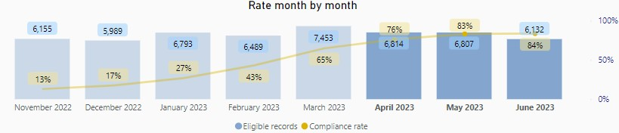

25
Improve understanding of victim needs and increase victim satisfaction
Serving
Victims
Achieve 80% of completed victim needs assessments for eligible crimes

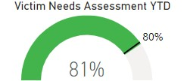

Increase victim satisfaction rate across the victim journey throughout 2023/24
Point of Contact Satisfaction Rates
Call
Online
73.5%
35.2%
Attendance Satisfaction Rate

86.9%

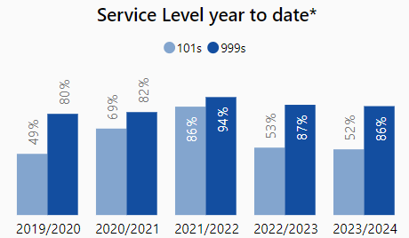
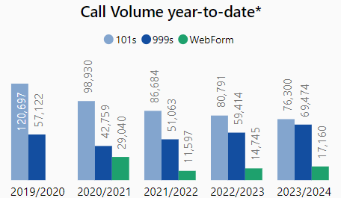
26
Improve call handling times
Serving
Victims
Reduce proportion of 101 callers waiting over 10 minutes for their call to be
answered to under 15%

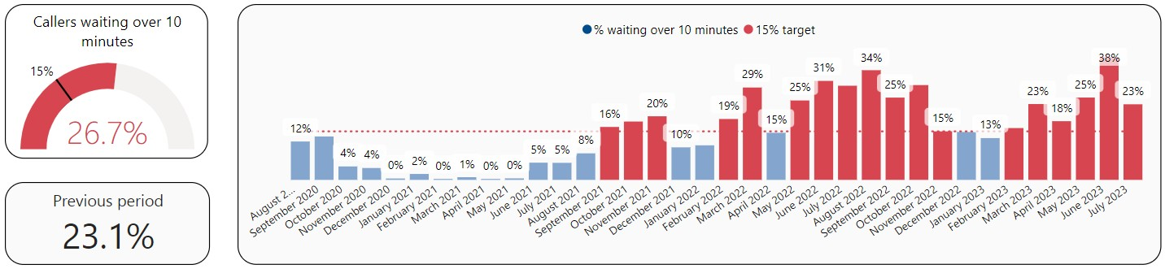
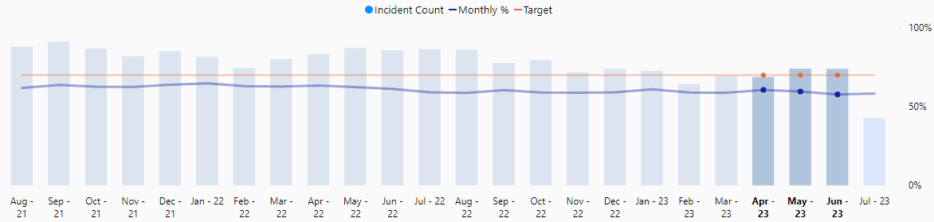
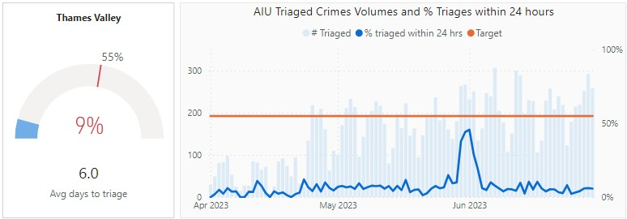
Ser
Victims
Increase proportion of grade 1 calls attended in under 20 minutes to 70%
ving
27
Improve attendance times and appointment management

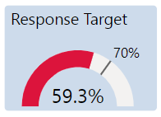

AIU to triage 55% of crimes within 24 hours

Fighting Crime
Static
28

Priority Overview
Improving
REDUCE KNIFE ENABLED CRIME
Static
Regressing

REDUCE NEIGHBOURHOOD CRIME

BRING MORE OFFENDERS TO JUSTICE THROUGH GREATER USE OF CHARGES, WITH A FOCUS ON VIOLENCE AGAINST WOMEN AND GIRLS

YTD

trajectory
PURSUE AND ACTIVELY MANAGE REPEAT OFFENDERS

The colour of the hexagon represents Year to Date performance for this aim;
Static
TARGET & DISRUPT SERIOUS ORGANISED CRIME, INCLUDING FRAUD & CYBER
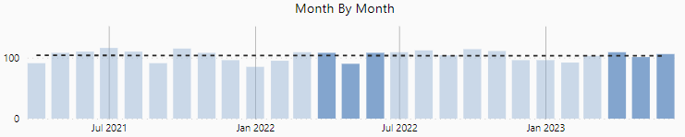
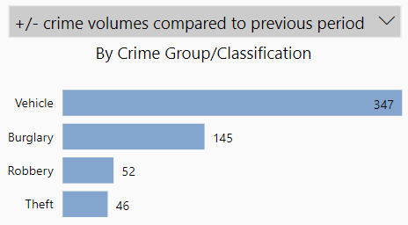
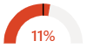
29
Reduce knife enabled crime / Reduce neighbourhood crime
Fighting
Crime
Reduce number of knife enabled crimes by 5% year on year
Reduce the volume of crime across all neighbourhood crime types

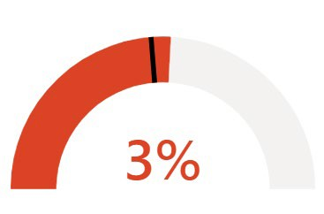

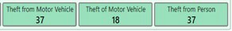
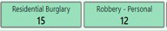
Latest IQUANTA data: April 2023, Crimes per 1,000 population
National Positions
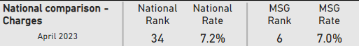
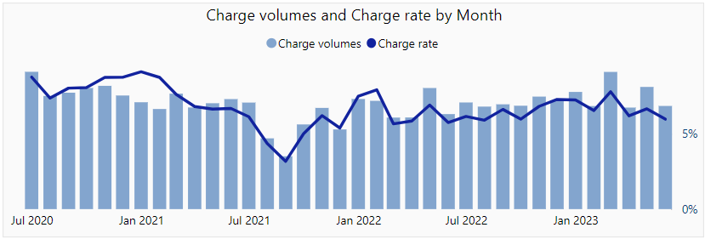

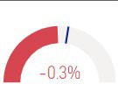
Charge rate 2022/23 | Charge rate 2023/24 | Change
6.6% | 6.3% | - 0.3

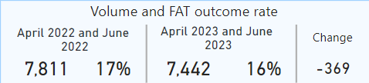
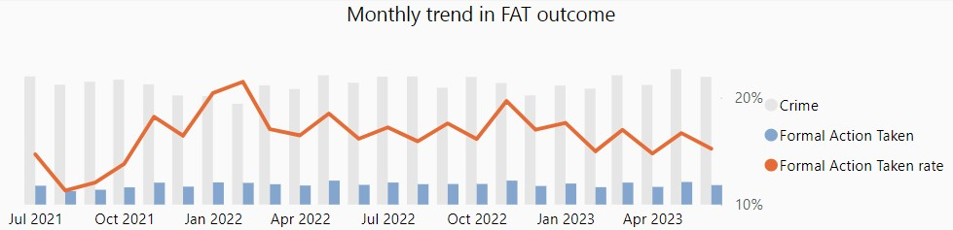
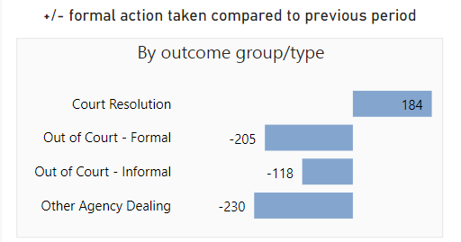
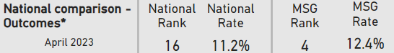

YTD previous month

YTD this month

Formal Action Taken outcome profile
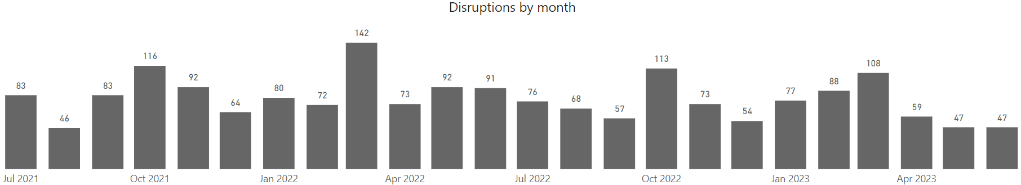
32
Target & disrupt serious organised crime including fraud & cyber crime
Fighting
Crime
Increase the number of SOC disruptions across prevent, prepare, protect, and
pursue and improve community safety using ‘clear, hold, build’ methodology

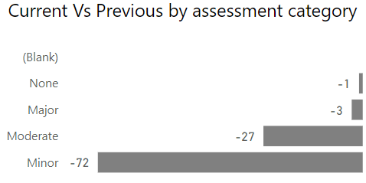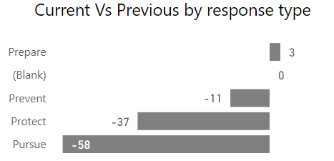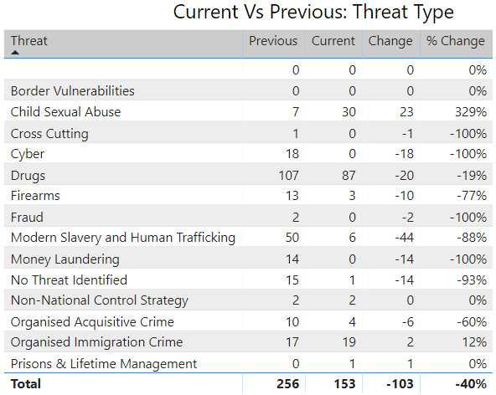
Disruptions
33
Improving
Static

Priority Overview

Building Trust
Improving
Static
DEVELOP GREATER UNDERSTANDING OF PUBLIC TRUST AND CONFIDENCE IN THAMES VALLEY POLICE

INCREASE VISIBILITY THROUGH TARGETED PATROLS

IMPROVE LOCAL COMMUNITY POLICING AND ENGAGEMENT, WITH CONSIDERATION FOR SELDOM HEARD FROM COMMUNITIES

YTD

trajectory
ENSURE TRANSPARENT USE OF POLICE POWERS

The colour of the hexagon represents Year to Date performance for this aim;
Regressing
TACKLE RURAL CRIME & UNAUTHORISED ENCAMPMENTS



34
Develop a greater understanding of public trust and confidence in Thames Valley Police
Building
Trust
Develop baseline for public trust and confidence and monitor progress throughout
2023/24

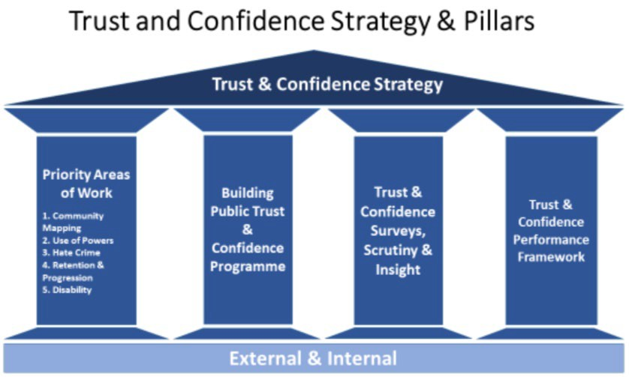
35
Increase visibility through targeted patrols
Building
Trust
Increase active patrol time through the use of Op Rasure Hotspot App

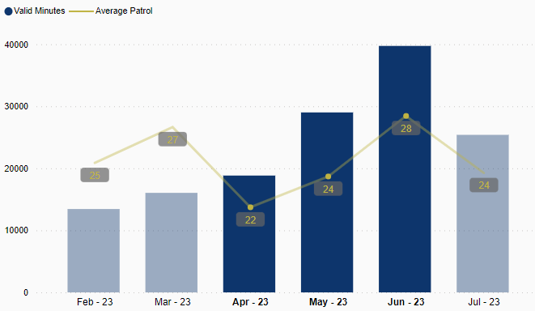
Improve local community policing and engag 36
ement,
with consideration for seldom heard from communities
Building
TrustEvidence of active engagement with selected communities in each LPA

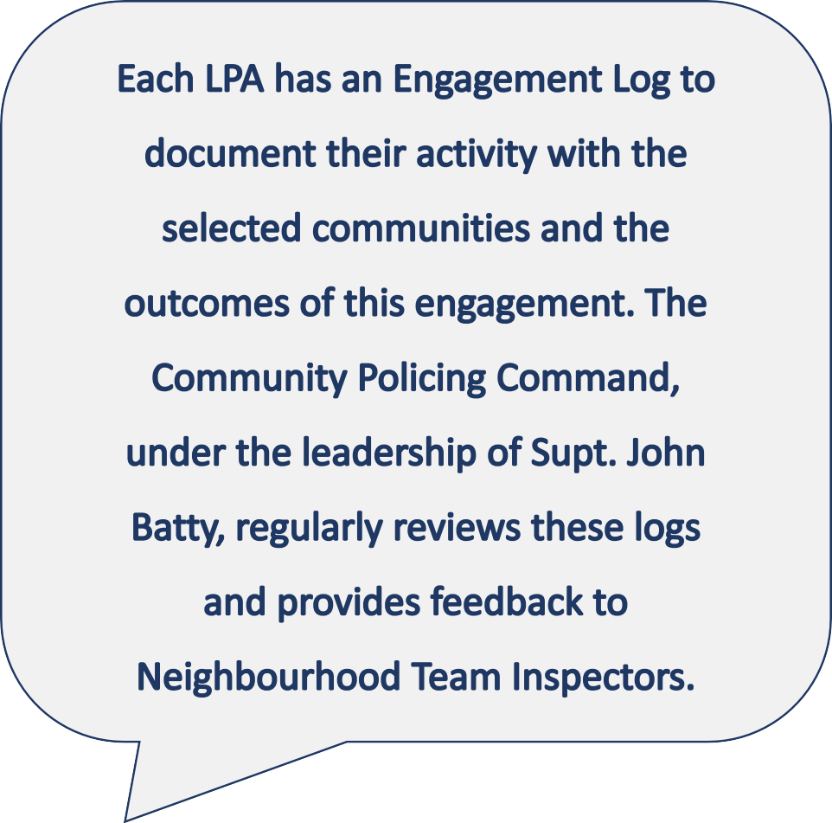
LPA | Selected seldom heard from community
Aylesbury Vale LPA | Disability
Bracknell & Wokingham LPA | Youth
Cherwell & West Oxon LPA | Rural
Milton Keynes LPA | Youth
Oxford LPA | East Timorese
Reading LPA | Deaf
Slough LPA | Homeless
South Buckinghamshire LPA | Geographical relevance (GRT, Chinese, Hindu, Polish, Sikh)
South Oxon & the Vale LPA | Gypsy, Roma and Traveller
West Berkshire LPA | Rural
Windsor & Maidenhead LPA | Youth

Building Trust
37

Ensure transparent use of powers

Improve understanding of disproportionality and outcomes achieved through Stop & Search
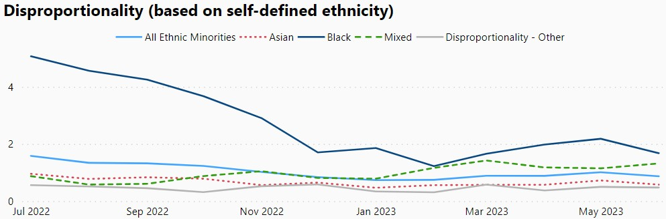
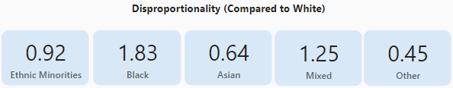
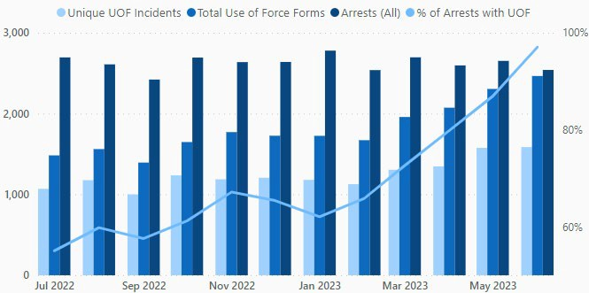
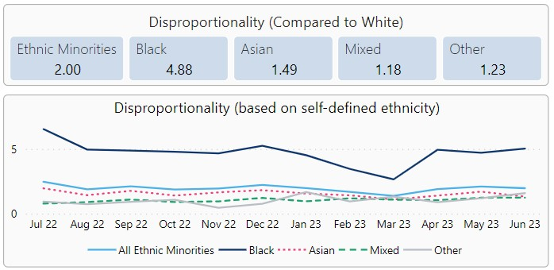
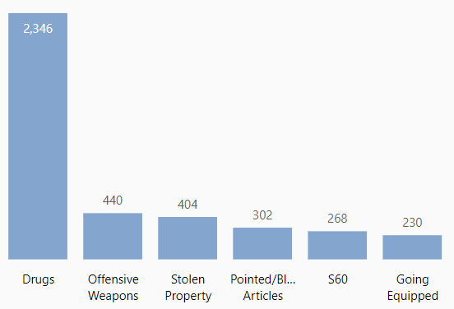

Improve recording and understanding of disproportionality within use of force

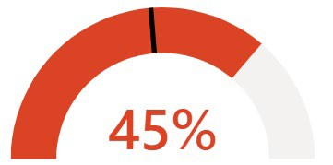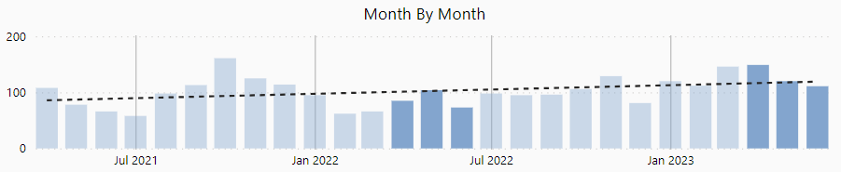
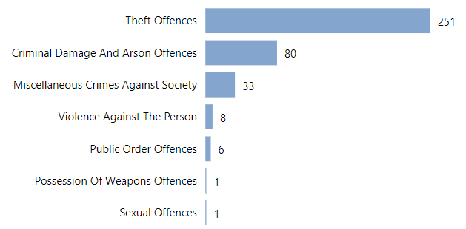
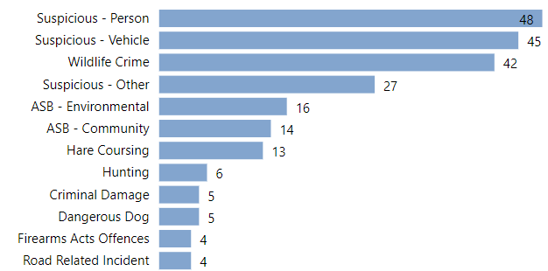

Year to date rural incident change
+33%
16


Unauthorised Encampments recording
100
100%
50
50%
0
0%
Unauthorised Encampment Occurrences
% with template

17
Action taken
(from 96 with template)
0
10
20
30
40
50
60
70
Section 60C used

Section 61 used
Section 62 used Local Authority Informed Local Authority attended Local Authority powers used Occupants moved voluntarily
40

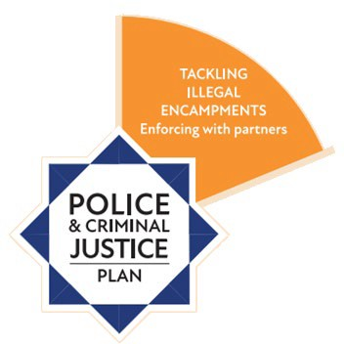
41
Valuing Our People – key indicators
AGENDA ITEM 5
Measure of Success | Last updated | Thames Valley
Reduce police staff vacancy factor, focusing on high risk operational areas, particularly Contact Management, Detention Officers, PCSOs and Forensics teams | 27/07/2023 | Contact Management (Police Staff) variance: -34.92 FTE (-7.55% vacancy factor)  Detention Officer variance: -40.38 FTE (-28.84% vacancy factor) PCSO variance: -145.36 FTE (-35.51% vacancy factor)  CSI (all roles) variance: -17.20 FTE (-23.55% vacancy factor)
Ensure Police Officer establishment is maintained at the 1st April 2023 level throughout the coming year | 27/07/2023 | Officer Establishment April 2023: 4524.00  Officer Actual June 2023: 4569.72
Reduce Neighbourhood Policing vacancies to be within 5% of Neighbourhood establishment by March 2024 | 27/07/2023 | The vacancy factor was -102.01 FTE (-22.5%). This relates to substantive ranks PC, Sergeant and Inspector.  Note: The high vacancy factor is predominantly due to the NH PC vacancy  factor, see notes for details.
Reduce attrition in police officer roles to an average of 36 per month | 27/07/2023 | There have been 137 leavers, an average of 45.7 per month.
Maintain above 200 Specials in force | 27/07/2023 | Specials actual June 23: 199
Reduce psychological sickness across all roles | 27/07/2023 | Total hours lost due to Psychological sickness April 23: 14,858  May 23: 16,645  June 23: 18,341
Reduce number of officers not fully deployable in their duties | 27/07/2023 | Police Officers on adjusted duties June 23: 321 Police Officers on recuperative duties June 23: 122
Ensure appropriate use of overtime against allocated budgets | 27/07/2023 | Overall we are £170,592 overspend YTD with a spend of £1.66m against a YTD budget of £1.49m. The annual budget is 19% spent with nine months data

