 | OFFICE OF THE POLICE & CRIME COMMISSIONER  FOR THAMES VALLEY

PCC DECISION REPORT - SECTION A - SUMMARY

Report for Decision

Report Reference Number: | PCC 2023 017

Report Title: Community Fund grant awards August 2023

Executive Summary:
The Community Fund (previously called the Police Property Act Fund) is created from the proceeds of sale of goods recovered by the police that cannot be returned to their original owner. In accordance with the Police Property Act Regulations (1997) all awards from the fund must be for charitable purposes.

The latest round of this funding launched on 21st August 2023 with £200,000 allocated to the pot. It closed on 11th September and received 189 applications, totaling approximately £2.1m. An evaluation panel of three members of staff from the OPCC, and the PCC, sat to review all applications.

Due diligence checks were made, as needed, and the list proposed to the Chief Constable who offered his input and approved the final shortlist. The recommendations were then approved by the PCC, and award letters (and unsuccessful letters) were sent out by email on 6th October 2023.

In total, the grant awards will support 51 organisations with total funding of £199,548.

The funding awarded is for the purpose outlined in the submitted bids; those organisations who were successful in this round will be required to submit information about how the grant was spent and the outcomes achieved. Consideration for any future grant eligibility will be only provided if acceptable reports have been received. If the funding has not been spent within 12 calendar months of the grant, the PCC reserves the right to request the funding be returned.

Community Fund Grant Awards – August 2023
Name | Amount
ACT Oxford (Aldates Community Transformation Initiatives) | £3,000
Action4Youth | £3,000
African Diaspora Foundation | £10,000
Age UK Oxfordshire | £10,000
APCAM Group | £2,000
Aylesbury Youth Motor Project | £5,000
Beenham Victory Hall and Beenham Club | £2,000
Berryfields Parish Council | £6,000
Bicester Town Council | £5,000
Boxing Clever MK CIC | £2,000
Bracknell Town Council | £5,000
BYHP | £3,000
C2C Social Action | £6,755
Carterton Football Club | £1,000
Charndon Parish Council | £2,000
Citizens Advice Milton Keynes | £3,925
Community Alleyway Art Project | £5,000
Crazies Hill and Cockpole Green Residents' Association (CHCGRA) | £3,000
Crowthorne Parish Council | £5,000
Didcot TRAIN - Inspiring Young People | £5,000
Edge Housing (part of Oxfordshire Community Churches) | £2,000
Farcycles Limited | £3,059
Faringdon Town Football Club | £3,000
Get Fed Coffee CIC | £1,000
Haversham-cum-Little Linford Parish Council | £6,000
Jordans Village Limited | £500
Kaleidoscopic UK | £6,905
Langford Village Community Association | £300
Lower Earley Salvation Army | £1,500
Maidenhead Community Watch Association | £1,890
Nash Parish Council | £1,500
Newport Pagnell Town Council | £5,800
Prevention Better Than Cure (PBC) | £5,000
Reading Cycle Campaign | £2,769
Reducing the Risk of Domestic Abuse | £6,000
Second Time Around Charities | £1,000
Slapton parish council | £5,000
Soul Restore CIC | £5,800
Thames Valley Partnership | £5,000
The Leys Community Development Initiative | £3,000
The Oasis Partnership | £3,285
The Parochial Church Council of The Church of St Peter, Hanwell | £1,000
The Sweatbox Youth Centre, c/o King Alfreds Academy, Vale Academy Trust | £5,000
Tilehurst Parish Council | £2,464
Town and Manor of Hungerford | £3,796
Waltham St Lawrence Cricket Club | £850
Ward Royal Residents Association | £5,000
West Oxon Boxing and Fitness Club | £10,000
Wingrave with Rowsham Parish Council | £1,450
Wolverton and Greenleys Town Council | £10,000
Youth Concern | £2,000
Total | £199,548

Recommendations:
- To approve the above grant proposals for this round of the Community Fund

Decision of Police and Crime Commissioner
I hereby approve the recommendation(s) above.

Signature: Date: 10/10/2023

GOVERNANCE CHECKS (Name & Role) | Officer Signature
Originating Officer / Head of Unit  Cath Marriott (Head of Partnerships & Community Safety) | 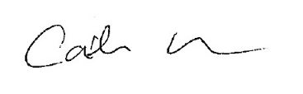
Legal Advice
Vicki Waskett (Head of Governance & Compliance)
Financial Advice  Martin Thornley (Chief Finance Officer & Dep. Chief of Staff) | 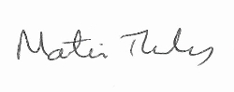
Equalities and Diversity  Gillian Ormston (Chief of Staff) | 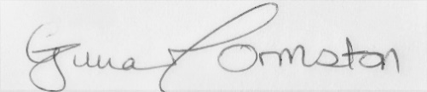

PCC’s STATUTORY CHIEF OFFICERS’ APPROVAL

We have been consulted about the proposal(s) contained in this Decision Report and confirm that financial and legal advice have been taken into account in the preparation of this report.

We are satisfied that this is an appropriate request to be submitted to the Police and Crime Commissioner for decision.

Chief of Staff (Monitoring Officer) Date: 10/10/2023

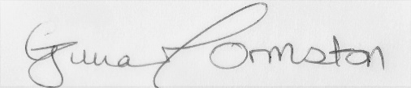

Chief Finance Officer Date: 10/10/2023

