PROPERTY 2033
PROPERTY ASSET MANAGEMENT FRAMEWORK
2023-2028

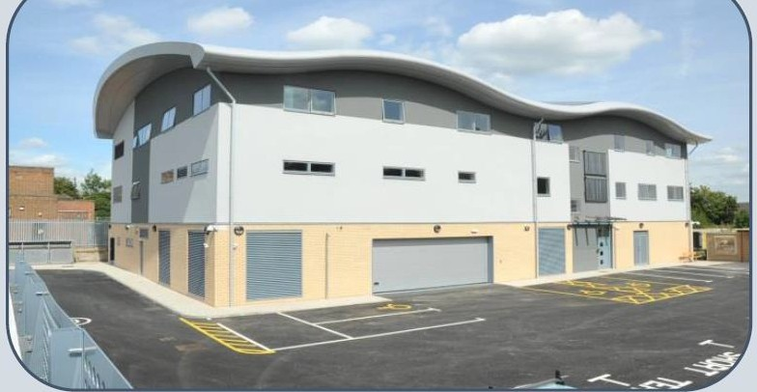
HELPING TO DELIVER A BETTER POLICE SERVICE ACROSS THAMES VALLEY

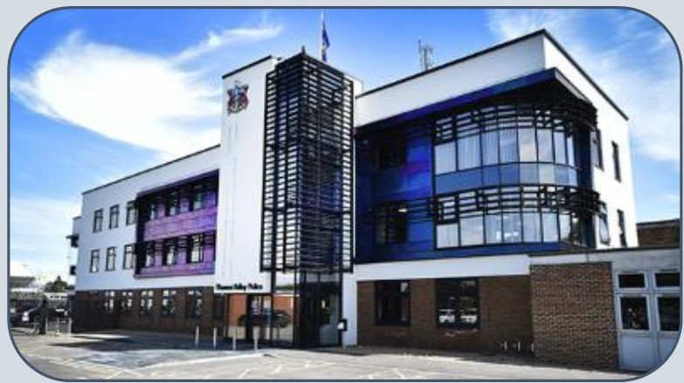



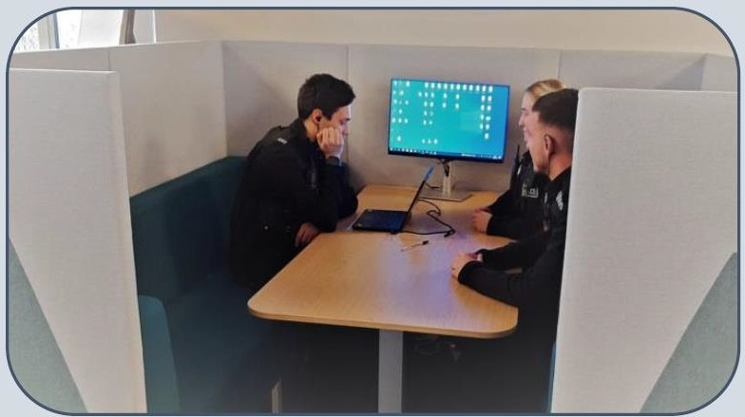



THAMES VALLEY POLICE ESTATES DEPARTMENT MARCH 2023

FOREWORD

The Police Service is continuing to go through a period of modernisation, with many drivers and opportunities for changes in approaches to service delivery, exciting developments in technology and collaboration expected between forces, “blue light” services and across the public sector. Since the last Asset Management Plan in 2018, there have continued to be organisational changes, increased demand for services and further challenging budget reductions required across the public sector - as well as a major pandemic. It is envisaged the public sector will continue in an environment of budget challenges for some time yet, with the added uncertainty of high inflation and the drive to achieve sustainability targets.

Property is a key resource for Thames Valley Police, as it is with any organisation – it has value, but costs money to use and maintain. While it is a critical component in supporting service delivery, it has to make a significant contribution towards reducing our revenue costs and environmental impact. It is therefore essential that it continues to be strategically and centrally managed over the long term, supports our organisational priorities, and is aligned where practical with our partners strategic plans.

Significant capital receipts and revenue savings have already been achieved, but there is more to do, with the next 10 years projected to add to these achievements. However, with over 120 property disposals since 2010, and a fewer number now remaining, additional worthwhile and affordable estate changes and opportunities are becoming more challenging to identify and deliver. One significant positive coming out of the recent pandemic, was the significant culture change shift embracing agile working. Our post pandemic Working Smart approach, and investment in [agile] ICT, are now seen as key enablers for future estate change, in terms of what estate we need and how we use it.

While good progress has been made, and with no fundamental gap in what property we have relative to current service requirements, the performance of our portfolio needs to continue to improve. It needs to contribute more to our Productivity Strategy and sustainability goals, by delivering enhanced value for money, have enhanced corporate identity and be a workplace of choice for our current and future workforce. We recognise that this will entail not only consistently challenging the need for property, but also a strong commitment from both the Force and PCC to provide the necessary support and investment to facilitate a programme of change over the next 10 to 20 years.

Jason Hogg Mathew Barber
Chief Constable Police & Crime Commissioner for Thames Valley

CONTENTS PAGE
  - INTRODUCTION & CONTEXT
  - Purpose of the Asset Management Framework (AMF) 3
  - Thames Valley context 3
  - How the Police Service is delivered 4
  - Organisational, political and Estates structure 4
  - ASSET VISION
  - Corporate mission and priorities 6
  - Asset vision 7
  - ASSET STRATEGY
  - Our estate 9
  - Our funding 11
  - Our Corporate Landlord approach 12
  - Other relevant property strategies 15
  - ASSET MANAGEMENT PLAN
  - Current external and internal issues affecting asset planning 18
  - Translating the Asset Vision 18
  - Strategic Estates Requirement Plan (SERP) 19
  - Individual site strategy – retention indicator 20
  - Disposal programme 20
  - Mitigating the impacts of planned population and housing growth 21
  - Maintenance work streams & priorities 22
  - Capital Schemes work streams & priorities 22
  - Facilities Management & sustainability work streams & priorities 22
  - Risks and issues 23
  - Asset Management Implementation Plan 23
  - ANNEXES
    - Overview of the Portfolio 25
    - Strategic Approach By Asset Category 26
    - Strategic Estate Requirements Plan (SERP) 30
    - Individual Site Strategy - Retention Indicator 31
    - Asset Management Implementation Plan 37

INTRODUCTION & CONTEXT

PURPOSE OF THE ASSET MANAGEMENT FRAMEWORK (AMF)
This framework document comprises 4 principal components:
    - Estate Vision – what the estate will aspire to be
    - Asset Management Strategy (AMS) – how the vision will be delivered – our approach
    - Asset Management Plan (AMP) – what will be delivered
    - Asset Management Implementation Plan (AMIP) – specific actions to be undertaken

This AMF builds upon the outputs and activity highlighted in the first 2008 Asset Management Strategy in 2008, which remain fundamentally valid, and the previous AMP format. Its purpose is to:

- Provide an overview of TVP’s strategic direction and corporate objectives, and the implications these have for the property portfolio over the next 10+ years
- Outline TVP’s vision and objectives for its property portfolio and how success will be highlighted
- Explain the overall strategic direction for the management of TVP’s property in supporting the corporate objectives and priorities
- Provide an overview of what property we have, how it is performing and is managed, and key activity required
- Highlight key issues affecting or that may affect future property provision and investment decisions, and to identify our main property priorities

The AMF will therefore outline where we are now, where we want to be and how we will get there. It will provide a strategic context for rational property investment decision making.
As TVP operates in an environment of change, with regular new initiatives locally and nationally, it is proposed to continue to update specific “live” aspects of the AMP annually, with a more comprehensive refresh of the AMF every five years.

THAMES VALLEY CONTEXT

Thames Valley is the largest non-metropolitan force in the country with an expected staff establishment (FTE) at the start of 2023 of approaching 8,400 officers, PSCOs and support staff, over 240 Special Constables and a significant number of volunteers. Thames Valley serves a population of approximately 2.5m.
The demographic and geographical characteristics of Thames Valley are diverse, across 8 unitary, 5 district and 1 county council areas. Thames Valley is projected to expand significantly over the next 20 years with an additional 245,000 new homes identified to be delivered by 2042 and the population set to increase by 130,000. Furthermore a number of new infrastructure,
employment and leisure developments will also be delivered. This scale of growth will continue to impact on the demand for policing services and resources, with areas of significant new development and regeneration.

HOW THE POLICE SERVICE IS DELIVERED

The Force currently operates through 11 Local Policing Areas (LPA’s) aligned to local authority political boundaries, and a range of forcewide shared service departments, delivering both operational and support functions centrally or from area based hubs. The LPA structure is under review in 2023 and may alter, with any implications for the estate needing to be considered.
TVP works closely with partners such as councils, other public, voluntary and emergency services and criminal justice organisations such as HM Courts & Tribunal Service, Probation Service, and the Crown Prosecution Service. TVP also works in collaboration with other forces to ensure community safety, in its broadest terms, is delivered as effectively as possible. The most significant are the Joint Operations Unit with Hampshire Constabulary, and South East regional working including counter terrorism, organised crime and other activity.
Estate provision needs to enable and support this complex organisational and operating structure, and to respond effectively to change.

ORGANISATIONAL, POLITICAL AND ESTATES STRUCTURE

The Police service is currently managed nationally through a tri-partite arrangement between the Home Office, the Chief Constables of each force and Police and Crime Commissioners.
Locally, the police service is delivered by Thames Valley Police and is overseen by the Police and Crime Commissioner (PCC) for Thames Valley. The actions, decisions and performance of the PCC are in turn scrutinised by an independent Police and Crime Panel. There are strong links at a strategic level between the Force and PCC, and both headquarters functions are currently based in Kidlington, Oxfordshire
All Force activity falls under the direction of the Chief Constable’s Management Team. Legal ownership of the property portfolio is vested in the Police & Crime Commissioner. The responsibility for the management of all aspects of the TVP estate on behalf of both the Chief Constable and the PCC, lies with the Force’s in-house Estates team, operating within the portfolio of the Deputy Chief Constable (DCC).
The primary estates oversight and decision making forum is the Strategic Estates Group (SEG) which typically meets quarterly, is chaired by the DCC and includes senior officers of the Force and Office of the PCC, and other relevant stakeholders.
The Estates department is an in-house HQ function comprising Strategy & Assets, Capital Schemes, Maintenance and Facilities teams, the latter predominantly area based. Departmental activity is supported, when needed, by the use of external consultants.


ASSET VISION
WHAT THE ESTATE WILL ASPIRE TO BE



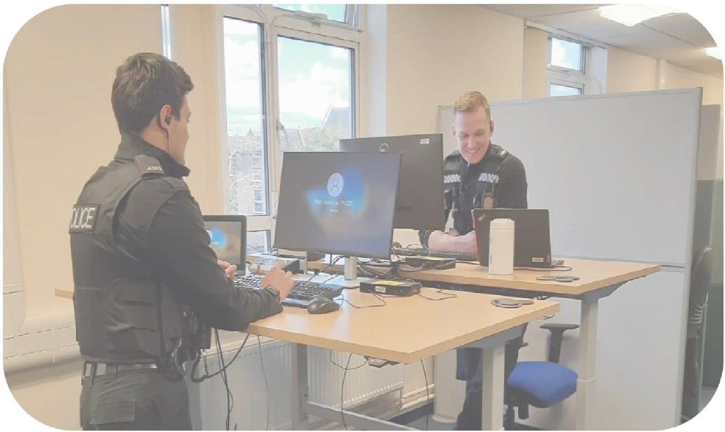

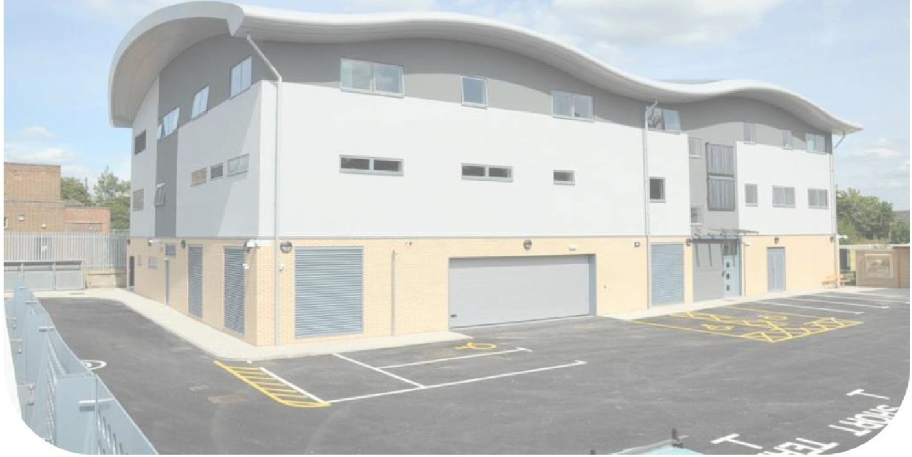

ASSET VISION
Estate planning necessitates taking a long-term view, and the provision of an investment and delivery framework aligned to organisational priorities, affordability, risks and opportunities.

CORPORATE MISSION AND PRIORITIES

The role of the estate is to support the PCC’s and Force’s mission, vision and priorities. They are summarised as follows;

TVP MISSION: | Protecting our communities
TVP VISION: | An excellent police force trusted by our communities
TVP VALUES: | We treat everyone with fairness and respect We are courageous and do the right thing We strive to improve every day  We are proud to be Thames Valley Police

PCC POLICING & CRIMINAL JUSTICE PLAN  2021-2025 | THAMES VALLEY POLICE STRATEGIC PLAN 2022/23
- Strong local policing*  - Fighting serious organised crime  - Fighting cyber crime and fraud  - Improving the criminal justice system  - Tackling illegal encampments  *The PCC’s Crimefighters strategy was published in April 2023 | - Reducing crime and incidents  - Bring more offenders to justice  - Protect the vulnerable & tackle violence against women and girls  - Improve victim services and public confidence  - Value our workforce  - Use our resources wisely  - Maximise the benefits of digital developments

Asset management, as a service delivery support strand, cross cuts a number of these corporate priorities.

“TVP 2025” is a longer term corporate strategy focusing over the medium term on areas of transformation around the following 6 pillars:

FOCUS ON FRONTLINE SERVICES | BECOME AN EMPLOYER OF CHOICE
EMBED PREVENTION | MODERNISE FORENSICS
BUILD TRUST & CONFIDENCE | BECOME A DATA DRIVEN ORGANISATION

ASSET VISION

To support the corporate vision, priorities, and service delivery generally, a clear asset vision is needed, which in effect becomes a 10+ year framework for planning the estate. From this an asset strategy and delivery plans can be developed.

By 2033, the TVP estate should demonstrate the following attributes, by being:

FIT FOR PURPOSE | PRODUCTIVE | IN GOOD CONDITION
- Right space, place and time  - Supports service delivery to the public  - Supports Working Smart principles  - Sufficient | - Supports the Force’s & PCC’s strategic objectives and priorities  - Contributes to workforce productivity  - Contributes to the Force’s Productivity Strategy | - Ensure the estate is kept operational and safe  - Maintain reliable condition survey data  - Highlight long term funding requirements (and deterioration risk)  - Prioritise maintenance activity effectively (& sustainably)
SUSTAINABLE | LEANER & MORE EFFICIENT | A MODERN CONDUCIVE PLACE TO WORK
- Progress estate de-carbonisation  - Support fleet electrification(with enabling infrastructure  - Reducing consumption & non- recyclable waste  - Apply (WLC and) sustainable procurement principles | - Maximise asset utilisation and VFM (Ensuring best use of resources  - Identify new viable replacement opportunities  - Identify new estate reduction and consolidation opportunities  - Monitor and progress worthwhile collaboration opportunities with partners  - Futureproof for change | - Flexible and safe (“our” not “my” space)  - Zoned not owned  - Supports diversity and wellbeing  - Clean and welcoming

How this looks in terms of a delivery strategy for specific property categories, and at a site/property level, is addressed in the Asset Management Strategy section 3 and the Asset Management Plan section 4 respectively. This Asset Vision provides a basis for assessing how successful asset management activity has been by 2033, in supporting the Force’s and PCC’s strategic objectives and priorities.


ASSET MANAGEMENT STRATEGY
HOW THE ASSET VISION WILL BE DELIVERED

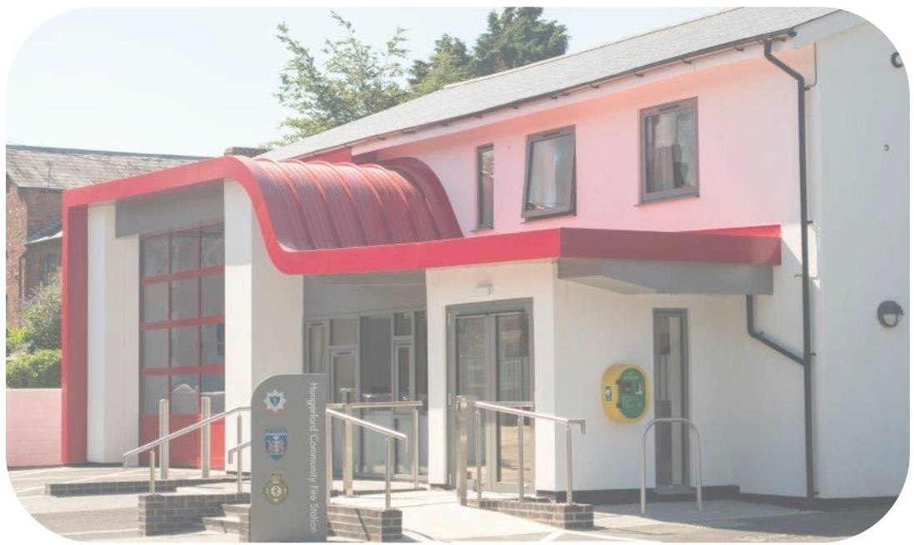


ASSET MANAGEMENT STRATEGY
This Asset Management Strategy (AMS) section provides an overview of our land and property estate, together with our approach to asset management and our main focus for managing and developing the estate over the next 10+ years. The AMS will be periodically reviewed to ensure our estate fully supports the PCC’s and Force’s corporate objectives and priorities

OUR ESTATE

    - Property categories

The TVP estate comprises operational, residential and shared equity portfolios. Police services are delivered through a range of operational property types reflecting the structure of current local policing delivery, force wide operational and business support requirements. A strategy for each property category is highlighted in Annex 2.

    - Size and nature of the portfolio

TVP’s operational portfolio including headquarters and support facilities, but excluding covert facilities, comprises:

- 94 sites (as at March 2023) with approximately 180 buildings
- 136,000 sqm gross floor area
- Asset (book) value, as at 31 March 2023 of £201m
- 7 stand alone communication mast sites
- 89% of the floor area is owned. This was 88% in 2018 and 72% in 2010
- Around 83% of the floor area dates between 1950 and 2000

An overview of the portfolio is in Annex 1. The portfolio is changing, with an ongoing disposal programme, with some more modern replacement facilities planned, and some significant building investment and maintenance projects underway and planned at any given time. The number of sites has reduced by 119 since 2010, with a net floor area reduction (after replacements) of nearly 22,000 sqm,

TVP has a small residual residential portfolio of 7 houses together with some trainers accommodation at the Sulhamstead training centre. This has diminished rapidly in recent years, with most of the remaining houses expected to have been sold by 2028.

    - Estate performance

TVP has actively participated in the annual National Police Estates Group benchmarking process for many years, although was unable to do so in 2022/23 covering the 2021/22 financial year. The NPEG assessment, currently managed through CIPFA, is a very detailed consideration across a range of criteria such as space, age, cost and consumption.
Performance in some categories has been in the 1st and 4th quartiles. Some highlights from the 2020/21 inter-force output:

KPI | PERFORMANCE | OTHER FORCES AVERAGE
Space density per FTE | 16 sqm | 18.1 sqm
Total property cost per sqm GIA | £149.53 | £149.69
Total operational space within GIA | 45% | 31%
Building stock aged 1946-2000 | 91% | 68%
Building floor area (GIA) owned | 89% | 79%

Direct comparisons with other forces while of interest, are not particularly reliable in any event, due to the inconsistent quality of the annual data provided across forces for the benchmarking process. Notwithstanding that, while relative performance in each category can vary, TVP’s performance has, overall, consistently been in the 2nd or 3rd quartile compared against at least 30 participating forces annually over a number of years.

In previous iterations of the AMP an internal KPI set was reported. Some key indicators from that had targets expiring by March 2022 which were achieved, such as;

INTERNAL KPI | TARGET | OUTCOME
Net* capital receipts | £45m | £47.8m
Net* revenue savings | £4.50m | £4.52m
*Of any replacement costs

These and other indicators are no longer considered fit for purpose or required as most are now reported elsewhere, such as through the NPEG benchmarking process, Environmental and Sustainability Strategy and Strategic Estates Group (sale receipts and savings).

    - Fitness for purpose and space utilisation

The remaining TVP portfolio has consistently been objectively rated either fit for purpose or generally fit for purpose across a range of performance criteria such as sufficiency, suitability, condition, environmental performance and cost.

The need to improve our utilisation of the portfolio was the key strategic direction of TVP’s 2008 Asset Management Strategy, which remains a valid objective. Highlights from the analysis of all sites for which there is detailed space data are:

      - Office space accounts for 32% of total gross internal floor area, up from 27% in 2018, reflecting a range of factors associated with policing such as the need for specialist buildings, training facilities, and the nature of operational police sites requiring a range of support facilities such as custody, storage, briefing, equipment locker and incident rooms etc

      - The usable floor area per workstation within all office areas is now 5.36 sqm across over c.5,800 workstations (5.76 sqm in 2018 and 7.30 sqm in 2010) which compares well with the recommended long term (10 year) target of 6 sqm set in 2008. It is unlikely this will be significantly improved upon, as the implementation of Working Smart necessitates the provision of adequate ancillary support spaces, which might affect the quantum, layout and use of core work/desk space.

Further and ongoing analysis will be undertaken on space data, as this provides important information for applying and monitoring workplace strategy at a site specific level.

    - Estate Collaboration

Collaborative asset management dialogues have been underway with most public sector partners across the Thames Valley area since 2010, seeking to identify and progress any opportunities to make better use of the public estate. TVP has participated in the One Public Estate initiative since 2016 across all 3 counties, and this has strengthened working relationships with our partners, in particular “Blue Light” partners. A Memorandum of Understanding around estate collaboration, entered into with all 3 Fire Services across Thames Valley in 2015, continues to prove constructive.

Partner premises can represent good value for money, they can enable site disposals, there can be operational benefits in co-location with the right partners, and co-location is attractive politically. At a local level TVP is located in partner premises at 40 locations, down from a peak of

57 in 2016 largely as a result of reducing the number of small underused neighbourhood offices. The ability of our partners to use TVP buildings is constrained by security requirements, but does occur at a specific operational team level.

OUR FUNDING

    - Financial context

The 2023/24 budget is prepared against a background of unprecedented inflationary increases, a tight recruitment market, supply chain shortages and market volatility, along with uncertainty about future government spending.

At the same time the Police service, both nationally and locally, is adjusting to the changing nature and complexity of crime, by investing in recruiting, training and developing officers, and adopting new technologies. To balance these financial pressures with the base cost of ongoing operations, the MTFP includes challenging productivity savings targets.

All new business bids are prioritised as part of the annual planning process against the same matrix, taking account of benefits and cost, with the highest priority projects progressed for funding consideration.

Inflation has had a disproportionate impact on the construction industry, adding to the existing pressures of maintaining an aging estate. Over the MTCP (including 22/23) it is anticipated that revenue spend will increase from 3.5% of net force revenue spend, to over 4%.

For the same period, total Capex spend will be approximately £191.7m, of which property expenditure will be £89.9m, and these figures are at risk of further inflation and slippage due to the above market pressures. The majority of new projects currently have only provisional approval for planning purposes, and to reflect the potential financial impact on force budgets. After full utilisation of estates reserves and reinvestment of asset sales proceeds, the majority of this is still likely to be funded from borrowing.

    - Cost in Use

The estate represents one of the most significant component revenue costs after staff cost. In 2022/23 the total revenue property budget, excluding reserve funded schemes but allowing for productivity savings, was £17.8m, which represents 3.53% of the force net revenue spend.

While estate rationalisation and reductions in estate operating budgets had reduced the cost of the estate steadily since 2012/13, when it was £25.4m, the current inflationary pressures require an increase in the projected budget for the next 4 years to £23.3m (4.02% of force net revenue spend).

    - Future Maintenance Requirements

The operational portfolio is estimated, as at March 2023, to have approximately £75m of identified maintenance requirements to 2033, based on a combination of condition survey information, ongoing annual servicing costs, and reactive/day-to-day repairs. This information is subject to continuous review so that estimate is likely to evolve. While the overall condition of the estate is currently reasonable, with the unavoidable consequence that reduced maintenance budgets will be insufficient to address long-term maintenance requirements, there is a need to closely monitor portfolio condition, maintenance expenditure (in particular for reactive works) and site specific building infrastructure performance. This is a national issue across the public estate and is reflected in the Force’s 10 year Strategic Estate Requirements Plan, and it is also highlighted as an estate risk in the Property Services Department’s Risk Register.

OUR CORPORATE LANDLORD APPROACH

    - Core departmental activity

TVP’s Estates department operates a centralised “corporate landlord” approach to asset management, ensuring robust central control and oversight, consistency and alignment of the estate with ongoing requirements and priorities, covering the following:

- Strategic management. Maintain/reinforce a “corporate landlord” asset management model:

  - Centralised strategic asset planning aligning with corporate objectives and priorities
  - Centralised sustainability planning and delivery
  - Centralised facilities management delivered locally
  - Centralised space management and allocation
  - Centralised works prioritisation informed by local input
  - Estate aligned to the Force’s operational delivery model and required footprints
  - Reducing expensive leased sites/buildings where practical
  - Prioritising strategic sites essential to service delivery
  - Identifying collaboration opportunities/enablers
- Embedding Working Smart principles and workplace application:

  - Develop and periodically review desk and supporting facility ratios
  - Plan and progress HQ & LPA Working Smart pilots and rollout force-wide
  - Monitor staff productivity and wellbeing
  - Monitor suitability & performance of WS workplaces over time
- Datasets. Ensure robust and reliable datasets covering:

  - Building Condition/FMR
  - Space and occupancy
  - Running costs & income
  - Consumption & emissions
  - Legal compliance
  - CAFM core information requirements
- Relevant strategies. Regularly refresh strategic estate plans and related strategies:

  - Asset Management Framework
  - Estate Maintenance Strategy
  - Environmental & Sustainability Strategy
- Demonstrate & measure performance: To cover:

  - Estate utilisation
  - Estate cost
  - Receipts (sale & s106/CIL), income & savings
  - Carbon emissions/energy consumption
  - Waste reduction/recycling
  - Estate reduction
  - Monitor status of Estate Maintenance backlog and condition deterioration
- Plan ahead: Maintain a rolling (“live”) 10+ year Strategic Estates Requirement Plan (SERP) covering strategic and site specific major projects and programmes with indicative timeframes, resourcing and cost:

  - Business requirements
  - Estate rationalisation

  - Addressing condition
  - Asset management opportunities
  - Sustainability

    - Asset management key operating principles

A set of key operating principles help to deliver the Asset Vision through robust asset management:

- With the need to protect frontline services, there will continue to be an overriding aim to
reduce non-staff premises related costs as much as possible
- Property is a corporate asset rather than in the “ownership” of any part of the service and a Corporate Landlord approach will be used consistently with defined standards and protocols
- The Force will identify those strategic sites that are essential to service delivery and fit for purpose, and seek to maximise space utilisation at those locations, thereby enabling the release of other sites for disposal
- The priority will be to dispose of premises that do not represent value for money through having relatively high revenue costs, require significant investment for poor return, are not fit for purpose, are operationally surplus to requirements and / or are under utilised
- The use and provision of property, and asset management activity generally, should contribute towards the Force’s commitment to reduce our impact on the environment
- Opportunities for co-location with partners, whether within TVP or third party premises, and worthwhile income generation should be actively identified, assessed and progressed where practical and viable to do so
- Property tenure is not the critical determinant for service delivery. There should be no rigid policy on the extent of property ownership and/or leasing. Procurement choice will reflect strategic, financial, operational and commercial circumstances, and any requirement to retain flexibility
- Decisions about retention or disposal of property will be subject to a business case review process that will include consideration of strategic, operational, financial, and political issues
- All use of premises will be assessed against the key components of the Working Smart approach (including team adjacency requirements, security standards, working styles, desk ratios) to ensure that space utilisation and agile working opportunities are maximised
- Decisions around expenditure and investment in property will be made having regard to the content of this AMF, and other related strategy documents such as the Estate Maintenance Strategy and Environmental & Sustainability Strategy, adopting a whole life assessment approach where appropriate.
    - Asset challenge

Asset challenge is an embedded process, based on sector best practice, meaning we will be reviewing our assets on a rolling basis. This ensures only those assets that are needed are retained. The aim is to identify and act upon under-performance, to reduce costs, to identify those assets to be retained and invested in, those that are or could be surplus to requirement and could be disposed of, and where new or amended provision is needed to meet service delivery requirements.

National best practice recommends a step by step challenge process, ensuring testing against common criteria:

STEP 1 STRATEGIC PURPOSE | STEP 2 OPPORTUNITIES AND RISK | STEP 3  PERFORMANCE APPRAISAL
Why do we hold the asset, what is expected of it? | Exploitable opportunities, barriers, risks | Cost benefits, financial/non- financial outcomes
STEP 4 OPTION APPRAISAL | STEP 5  PRE-IMPLEMENTATION CONSULTATION | STEP 6 OUTCOME
Qualitative and quantitative benefits and risks | Engaging stakeholders | Should the asset be retained, re-purposed or disposed of?

Between 2010 and 2018, the TVP estate was assessed every 2 years through a Property Retention Challenge (PRC) process. This is an objective assessment of all sites undertaken to provide an indicator of the site’s retention rationale or indicative value for money. The PRC assessment covers 32 criteria over 5 categories:

      - Service delivery
      - Fitness for purpose
      - Space utilisation
      - Asset management issues
      - Financial performance

This is a useful objective indicator to inform both strategic planning and day to day estate management activity.

The outputs for the 91 sites (excluding car parks) assessed in 2018 are summarised in the table below:

SITES | PRC OUTCOME |  |  | TOTAL
SITES | GOOD | SATISFACTORY | POOR | TOTAL
Total Sites | 54 | 37 | 0 | 91
% of Total | 59% | 41% | 0% | 100%

59% of sites were in the “good” category, with 53% identified for retention. Of the 37 properties in the “satisfactory” category, 31 were either disposal or potential disposals. With the limited disposals undertaken since 2018, some with smaller modern replacements, and with the consistent outcomes seen between previous assessments, the position is not expected to have substantively changed since 2018. A further PRC challenge of each asset will be undertaken before 2028.

In summary, the operational portfolio generally performs well in supporting service delivery, with very few sites requiring essential (as opposed to desirable) replacement, or significant change or investment not already identified or planned for. Very few of TVP’s properties are therefore currently identified for disposal as a result of poor performance or corporate and functional re- structuring. What may seem to be reasonably well performing buildings still have the potential to be re-provided in a much more cost effective way, exploiting a reduced space requirement, high site values, collaboration and lease break/expiry opportunities to release capital receipts, revenue savings, and improved utilisation of core retained sites, by relocating functions not requiring a local presence.

OTHER RELEVANT PROPERTY STRATEGIES

In addition to this Asset Management Framework, there are two key strategies sitting alongside the AMF that influence and inform day to day and strategic estates activity and workstreams:

    - Estate Maintenance Strategy

The Estate Maintenance Strategy (EMS) is updated at periodic intervals and is submitted for review/consideration by the Strategic Estates Group. It provides an overarching framework for the force’s approach to maintaining the estate and it works in parallel with other key strategic estate documents (e.g. AMP, SERP, and the Sustainability & Environmental Strategy.

The principal aims and objectives of the EMS are as follows:

      - To provide the information platform upon which we can understand the condition status of the repair and maintenance of our estate.
      - To understand the current and expected future costs of owning, managing and maintaining our estate.
      - To establish a robust basis for assessing, planning and prioritising our repair and maintenance requirements aligned to the Force’s Asset Management Plan (AMP).
      - To facilitate the accurate and periodic reporting on current levels of maintenance expenditure against assessed need and to provide a framework whereby maintenance backlog and estate condition deterioration can be monitored
      - To provide a methodology for assessing and ensuring that the accommodation/buildings occupied by the Force are in a safe condition and comply with statutory & legislative, health & safety, welfare and security requirements.
      - To ensure through appropriate maintenance plans/programmes that the estate is capable of supporting the Force’s delivery of its strategic operational priorities/objectives.
      - To ensure that the EMS is considered and approved at an appropriate level within the organisation and that it is reviewed at agreed regular intervals to ensure it remains fit for purpose.

The EMS provides clarity about the approaches to be applied in order to undertake prioritisation of detailed estate maintenance activities at site or building level in relation to a range of factors including business continuity impact, retention status (as stated in the AMP), operational performance standards, wellbeing considerations and compliance requirements.

    - Environment & Sustainability Strategy 2022-2032

In 2022 TVP adopted a 10 year strategy to achieve the required environmental sustainability performance. Strategy drivers include legislative requirements, financial benefits, operational efficiencies for example reducing energy use, public perception and staff expectations.

One of the 7 strategic objectives relates to the estate, and focuses on de-carbonisation (for example, a requirement to replace traditionally fuelled heating systems with low carbon alternatives) and to reduce energy consumption. By 2032 TVP aims to reduce carbon emissions from our buildings by a further 36%, representing a cumulative 85% reduction from the original 2009/10 baseline. By 31 March 2022 there had been a 53% reduction achieved.

To support delivery of the strategy outcomes, the estate related priorities are to:

- Improve estate data monitoring and analysis to better understand environmental performance and where there may be opportunities
- Embed sustainability initiatives as business as usual across maintenance and project activity

- Assess electrical infrastructure and supply availability for key sites which supports electrical vehicle charging and heating decarbonisation
- Promote collaboration between teams and with contractors to establish key decarbonisation opportunities
- Develop supporting information to assist in assessing asset disposal and purchase
- Promote staff behaviours
- Establish sustainability credentials for new buildings and large refurbishments.

Sustainability related estates activity and specific projects are reflected in the Asset Management Plan section 4.

ASSET MANAGEMENT PLAN
WHAT WE WILL DO



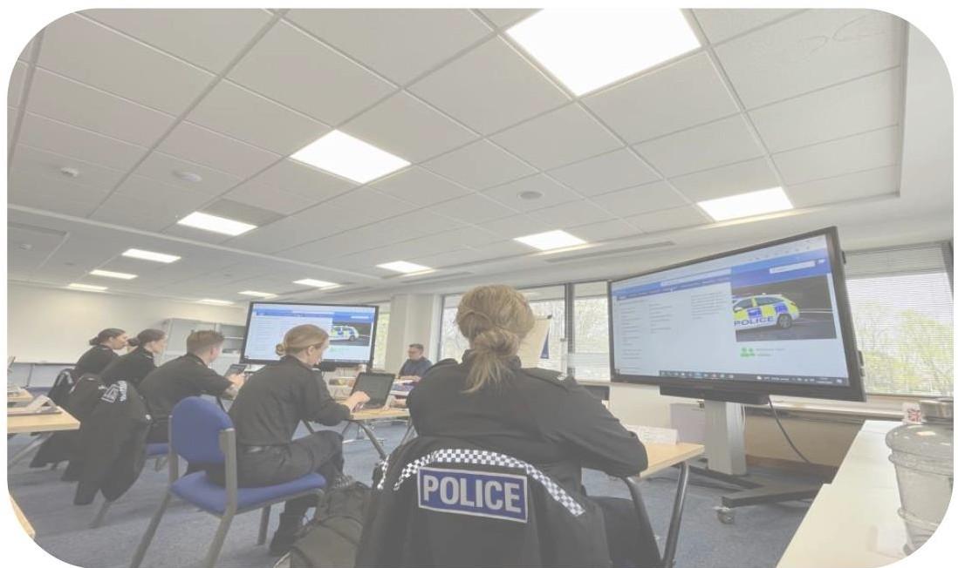

ASSET MANAGEMENT PLAN

This section outlines what we plan to do to deliver the asset vision and strategy, and will address the following:
    - Overarching estate plans and activity over the next 10 years:
      - Translating the asset vision
      - Strategic Estate Requirements Plan
      - Individual site strategy retention indicator
      - Disposal programme
      - Mitigating the impacts of planned population ad housing growth
      - Property Services (Estates department] team priority workstreams
    - Risks and issues
    - Specific strategic and procedural implementation activity envisaged over the next 3 years. This is reflected in the Asset Management Implementation Plan in Annex 5.

CURRENT EXTERNAL AND INTERNAL ISSUES AFFECTING ASSET PLANNING
There are a number of identified internal and external issues and initiatives that are known to or may have a significant property implication in the future. The Force undertakes an annual scanning assessment to ensure new issues and possible impacts and key risks are identified, and disseminated as part of the Force’s regular strategic assessment process. Some issues could impact upon estate requirements, resource commitments and forward planning, such as:

INTERNAL | EXTERNAL
- Funding/affordability – a need to prioritise  - Working Smart – embedding a key enabler  - Custody estate condition & suitability  - Increased training pressures  - Wellbeing, recruitment & retention  - Force Review/LPA structure | - Officer Uplift – absorbing growth  - Population & housing growth impacts  - Strategic Review of Policing  - Sustainability agenda incl de-carbonisation  - National policy changes  - National funding & the need for savings

These issues can be fluid and take some time to develop, and need to be monitored and forward plans adjusted where necessary.
The most significant “new” issue (2023) is the TVP Force Review. This concerns the potential restructuring of the current 11 Local Policing Areas. There is the potential opportunity to revisit certain sites that have proven too challenging to replace, to consolidate certain assets and to further challenge others. Conversely, any significant changes around the size and location of teams may impact on the viability of some sites.

TRANSLATING THE ASSET VISION

The asset vision in section 2.4 and the asset strategy by category in Annex 2 can be translated into a specific, but high level, picture of estate change by 2033. This sets the scene for planning activity at a site level:

    - Embed Working Smart as BAU, aligned to IT developments, to enable estate reduction, the holistic provision of wellbeing and other support facilities, any required new capacity and to help promote TVP as an employer of choice

    - Consolidate the two Headquarter sites to a single primary HQ site in Kidlington, expected to be HQ South, but potentially re-purposing HQ North if retained

    - Reduce the size and cost of the LPA Operational Area HQ estate, while retaining substantial local footprints, where practical and viable to do so, aligned to the prevailing LPA delivery structure. To include termination of the Abingdon PS PFI agreement in 2030 and purchasing its freehold interest, and consolidation of the Oxford estate if deliverable

    - Reduce the number of remaining large Sector Stations, with smaller local replacements where needed, affordable and deliverable, preferably through collaboration, and aligned to the prevailing operating model

    - Reduce the cost of the Neighbourhood Police Office estate through periodic challenge of the existing estate, disposing of underused and/or expensive offices, but developing alternative informal low cost solutions, aligned to technology, to maximise Officer & PCSO agile working

    - Align Operational Support functions with the required delivery model, whether in hubs or aligned to the prevailing LPA structure. Consolidate HQ forensics functions in a new hub in Bicester, enhance geographical CSI hubs, and monitor the requirement for a consolidated digital forensics hub and/or regional income generation opportunities

    - Consolidate the Custody estate from 8 to preferably 5 suites aligned to the Custody Estate 2030 strategy, building a new suite in Maidenhead, a new suite in Kidlington (potentially on HQ North) and Theale (if possible at a future date), and refurbish all other long term retained suites to ensure they remain fit for purpose. If Theale were progressed then it would replace Loddon Valley

    - Develop the business case for a new Northern Training Hub in Bicester, consolidate Sulhamstead Training Centre and Upper Heyford as critical training hubs, maintain capacity at the REC, reduce Contact Management Centres from three to two, and develop a fleet workshop strategy

    - Dispose of all remaining Staff Housing when the opportunity arises, and upgrade Sulhamstead training houses to a modern en-suite standard

    - To sufficiently fund estate expenditure in order to deliver both PCC approved strategic needs as well as ongoing maintenance, infrastructure and sustainability requirements to ensure estate operability and achieving mandatory targets and legal compliance

    - Maximise income from commercial telecoms installations, and develop other income generation, cost reduction and collaborative opportunities across the estate, where practical and worthwhile.

STRATEGIC ESTATE REQUIREMENTS PLAN (SERP)

Annex 3 contains the most significant projects and workstreams considered to be required over the next 10-15 years. Most are one-off projects but some represent a long term annualised work programme (e.g maintenance or sustainability) or a grouping of inter-related projects that together reflect a programme of delivery activity over a period of years.
They reflect a mixture of business requirements, strategic planning, estate rationalisation, building condition and sustainability. Each has clear drivers, implications if not undertaken and relevant inter-dependencies. In view of the very significant cost of all these projects/programmes, it is not guaranteed that all of them will ultimately be affordable, and there will be a prioritisation.

One of the more complex geographical areas is central Oxfordshire, with a developing strategy focussing on the HQ estate and the expensive Abingdon PFI site, but also impacting on Milton Keynes, Bicester and Oxford. There are numerous inter-dependencies. During 2023/24 it is expected that decisions will be made on which of multi-faceted estate scenarios/options should be developed and progressed, and the required funding and enabling projects arising from that process. The scenarios reflecting significant estate change would enable between 7 and 9 of the 27 SERP projects to be addressed.

INDIVIDUAL SITE STRATEGY – RETENTION INDICATOR
Annex 4 lists all overt operational sites by County and current Local Policing Areas. It gives a RAG rated indicator as to its condition and business continuity status. It also more importantly indicates the recommended retention/disposal status of each site/property and any activity focus needed. These ratings may alter if circumstances change over time, however, as well as confirming definite disposals (which will ultimately be reflected in the disposals programme at an appropriate time) it highlights a number of “potential” disposals that may translate into definite disposals, or be confirmed for retention, in due course. Many of those are subject to periodic or ongoing reviews, and decisions can often be affected by organisational changes, wider estate strategy development, or the viability and/or the deliverability of any required replacements.

DISPOSAL PROGRAMME
There has been a significant programme of site disposals and surrender of leases, with or without replacements, since 2010. Disposals represent a significant contribution to the Force’s Productivity Strategy, generating receipts to offset funding pressures, and securing revenue savings.

The disposal programme reflects opportunities arising from lease expiries or break clauses, and the potential to “downsize” the Police presence in an area by replacing often oversized and under-utilised buildings with a smaller more fit for purpose, lower cost replacement to accommodate typically only locally facing teams, and any appropriate public interface.

In terms of estate rationalisation prioritisation, the key approach will continue to be to:

    - Challenge lease retention. Low cost well used facilities can be presumed retained, but underused ones should be surrendered, and expensive ones replaced where practical with a lower cost option. Preference for increasing use of informal facilities, or low cost partner space, avoiding commercial leases where practical
    - Sell freeholds for valuable alternative use (with low cost replacement off site where practical) where no worthwhile income generation alternative
    - Backfill surplus space in core retained sites with TVP users and/or public sector partners.
    - Pursue co-location options in partner premises if value for money and deliverable
    - Purchase and refurbish private sector freeholds – eg industrial or office premises where practical as a replacement operational team base
    - Provide smaller new build replacements on part of high value freehold disposal sites, provided by the purchaser/developer, where no cheaper or suitable alternative is available.
    - Purchase new, or build new, off site only where there is no other option and where affordable – ie significantly smaller replacements with a lower revenue cost.

As at March 2023, 119 operational estate disposals have been achieved since 2010 with house sales in addition, contributing significantly to the forces MTFP, Capital Programme and Productivity Strategy.

It has become increasingly harder to identify a significant programme of disposal/replacement opportunities that is deliverable and affordable. Over the next 5 years (April 2023 to March 2028) the disposal programme will aim to achieve the following confirmed disposals:

PROPERTIES | PROJECT STATUS
- Princes Risborough  - Newport Pagnell  - Pangbourne  - Faringdon  - Reading  - Windsor  - Wolverton  - Carterton  - 7 house sales | - Replaced at nearby Fire Station. Site sold STP  - Replaced at nearby Fire Station. Site sold STP  - Replaced at Theale new Tri-Service Hub. Site to be sold  - To be replaced with a smaller local facility  - Replaced. Site sold STP  - To be replaced with on-site facility and surplus land sold  - Replaced. Site to be sold when short term need ends  - To be replaced with a smaller local facility  - Aligned to when they become surplus

These sales are expected to generate the following:

GROSS SALE RECEIPT  (ESTIMATED) | REVENUE SAVING  (ESTIMATED) | REDUCTION IN SPACE  (GROSS INTERNAL FLOOR AREA)
£29.3m | £390,000 pa | 15,553 sqm

The programme can be fluid, with circumstances changing, some disposals slipping or advancing and new ones being identified. Within the Site Retention Strategy (Annex 4) there are always a number of potential disposals identified, some of which can translate into new disposals in the future when circumstances become appropriate. It is therefore a snapshot, but there are regular reports internally to the SEG on the status of and progress with the programme.

MITIGATING THE IMPACTS OF PLANNED POPULATION AND HOUSING GROWTH

Planned housing growth to 2033 and beyond, continues to represent a significant current impact and future risk. A number of large scale housing developments are at various stages of delivery, and the majority of councils within the TVP area are planning for their future housing growth.

A housing requirement calculation from Central Government indicates that over the next 20 years 245,000 homes should be delivered in the Thames Valley operational area. This will result in an indicative increase in population of 5.4% or 130,000 by 2042. TVP are seeking to mitigate the impact of this growth through:

    - 18 new local Neighbourhood Policing facilities identified to councils
    - 3 have been delivered - 1 in Didcot and 2 in Milton Keynes
    - 10 of these recognised in local planning policy, 8 more secured in legally binding S106 Agreements. All assumed to be capital funded by developers
    - TVP has secured £3.6m in legally binding S106 contributions to date (March 2023) of which £1.5m has been received to spend on items of infrastructure, vehicles and equipment

The Force’s ability to police an expanded Thames Valley, relative to its resource, will continue to be monitored, and may become a formal risk. The scale of growth will generate pressure points where new or adapted existing accommodation will be required, alongside the need for more vehicles and equipment.

10 Councils across the Force area have so far formally adopted CIL, and while TVP has secured recognition for CIL funding and our requirements arising from growth, as yet (March 2023) no funding has been received via CIL.

MAINTENANCE WORKSTREAMS & PRIORITIES

The Maintenance team has a typical revenue budget of around £4-5m and delivers across planned preventative (servicing), planned and reactive workstreams. Current priority or high profile activity includes:
    - Condition surveys – a programme of outsourced surveys to inform forward maintenance requirements for at least the next 10 years, informing the annual planned maintenance programme
    - Fire compartmentation – an essential programme of activity to ensure the ongoing safety of our estate
    - Kitchens and toilets upgrade – rolling out a programme across all large sites. Those currently funded sites are High Wycombe, Amersham and Aylesbury. Others will follow
    - Working Smart enabling works – focussed around decoration and minor works to support the rollout of WS across HQ and large operational sites
    - CSI hub expansion and upgrades – 6 hubs are to be upgraded during 2023 and 2024
    - Oxfordshire CCTV hub – a collaborative project to consolidate 4 small suites into a single location

CAPITAL SCHEMES WORKSTREAMS & PRIORITIES
The Capital Schemes team has a typical revenue budget of around £3-5m and an agreed allocation of capital programme funding in the 5 year Force MTFP, focussing on a range of current and planned capital and revenue funded projects such as:
    - Acquisition and fitting out of Atlantic House to replace Reading PS
    - Acquisition, construction and fitting out of new regional operational hubs
    - Design and construction of a new Forensics hub in Bicester on TVP owned land
    - Relocation of the Force Mounted Section to a new facility in Buckinghamshire
    - Delivery of AMP generated local replacements where required
    - Development of key new build and refurbishment projects arising from the Custody 2030 Strategy
    - Enhancements to force training facilities
It is expected that a significant volume of project work will arise from decisions on SERP projects (and in particular the central Oxfordshire estate strategy), and from the updated Forward Maintenance Register following completion of a programme of condition surveys.

FACILITIES MANAGEMENT & SUSTAINABILITY WORKSTREAMS & PRIORITIES
The Facilities Manager is responsible for day to day FM and sustainability with a varied range of projects and initiatives such as:

- The Environment & Sustainability Strategy. This encompasses significant aspects of the organisation and implementation will focus on the following areas:

  - Short term opportunities around improvements to building controls, insulation, completing the transition to LED lighting, and changing staff behaviour.

  - Detailed review of representative sample of buildings to understand challenges and opportunities for carbon reduction. This will lead into the development of a medium/long term plan to improve building efficiency and replace carbon based heating systems.
  - Over the next 12 months conduct an EV charging pilot, leading to a major project to decarbonise the fleet.
  - A review of travel, business and commuting, across the force focusing on sustainable alternatives.
  - Continued focus on waste management with a drive on user behaviour to improve recycling rates.

- Other focus areas for FM work include:

  - Continued development of the CAFM system
  - Improving the efficiency and resilience of bulk postage through secure outsourcing
  - The replacement of our key management system by 2027.

  - RISKS & ISSUES (Affecting estate infrastructure, delivery of estate services & the estate’s capacity to support organisational priorities)
The Estates Department maintains a departmental Risk Register which is formally reviewed at regular intervals (6 monthly) but with substantive changes to individual risks made whenever necessary or when a new risk/issue is identified. The SEG is provided with periodic updates on the Risk Register with the focus on highlighting the most significant risks at any given point in time; those that pose the greatest/most immediate potential threat to the organisation are escalated to CCMT through the Governance & Service Improvement team.

In the Risk Register (@ March 2023), the reported/highlighted issues/risks from an estate performance, resilience and delivery perspective are as follows:

    - Building Cost Inflation (C)
    - Estate Condition & Deterioration (+ Financial Implications) (C)
    - Compliance & Replacement of our Data Centres (x2) (C)
    - Fire Compartmentation (N)
    - Estate Department Resourcing/Recruitment (C)
    - Impact of Vetting Delays (N)
    - Implementation/Delivery of TVP’s Working Smart Approach (C)
    - Overall Affordability of Strategic Estate Change Forward Plans (E)
    - Delivery of Custody Estate Programme 2030 (N)

Note: C = Current; N = New; E = Emerging

Although TVP is currently receiving some developer contributions, there remains a future risk around the scale and impact of long-term population and housing growth and whether TVP’s resources will be aligned with these demand change drivers. This risk will continue to be monitored.

ASSET MANAGEMENT IMPLEMENTATION PLAN

The key activity required and planned over the next 3 years is tabulated within Annex 5, together with an expected outcome, indicative timescale for implementation, staff resource implications and link to strategic objectives. These activities will help facilitate the achievement of the Asset Vision, strengthen the corporate role of the asset management function and help deliver our asset plans. They will be periodically monitored and progress reported to the SEG.

APPENDICES

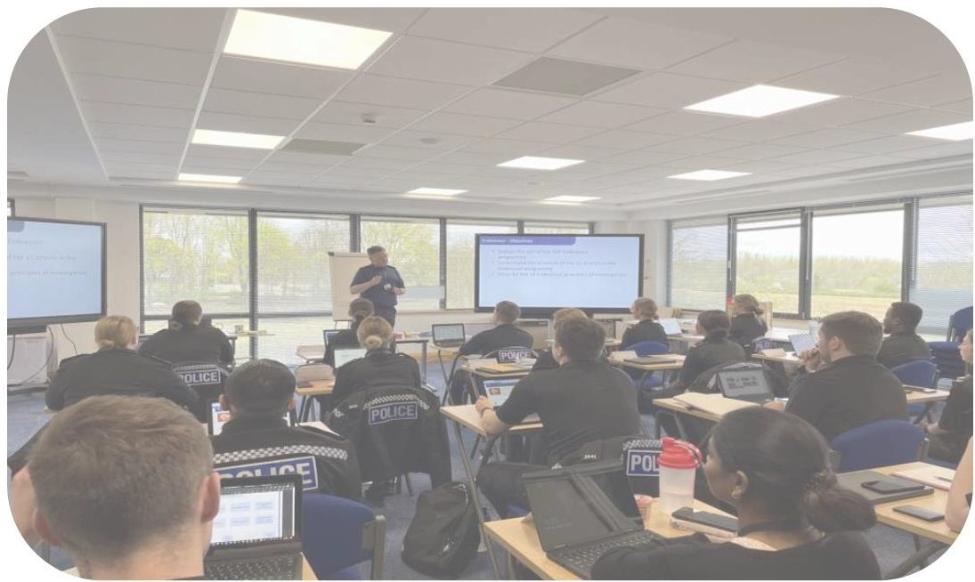



AMS Annex 1
Table 1: Overview of Operational Sites

Building Type |  | No. of Site | Asset Value | SQM GIA | No. of Site % | Asset Value% | SQM%
Site | Misc | 4 | £25,903,100 | 15,825 | 4% | 13% | 12%
FHQ | Force Headquarters | 5 | £37,640,000 | 29,823 | 5% | 19% | 22%
L1 | L1 - LPA/BCU HQs | 8 | £62,954,100 | 39,949 | 9% | 31% | 29%
L1C | LPA/BCU HQs with Custody spaces | 1 | £9,323,920 | 4,229 | 1% | 5% | 3%
L1CP | LPA/BCU HQs with Custody spaces – PFI building | 16 | £18,391,700 | 13,882 | 17% | 9% | 10%
L2 | Operational Stations | 43 | £2,830,600 | 2,420 | 46% | 1% | 2%
L3 | Neighbourhood Offices | 8 | £35,420,471 | 26,598 | 9% | 18% | 19%
L4 | Force Support Facilities | 4 | £8,474,880 | 3,925 | 4% | 4% | 3%
L6 | Other specialised sites | 5 | £0 | 0 | 5% | 0% | 0%
 |  | 94 | £200,938,771 | 136,651 | 100% | 100% | 100%
 | Tenure | No. of Site | Asset Value | SQM GIA | No. of Site % | Asset Value% | SQM%
 | Freehold | 43 | £186,369,551 | 121,544 | 46% | 93% | 89%
 | Leasehold | 51 | £14,569,220 | 15,107 | 54% | 7% | 11%
 |  | 94 | £200,938,771 | 136,651 | 100% | 100% | 100%
 | Age | No. of Site | Asset Value | SQM GIA | No. of Site % | Asset Value% | SQM%
Freehold | Pre 1920 | 3 | £28,339,371 | 15,505 | 3% | 14% | 11%
Freehold | 1921 - 1950 | 2 | £11,289,300 | 6,844 | 2% | 6% | 5%
Freehold | 1951 - 1980 | 20 | £76,469,880 | 56,142 | 21% | 38% | 41%
Freehold | 1981+ | 18 | £70,271,000 | 43,053 | 19% | 35% | 32%
Freehold | Unknown | 0 | £0 | 0 | 0% | 0% | 0%
Freehold | n/a | 0 | £0 | 0 | 0% | 0% | 0%
Leasehold | Pre 1920 | 2 | £0 | 19 | 2% | 0% | 0%
Leasehold | 1921 - 1950 | 1 | £0 | 73 | 1% | 0% | 0%
Leasehold | 1951 - 1980 | 18 | £4,916,300 | 8,947 | 19% | 2% | 7%
Leasehold | 1981+ | 23 | £9,652,920 | 6,008 | 24% | 5% | 4%
Leasehold | Unknown | 0 | £0 | 0 | 0% | 0% | 0%
Leasehold | n/a | 7 | £0 | 60 | 7% | 0% | 0%
 |  | 94 | £200,938,771 | 136,651 | 100% | 100% | 100%
 | Asset Value (@1/3/23) | No. of Site | Asset Value | SQM GIA | No. of Site % | Asset Value% | SQM%
 | Less than £500,000 | 12 | £2,805,180 | 2,004 | 13% | 1% | 1%
 | £500,001 - £1m | 7 | £4,705,600 | 3,939 | 7% | 2% | 3%
 | £1.001m - £3m | 6 | £12,266,100 | 9,259 | 6% | 6% | 7%
 | £3m + | 20 | £180,791,591 | 113,546 | 21% | 90% | 83%
 | n/a - (Leasehold/Other) | 49 | £370,300 | 7,903 | 52% | 0% | 6%
 |  | 94 | £200,938,771 | 136,651 | 100% | 100% | 100%

Note: excludes covert properties and masts

AMS Annex 2
Strategic Approach to Asset Categories

Asset Category | Outline Asset Strategy Approach
Headquarters | - Implement Working Smart (WS) principles developed during and after the Covid 2020/21 pandemic  - Consolidate HQ functions into HQ South and potentially part of HQ North if retained and if validated by WS modelling, and identify and progress any required enabling activity on or off site  - Progress demolition of G Block HQ South when it becomes surplus to requirement  - Progress demolition of C Block when temporary uses are re- located. Periodically review the need for any replacement linked to the HQ consolidation project  - Monitor the strategy for ICT data centres and implications for current data centre suites, opportunities for alternative use of released space and legal compliance  - Assess the longer term suitability of HQ North (where not required for the HQ function) for potential delivery of the Oxfordshire custody strategy, with expected demolition and redevelopment of part of the site, and any worthwhile alternative use of the remainder.  - Seek to acquire the residual Management Company land at the HQ North site and dissolve the Management Company.
Area Command HQs | - Retention of identified existing core sites particularly where there are custody suites identified for retention  - Implement Working Smart (WS) principles in the Reading Atlantic House site, and develop plans for implementing WS across all major LPA sites  - Apply Working Smart principles more widely to release space for new facilities, and/or to subsume teams relocating from disposal sites or from new operational requirements  - Maximise use of any surplus space within Atlantic House Reading, and ensure the Reading Town Centre facility is provided as part of the Reading PS site sale  - Assess viability of replacements at other locations such as Bracknell and Oxford  - Monitor opportunities for enhanced space utilisation, team adjacencies, co-location opportunities with partners, and accommodating requirements from new operating models and long term growth needs where required  - Identify opportunities to reduce the estate and it’s cost, whether by whole site replacement if viable, or partial demolition where practical  - Support the Evidential Management Unit seeking to consolidate storage into a reduced footprint on retained sites
Sector Police Stations | - Align estate provision with required operational geographical footprint model  - Replace Windsor on-site and progress other AMP approved replacements where needed, viable and deliverable, preferably through collaborative solutions  - Replacement facilities are envisaged to accommodate local facing teams and functions only, and may be touchdown offices only

Asset Category | Outline Asset Strategy Approach
- Monitor additional opportunities for estate reduction with or without replacements e.g. Henley, Cowley, Didcot
- Monitor cross boundary arrangements, particularly where local authorities merge, to optimise use of property and encourage enhanced collaboration within TVP area and adjacent forces if practical
- Monitor potential to rationalise space allocated for evidence storage on operational sites and convert to alternative uses
Neighbourhood Facilities | - Presumed retention of existing low cost and well utilised facilities, but review utilisation and challenge retention of all offices periodically and upon lease renewal/break opportunities  - Monitor the implications of the prevailing LPA structural operating model and the introduction of mobile ICT technology for Neighbourhood Policing staff and in fleet vehicles, and the consequential implications on the future need for offices  - Challenge all remaining commercially leased offices and review the opportunity for negotiating a cost reduction, or surrender leases with a low cost local replacement if required, or consolidation into main stations where appropriate  - Monitor any gaps in current provision, with Local Policing department, and consider all property and non-property (eg Working Smart) solutions  - Work with partners to identify options for current and future provision where required, with co-location or informal drop-in options demonstrating service delivery benefits preferred, where practical. Each case to be considered on its merits  - Pursue recognition of identified future requirements, arising from population and housing growth, with local planning authorities and seek developer (s106 & CIL) funding for local and off site growth/capacity provision. Periodically review ongoing requirements for any change in the mix of identified  facilities and equipment
Operational Shared Service Units  (where not covered by other asset categories) | - Monitor ongoing requirement for Joint Operations Unit bases  - Review the need for Shared Service teams to be located in all existing buildings with priority for operational accommodation given to teams requiring a local presence  - Implement Working Smart across all Force level operational units as opportunities arise  - Support the consolidation of OSSU functions into fewer hubs on area where supported by a delivery model, business case and estate capacity  - Local facing teams within identified disposal sites will be presumed to be relocated to alternative retained sites to minimise the size of any replacement building
Support Departments  (where not covered by other asset categories) | - Monitor the implications of Force transformation and Productivity Strategy programmes on accommodation requirements  - Maximise use of available space and land at the REC. Monitor capacity and ongoing requirement  - Implement Working Smart across all support departments as opportunities arise  - Consolidate Sulhamstead as TVP core Force training establishment, addressing outstanding long term maintenance/upgrade requirements, embed utilisation of the

Asset Category | Outline Asset Strategy Approach
White House for office use, focus training facilities within the Training Block, review opportunities for collaborative use by partners and other forces
- Review long term L&D requirements both at Sulhamstead and on area, in particular the North of the force, and the business case for a potential Northern Training Hub. To seek to provide a range of facilities within the TVP estate where they are needed and where practical, reducing reliance on use of external venues and the need to lease commercial premises while maximising the utilisation of what we have
- Maintain Upper Heyford as a key operational training facility (public order, CBRN, fitness and safety, driver, Taser)
- Monitor the ongoing requirement for fleet support facilities and collaboration opportunities
Staff Housing | - Continue to deal with all aspects of past equity loan advances for and on behalf of the PCC  - Dispose of all remaining standalone vacant family houses as they become surplus to requirements, and subject to prevailing market conditions or as development/sale opportunities are identified  - Dispose of all remaining standalone single quarters accommodation not located on Police Station sites, and also those that are integral to Police Stations identified for sale  - Re-purpose, or demolish where practical, any remaining former Single Quarter bedrooms within Police Station sites identified for retention  - Training requirements: Retain en-suite accommodation provision at Banbury for Driving School use, and improve Trainers accommodation at Sulhamstead. Review requirements for trainer accommodation in the North of the  force aligned to any Northern Training Hub
Telecom Masts | - Retain with periodic review where required for operational use and income generation  - Review facilities on buildings or sites identified for disposal, and if/how they can be re-provided to maintain TVP resilience and third party income  - Monitor implications of changes to the “Telecom Code” particularly in relation to disposal sites
Custody | - Consolidate the number of custody suites where practical, aligned to the Custody 2030 strategy  - Embed the status of retained primary custody suites by ensuring the enhancement of support facilities and co-location of relevant support teams from other sites or partners where practical  - Develop plans for replacement custody facilities at Maidenhead PS, and potentially in Oxfordshire  - Identify future growth needs, particularly in Milton Keynes, and assess potential impact on custody capacity, seek developer contributions, and where necessary reflect in future capital programming if pump priming can/needs to be agreed  - Robustly assess through condition surveys and plan future maintenance/refurbishment priorities for the retained custody suites to ensure they are appropriate and funded, and that  suites remain fit for purpose

Asset Category | Outline Asset Strategy Approach
Front counters | - Monitor the Force strategy for public interface/contact and review the need for and format of a continued front counter presence on sites identified for disposal  - PCEO staffed front counter locations at approved core sites to be maintained, or appropriately re-provided in respect of disposal/replacement sites, unless there is a material change in circumstance  - Future scope of service delivery from existing PCEO staffed front counter (typically a primary LPA HQ Police Station) locations will be subject to a business case review on a site specific basis, aligned to site disposals or a material change in circumstances  - Re-provision of a public interface could be through co-location with partners where practical, although this may impact on some services delivered, or else be delivered on the  disposal/replacement site as appropriate.

AMP Annex 3
Strategic Estate Requirements Plan (SERP)

Priority Ranking | Project | Category | Size/cost | Project or Workstream | Delivery When | Link To Asset Vision
1 | Forensics Investigation Unit consolidation | Condition |  |  | 4 to 6 yrs | Service Delivery
2 | Custody improvement central Oxfordshire | Business Requirement |  |  | 7 to 10 yrs | Service Delivery
3 | Custody improvement Berkshire | Business Requirement |  |  | 7 to 10 yrs | Service Delivery
4 | HQ estate consolidation | Estate Rationalisation |  |  | 4 to 6 yrs | Use of Resources
5 | Training strategic accommodation needs | Business Requirement |  |  | 7 to 10 yrs | Service Delivery
6 | Windsor Base replacement& enabling works | Estate Rationalisation |  |  | 1 to 3 yrs | Use of Resources
7 | Sulhamstead short term training needs | Business Requirement |  |  | 1 to 3 yrs | Service Delivery
8 | Contact Management capacity building at MKPS | Estate Rationalisation |  |  | 1 to 3 yrs | Service Delivery
9 | ICT HQ server reprovision | Business Requirement |  |  | 1 to 3 yrs | Service Delivery
10 | Abingdon PS PFI expiry | Estate Rationalisation |  |  | 7 to 9 yrs | Use of Resources
11 | Electric unmarked fleet charging infrastructure | Sustainability | Annual |  | 1 to 5 yrs | Sustainability
12 | De-carbonisation of heating systems | Sustainability | Annual |  | 1 to 10 yrs | Sustainability
13 | Milton Keynes Working Smart Innovation | Estate Rationalisation |  |  | 1 to 3 yrs | Use of Resources
14 | HQ South C & G Block demolition | Condition |  |  | 1 to 3 yrs | Use of Resources
15 | Estate condition FMR requirements | Maintenance Backlog | Annual |  | 1 to 10 yrs | Service Delivery
16 | Mounted Section relocation | Business Requirement |  |  | 1 to 3 yrs | Service Delivery
17 | Oxford LPA estate strategy | Estate Rationalisation |  |  | 4 to 8 yrs | Use of Resources
18 | Maidenhead PS masterplan development | Strategy |  |  | 4 to 6 yrs | Use of Resources
19 | Bicester workshop & bases replacements | Condition |  |  | 5 to 10 yrs | Service Delivery
20 | Milton Keynes drainage infrastructure improvement | Condition |  |  | 1 to 3 yrs | Service Delivery
21 | Oxfordshire support unit roof works | Condition |  |  | 4 to 6 yrs | Use of Resources
22 | Reading Atlantic House surplus space use strategy | Estate Rationalisation |  |  | 1 to 3 yrs | Use of Resources
23 | Custody improvement Buckinghamshire | Business Requirement |  |  | 4 to 6 yrs | Service Delivery
24 | Bracknell PS replacement aligned to regeneration | Estate Rationalisation |  |  | 7 to 10 yrs | Use of Resources
25 | Solar panel & battery system installations | Sustainability | Annual |  | 1 to 10 yrs | Sustainability
26 | Gowell Farm Bicester masterplan | Strategy |  |  | 7 to 10 yrs | Use of Resources
27 | Sulhamstead infrastructure | Condition |  |  | 4 to 6 yrs | Service Delivery

Size/cost key | Project Type
small <£3m | One off
med £3-5m | Workstream
large £6-10m
v large >£10m

AMP Annex 4
Individual Site Strategy - Retention Indicator
(Note: Counter Service. A formal staffed facility offering statutory counter services)

Local Policing Area | Property | Tenure | Counter Service | Condition | Business Continuity | 2023 Future Retention Strategy | Activity Focus | Timescale
Bracknell & Wokingham | Loddon Valley Police Station | Owned | Yes |  |  | Retain | Monitor custody strategy & LPA Bracknell requirement | Ongoing
Bracknell & Wokingham | Bracknell Police Station | Owned |  |  |  | Potential dispose & replace | Monitor regeneration & replacement options | Ongoing
Bracknell & Wokingham | Wokingham Police Office | Leased |  |  |  | Dispose & replace | Identify a local replacement aligned to Force Review | 2023/24+
Bracknell & Wokingham | Easthampstead Police Office | Leased |  |  |  | Potential disposal | Monitor ongoing requirement | Ongoing
Bracknell & Wokingham | Sandhurst Police Office | Leased |  |  |  | Dispose | Monitor ongoing requirement aligned to Force Review | Ongoing
Bracknell & Wokingham | Bracknell Jennetts Park Police Office | Leased |  |  |  | Retain | Monitor ongoing requirement | Ongoing
Bracknell & Wokingham | Finchampstead Police Office | Leased |  |  |  | Dispose | Monitor ongoing requirement aligned to Force Review | Ongoing
Bracknell & Wokingham | Woodley Police Office | Leased |  |  |  | Potential dispose & replace | Monitor ongoing requirement | Ongoing
Slough | Slough Police Station | Owned | Yes |  |  | Retain | Maximise occupancy | Ongoing
Slough | Buckingham Ave Police Office | Leased |  |  |  | Retain | New replacement facility. No identified activity
Slough | Britwell Police Office | Leased |  |  |  | Retain | Monitor ongoing requirement | Ongoing
Slough | Slough Car Park | Licensed |  |  |  | Retain | No identified action | Ongoing
Windsor & Maidenhead | Maidenhead Police Station | Owned | Yes |  |  | Retain | Maximise utilisation | Ongoing
Windsor &  Maidenhead | Ascot Police Office | Leased |  |  |  | Retain | Maximise utilisation | 2023/24
Windsor & Maidenhead | Windsor Police Base | Owned |  |  |  | Dispose & replace | Progress on-site replacement & dispose of site | 2023/24+
Windsor & Maidenhead | Datchet Police Office | Leased |  |  |  | Potential disposal | Monitor requirement linked to Windsor replacement | Ongoing

Local Policing Area | Property | Tenure | Counter Service | Condition | Business Continuity | 2023 Future Retention Strategy | Activity Focus | Timescale
Windsor & Maidenhead | Old Windsor Police Office | Leased |  |  |  | Potential disposal | Monitor requirement linked to Windsor replacement | Ongoing
Windsor & Maidenhead | Cox Green Library Police Office | Leased |  |  |  | Dispose | Monitor ongoing requirement aligned to Force Review | Ongoing
Windsor & Maidenhead | Cookham Police Office | Leased |  |  |  | Potential disposal | Monitor ongoing requirement | Ongoing
Reading | Reading Police Station | Owned | Yes |  |  | Dispose | Ensure Town Centre facility provided & progress site sale | Ongoing
Reading | Atlantic House Police Station | Owned | Yes (2024) |  |  | Retain | New facility. Complete fitting out works & occupy | 2024
Reading | Three Mile Cross Traffic Base | Owned |  |  |  | Retain | Maximise site utilisation and monitor ongoing requirement | Ongoing
West Berkshire | Newbury Police Station | Owned | Yes |  |  | Retain | Monitor redevelopment of adjacent former Court site | Ongoing
West Berkshire | Hungerford Fire Station Police Office | Leased |  |  |  | Retain | Monitor ongoing requirement | Ongoing
West Berkshire | Pangbourne Police Base | Owned |  |  |  | Dispose | Progress site sale | 2023/24
West Berkshire | Thatcham Police Office | Leased |  |  |  | Retain | Monitor ongoing requirement | Ongoing
West Berkshire | Theale FS Tri-Service Base | Leased |  |  |  | Retain | New facility. No identified action
West Berkshire | Theale Office | Owned |  |  |  | Potential disposal | Review ongoing requirement | 2025+
West Berkshire | Sulhamstead Training Centre | Owned |  |  |  | Retain | Optimise utilisation, capacity & review future requirements | Ongoing
West Berkshire | Sulhamstead VRI Suite | Owned |  |  |  | Retain | Assess requirement and off site options | 2023/24
West Berkshire | Reading F&RS HQ Office | Leased |  |  |  | Potential disposal | Review ongoing requirement at lease break | 2023/24
Aylesbury Vale | Aylesbury Police Station | Owned | Yes |  |  | Retain | Maximise utilisation & team adjacencies | Ongoing
Aylesbury Vale | Waddesdon Police Office | Owned |  |  |  | Retain | Periodically monitor ongoing local requirement | Ongoing
Aylesbury Vale | Buckingham Police Base | Leased |  |  |  | Potential dispose & replace | Monitor opportunities to replace & reduce cost | Ongoing

Local Policing Area | Property | Tenure | Counter Service | Condition | Business Continuity | 2023 Future Retention Strategy | Activity Focus | Timescale
Aylesbury Vale | Wing Police Office | Leased |  |  |  | Potential dispose & replace | Monitor ongoing requirement | Ongoing
Aylesbury Vale | Mounted Section Base Lillingstone Lovell | Leased |  |  |  | Retain | New facility. No required action
Chiltern & South Bucks | Taplow Police Base | Owned |  |  |  | Retain | Maximise utilisation | Ongoing
Chiltern & South Bucks | Amersham Police Station | Leased |  |  |  | Retain | Monitor utilisation & ongoing requirement | Ongoing
Chiltern & South Bucks | Iver Police Office | Leased |  |  |  | Retain | Monitor ongoing requirement | Ongoing
Chiltern & South Bucks | Chesham Library Police Base | Leased |  |  |  | Retain | New facility. No required action
Chiltern &  South Bucks | Burnham Library  Police Office | Leased |  |  |  | Dispose | Monitor ongoing requirement aligned to Force Review | Ongoing
Chiltern & South Bucks | Great Missenden Library Police Office | Leased |  |  |  | Potential disposal | Monitor ongoing requirement | Ongoing
High  Wycombe | High Wycombe  Police Station | Owned | Yes |  |  | Retain | Optimise utilisation | 2023/24
High Wycombe | Princes Risborough Police Base | Owned |  |  |  | Dispose | Progress site sale | Ongoing
High  Wycombe | Princes Risborough FS  Police Base | Leased |  |  |  | Retain | New facility. No required action
High Wycombe | Marlow Police Base | Owned |  |  |  | Retain | New facility. No required action
Milton  Keynes | Milton Keynes  Police Station | Owned | Yes |  |  | Retain | Optimise utilisation & review cost saving opportunities | Ongoing
Milton Keynes | West Ashlands Tri- Service Police Base | Leased |  |  |  | Retain | New facility. No required action
Milton  Keynes | Newport Pagnell  Police Base | Owned |  |  |  | Dispose | Progress disposal | Ongoing
Milton Keynes | Newport Pagnell FS Police Base | Leased |  |  |  | Retain | New facility. No required action
Milton  Keynes | Wolverton Police Base | Owned |  |  |  | Dispose | Progress disposal once LPA requirement has ceased | 2024/25
Milton Keynes | Whitehouse Health Centre Police Office | Leased |  |  |  | Retain | New facility. No required activity

Local Policing Area | Property | Tenure | Counter Service | Condition | Business Continuity | 2023 Future Retention Strategy | Activity Focus | Timescale
Milton Keynes | Broughton Fire Station Police Office | Leased |  |  |  | Potential dispose & replace | Monitor ongoing utilisation & drainage issues | Ongoing
Milton Keynes | Fishermead Police Office | Leased |  |  |  | Retain | Renew lease. Monitor ongoing utilisation & cost | Ongoing
Cherwell & West Oxon | Kidlington HQ South | Owned |  |  |  | Retain | Review as part of wider HQ accommodation strategy & maximise utilisation | Ongoing
Cherwell & West Oxon | Kidlington HQ North - Fountain Court | Owned |  |  |  | Potential disposal | Review as part of wider HQ accommodation strategy | Ongoing
Cherwell & West Oxon | Kidlington HQ North - Meadow House | Owned |  |  |  | Potential disposal | Review as part of wider HQ accommodation strategy | Ongoing
Cherwell & West Oxon | Kidlington HQ North - Kingfisher Court | Owned |  |  |  | Potential disposal | Review as part of wider HQ accommodation strategy | Ongoing
Cherwell & West Oxon | Witney Police Station | Owned |  |  |  | Retain | Maximise utilisation | 2022+
Cherwell & West Oxon | Banbury Police Station | Owned | Yes |  |  | Retain | Monitor ongoing requirement | Ongoing
Cherwell & West Oxon | Woodstock FS Police Office | Leased |  |  |  | Retain | New facility. No identified action
Cherwell & West Oxon | Bicester Police Station | Owned |  |  |  | Potential dispose & replace | Monitor redevelopment & replacement opportunities | 2024+
Cherwell & West Oxon | Carterton Police Base | Owned |  |  |  | Dispose & replace | Progress smaller replacement locally | Ongoing
Cherwell & West Oxon | Chipping Norton FS Police Base | Leased |  |  |  | Retain | New facility. No identified action
Cherwell & West Oxon | Deddington Library Police Office | Leased |  |  |  | Dispose | Monitor requirement aligned to Force Review | Ongoing
Cherwell & West Oxon | Eynsham Police Office | Leased |  |  |  | Potential dispose & replace | Monitor ongoing requirement | Ongoing
Cherwell & West Oxon | Upper Heyford B3029 Training Facility | Leased |  |  |  | Potential disposal | Replace with short term lease with link to B3032 | 2023/24
Cherwell & West Oxon | Upper Heyford B3032 Storage Facility | Leased |  |  |  | Retain | Retention if long lease secured. Linked to B3029 | 2023/24
Cherwell & West Oxon | Upper Heyford B249 Training Facility | Leased |  |  |  | Retain | No identified activity

Local Policing Area | Property | Tenure | Counter Service | Condition | Business Continuity | 2023 Future Retention Strategy | Activity Focus | Timescale
Cherwell & West Oxon | Bicester REC | Owned |  |  |  | Retain | Monitor utilisation & capacity | Ongoing
Cherwell & West Oxon | Bicester Traffic Base & Workshop | Owned |  |  |  | Potential dispose & replace | Monitor condition, capacity & replacement options | Ongoing
Cherwell & West Oxon | Kidlington HQ North - Car Park | Leased |  |  |  | Potential Disposal | Monitor requirement linked to HQ strategy | Ongoing
Cherwell & West Oxon | Witney Police Station Car Park | Leased |  |  |  | Retain | No identified activity | Ongoing
Cherwell & West Oxon | Bicester Gowell Farm Site | Owned |  |  |  | Potential disposal (of part) | Promote masterplan & develop TVP requirements | Ongoing
Oxford | St Aldates Police Station | Owned | Yes |  |  | Potential dispose & replace | Assess viability of retention & replacement options | 2023+
Oxford | Cowley Police Base | Owned |  |  |  | Potential dispose & replace | Linked to St Aldates strategic assessment. | 2023+
Oxford | Warneford Hospital  Police Office | Leased |  |  |  | Retain | Assess requirement aligned to LPA estate review | Ongoing
Oxford | Blackbird Leys Police Office | Leased |  |  |  | Retain | Assess requirement aligned to LPA estate review | 2020+
Oxford | Barton Police Office | Leased |  |  |  | Retain | Assess requirement aligned to LPA estate review | Ongoing
Oxford | Marston Northway Police Office | Leased |  |  |  | Potential disposal | Assess requirement aligned to LPA estate review | Ongoing
Oxford | East Oxford Police Office | Leased |  |  |  | Retain | Assess requirement aligned to LPA estate review | Ongoing
Oxford | Littlemore Hospital Police Office | Leased |  |  |  | Dispose | Surrender tenancy | 2023/24
Oxford | Rosehill Police Office | Leased |  |  |  | Retain | Assess requirement aligned to LPA estate review | Ongoing
Oxford | Cowley Car Park | Leased |  |  |  | Potential disposal | Aligned to Cowley PS & LPA estate strategy | Ongoing
South & Vale | Abingdon Police Station | PFI | Yes |  |  | Potential dispose & replace | Review ongoing need aligned to PFI expiry | 2023/24+
South & Vale | Wantage Grove Police Base | Owned |  |  |  | Retain | Monitor future growth impacts | Ongoing
South & Vale | Thame Police Base | Owned |  |  |  | Retain | Maximise utilisation & monitor ongoing need | Ongoing

Local Policing Area | Property | Tenure | Counter Service | Condition | Business Continuity | 2023 Future Retention Strategy | Activity Focus | Timescale
South & Vale | Didcot Police Base | Owned |  |  |  | Potential dispose & replace | Monitor future growth & align to future strategy for Abingdon PS PFI | Ongoing
South & Vale | Great Western Park Police Office | Leased |  |  |  | Retain | New facility in growth area. No required activity
South & Vale | Faringdon Police Base | Owned |  |  |  | Dispose and replace | Progress local replacement | Ongoing
South & Vale | Henley Police Base | Leased |  |  |  | Potential dispose & replace | Assess opportunities aligned to future lease break | Ongoing
South & Vale | Abingdon VRI Suite | Owned |  |  |  | Retain | Monitor ongoing utilisation | Ongoing
South & Vale | Didcot FS Office | Leased |  |  |  | Dispose | Surrender lease | 2023/24
South & Vale | Botley Police Office | Leased |  |  |  | Retain | Monitor ongoing requirement | Ongoing
South & Vale | Henley Car Park | Leased |  |  |  | Potential dispose & replace | Aligned to TVP facility. No identified activity | Ongoing
 |  |  |  | Condition | Business Continuity
 |  |  |  | Good | Limited Impact
 |  |  |  | Fair | Significant Impact
 |  |  |  | Poor | Immediate Impact

AMP Annex 5
Asset Management Implementation Plan

Ref  No. | Action | Responsible | Owner | Target  Timing | Output/Outcome | Action Resourcing  Implications | Key Link To  Asset Vision
1 | Roles & Responsibilities  & Resourcing
1.1 | Embed appropriate references to asset management objectives & priorities in Force strategy documents | HOE | CCMT | Ongoing | To maintain the profile of property asset planning & integration with corporate planning | Needs to align with annual review of strategic priorities & delivery plans | Supporting Service Delivery
1.2 | Review Estates department resourcing requirements | HOE | HOE | 03+/24 | To ensure staff delivery resources align with future demands from both BAU, SERP & any new approved workstreams | No significant impact. Address as rolling SMT activity aligned to strategic estate decision making | Supporting Service Delivery & Better Use of Resources
2 | Decision Making & Consultation
2.1 | Monitor the Strategic Estates Group & ToR for ongoing fitness for purpose | HOE/DCC | CCMT & PCC | 07/23 & 3  yearly | To ensure an appropriate estates decision making & governance structure | No significant impact | Supporting Service Delivery
3 | Identifying Property  Needs & Strategic Issues
3.1 | Refresh Asset Management Framework on a 5 year cycle with an interim annual update of relevant “live” content items | SAM | HOE | 03/28 with key annex updates annually | AMF aligned to prevailing corporate priorities, operational requirements & asset circumstances | Significant for SAM | Supporting Service Delivery & Better Use of Resources
3.2 | Review the Estate Maintenance Strategy for ongoing fitness for purpose | MM | HOE | 03/26 | To ensure a robust framework for informing decisions on & priority of maintenance expenditure aligned to AMF & Business Continuity | Moderate impact for MM | Supporting Service Delivery & Better Use of Resources
3.3 | Review the Environmental  & Sustainability Strategy for ongoing fitness for purpose | HOF | HOE | 03/26 | To ensure delivery  requirements & outcomes are aligned to Force activity | Moderate impact for HOF and ESM | Sustainability  & Better Use of Resources

Ref  No. | Action | Responsible | Owner | Target  Timing | Output/Outcome | Action Resourcing  Implications | Key Link To  Asset Vision
3.4 | Review & adjust SERP to reflect project status & any new requirements | SAM | HOE | 03/24 & annually | To ensure the SERP is up to date & projects are appropriately prioritised & funded | Moderate impact for SAM | Supporting Service Delivery & Better Use of  Resources
4 | Major Projects Programme Development & Management
4.1 | Develop a rolling programme of projects incl:  - Capital investment projects  - Major building infrastructure projects  - Enabling projects (eg AMP replacement sites)  - Space utilisation & WS projects | CSM, MM & SAM | HOE | 11/23 & reviewed annually | A holistic 5 year rolling programme covering 3 primary project work streams | Moderate resource time in developing sufficient robustness in cost estimates for future projects, aligned to budget development activity | Supporting Service Delivery & Better Use of Resources
4.2 | Develop a programme of sustainability projects incl;  - Energy efficient alternatives e.g. lighting  - Building fabric & insulation  - Monitoring & measuring equipment  - Decarbonisation of heating & fleet (e.g. EV charging)  - Renewables & energy generation  - Plug load & building use  - Reduce water consumption  - Increasing biodiversity value  -Waste reduction & increasing % recycling | HOF & ESM | HOE | 03/24 | A programme of works meeting the objectives of the Environmental & Sustainability Strategy by 2032. | Use of contractors to support project identification, feasibility & suitability  Funding opportunities may be available e.g. Salix. | Sustainability & Better Use of Resources

Ref  No. | Action | Responsible | Owner | Target  Timing | Output/Outcome | Action Resourcing  Implications | Key Link To  Asset Vision
5 | Managing Properties In  Use
5.1 | Develop Working Smart plans at a site level & implement aligned to Force requirements & change  programme | SAM & CSM | HOE | Ongoing | Implement Working Smart principles and space plans across the estate, prioritising larger sites & HQ | Significant for SAM (planning) and Capital Schemes and Maintenance teams  (implementation). | More Effective Use of Property & Better Use of  Resources
5.2 | Embed & enhance our CAFM system and outputs | HOF | HOE | Ongoing | To ensure up to date estate data, relevant outcome reporting and analysis to support estates department  activity & performance | Moderate for HOF | Better Use of Resources
5.3 | Replace existing Traka key cabinets & software | HOF | HOE | 03/26 | To ensure management of  access to vehicles & Tasers is maintained | Moderate for HOF | Supporting  Service Delivery
6 | Performance  Management
6.1 | Monitor our sustainability performance & required  activity | HOF & ESM | HOE | Ongoing | To ensure outcomes and trajectory to mandated targets  are on track | Moderate impact for HOF & ESM | Better Use of Resources
6.2 | Monitor our performance against National Police Benchmarking System | SAM & HOF | HOE | 09/24 & annually | To benchmark our performance with other forces as well as to our own targets and standards, & identify any best practice | Not significant for SAM but significant for annual submission data collation. No participation during 22/23 and 23/24 due to  resourcing constraints | Better Use of Resources
7 | Partnership Working & Collaboration
7.1 | Engage with Blue Light partners to identify collaboration opportunities | SAM | HOE | Ongoing | Ensuring any VFM opportunities are identified & a standardised approach | Moderate impact for SAM | Better Use of Resources
7.2 | Engagement with National Police Estates Group to develop best practice  across the Police estate | SAM | HOE | Ongoing | To ensure monitoring of other force and best practice activity & training/skills opportunities | Moderate impact for SAM | Better Use of Resources

Glossary

AMF Asset Management Framework CCMT Chief Constables Management Team CSM Capital Schemes Manager Estates DCC Deputy Chief Constable
ESM Energy & Sustainability Manager Estates HOF Head of Facilities
HOE Head of Estates
MM Maintenance Manager Estates PCC Police & Crime Commissioner SEG Strategic Estates Group
SGP Strategic Growth Planner Estates SAM Strategy & Assets Manager Estates VFM Value For Money

