Thames Valley Police and Crime Commissioner Response to HMICFRS report on:
PEEL 2023–2025: An inspection of Thames Valley Police
Full report: Thames Valley PEEL Assessment 2023–2025 - His Majesty’s Inspectorate of Constabulary and Fire & Rescue Services (justiceinspectorates.gov.uk)

Report publication date: 06.12.23
____________________________________________________________________
Key findings
- The HMICFRS inspection assessed how good Thames Valley Police is in nine areas of policing. It made graded judgments in eight of these nine as follows:
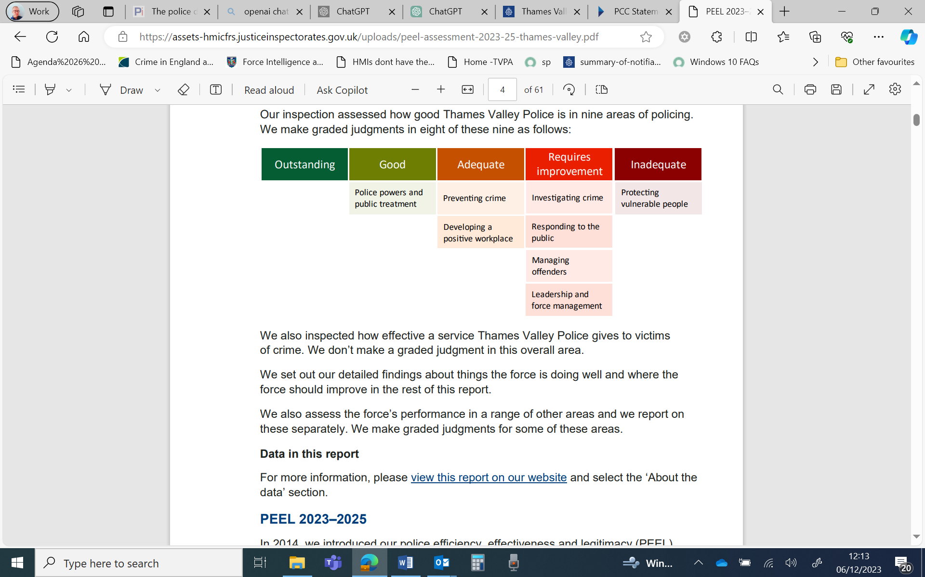

- HMICFRS also inspected how effective a service Thames Valley Police gives to victims of crime (but does not make a graded judgment in this overall area). It sets out detailed findings about things the force is doing well and where the force should improve. It also assess the force’s performance in a range of other areas and reports on these separately. It makes graded judgments for some of these areas.

- The Inspectorate said that the force was found to make good use of stop and search to prevent and detect crime and is involving community members in the scrutiny of how it uses police powers, however they recommended improvements to how it works with partner organisations to assess and manage risks to vulnerable people, including making sure that risk assessments are detailed enough and dealt with promptly.

- Thames Valley Police has emphasised its commitment to protecting its communities, which is set out in its own media release:
https://www.thamesvalley.police.uk/news/thames-valley/news/2023/december/04-12-2023/thames-valley-police-has-emphasised-its-commitment-to-protecting-its-communities/

PCC response
“I take the findings from this inspection extremely seriously.
“There are a number of areas for improvement highlighted in the report including those relating to the management of risks to vulnerable people. It’s vital that the residents of the Thames Valley feel confident that the force are able to act quickly and have effective processes in place to protect vulnerable people from harm. From regular communication with the Chief Constable I know that actions have already been implemented since this inspection, including increasing staffing levels within safeguarding teams, which are addressing the issues highlighted. I will continue to monitor this to ensure that sustainable systems and effective processes are in place which are better placed to respond to demand.
“There are many areas of good practice cited within the report including how Thames Valley Police uses its police powers, its fair treatment of people and communication with the public. However, there is more that needs to be done to improve service delivery for Thames Valley communities. I will assess the recommendations from His Majesty’s Inspectorate alongside the Chief Constable and monitor appropriate actions through my ongoing scrutiny to drive forward the improvements that are needed.”
https://www.thamesvalley-pcc.gov.uk/news/pcc-statement-on-hmicfrs-peel-inspection/

