 | OFFICE OF THE POLICE & CRIME COMMISSIONER  FOR THAMES VALLEY

PCC DECISION REPORT - SECTION A - SUMMARY

Report for Decision

Report Reference Number: | PCC 2024 – 004

Report Title:
Chief Resilience Officer Recruitment - Stronger LRF Programme

Executive Summary:

Context:

What is the Stronger LRF Pilot Programme?
The Integrated Review (also referred to as ‘Global Britain in a competitive Age’) was commissioned by then Prime Minister Boris Johnson and published in 2021. It was the largest review of homeland security, defence, development and foreign policy since WW2. The document outlined a vision for “Global Britain” for the next decade. This review was refreshed in 2023, with one of the four key pillars for delivery being ‘addressing vulnerabilities through resilience’. Answering to this review, the Cabinet Office then published its first UK Government Resilience Framework (2022).
The UK Government Resilience Framework sets a clear ambition to significantly reform the delivery of local resilience in England. Critical to this is the idea of strengthening the Local Resilience forum strata. The Cabinet Office have committed to delivering a programme of reform to LRFs by 2030 and will test and refine proposals through a series of pilot projects. This has become the Stronger LRF pilot programme, which DLUHC is responsible for delivering nationally. The Stronger LRF programme has three key pillars for testing and developing:
- Leadership,
- Accountability and
- Integration

Following a presentation at the TVLRF Executive on March 23rd, 2023, the Executive agreed that the LRF could put itself forwards for the Stronger LRF Programme, via an Expression of Interest (EOI).

The EOI form asked the LRF to consider opportunities and challenges to the programme's potential implementation. Following completion, the EOI was submitted on 26th May. This submission enables an opening up of conversation between DLUHC Stronger LRF Programme managers, and the LRF, to consider whether there is scope to develop a pilot.

22 LRFs have put forwards an EOI, with 4 in the Southeast region to include:

• Hampshire and Isle of Wight,
• Thames Valley,
• Surrey, and
• London.

Funding
The Stronger LRF programme was put together with attached funds of £800,000 (minimum) per pilot area, over the 24 month period inclusive. DLUHC noted this funding to cover the recruitment costs. Additional funding (to be determined by DLUHC) will be required for delivery of the pilot, but is expected to increase the funding contribution awarded to the Thames Valley to potentially between £1,500,000 and £2,000,000

The Stronger LRF Programme will have financial de-risking in place for whole lifetime costs for:

- The newly created position of Chief Resilience Officer with a salary of £103,000 (gross). This salary has been set in line with the Chief of Staff salary for the OPCC given the similarities in roles and responsibilities and the lack of any coherent proposals for salary from DHLUC

- Indicative costings for setting up an associated Executive Office may cost between £500-800,000, initial outlay costs, depending on the degree that this is set up from scratch (see Annex A for schematic of a potential executive Office).

Thames Valley will work with Department for Levelling Up Housing and Communities (DLUHC) to balance financial expectations and practicalities of both sides.

The current plan on a page for delivery of the Stronger LRF pilot can be seen below although costs are estimates at this stage of planning. Please note the financial information within the plan below relates purely to the administrative function for the Stronger LRF pilot and detailed costings can be found in Annex A – Stronger LRF draft delivery plan, which is currently with LRF partners for consultation.

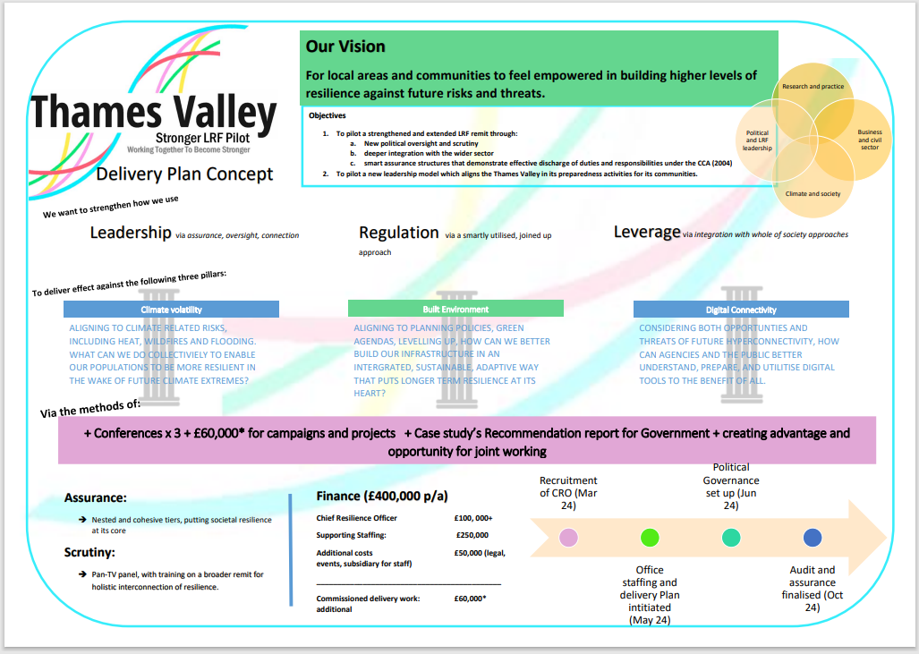

Request for decision:
The Police and Crime Commissioner for Thames Valley, in principle, will commence the recruitment of a Chief Resilience Officer, following further confirmation and agreement of the recruitment timescales.
This will be advertised as a Full Time Temporary role as a member of staff within the Office of the PCC. However, no commitment will be made to any successful candidate until external funding has been secured from DHLUC to cover the total costs including all expenses of any such commitment. If funding is not secured, then the process will be terminated.
This reporting arrangement is anticipated to be an interim arrangement for the 2 year pilot phase The longer-term expectation is that the CRO will be set up as a separate legal entity (eg Corporation Sole). If the CRO wishes to make use of Stronger LRF funding to set up an interim executive office within the Office of the PCC, then this would be submitted to the PCC as a further decision.
Whilst the CRO will be accountable to the PCC for the work they undertake within the role, the day-to-day line management responsibility for the CRO role during the 2year pilot phase will sit with the OPCC Chief of Staff within their remit as Head of Paid Service.
The CRO will also need to ensure that all governance arrangements financially and otherwise are in line with the arrangements in place of the Office of the Police and Crime Commissioner. This means the Chief Finance Officer within the OPCC will have oversight of the CRO budgets and authority to approve any spend will be in line with the existing OPCC Governance Framework.
Whilst there will be a sterile corridor between the work of the CRO and that of the OPCC, the Chief of Staff and Chief Finance Officer of the OPCC will have statutory roles to play within the governance of the CRO and any executive office that is put into place. An addendum will be added to the Governance Framework to clearly outline role and responsibilities once the CRO has been recruited to ensure practical day-to-day working arrangements are in place.
A decision is required in principle that the arrangements for recruitment of the CRO role within the current legal framework of the OPCC is approved.
Decision of Police and Crime Commissioner
I hereby approve the recommendation(s) above.
Signature: Date:
PCC DECISION REPORT - SECTION B - INFORMATION

PART 1:

NON-CONFIDENTIAL INFORMATION

- Introduction and background

In December 2022, the UK Government Resilience Framework (UKGRF) was published, following a consultation which the LGA responded to. The framework is based upon three core principles:
- A shared understanding of the risks we face is essential: it must underpin everything that we do to prepare for and recover from crises.
- Prevention rather than cure wherever possible: resilience-building spans the whole risk cycle so we must focus effort across the cycle, particularly before crises happen.
- Resilience is a ‘whole of society’ endeavour: so we must be more transparent and empower everyone to make a contribution.
Of the six themes in the framework (risk; responsibility and accountability; partnership; community; investment, and skills), the responsibility and accountability section, which includes a series of proposals on strengthening Local Resilience Forums (LRFs), will be of particular interest to councils. Councils are already core members of their local resilience forums, and the framework’s proposals to strengthen LRFs and focus more on preventative activity are likely to enhance the role of councils and councillors in this space.
  - Strengthening LRFs
The UKGRF sets out three pillars to significantly strengthen LRFs, focusing on leadership accountability and integration.
  - Leadership
The framework proposes to pilot a permanent chief resilience officer role (CRO) for each LRF area, replacing the current model of part time LRF chairs drawn from individual LRF members such as the police/fire services or councils.
The CRO would be supported with the resources and mandate to bring partners together to drive and enhance resilience. They would be accountable, in addition to the PCC, OPCC Chief of Staff and OPCC Chief Finance Officer, to executive local democratic leaders, giving leaders a clear role in ensuring effective delivery of resilience activity.
  - Accountability
To strengthen accountability and assurance across LRFs, the framework sets out an ambition that clear mechanisms and expectations between the CRO and executive local leaders will make LRFs more accountable and provide mechanisms for local communities to hold local leaders to account for driving resilience. The Government will consider the means for stronger assurance of LRFs’ collective delivery, including auditable frameworks and building assessment of resilience into the inspection and audit regimes of individual responders.
  - Integration
The Government wants to integrate resilience into levelling up and place making to build a solid foundation for resilient communities, with the CRO and local elected leaders empowered to work across the full range of local policy making and delivery to build resilience into wider policy making.
To support this, the Government intends for resilience to be included as a key aspect of devolution deals (the recent Greater Manchester Combined Authority Trailblazer deeper devolution deal is the first example of this) and will consider making the case for combined authorities and mayoral combined authorities to become category one responders under the Civil Contingencies Act; where there are no devolution deals, it proposes to integrate resilience into wider delivery.
  - Stronger LRF pilots and implications for councils/councillors
The Government has committed to piloting different aspects of the stronger LRFs programme, ahead of any changes that would be required to the Civil Contingencies Act to implement it. It aims to undertake pilots by 2025 and to deliver the LRF reform programme by 2030. It is expected that funded pilots will begin at the end of 2023 following a process to select pilot areas earlier in the year.
- CRO areas of influence
  - Planning
- Influence changes to the National Planning Policy Framework which supports the new Levelling Up and regeneration Bill
- Statutory consultation on several regulations, policies and national frameworks. These are explored below:
- The CRO would be expected to use influence with councillors to influence democratic plans on areas such as mineral and waste planning authorities, neighbourhood plans, and spatial development plans. Potentially the CRO office could become part of the final independent Plan examination process.
- As a statutory consultee, the CRO Office should have the ability to give firm grounds for overriding or amending plans bought forwards by local leaders, or challenge in court decisions which breech minimum standards of resilience preparedness.
- Supplementary plans would also need to be subject to a resilience standard, set by the CRO Office.
- Work with local planning authorities to build its own design code (as required through the Levelling Up Bill) with Resilience incorporated.
- Influence the criteria of an area development plan, putting a standardisation of ‘good design’ into definition as being one that influences and considers longer term preparedness and resilience for its communities, through the national model design code.
  - Whole of Society
- The whole of society resilience agenda will be championed through increased opportunities for communities and interested parties to influence and comment on emerging plans, giving focus on building sustainability, resilience and hazard education into the consultation process.
- The CRO would campaign that a ‘street vote’ on local neighbourhood designs should also be subject to meeting a resilience standard before planning permission is granted.
- Influencing and championing for resilience to be integral in new Infrastructure delivery strategies by being a trusted consultant in the process.
- Potentially (?) create a Local People Recovery Strategy to sit alongside the Local Nature Recovery Strategy, outlining how new development plans should consider the ability of a community to recover from threats and hazards that may manifest in the new development.
  - Emergency Response and LRF MA escalation
- Conduct a gap analysis on the current legislation to facilitate effective, joined up emergency response nationally.
- Ability to create secondary legislative changes to the CCA to make it of most effect to partners in response environments
- Challenge, campaign and influence response scenarios where additional legislation is required
- Hold partners and wider stakeholders to account via public enquiries, where failings are identified as resulting from breeching minimum resilience standards
  - Infrastructure levy (?)
- Under the new Bill (2022) the CRO should ensure their office is a recipient of the new Infrastructure Levy- spending proceeds could become revenue for LRF secretariat?
- CRO Office should influence regulations, alongside the bill, to ensure that developers deliver infrastructure that meets a baseline resilience standard needed to ensure operational and physical site design compliance.
- Influence the new Environmental outcome reports (as detailed in the new Bill) to consider a wider range of natural and man-made hazards which can influence relevant plans and major projects, particularly where climate hazards have cascading consequences and complex interdependencies. The Disaster Science Advisor will prove particularly useful here.
  - Wider spheres of influence
- The CRO should work closely with the Office for Place in embedding resilience preparedness into its national and local design codes.
- The CRO may help influence changes to the National Planning Policy Framework to strengthen the role of resilience as a key measure.
- The CRO will work closely with Elected members to improve their knowledge of Complex resilience geographies in their area
- The CRO should work closely with the C-suite of emergency responder agencies (including those who already consult on planning) to add weight to campaigns and seek collective challenge against other bids.
- Work strategically with a range of CAT 1 and 2 responders, such as Active Travel England and the Environmental agency, ensures a joined-up approach to development meeting a resilience standard
- The CRO office advises into policy making within DLUHC via the Office for Place, and others.
- Issues for consideration

  - Outcome
- The CRO Office should ensure long-term resilience preparedness is embedded in both the planning and community development plans for its geography.
- The CRO Office should draw and direct additional revenue streams into the LRF secretariat to build towards a sustainable structure.
- The CRO Office should influence in the design and implementation of new and current legislation, powers and policies to support effective response and recovery work of emergency responders.
- Act as an accountable office for the public and Government in the effective discharge of duties of emergency responders in prevention, planning, response and recovery via effective assurance.
  - Links to the Police and Crime Commissioners Strategic Priorities
- The involvement of Thames Valley in the Stronger LRF pilot programme has direct links to the Police and Crime Commissioners Police and Criminal Justice Plan. The Plan brings together the priorities of all agencies and authorities with a responsibility for cutting crime and improving community safety, like the requirement for agencies within the LRF to work together to reduce risk and prevent disasters.
- Under the terms of the Police Reform and Social Responsibility Act 2011, PCCs must, amongst other things, ensure community needs are met as effectively as possible and are improving local relationships through building confidence and restoring trust. They work in partnership across a range of agencies at local and national level to ensure there is a unified approach to preventing and reducing crime. As a result, PCC’s bring together community safety and criminal justice partners, to make sure local priorities are joined up. This creates a natural fit for the Stronger LRF programme to sit within the governance of Thames Valley PCC’s Office given the existing requirement for the PCC to bring statutory organisations together to address community issues.
- The Thames Valley PCC has set a strategic priority to bring together statutory organisations to address Thames Valley issues affecting cross-cutting organisations to create efficiencies in the Criminal Justice System. This creates an efficiency in bringing the same organisations together to address Stronger LRF objectives.
  - Financial
The CRO Office will legally need to be a structure, which can receive revenue, which for the pilot phase will be through the Office for the Police and Crime Commissioner governance arrangements
- The CRO Office should expect to receive revenue via a government grant, with expenditure of the grant being overseen by the OPCC Chief Finance Officer
- The CRO office should also hold delegated General Power of Competence from the PCC to receive payment from its role as a Statutory Consultee, on behalf of other Categorised responders.
- The CRO office should be added to the list of recipients of the new Infrastructure Levy through the PCC
  - CRO Resources
- The CRO will require a small executive office to carry out its function, including management functions and specialist consultation functions.
- Specialist functions to support the CRO are outlined in more detail below
- The schematic below is a first draft of what an administrative function for the CRO could be and will be fully reviewed once the CRO is in place. A further decision paper relating to the functions and structure of the administrative function will be required once pilot funding is confirmed.
- Employees of the CRO administrative function will be formally OPCC employees and follow all the policies and procedures currently in place.
Elected Members
Chief Resilience Officer
LRF Partnership Manager
LRF Secretariat Team
Partnership Members
HR Manager
EA to the CRO
Comms and Project Officer
Disaster Science Advisor
Legal Advisor
Treasury Assurance Officer
Executive Audit Board
0.5 FTE
0.5 FTE
0.5 FTE
0.5 FTE
0.5 FTE
0.75 FTE
1.0 FTE
1.0 FTE
3.5 FTE

    - Specialist Functions
- Specialist roles who will advise the CRO, creating reports
- Could be ‘true’ consultants, contracted for set service delivery periods. This keeps it agile, overheads lower, clarity over tasks.

    - Legal Advisor/Consultant
- Work with the Disaster Science Consultant to build up retrospective case studies and reports to demonstrate the business case for Resilience to be a core component of democratic plans, including legislative challenges and barriers.
- Conduct gap analysis on existing legislation
- Produce consultation reports commissioned by CRO
- Offer legal advice for the CRO when represented in Court
    - Disaster Science Consultant
- Works with the Legal advisor to deliver reports commissioned by the CRO
- Offers specialist advice on emergency response and planning capability, both nationally and locally
- Identifies where current plans and procedures have not been followed in incident response, planning or recovery
    - Treasury Assurance Consultant
- Financial monitoring
- Assurance reporting
- Whole of Society ‘soft’ KPIs translated into Annual financial saving report for the Treasury.
- Support with the creation of reports to posit on the financial costings (theory/retrospective from case studies) of specific incidents.
- Financial consultant for the CRO regarding legal action proceedings.
- Financial comments

  - Pilot funding was confirmed verbally on the 26th September 2023, starting 1st April 2024. A Pilot Delivery Plan need to be submitted to DLUHC by the February 2024 setting out how the funding will be spent.
  - The Stronger LRF draft delivery plan, which is currently with partners for consultation, is attached at annex A with detailed costings embedded.
- Legal comments

  - There is currently no legislation or statutory support mechanisms in place for the Stronger LRF Pilot which provides a challenge in being able to embed the programme into the local infrastructure. This creates a reliance on the ‘goodwill’ of the statutory organisations to engage with the pilot.

    - CRO Legal structure
- In the longer term, the CRO role would need to become a Corporation Sole, who will employ its office as its own entity.
- However, in the interim the CRO and their executive office will sit within the TV OPCC legal structure accountable to the Police and Crime Commissioner and reporting to the Chief of Staff for the OPCC. The CRO financial arrangements will be overseen by the OPCC Chief Finance Officer in line with the Governance Framework in place.
- All employees including the CRO will be employees of the OPCC and therefore HR arrangements will be through Thames Valley Police People Services
- Whilst there will be a sterile corridor between the work of the CRO and that of the OPCC due to their differing responsibilties, the Chief of Staff and Chief Finance Officer of the OPCC will have statutory roles to play within the governance of the CRO and any executive office that is put into place. An addendum will be added to the Governance Framework to clearly outline role and responsibilities once the CRO has been recruited to ensure practical day-to-day working arrangements are in place.
    - Assets for management
- Creation and management of a 10 year Resilience Strategy, such as this one: Greater Manchester Resilience Strategy 2020-2030 (greatermanchester-ca.gov.uk).
- Creation of additional strategic documents, such as a Local People Recovery Strategy (akin to the Local Nature Recovery Strategy) outlining how new development plans should consider the ability of a community to recover from threats and hazards that may manifest in the new development.
- Lead on campaigns and bids to strengthen societal resilience, such as via the Resilient Cities Our Story - Resilient Cities Network
- Direct line report for Executive Office personnel, plus the LRF Manager
    - Powers, Policies, Statutory Duties, Legislation
- To facilitate the enhanced use of the CCA (2004) through better use of secondary legislation
- Advise in the changes in statutory duties required where there are gaps, or where new roles need to be recognised in the CCA (2004)
- Alignment with the Levelling up and Regeneration Bill (2022)
- Influence integrated policy making at local levels
- Support in the creation of a new Act (if required) to give powers to the CRO role
- Equality comments

  - A full equality impact assessment will be conducted during the implementation phase of the pilot

PUBLIC ACCESS TO INFORMATION
Information contained in this Decision Report is subject to potential disclosure under the Freedom of Information Act 2000 (FOIA) and other legislation.

Part 1 of this Section (information to be disclosed) will be made available on the website within 1 working day of approval of the Decision Report. Any facts and advice that should not be automatically available on request should not be included in Part 1 but instead in the separate Part 2 (‘Exempt Information’) section.

Deferment of publication of this Decision Report is only applicable where release of information contained within it before a specified date would compromise the implementation of the decision being approved.
Is there a Part 2 ‘Exempt Information’ section? | Yes
Is the publication of this Decision Report to be deferred? | Yes / No
If ‘Yes’, please state specified earliest date for publication and reasons for deferment:

GOVERNANCE CHECKS (Name & Role) | Officer Signature
Originating Officer / Head of Unit

Legal Advice

Financial Advice

Equalities and Diversity

PCC’s STATUTORY CHIEF OFFICERS’ APPROVAL

We have been consulted about the proposal(s) contained in this Decision Report and confirm that financial and legal advice have been taken into account in the preparation of this report.

We are satisfied that this is an appropriate request to be submitted to the Police and Crime Commissioner for decision.

Chief of Staff (Monitoring Officer) Date:

Chief Finance Officer Date:

Annex A – Stronger LRF Draft Delivery Plan

