Charlotte Roberts Email:Charlie.roberts@thamesvalley.police.uk Date: 28 March 2024
Tel: No. 01865 541948

Dear Chief Constable

Performance & Accountability Meeting (PAM)

You are requested to attend a PAM meeting on 5 April 2024 at 09:00-11:00hrs in the CCMT Meeting Room and via MS Teams for those unable to attend in person.

Microsoft Teams meeting
Join on your computer, mobile app or room device
Click here to join the meeting
Meeting ID: 375 995 838 26
Passcode: ZrsLZz
+44 20 7660 8499,,111194923# United Kingdom, London
Phone Conference ID: 111 194 923#

Yours sincerely

Gillian Ormston
Chief of Staff (OPCC)

Agenda Item Page No. Timings

1. | Apologies - none  (PCC) | - | 09:00 - 09:05
2. | Minutes of the PAM meeting held on 18 January 2024  (PCC) | 3 - 10 | 09:05 - 09:10
3. | TVP Strategic Delivery Plan (Claire Widdison/Ali Nicholls) | 11 - 32 | 09:10 – 09:30
4. | OPCC Strategic Delivery Plan 2023/24  (Gillian Ormston) | 33 - 50 | 09:30 – 09:50

2

5. | Treasury Management Strategy Statement  (Martin Thornley) | 51 - 72 | 09:50 – 10:10
6. | OPCC Financial Delegations  (Martin Thornley) | 73 - 76 | 10:10 – 10:20
7. | Income Charging Rates 2024/25  (Linda Waters) | 77 - 92 | 10:20 – 10:40
8. | Decisions under the Scheme of Governance  (Linda Waters) | 93 - 97 | 10:40 – 10:50
9. | AOB  (PCC) | - | 10:50 – 11:00

Date of next PAM meeting: Tuesday 4 June 2024 at 10:30-12:30hrs CCMT Meeting Room/MS Teams.
AGENDA ITEM 2

3



POLICE & CRIME COMMISSIONER FOR THAMES VALLEY MINUTES OF THE PERFORMANCE AND ACCOUNTABILITY MEETING
HELD IN THE CCMT MEETING ROOM AND/OR VIA MS TEAMS ON THURSDAY 18 JANUARY 2024 COMMENCING AT 10:30 HRS

Present:
M Barber (Police & Crime Commissioner) (OPCC) J Hogg (Chief Constable) (TVP)
L Waters (Director of Finance) (TVP) J Lynn (Finance Assistant) (TVP)
M Butler (Lead Advisor, Service Improvement) (TVP) C Widdison (Head of Strategic Governance) (TVP)
A Nicholls (People Services Manager) (TVP) G Ormston (Chief of Staff) (OPCC)
M Thornley (Chief Finance Officer) (OPCC)
G Evans (Policy Development Manager) (OPCC)
C Roberts (Executive Assistant to the PCC & Chief of Staff) (OPCC)

External Present:
Cllr Werner (Police & Crime Panel)
Cllr Robin Bradburn (Police & Crime Panel) Cllr Keith McLean (Police & Crime Panel) Khalid Ahmed (Police & Crime Panel)

Apologies: N/A

Agenda Item

Apologies

The PCC welcomed all to the meeting and noted no apologies had been received.

Minutes of the PAM (Performance Accountability Management) meeting held on 7 November 2023

An update on AIU would be presented during today’s meeting by Matthias Butler (MB). The PCC APPROVED the Minutes of the Meeting held on 7 November 2023.

HMICFRS Recommendation Monitoring Reports

There had been a lot of housekeeping dealt with as to the HMICFRS Reports and the Force were now down to 143. Once this was complete, the Force would know the current position. Thematic inspections were carried out every fortnight. Gary Evans (GE) had sight of HMICFRS Reports and had no issues and liaised with Claire Widdison (CW) as to the current position and arrangements for monitoring.

The PCC NOTED the HMICFRS Report updates.

TVP Strategic Delivery Plan 2024-2025

The main update since last quarter had seen four measures of improvements and reductions. The other measures had stayed relatively static with no substantial changes to note.

(MB) provided key points to note from the Strategic Delivery Plan in achieving 80% of completed victim needs assessments for eligible crimes. There was an increase in victim satisfaction rate across the victim journey throughout 2023-24. Themes to pull out from victims were set out on page 34 and 35 for initial contact and initial officer attendance. Those areas where more work was required was on waiting times and dealing with the victims. There was clearly good satisfaction rates for initial contact and initial officer attendance. The PCC noted the initial call wait time needed to be focussed on as well as the speed report dealt with. In terms of initial contact, there was a clear definition between both for speaking on the phone and online reporting.

Expectation setting was key to improving the understanding of victim needs set out on page 35. The final outcome showed the lowest satisfaction rate and this was down to whether the victim received the outcome they wanted. The Force needed to be focussed on the elements of the quality of update, time taken to update were the areas to drive moving forwards.

Reduction proportion of 101 callers showed waiting time of over 10 minutes for their call to be answered was under 15%. (MB) had discussed this with ACC Rob France with a view to where the fluctuation would be and not to go over certain thresholds. This was an area to remain focussed on.

There was an increased proportion of grade 1 calls attended in under 20 minutes to 70% and this was discussed at Force Performance Group meetings. (MB) had met with the Contact Management team for Thames Valley Police (TVP) and Hampshire to articulate the path through to grading and dispatch etc. and would have a shared understanding with Hampshire for the framework implementation in due course, where an update would be provided to the PCC.

The AIU Hubs had been able to reduce the average time to triage cases and was down to within 24 hours in November. This had been maintained into December 2023. The metrics shown on page 38 included cases that were triaged within 24 hours. A mechanism to record cases that the AIU

were holding due to victims not responding, had been established and would be shown in performance metrics in the future.

There was a reduction in the number of knife enabled crimes by 5% year on year and an increase overall charge rate by 1% point (TVP to 7.5%). The Force had seen a positive reduction, certainly with knife crime.

(MB) referred to the increase charges in violence against women and girls’ crime in VAWG. Year to date, the Force were slightly down from last year and (MB) would have an update after the next Force Performance Group meeting.

As to target and disruption for serious organised crime including fraud and cyber crime, there was an increase in the number of serious organised crime disruptions across Prevent, Prepare, Protect and Pursue and improve community safety using ‘Clear, Hold, Build’ methodology. Chief Constable Jason Hogg (JH) had added more resources into the Crime Registrar team to enable better figures.

To develop baseline for public trust and confidence and monitor progress throughout 2023/24 with the results of the initial snapshot, the Trust and Confidence Survey commissioned by the OPCC would be returned in mid-January. Discussions were ongoing regarding the reporting requirements and raw data provision to the Force.

(MB) presented the key points on the increased active patrol time through the use of Op Rasure Hotspot App and evidenced the active engagement with selected communities in each Local Policing Area (LPA) to ensure the transparent use of powers. (MB) noted the latest figures had increased.

Action: The PCC noted this was an area the PCC would look at, especially around the East Force where there were lots of other issues at a high rate with HMICFRS.

As to rural crime, the levels had reduced by 5% with no rural incident changes year to date. The PCC NOTED the TVP Strategic Delivery Plan.

OPCC Strategic Delivery Plan 2024/25

There was nothing of significance to report on the OPCC Strategic Delivery Plan with all the work on track. One thing to raise was the Chief Resilience Officer role pilot project. Gillian Ormston (GO) had news that the potential funding would be delayed until May 2024 which caused issues with the recruitment process. Progression would not progress until there was confirmation from Delux as to a proposal for a way forward and would provide an update to the PCC for the next internal SMG meetings. (GO) had also discussed this with DCC Ben Snuggs (BS).

The PCC NOTED the OPCC Strategic Delivery Plan 2024/25.

Treasury Management Quarterly Performance update

Martin Thornley (MT) presented the quarterly update to the PCC. Two points to highlight were:

- The continuation to get strong interest receipts as it would appear this was about to peak; and

- On the last working day before the Christmas period, the portal Sungard which the OPCC used for moving money in and out to get better interests overnight, un-expectedly closed early and the organisation was left with a £23 million unarranged overdraft.

This would cost the organisation £24,000 albeit a complaint had been raised about this and clearly there was two areas to be dealt with:

- The complaint against Sungard; and

- Mitigation for the future.

The PCC NOTED the Treasury Management Quarterly Performance update.

Budget & Medium Term Financial & Capital Plans & Capital Strategy

Linda Waters (LW) presented the papers for the Budget and Medium Term Financial and Capital Plans and Capital Strategy, with the main focus on the revenue balance for the first year. The significant items that stood out was clearly the increase in inflation for next year which had influenced the 7% increase of pay last year and to find additional savings. In relation to the main revenue position, most of these points had been discussed. Funding had been included in the current revenue for 158 officers in excess of the base PUP uplift and an Estates revenue had been created to support capital investment to provide for future borrowing costs. (LW) provided an update of the productivity plan for years 1 and 2 to ensure there was value for money on spending.

(LW) asked the PCC to approve the bullet points set out and provided an update on the Revenue Overview 2023/24 to 2026/27. The Budget was balanced in year 1 with a small cumulative deficit in years 2 - 4:



The PCC noted it was worth looking at the future savings of the £2m per annum as there would certainly be some growth and a need to be clear on this. The Force were carrying out this work and had invited (GO) and (MT) to attend meetings to discuss where savings could be made between the Force and the OPCC. This was helpful to enable and build continuous improvements with the organisation being in a much better place than in previous years.



(LW) provided slides noting the Council Tax increase had been budgeted at £13.00 for 2024/25, which allowed the Force to increase budgets to strengthen Local Policing, support Public Contact and Prevent Crime and to cover inflationary pressures. The Police Officer Establishment for 2024/25 was set at 4.689 FTE and included an additional 158 FTE Officers, funded through additional PUP funding in the first year.


The direct link between funding and PUP increased officer numbers may in the future hamper a holistic approach to savings delivery.



As to the Current Capital Overview 2023/24 to 2027/28, the area which would be most focussed on over the next 12 months was the potential future schemes. These were significant schemes and a potential spend over the next 4 years. Business cases would be provided albeit, there was value for money within these schemes. Outside of the 4-5 years, there were no financial provision for additional monies and would need look at Force Estates requirements. The capital risks was the risks of inflation although, (MT) felt that this was sensible and sustainable to sign off. However, there were three key risks to be aware of:

- The efficiency of the Force Review (which was challenging);
- Estate capital requirements; and
- The ongoing gap between funding and growth in demand and costs which would continue in the public sector environment as it was about getting the right balance to deliver services.
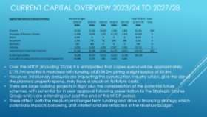
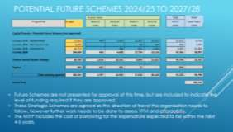



The PCC noted that the Revenue showed a more robust footing around finance and funding and was confident to ‘agree’ and ‘sign off’ the budget knowing what the implications would be, due to the improved detail captured and provided at today’s meeting.

Action: (LW) to email the PowerPoint slides to the Police & Crime Panel. (JH) had written a letter to the PCC and highlighted the following:
  - Assessment Investigation Unit as a team to enable officers to be more proactive and improve overall crime rates.
  - The DIVA phase 2 project with officers being able to observe information quicker from downloading data from phones and laptops enabling officers to close cases.

  - TVP were the first Force in the country to set up a joint Contact Management Platform with Hampshire and investment provided to protect vulnerable people in addressing their needs.

The PCC noted (MT) would be chairing a Board with Andrew Grimley (AG) to discuss existing reserves.

CCTV funding within the Force budget was £358k and this was to assist Local Authorities to move into the CCTV Partnership.

The PCC was working through Cyber Prevention with additional monies funding more public facing pieces of work. The PCC was also extending the funding for Op Deter which had been successful in Slough and other local areas within Thames Valley.

In terms of the work with the Local Authorities and Crime Prevention, funding would be increased to allow this work to continue.

The PCC AGREED and SIGNED OFF all the Budget papers and these would be going to the Police & Crime Panel for their agreement.

The PCC APPROVED the Capital Strategy.

Decisions under the Scheme of Governance

(LW) presented the Decisions under the Scheme of Governance. This was a standing item with nothing to draw to the PCC’s attention during today’s meeting.

The PCC NOTED the Decisions under the Scheme of Governance.

AOB

Nothing to discuss.

The meeting concluded at 12:00hrs.

Date of next PAM meeting: 28 March 2024 at 10:30-12:30hrs in the CCMT (Chief Constable s Management Team) meeting room, HQ South or via MS Teams.


SIU
11 AGENDA ITEM 3






Performance and Accountability Meeting
Serving
Victims
Building
Trust
Fighting
Crime
Valuing Our
People

April 2024

OFFICIAL - SENSITIVE 1

Serving Victims
Improving
12

Priority Overview
Static
IMPROVE UNDERSTANDING OF VICTIM NEEDS AND INCREASE VICTIM SATISFACTION

Static
Static

IMPROVE CALL HANDLING TIMES

IMPROVE ATTENDANCE TIME AND APPOINTMENT MANAGEMENT

YTD

trajectory
IMPROVE MANAGEMENT OF INDIVIDUALS VULNERABLE TO EXPLOITATION

The colour of the hexagon represents Year to Date performance for this aim;
Improving
IMPROVE INVESTIGATION QUALITY AND TIMELINESS

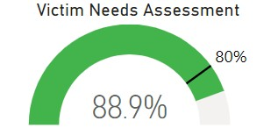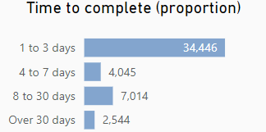
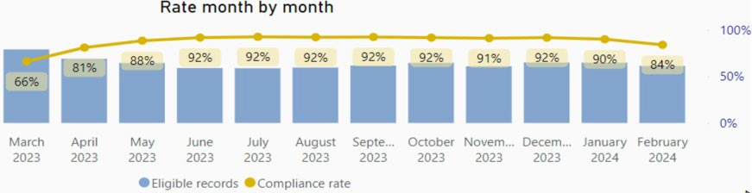
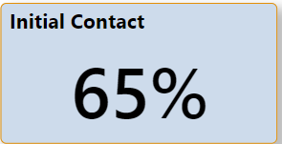
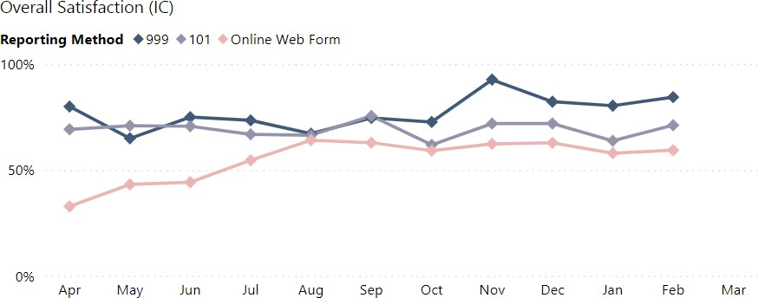
{
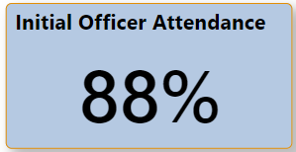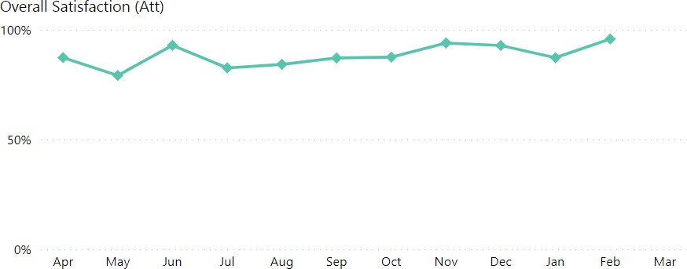
4
999 | 77%
101 | 69%
Online | 57%

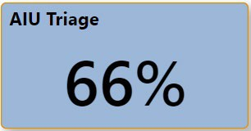
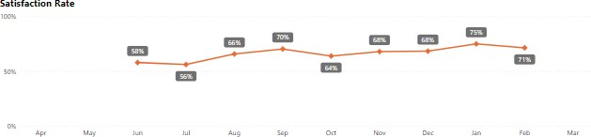
{
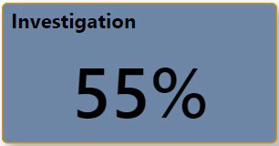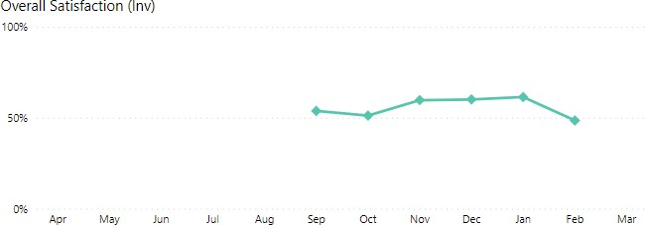
5
Berkshire | 58%
Buckinghamshire | 65%
Oxfordshire | 71%

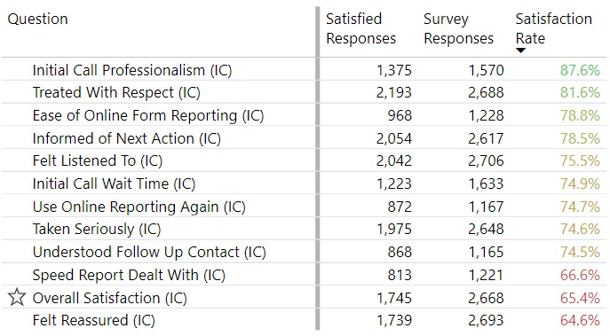
Initial Contact

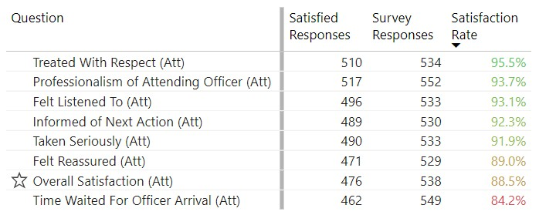
Initial Officer Attendance
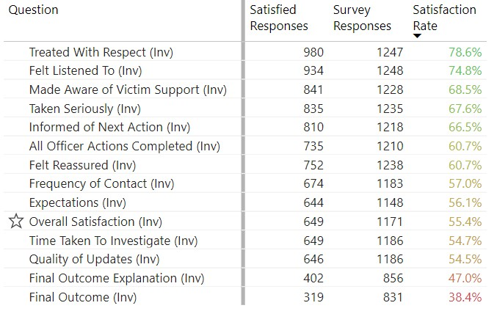
Investigation

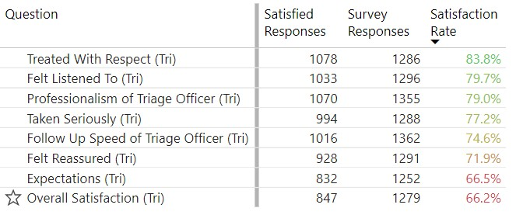
AIU Triage
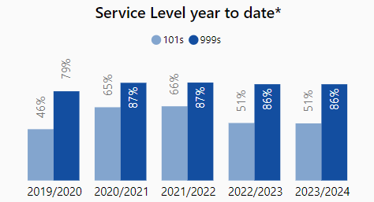
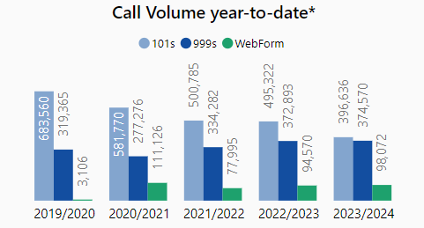
18
Improve call handling times
Serving
Victims
Reduce proportion of 101 callers waiting over 10 minutes for their call to be
answered to under 15%

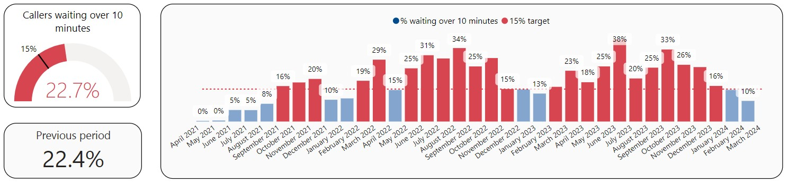

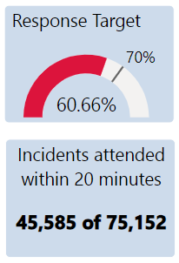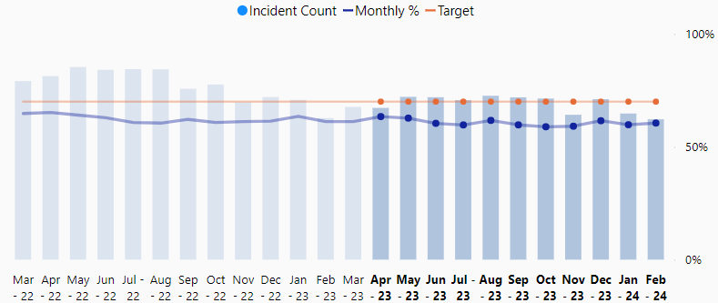
Response Performance Against Target – Rolling 24 Months
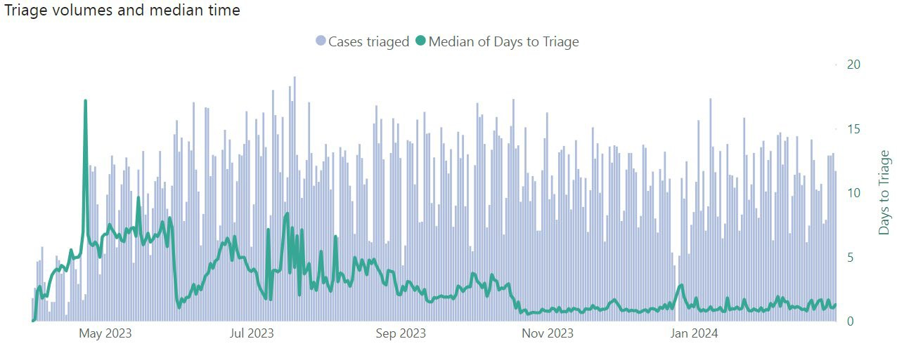
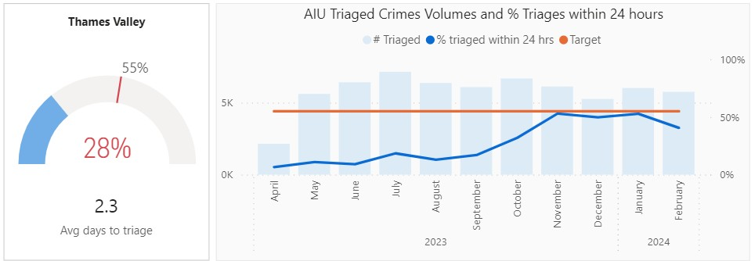
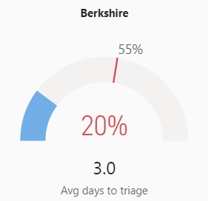
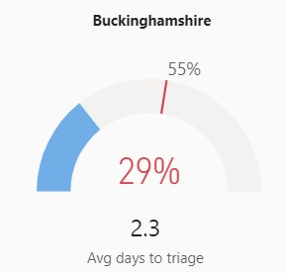
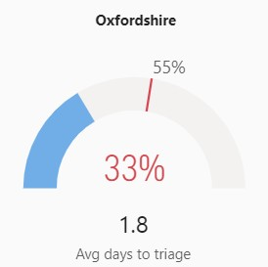

The AIU Hubs have been able to reduce the average time to triage cases down to within 24 hours since mid-October and this has been maintained.
The metrics shown include cases where the triage template was completed within 24 hours. In other cases, a victim may be contacted within 24 hours but not answer or be available to
speak. In those situations the triage template will be completed after 24 hours and be shown as having not met the aim for this metric. A mechanism to record the timeliness of the initial contact has been established and will be shown in performance metrics in the future.

Fighting Crime
Improving
21

Priority Overview
Static
REDUCE KNIFE ENABLED CRIME
Static
Improving

REDUCE NEIGHBOURHOOD CRIME

BRING MORE OFFENDERS TO JUSTICE THROUGH GREATER USE OF CHARGES, WITH A FOCUS ON VIOLENCE AGAINST WOMEN AND GIRLS

YTD

trajectory
PURSUE AND ACTIVELY MANAGE REPEAT OFFENDERS

The colour of the hexagon represents Year to Date performance for this aim;
Static
TARGET & DISRUPT SERIOUS ORGANISED CRIME, INCLUDING FRAUD & CYBER
22
Reduce knife enabled crime / Reduce Neighbourhood Crime
Fighting
Crime
Reduce number of knife enabled crimes by 5% year on year
1212

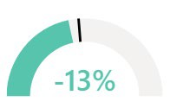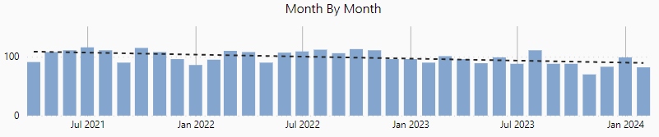
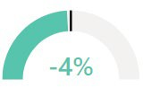
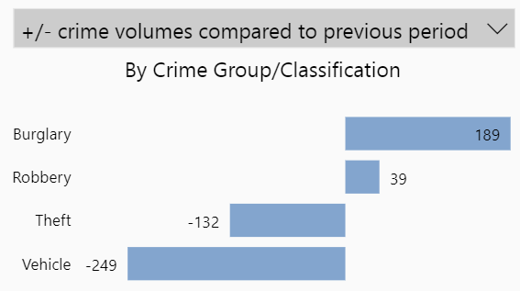
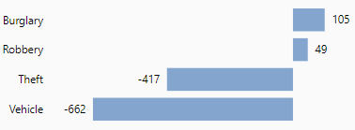


Reduce the volume of crime across all neighbourhood crime types
Latest IQUANTA data: January 2024, Crimes per 1,000 population
National Positions

Fighting Crime
23
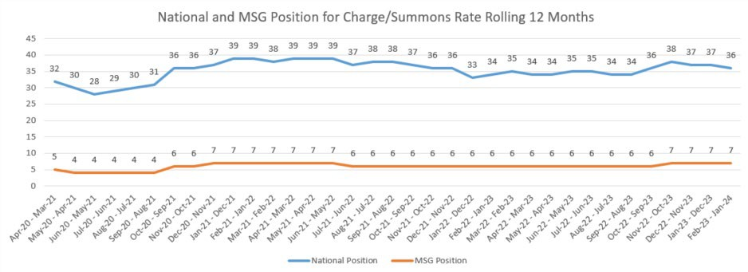
Bring more offenders to justice through greater use of charges,
with a focus on violence against women and girls (1 of 4)
Increase overall charge rate by 1 percentage point (TVP to 7.5%)

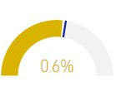
Charge rate 2022/23 | Charge rate 2023/24 | Change
6.6% | 7.2% | +0.6

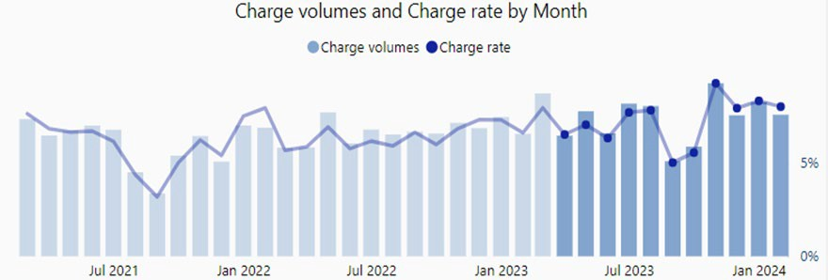
Bring more offenders to justice through grea 24 use of charges,
ter
Fighting
Crime
with a focus on violence against women and girls (2 of 4)
Increase charges in violence against women and girls’ crime

 | Overall VaWG | DA related | Rape | Other Sexual  Offences | Stalking &  Harassment
Year-to-date 2023/24 | 6.3% | 8.5% | 5.1% | 9.2% | 5.1%
Year-to-date 2022/23 | 6.3% | 8.7% | 5.3% | 8.9% | 5.3%

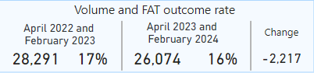
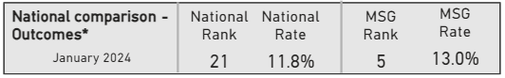
Formal Action Taken outcome profile
Rolling 12 months

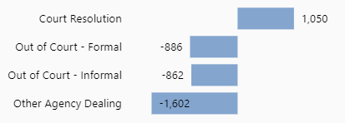
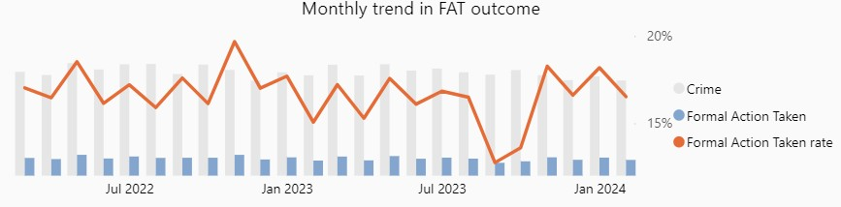
14
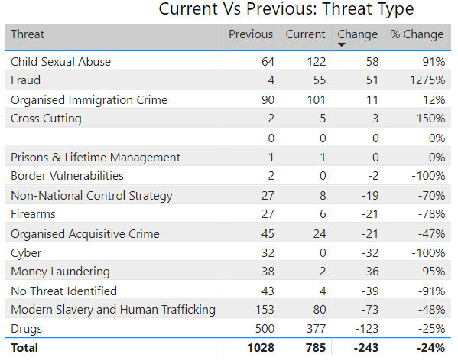
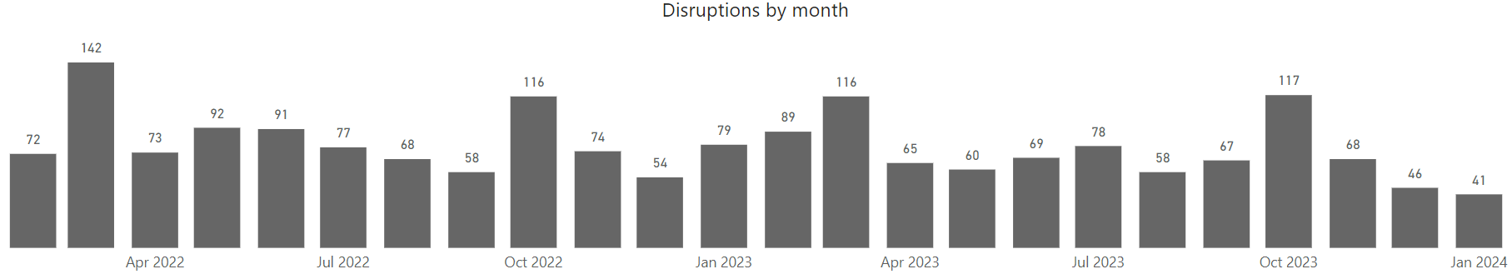
25
Target & disrupt serious organised crime including fraud & cyber crime
Fighting
Crime
Increase the number of SOC disruptions across prevent, prepare, protect, and
pursue and improve community safety using ‘clear, hold, build’ methodology
Disruptions
Apr 23 – Feb 24
15

 | Major | Moderate | Minor | Total
Apr-23 | 2 | 9 | 54 | 65
May-23 | 5 | 12 | 42 | 59
Jun-23 | 7 | 7 | 58 | 72
Jul-23 | 3 | 12 | 63 | 78
Aug-23 | 2 | 9 | 46 | 57
Sep-23 | 4 | 10 | 52 | 66
Oct-23 | 1 | 13 | 101 | 115
Nov-23 | 2 | 9 | 56 | 67
Dec-23 | 1 | 9 | 35 | 45
Jan-24 | 0 | 8 | 31 | 39
YTD 2023/24 | 27 | 98 | 538 | 663
YTD 2022/23 | 54 | 154 | 596 | 804
Change | -27 | -56 | -58 | -141

 | Apr – Jan 22/23 | Apr - Jan 23/24 | Change
Prepare | 43 | 54 | +11
Prevent | 24 | 21 | -3
Protect | 129 | 93 | -36
Pursue | 586 | 501 | -85

26
Static
Static

Priority Overview

Building Trust
Static
DEVELOP GREATER UNDERSTANDING OF PUBLIC TRUST AND CONFIDENCE IN THAMES VALLEY POLICE
Regressing

INCREASE VISIBILITY THROUGH TARGETED PATROLS

IMPROVE LOCAL COMMUNITY POLICING AND ENGAGEMENT, WITH CONSIDERATION FOR SELDOM HEARD FROM COMMUNITIES

YTD

trajectory
ENSURE TRANSPARENT USE OF POLICE POWERS

The colour of the hexagon represents Year to Date performance for this aim;
Improving
TACKLE RURAL CRIME & UNAUTHORISED ENCAMPMENTS
The word to the right describes how the current Year to Date performance compares to last month’s assessment 16

27
Develop a greater understanding of public trust and confidence in Thames Valley Police
Building
Trust
Develop baseline for public trust and confidence and monitor progress throughout
2023/24

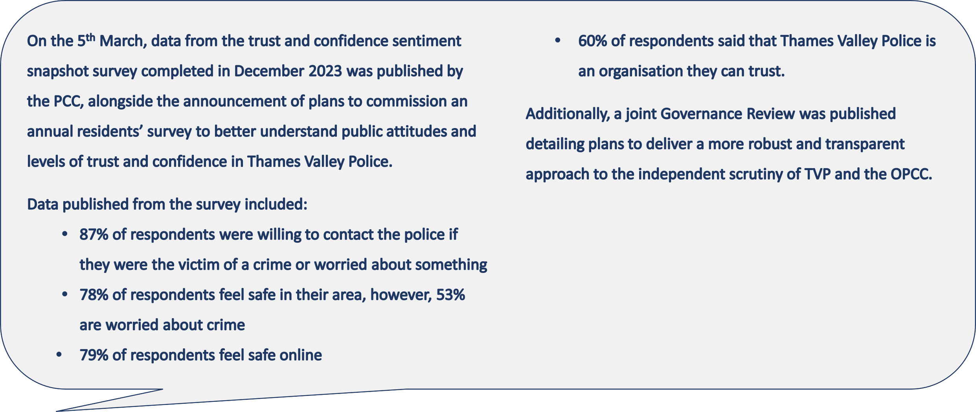
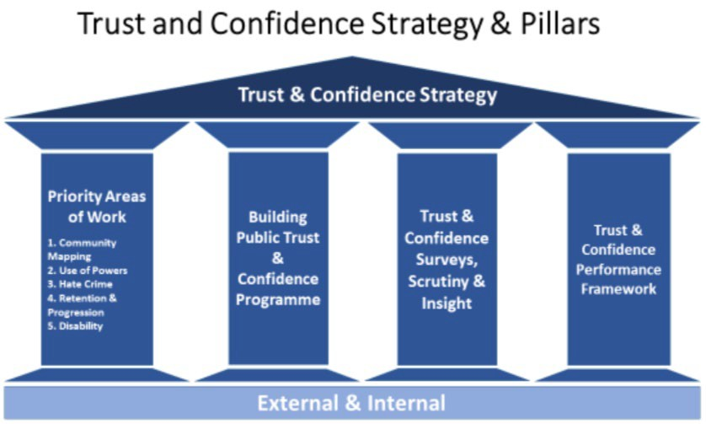
7
1

Building Trust
28
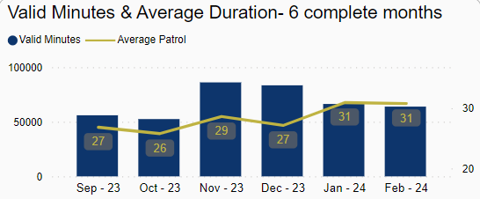
Increase visibility through targeted patrols / Improve local community policing engagement, with
consideration for seldom heard from communities
Increase active patrol time through the use of Op Rasure Hotspot App

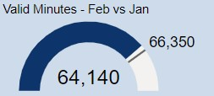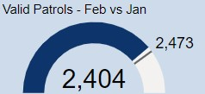

Evidence of active engagement with selected communities in each LPA

8
LPA | Selected seldom heard from community
Aylesbury Vale LPA | Disability
Bracknell & Wokingham LPA | Youth
Cherwell & West Oxon LPA | Rural
Milton Keynes LPA | Youth
Oxford LPA | East Timorese
Reading LPA | Deaf
Slough LPA | Homeless
South Buckinghamshire LPA | Gypsy, Roma, and Traveller
South Oxon & the Vale LPA | Gypsy, Roma, and Traveller
West Berkshire LPA | Rural
Windsor & Maidenhead LPA | Youth

1

Building Trust
29

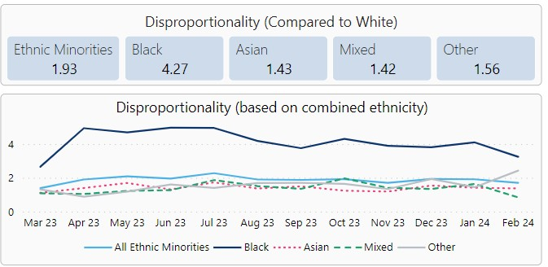
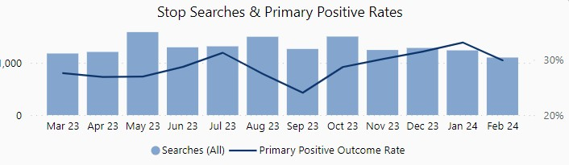
Ensure transparent use of powers

Improve understanding of disproportionality and outcomes achieved through Stop & Search

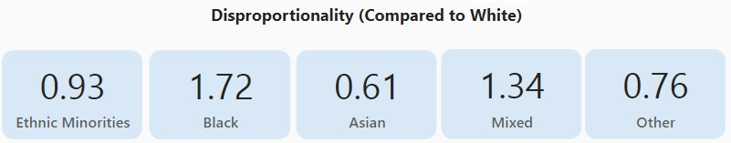
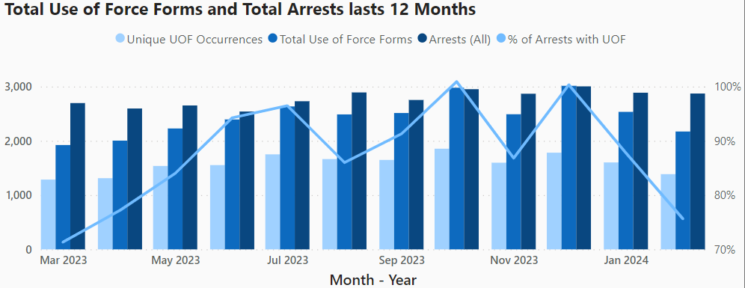
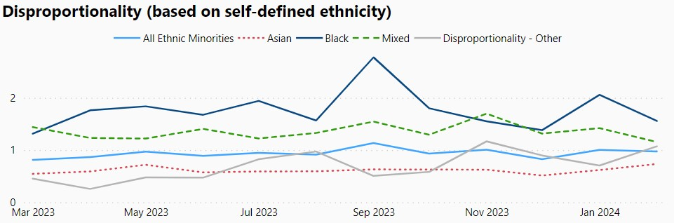
19
Improve recording and understanding of disproportionality within use of force
30
Tackle rural crime and unauthorised encampments (1 of 2)
Building
Trust
Reduce rural crime levels by 5%

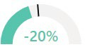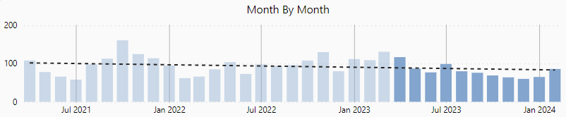

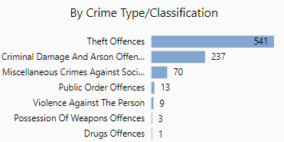
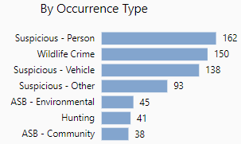
20
Year to date rural incident change
-9%

31
Tackle rural crime and unauthorised encampments (2 of 2)


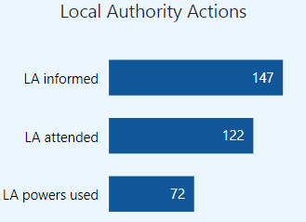
Buil
ding
Trust

Ensure consistent use of powers in response to unauthorised encampments

Proportion of Incidents Attended
91%
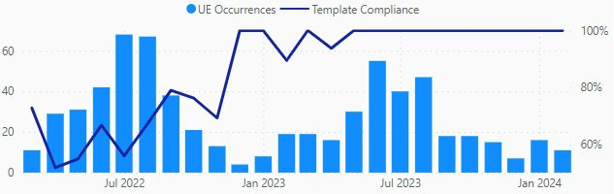
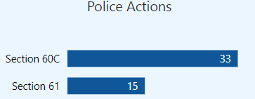
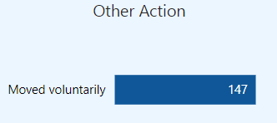
21

Valuing Our Peopl3e2– key indicators
Presenter
2024-03-28 13:23:58
--------------------------------------------
Measure 1: Data from January CCMT DB
Vacancy Factor has increased (worsened) in Contact Management, PCSOs and CSI but it has reduced for DOs. Vacancy factor based upon January 24 data from the CCMT DB
A full establishment and actuals breakdown for the high risk areas are as follows:
January
CM Police Staff (CMC & PCR only) Establishment: 469.52 FTE
Actual: 417.45 FTE
DO
Establishment: 140 FTE Actual: 137.37 FTE PCSO
Establishment: 335.88 FTE Actual: 247.33 FTE
CSI
Establishment: 78.73 FTE Actual: 59.78 FTE
Measure 2: Figures from January CCMT DB Measure 3: PC vacancy: -129.48 FTE (-31.7%)
Sergeant vacancy: -1.07 FTE (-1.6%)
Inspector vacancy: +1.83 FTE (+7.0%)
Overall: -128.72 FTE (-25.7%) (This data has been provided by Fiona Sherlock)
Measure 4: Based on Police Uplift Programme leavers (now in maintenance year and referred to as National Workforce Data), YTD February 2024, there have been 456 leavers, an average of 41.5 per month. (Projected leavers for March 2024 is 40, therefore 12 month average would be 41.3 per month) Note: The plan doesn’t specify how this should be measured, so National Workforce leavers data has been used, which includes externally funded departments.
(This data has been provided by Fiona Sherlock) Measure 5: Data from January CCMT DB
Measure 6: Psychological sickness Hours lost breakdown from Strategic Attendance Toolkit:
July 23: 19,789 August 23: 21,947 September 23: 23,435 October 23: 23,702 November 23: 23,301
Overall Q3 (Oct-Dec): 69,990 hours Q3 Officers: 46,928 hours
Q3 Civilians: 23,062 hours
*Civilians not broken down into Staff/PCSO* Measure 7: Numbers taken from January SRDP Change since last PAM:
Police Officers on adjusted duties November 23: 325 Police Officers on recuperative duties November 23: 114
Measure 8: Tier 1 data for Q4 reporting. This is 10 months overtime data and it has been provided by Zach Bishop. Compared to last Quarter’s YTD Variance (£206,072) there has been a £93,816 decrease this quarter (£112,256).

Last Updated 11/03/2024
Measure of Success | Thames Valley Q2 | RAG  Score | Change from last Quarter
Reduce police staff vacancy factor, focusing on high risk operational areas, particularly Contact Management, Detention Officers, PCSOs and Forensics teams | Contact Management (Police Staff) variance: -51.07 FTE (-11.09% vacancy factor) Detention Officer variance: -2.63 FTE (-1.88% vacancy factor)  PCSO variance: -88.55 FTE (-26.36% vacancy factor) CSI (all roles) variance: -18.95 FTE (-24.07% vacancy factor) |  | *See notes
Ensure Police Officer establishment is maintained at the 1st April 2023 level throughout the coming year | Officer establishment April 2023: 4524.00 Year end agreed establishment: 4657.00 Officer actual January 2024: 4591.79
Reduce Neighbourhood Policing vacancies to be within 5% of Neighbourhood establishment by March 2024 | The vacancy factor was -128.72 FTE (-25.7%) as at 29 February 2024.  This relates to substantive ranks PC, Sergeant and Inspector.
Reduce attrition in police officer roles to an average of 36 per month | There have been 456 leavers YTD February 2024, an average of 41.5 per month..
Maintain above 200 Specials in force | Specials actual January 24: 178
Reduce psychological sickness across all roles | Total hours lost due to Psychological sickness December 23: 23,375  January 24: 22,837
Reduce number of officers not fully deployable in their duties | Police Officers on adjusted duties January 24: 330 Police Officers on recuperative duties January 24: 107
Ensure appropriate use of overtime against allocated budgets | Overall we are £112,256 overspend YTD with a spend of £8.88m against a YTD budget of  £8.81m. The annual budget is 82% spent with two months of data to go.

OPCC Strategic Delivery Plan 2023-24 (PAM update: 5 April 2024)

*RAG Risk Definitions:
Green = Project/action is on track to deliver as planned (if completed, mark as ‘Completed’)
Amber – Project/action has issues that are being dealt with by the team (moderate risk of not delivering objective);
Red – Project/action requires management intervention (significant risk of not delivering objective)

Ref | Strategic Delivery Plan Objective | Strategic Priority | SMG  Sponsor | Actions | Action Owners | Progress Updates | *RAG Risk
1 | To transition the Violence Reduction Unit to be hosted by the Office of the Police and Crime Commissioner | Fighting Serious and Organised Crime; | Gillian Ormston | Recruitment of Head of Violence Reduction Unit  Agreement in relation to DATA Protection | GO VW | Everything in relation to the transition is moving according to plan with the Head of VRU due to start on 24th July. Vetting and OHU reviews are almost completed and offer letter will be sent wc 10/7 VW has made a proposal re data protection requirements which is currently being considered and will be confirmed wc 10/7  Completed - data protection agreements and governance of TVT have now been agreed
2 | To review the VRU strategic plans leading up to March 2025 and develop a business as usual approach to violence reduction | Fighting Serious and Organised Crime; | Jules Bottazzi | Review structure and current plans  Liaise with stakeholders to map out future plans  To embed SVD into VRU plans moving forward | JB  JB JB | Update 19/03 - Delivery Plan submitted to Home Office by March deadline. New operating model, governance structure and core mission agreed with partners. Propose closure. Completed

3 | To develop a strategic plan to spend the Crime Prevention budget | OPCC  Governance; Strong Local Policing; Fighting Serious and Organised Crime; Improving Criminal Justice  System; | Martin Thornley | To develop a delivery plan with budget suggestions to utilise the crime prevention budget allocated by the PCC to meet his priorities | CM | Budget has been agreed.  More detailed business cases and proposals are being worked up for each project where appropriate.  Programme Manager recruitment (starting Mar-24) will strengthen support to ensure deliverable timelines.
4 | To conduct a review of the OPCC organisational structure to ensure fit for purpose given recent  changes | OPCC  Governance; | Gillian Ormston | Draft structure to be produced for SMG consideration | GO | Workshops are now in the diary with the independent consultant and HR organisational design lead between now and December 2023.  Following feedback from these workshops a draft structure will be produced ready to share with the PCC following the May elections
5 | To ensure appropriate strategies, policies and plans are in place to deliver the PCC's strategic plans for 23- 24 | OPCC  Governance; | Gillian Ormston | Review of current policies and strategies in place to be conducted | VW | This work is important although not currently urgent due to other priorities. The aim is to conduct this review by the end of the calendar year. Policies on website reviewed annually on the PCC website in any event to confirm compliance with the SIO. This has already been conducted for 2023. Further to the Process Review, additional work is to be conducted in terms of listing all of the PCC’s statutory obligations and evidence of how they have been met. Again, this  work is not urgent but currently is being undertaken.
6 | Ensure that the PCC complies with new regulations and SIO on the  Strategic Delivery Plan | OPCC  Governance; | Vicki Waskett | Conduct audit of new website against the requirements of the SIO. | MT | Completed – senior salaries now published
7 | Review external TVP governance to ensure synergy of oversight and consistency of scrutiny of various groups and committees within TVP and  the PCC. | OPCC  Governance; | Vicki Waskett | Conduct a survey to understand how other PCCs are overseeing external scrutiny groups in order to provide overarching best practice. | VW | 9/02/24 Signed off by PCC and Chief Constable. Advisory and Scrutiny groups to be updated on 4th March. VW and LW leading implementation thereafter.

8 | To ensure Appropriate Authorities have acted with due probity and in an efficient manner in the delivery of misconduct cases | OPCC  Governance; Strong Local Policing; Fighting Serious and Organised Crime; Improving Criminal Justice System; | Vicki Waskett | Draft and delivery of new process in collaboration with SE colleagues in order to achieve greater transparency and robust processes | VW | A joint framework is being prepared to streamline processes and monitor progress of our respective AAs and panel members by having a clear, reliable data flow. Meetings are taking place and a draft template completed. Members of the Governance Team will be invited to observe hearings for the new LQCs by way of oversight. The findings of the Dismissal Review have changed the role of the LQC to a LQP in the future so further training and engagement is required in the forthcoming months. However, a further 10 LQCs have now been appointed which should assist with availability to chair hearings. Some changes are pending due to new legislation, but final outcomes are  awaited from the Home Officer as per the Dismissal Review.
9 | To develop a lessons learned approach to DHRs to identify patterns and trends in order to assist in early intervention and prevention of domestic violence by way of a multi- agency approach. | OPCC  Governance; Strong Local Policing; Fighting Serious and Organised Crime; Improving Criminal Justice  System; | Vicki Waskett | Collaborate with Victims First Hub to establish a clear process to ensure compliance with the legislation. | VW | A new process has been produced - due diligence is being performed on contracts and GDPR training for VFO's in relation to the Hub re- structure which includes a visit to the Hub in early 2024 by the Head of Governance and Complaints Review Manager
10 | Sign off audited accounts annually | OPCC Finance; | Martin Thornley | Draft accounts - 31 May External audit - 30 Sep | RM | Completed on time  EY have advised that Audit will not be completed within statutory deadline due to national Local Authority audit capacity and delayed audits from prior years. We are working with EY to complete audit by 31 Mar 2024 (noting that this is not within either of our direct control  due to national uncertainty).
11 | Approve budget and medium-term plans supporting sustainable deliver of strategic priorities  annually | OPCC Finance; | Martin Thornley | To be approved in Jan P&CP | MT
12 | Deliver internal audit plan to provide assurance and  challenge | OPCC  Governance;  OPCC Finance; | Martin Thornley | Approve audit plan Deliver audit plan | NS | Completed and reviewed at JIAC Currently on track

13 | Plan and deliver Value for Money action plan in conjunction with CC Director  of Finance | OPCC  Governance; OPCC Finance; | Martin Thornley | Complete plan for October JIAC  Complete actions in plan | MT (with LN) | Completed – VfM policy and plan was well-received by JIAC
14 | Embed OPCC finance monitoring, controls and grant management processes, ensuring appropriate scrutiny of  OPCC finances | OPCC Finance; | Martin Thornley | Embed quarterly financial monitoring  Review all finance processes | RM | This is now part of the ongoing OPCC SMG timetable

15 | Improve outcomes for victims in the Thames Valley to ensure that the voice of victims is heard and responded to effectively | Strong Local Policing; Improving Criminal Justice System; Fighting Cyber-Crime and Fraud; | Helen Wake | - Development of database of victims who have indicated they wish to be involved with OPCC future engagement.  - Involve victims in the redesign of victims’ service provision and the tender evaluation process.  - Plans are in development of how we will incorporate victims’ voice in all of our work moving forward. A Lived Experience expert is helping the OPCC to develop a victim’s engagement roadmap to embed robust processes to ensure victims voices are front and centre.  - The new victim contracts will have requirements for victim engagement and continuous feedback mechanisms to improve service delivery and will have Victim Ambassador roles to offer a 'lived experience' route into volunteer or paid employment. Also under consideration: a victim’s conference, secret  shopper’s ideas. | AK HW LW | - Database now up and running and a process in place to add victims as they indicate they would like to be involved in future engagement.  - Face to face engagement events have taken place with victims in March and April this year, as well as two further detailed surveys to ensure that victims feedback is fully incorporated into future service delivery,  - A professionals survey currently open (July) to scope what victims engagement/ service users feedback that is currently taking place across the Thames Valley to help the OPCC to map across information and feedback processes already in place. This will help to ensure that feedback can be shared affectively across the CJS network and there is no duplication moving forward.  - Specifications for the new services have been written to incorporate new responsibilities for providers to listen and engage with victims.  - Mapping work has been completed on what engagement is being done by other partners and stakeholders with victim across the Thames Valley this will inform the gap analysis and plans moving forward  - New lived Experience Strategy is currently being developed which will incorporate the learning from the mapping exercise. The Strategy will embed Live Experience all relevant to OPCC activity.  - Following feedback from victims about the need to be able to talk directly with commissioners the OPCC will be having quarterly forums in each of the commissioned services where victims can talk to the OPCC directly about their experiences of the service and what is working well and what could be improved.

16 | Ensure that Commissioning and Contracting processes are robust ensuring public funds are spent affectively | OPCC  Governance; OPCC Finance; | Helen Wake | 1) Extensive engagement has taken place with Victims and the provider market and other commissioner to support the design of the new victims service model 2)Robust research and modelling has taken place to ensure that the new services not only provide high quality interventions that have positive outcomes for victims but to ensure that public funds are being spent effectively.  3) Recruit Programme Manager to support a strategic approach to Grant funding opportunities. Programme Manager review  & implement processes | HW MT | - Engagement sessions with Victims held in February this year and further victims’ surveys completed subsequent to this to obtain further detailed feedback. Market engagement session held with providers and stakeholders in March and April, and further surveys completed to fully understand the markets thoughts about the new contract development.  Update - Procurement process took place for three new victim services over the summer and bids are currently being evaluated.  - Analysis of effective interventions of victim of crime completed to help inform requirements of service delivery. Specifications have been drafted and modelling completed and checked with OPCC Finance team  - Programme Manager starting in March 2024  - The procurement for the three new victim services was successful with new contracts have been awarded. Currently in the mobilisation stage. The OPCC is working closely with Providers to ensure that the new services are up and running successfully for the 1st April 2024 and any victims currently engaged in support are seamlessly transitioned into the new Services where required.
17 | Project Manage the 12- month extension of Restart to develop Business As Usual options for approval / evaluation | Improving Criminal Justice System; | Cath Marriott | 1. Recruit Project Support and Service Manager | RB | Confirmation from Probation of financial support - documentation awaited  Project now fully resourced and stable with co-location in Bullingdon now in place  Next Exec Board Sept 2023  Completed
18 | Deliver quality analytical support to CSPs in collaboration with the Violence Reduction Unit through to 2025 | Strong Local Policing; | Cath Marriott | - Engage with Crest Advisory on Home Office CSP support for the SV Duty including review of Needs Assessment  - Work with new Head of Violence Reduction to  progress next steps, subject to Crest workshop | CM  CM, JB | - Needs Assessments in production as of Aug, and completed in Sept 2023  Completed  - Crest workshop scheduled for 18th Sept, with new Head of VR attending. Jules proceeding to oversee the remaining two Crest workshops with support of VRU team.  Completed

19 | Provide robust governance and oversight of the CSP grant funding | OPCC  Governance; OPCC Finance; Strong local policing | Cath Marriott | - Update and issue 2023/24 Grant Agreements  - Develop robust and auditable tracking document for monitoring finance aspects  - Review Q1 & Q2  submissions (returns due to be received by end Oct 23) | CM JN  JN | - Issued May 2023 - Completed  - Draft spreadsheet created for review and testing in Q1 and Q2 of 2023/24.  Ongoing - Draft spread sheet created, improvements socialised, and supporting processes updated to support. Expected to launch as BAU for 2024/25 FY.  - CSPs will be sent a reminder of submission date in late Sept  Completed
20 | Oversee compliance with the Serious Violence Duty | Fighting Serious and Organised Crime; | Gillian Ormston | - Definition of serious Violence agreed  - Performance metrics matching the definition to be defined  - Performance reporting using Interact to be designed  - Handover of SVD to the  Head of VRU on arrival | CM CM  AC CM | 1. The definition of SVD has been agreed and a letter sent to partners  - completed  - The metrics available to monitor performance against the SVD and conduct the Strategic Needs Analysis has been developed using Interact. This will be further developed using Thames Valley Together data once available  - Dashboard created by Aaron – completed  - Handover completed - actions will sit under JB from Nov onwards.

21 | To develop a Thames Valley CCTV (TVCCTV) network partnership | Strong Local Policing; | Cath Marriott | - Run procurement process for the upgrade of the MK CCTV Hub to monitor Slough and MK.  - Consult with phase 1 and 2 LAs (Slough, MK and Oxon) on the operating model and funding formula to be used.  - Decommission Aylesbury CCTV Control Room and transition of service to Buckinghamshire Council  - Develop Partnership Agreement between the OPCC/TVP and LAs involved in Phase 1 of the CCTV Partnership | RF, AJ, JO  AS, JO  JO, FP  SF, JO, AS | - Procurement process is now complete, and the contract has been awarded to the supplier CDS. Vetting of contractors is underway and POs have been raised. The fibre connection between Slough and MK has been commissioned. Delivery is on track for the MK Hub to monitor CCTV for MK and Slough from 1 January 2024. Completed  - LA responses to the consultation paper are being reviewed with an options paper due to go to the December CCTV Programme Board. Recommendations will then go to the PCC and CCMT for decision. Completed  - Aylesbury CCTV Control Room is no longer operational, and Buckinghamshire Council now monitor all Buckinghamshire cameras from High Wycombe. There are ongoing conversations regarding the future funding contributions from TVP to the Buckinghamshire service. Further exploratory work taking place. Ongoing – funding contributions element continues  - A draft Partnership Agreement has been produced and shared with Guy Lemon – it is likely that this will need to be reviewed by TVP’s external supplier. Discussions with LA Highways teams regarding ownership of CCTV/lighting columns and other assets have taken  place to inform this document. Ongoing
22 | To scrutinise and evaluate the operational delivery of Op Deter | Fighting Serious and Organised Crime; | Cath Marriott | - Complete some market research to understand which providers exist and the scope of the evaluation.  - Engage with Op Deter partners to ensure buy-in from adults and youth sectors.  - Develop specification  - Engage with Procurement to progress toward Invitation to Quote  - Evaluation awarded to  successful bidders | CM  AS, CM AS, CM CM, AS  RB | - List of possible providers collated and evaluation scope completed.  - Various meetings held with Op Deter leads to put together a briefing / info pack - completed  - Specification in development with advice from Col of Policing on robustness - completed  - Procurement discussions and recommendation is to go to ITQ in mid-Sept when academic bodies are back. ITQ closes and will be awarded in Nov 2023 – completed  - Procurement evaluation ongoing, expected to award January 2024  – completed

23 | To develop a consistent approach and ensure robust management (programme, finance, governance) of externally funded projects across the OPCC | OPCC Finance; | Cath Marriott | - Review the process for allocating the Community Fund  - Implement recommendations from the Internal Audit (completed May 2023)  - Consider capacity issues in response to multiple complex externally funded projects  - Review formal documentation such as Grant Agreements, Terms & Conditions, and Contracts | CM, MT, MB  CM  GO,MT, MB  HW, MT,CM | - Agreement to continue to run CF rounds twice per year with some direct awards to TV wide voluntary networks – completed  - All actions are scheduled from May to Oct 2023 and updates provided to Audit Team  completed  - OPCC recruiting a Programme Manager to correctly resource this area of demand – appointment made. The successful candidate for this role will develop programme, project management, and commissioning processes - completed  - Meeting with Head of Procurement took place in June to complete assurance checks and move towards one single template for all grants and contracts  MT has commenced process reviews within Finance to test his process and wider commissioning processes will be reviewed by the new  Programme Manager - ongoing
24 | Utilise the OPCC Fund to target identified gaps and opportunities | Strong Local Policing; Cyber-crime | Cath Marriott | - Consult with key contacts (e.g. SMG and the VRU) to horizon scan  - Agree likely investment areas and prioritise list  - Rename fund for internal and external clarity  - Agree mechanism by which adjustments to the plan are propose and  confirmed | CM  CM, MT, MB  MB  PCC SMG | - Completed including discussion with VRU and PCC commissioning areas leads - completed  - List approved at SMG in May 2023, with prioritisation by the PCC and handed to finance for oversight in November 2023 - completed  - Fund renamed Crime Prevention Fund - completed  - Arrangements confirmed and signed off at July SMG  Completed

25 | Improve management of individuals vulnerable to exploitation | Strong Local Policing; | Chief Constable |  | T/ACC  Barrow- Grint/ Charlotte Donohoe | - 12/02/2024 update – Exploitation dashboard almost ready to start peer testing phase: 3% of children at highest risk of high harm across the force = 404  Group Based CSE meeting and CP board now both initiated, chaired by PP&S lead DCS Kidman. Actions arising from GB-CSE include monthly meetings for legacy cases and workshop for progressing intelligence and identification strands. Informal feedback from JTAI was positive: “The Police MASH Exploitation hub works well with partners in Buckinghamshire and a MASH Exploitation Strategic Plan (2024) clearly sets the focus for the next year. There is a good flow of information between social care and the police in this area.  - A review of exploitation cases sent to the LPA found the tactical options recorded were appropriate and helped officers address the concerns raised. However, the LPA are not mandated to conduct these activities and therefore not all cases had follow-up activity recorded.  - The force recognises that it needs to better equip officers allocated these cases and the planned Tactical Exploitation Training Day with partners and outside agencies for 7th February will help with this.  - There is no community intelligence portal for partners in Buckinghamshire to use to share intelligence with the force or to feedback on children already adopted by multi agency panels.  - Officers in the focus group were not aware of any list of the highest risk children who were regular missing children, exploited children or offenders. They will see bespoke briefings around a child, but they did not know which children were at most risk in their area. They did not receive any tasking around these children.”

26 | Reduce neighbourhood crime | Strong Local Policing; | Chief Constable |  | ACC  Bunt/ Supt. John Batty | - Supt Batty in new post for upscaling the NHPT and Community Policing Command structure as per PCC's Crime Fighters Plan.  - By end of this year NHPT increase by 72 officers across TVP NH’s.  - Each LPA given task to set priorities and add updates for their progress.  - NH Crime levels available on SIPO and these will be monitored through Force PG and also the Community Policing Board. Performance measures being developed for the Community Policing Board which will include monitoring of NH Crime levels and effectiveness of NH engagement and problem solving/crime reduction work to see how this work links to NH crime  - Wider Embed Prevention work also being developed and will be monitored through Community Policing Board as it is not just role of NH teams to tackle and reduce NH Crime.  - NH Crime Prevention Plan has been Agreed and publicised internally in”In the Know” in February 2024. Clear action owners and timelines within the plan. Focus on targeted problem solving and  reviewing investigation ownership and processes.
27 | Bring more offenders to justice through greater use of charges, with a focus on violence against women and girls | Fighting Serious and Organised Crime; Improving Criminal Justice System; | Chief Constable |  | T/ACC  Barrow- Grint/ Matthias Butler | The Charge rate for April 2023 to February 2024 is 7.2%, this is an increase when compared to 6.6% the previous year.  It has been a positive February in terms of charge volumes, which is a result of the significant focus that was placed on improving performance in this area within Force Performance Group.  Our improvements in charge volumes are still being driven in large part by shoplifting with an increase of 849 charges.  In respect of VAWG offences, the charge rate is at 6.3% which is the same as February 2023, however an increase compared to 6.1% in January 2024.

28 | Target & disrupt serious organised crime including fraud and cyber-crime | Fighting Serious and Organised Crime; Fighting Cyber-Crime and Fraud; | Chief Constable |  | SOC & CYBER- CRIME - ACC  Metcalfe  / Ch.Supt Steve Boniface (SOC)  and D.Supt Ben Lee (CC) FRAUD - T/ACC  Barrow- Grint/ DCh.Supt Jim Weems | CYBER – February 2024  TVP Cybercrime executed a warrant in relation to a Microsoft 365 unauthorised access to an employee of ‘Yell’. The cyberattack appears to have been conducted via a token theft where the ‘hacker’ has stolen the multi-factor authentication credentials which allowed them to gain access and send an email as if they were the legitimate user of the account. Investigation has involved complex tracing of IP addresses and overseas financial enquiries in Poland. This led to the identification of three subjects residing in an address in Kent. Warrant was executed with a number of significant digital devices seized for examination. All three subjects have denied the offence and are on Police bail.  Operation Lightyear has continued as a joint SEROCU & TVP cybercrime investigation into an OCG with a number of individuals using online encrypted communication platforms to commit a range of CMA offences, Fraud, Money laundering. During early part of February, a further three (3) subjects have been arrested, significant digital devices seized, and key documentary evidence recovered. One individual was identified who was at risk from CL drug gang related violence has been safeguarded and is now engaged with local Neighbourhood Officers. The victim count has now risen to over a  100. The newly identified victims from the review of the seized digital devices are receiving personal contact from TVP Cyber Protect officers providing both cyber security and fraud advice/guidance.  TVP Cybercrime unit received 45 disseminations in the month of February. Two of those disseminations have been identified as pursue investigations being carried out by TVP Cybercrime. Twelve disseminations were already being investigated by other TVP teams as primarily linked to domestic related offences. TVP Cybercrime officers have engaged with those OIC’s to assist. The remaining 31 victims have received Cyber Protect advice.

TVP Cybercrime is now fully resourced after a period of 14 months of low staffing. The team is small comprising of a DS & 5 x
Detectives. Due to a long-term sickness issue and abstractions to TVP Major Crime investigations there has been an impact on performance levels.

From the 1st of April Surrey, Sussex and Hampshire Cyber Crime Units will join SEROCU and TVP Cyber under a regional collaboration, bringing South East Cyber together as one command. This is a 12- month pilot which is being evaluated by the Home Office. DCI Simon Doyle joins SEROCU to lead the new command and DI Joel Brooks will take operational command of TVP Cyber alongside the 3 other regional forces.

Feb 24 update: Launch of new Drugs and Serious Organised Crime unit focussing on a flexible and targeted response to Drugs lines and serious organised crime. This is an amalgamation of the DFT and SOCU teams streamlining surveillance and intelligence whilst maintaining
investigative capacity.

29 | Develop greater understanding of public trust and confidence in Thames Valley Police | Strong Local Policing; | Chief Constable |  | ACC  Murray | March 2024 update:  - The Scrutiny review is now complete – we now move to implementation over the next 6-9 months. Vicky Waskett will lead for the PCC supported by Louise Warbrick for TVP.  - TVP won the Police force of the year in the GG2 awards for its work on Trust and Confidence – PRAP, VAWG etc. We are finalists for the work of our CADOs and PRAP in the Thames Valley Awards (22/03/24).  - The sentiment survey and Scrutiny review have been published. A revised question set has been developed and MARU are quoting on this for our 5-year plan. This will then be signed off by ACC Murray for our future approach.  - The group for emerging PSD/Trust and Confidence issues has now met and will continue as we go forward.  - Our use of powers board is being put in place by CH Supt Ben Clark and Dr Tim Lowe is working on a revised data set.  - The Trust and Confidence portfolio now has full staffing.
30 | Increase visibility through targeted patrols | Strong Local Policing; | Chief Constable |  | ACC Bunt  - VRU | New Hot spot app from Op RASURE is live. Each area is updating their patrols, done via ICR capturing live data for patrolling key areas identified as hotspots for knife crime and serious violence. Op Rasure is funded by HO Grip fund, with regular meetings to review  performance of each LPA's compliance with this.
31 | Improve local community policing and engagement, with consideration for seldom heard from communities | Strong Local Policing; | Chief Constable |  | ACC  Bunt/ Supt John Batty | - LPA Tactical Plans now focused on seldom heard communities and how they are engaging with them.  - New process introduced for recording engagement activity by NH teams which is more easily audited to assess effectiveness.  - Performance framework being developed for Community Policing Board which will seek to also monitor and assess effectiveness of NH engagement.  - NH App being developed which will make recording of engagement easier for staff and extraction of data for measuring effectiveness of  activity. NH App to be trialled in West Berks April 2024.

32 | Reduce knife enabled crime | Fighting Serious and Organised Crime; Strong Local Policing; | Chief Constable |  | ACC Bunt  - VRU/ T/ACC  Barrow- Grint/ Supt Lewis Prescott- Mayling | March 2024 update: All LPAs are showing over 5% reduction in Knife crime apart from West Berks who have a -3% reduction and unfortunately Slough are showing an increase of 3%. There are plans in place to reduce this with a dedicated team to oversee the gang issues as authorised by ACC Bunt.  SVRO projects is going well with now 17 authorised across the force with the majority of these still in prison. We are the 2nd highest force for authorised SVRO applications out of the 4 trail forces to.  Applications from our officers are improving and we are working closely with CPS and the courts to continue improving.  Op Rasure will move over to Community Policing under the command of Supt Batty on the 25th March once CI Hewitt is posted to MK. The transition of staff has already started. This year the fund from the Home Office has increased by 1million pounds this is to tackle ASB as well as knife crime and identification of ASB hotspots is already underway with the team. The Op Rasure team have now taken on Op Deter.

33 | Improve call handling times | Strong Local Policing; | Chief Constable | - Realise the benefits of CM101  - Recruit to establishment  - Evaluate effectiveness of CMP as a command and control platform  - Implementation of Right Care Right Person  - Extension of SOLH services | ACC Rob France/ Chief Supt Simon Dodds | Update 20.02.24  - Salesforce Victim Two Way Portal went live on 7th February which now allows the victim to contact the OIC directly without coming through the contact centre. The officer is then sent a task in NICHE and is able to respond. Early engagement proving very positive. All part of marginal gains in managing demand and improving call handling times. 101 ASA for February currently at 3 minutes.  - The number of vacancies being carried by the department continue to impact on capability. Staff vacancies at –41 FTE across CMC and PCR. Vacancy gap is closing but period of training will impact on service over the summer period 2024. Force have now directed 14 PCs to fill officer vacancies as mitigation. Risk remains if current retention levels can’t be improved.  - Cliff 44 appointed by HIOWC OPCC to conduct review of CMP. Due to report in March 2024.  - Use of RCRP continues. Efforts to monitor use hampered by processes involved when staff record having done so. Prioritisation now agreed to add two qualifiers to CMP which should improve recording. To go live end Feb 2024.  - SOLH services continue to be extended in line with national upgrades. Future decision will be required on when to upgrading the version of SOLH being used. The force is linked in with ICT and the provider to monitor. Currently low risk. The RPA abandonment tool is now live and has attracted positive commentary from HMICFRS.

34 | Tackle rural crime & unauthorised encampments | Tackling Illegal Encampments; | Chief Constable | Rural Crime -  - Establish Rural Crime Partnership Group  - Establish Operational Group  - Establish LPA level plans to reduce and respond to Rural Crime  - Launch Rural Crime Strategy  - Establish, recruit, train and develop capabilities of the Rural Crime Taskforce  - Launch Service Improvement Dashboard of Rural Crime  Unauthorised encampments - Thames Valley Police Strategic Plan 2023/24  15. Tackle Rural Crime and Unauthorised Encampments  - Ensure consistent use of powers in response to unauthorised encampments  Thames Valley Police and Criminal Justice Plan 2021- 2025  5. Tackle Unauthorised Encampments  - Ensuring that the police  and local authorities | ACC  Bunt/ Illegal encamp ments - Ch Insp James Sullivan/ Rural Crime - Supt.  Lewis Prescott- Mayling | Rural Crime - Progress Update: All actions complete. The TVP strategy has been launched and actions against the strategy are monitored via the Operational Group and via Teams planner. The taskforce is established and equipped with capabilities such as drones, 4x4s and off-road bikes – their establishment has been increased under the OPCC funding increase and recruitment continues this coming financial year to fill those posts.  Unauthorised encampments  End of year activity summary:  - Reduction in the number of Unauthorised Encampments (Jan-Dec 2023) by 68 compared to 2022 previous calendar year  - Increased local scrutiny and accountability of Unauthorised Encampments through Force PG and FDMM processes  - Launch of the Service Improvement (SIPO) Unauthorised Encampment performance page  - Launch of the Summer demand LPA Unauthorised Encampments Operational Support Group (June-August)  - Inspector training workshop to ensure consistency of response  - Annual Review meeting with all Thames Valley Local Authority representatives held in November at Exeter Hall, Kidlington  - Operational SNAP Guides created  - Operational Guidance updated  - Refreshed public facing unauthorised encampment TVP webpage with updated video and legislation, for partner distribution Unauthorised Encampments | Thames Valley Police  - Updated TVP Unauthorised Encampment Policy  - Inspector level Niche templates created for improved decision- making rationale consistency  - Joint Protocol TVP/LA signed by all Local Authorities with the exception of Reading District Council

establish (and keep under review) a clear strategy to respond to unauthorised encampments
- Reducing the number of illegal encampments across the Thames Valley
- Working with local authorities on the appropriate provision of sites
- Improving intelligence
gathering and site security

1

AGENDA ITEM 5


Treasury Management Strategy Statement 2024/25

Incorporating the Minimum Revenue Provision Policy Statement and Annual Investment Strategy 2024/25
2
3

INDEX

- INTRODUCTION 4
  - Background 4
  - Reporting requirements 4
  - Treasury Management Strategy for 2022/23 5
  - Training 5
  - Treasury management consultants 6
- THE CAPITAL PRUDENTIAL INDICATORS 2020/21 – 2024/25 6
  - Capital expenditure 6
  - The PCC’s borrowing need (the Capital Financing Requirement) 7
  - Liability Benchmark 8
  - Minimum revenue provision (MRP) policy statement 9
  - Core funds and expected investment balances Error! Bookmark not defined.
- BORROWING 10
  - Current portfolio position 10
  - Treasury Indicators: limits to borrowing activity 10
  - Prospects for interest rates 11
  - Borrowing strategy 122
  - Policy on borrowing in advance of need 133
  - Debt rescheduling 133
- ANNUAL INVESTMENT STRATEGY 134
  - Investment policy 134
  - Creditworthiness policy 145
  - Country limits 166
  - Investment strategy 166
  - Investment risk benchmarking 18
  - End of year investment report 18
- Appendices 19
  - Economic Background 20
  - Treasury Management Practice (TMP1) – Credit and Counterparty Risk Management 20
  - Approved countries for investments 22
4

INTRODUCTION

Background
The Police and Crime Commissioner (PCC) is required to operate a balanced budget, which broadly means that cash income raised during the year will meet cash expenditure. Part of the treasury management operation is to ensure that this cash flow is adequately planned, with cash being available when it is needed. Surplus monies are invested in low risk counterparties or instruments commensurate with the PCC’s low risk policy and appetite, providing adequate liquidity initially before considering investment return.

The second main function of the treasury management service is the funding of the PCC’s capital plans. These capital plans provide a guide to the PCC’s borrowing need, essentially the longer term cash flow planning to ensure that the PCC can meet his capital spending obligations. This management of longer term cash may involve arranging long or short term loans, or using longer term cash flow surpluses. On occasion any debt previously drawn may be restructured to meet the PCC’s risk or cost objectives.

The contribution the treasury management function makes to the authority is critical, as the balance of debt and investment operations ensure liquidity or the ability to meet spending commitments as they fall due, either on day-to-day revenue or for larger capital projects. The treasury operations will see a balance of the interest costs of debt and the investment income arising from cash deposits affecting the available budget. Since cash balances generally result from reserves and balances, it is paramount to ensure adequate security of the sums invested, as a loss of principal will in effect result in a loss to the General Fund Balance.

The Chartered Institute of Public Finance and Accountancy (CIPFA) published the updated Treasury Management and Prudential Codes on 20th December 2021 and defines defines treasury management as:

“The management of the local authority’s investments and cash flows, its banking, money market and capital market transactions; the effective control of the risks associated with those activities; and the pursuit of optimum performance consistent with those risks.”

Reporting requirements

    - Capital strategy
The CIPFA 2021 Prudential and Treasury Management Codes require all local authorities to prepare a Capital Strategy report which will provide the following: -

- a high-level long-term overview of how capital expenditure, capital financing and treasury management activity contribute to the provision of services
- an overview of how the associated risk is managed
- the implications for future financial sustainability

The aim of this capital strategy is to ensure that the PCC fully understands the overall long-term policy objectives and resulting capital strategy requirements, governance procedures and risk appetite.

This capital strategy is reported separately from the Treasury Management Strategy Statement as part of the budget papers.
5

Treasury Management reporting
Treasury management activity is reported quarterly during the year. This will update the PCC with progress on the capital position, amending prudential indicators as necessary, and will indicate whether the treasury operation is meeting the strategy requirements and whether any policies require revision.

The Annual Treasury Report after Year End provides details of a selection of actual prudential and treasury indicators and actual treasury operations compared to the estimates within the strategy.

All reports are presented to the PCC at the Performance and Accountability Meeting and the Annual Report is also provided to the Joint Independent Audit Committee for scrutiny.

Treasury Management Strategy for 2024/25
The strategy for 2024/25 covers two main areas:

Capital issues
- the capital plans and the prudential indicators;
- the minimum revenue provision (MRP) strategy.

Treasury management issues
- the current treasury position;
- treasury indicators which limit the treasury risk and activities of the PCC;
- prospects for interest rates;
- the borrowing strategy;
- policy on borrowing in advance of need;
- debt rescheduling;
- the investment strategy;
- creditworthiness policy; and
- policy on use of external service providers.

These elements cover the requirements of the Local Government Act 2003, the CIPFA Prudential Code, CLG MRP Guidance, the CIPFA Treasury Management Code and CLG Investment Guidance.

Training
The CIPFA Code requires the responsible officer to ensure that members (sic) with responsibility for treasury management receive adequate training in treasury management. This especially applies to members (sic) responsible for scrutiny.

Furthermore, pages 47 and 48 of the Code state that they expect “all organisations to have a formal and comprehensive knowledge and skills or training policy for the effective acquisition and retention of treasury management knowledge and skills for those responsible for management, delivery, governance and decision making.

Appropriate training will be provided to the PCC and members of the Joint Independent Audit Committee.
As a minimum the PCC should carry out the following to monitor and review knowledge and skills:
- Prepare tailored learning plans for treasury management officers and relevant committee members.
- Require treasury management officers and relevant committee members to undertake self-assessment against the required competencies.
- Have regular communication with officers and relevant committee members, encouraging them to highlight training needs on an ongoing basis.

The training needs of treasury management staff are reviewed periodically.

Treasury management consultants
The Office of the PCC uses Link Treasury Services as its external treasury management advisors.

The PCC recognises that responsibility for treasury management decisions remain with the organisation at all times and will ensure that undue reliance is not placed upon our external service providers.

The PCC also recognises that there is value in employing external providers of treasury management services in order to acquire access to specialist skills and resources. The PCC will ensure that the terms of their appointment and the methods by which their value will be assessed are properly agreed and documented, and subjected to regular review.

THE CAPITAL PRUDENTIAL INDICATORS 2024/25 –
2027/28

The PCC’s capital expenditure plans are the key driver of treasury management activity. The output from the capital expenditure plans are reflected in prudential indicators.

Capital expenditure and financing

The PCC is asked to approve the summary capital expenditure and financing projections. Any shortfall in resources results in a funding borrowing need. This forms the first prudential indicator.

Table 1 | 2023/24  Revised Estimate  £m | 2024/25  Estimate  £m | 2025/26  Estimate  £m | 2026/27  Estimate  £m | 2027/28  Estimate  £m
Capital Expenditure | 47.262 | 64.448 | 26.946 | 26.275 | 14.812
Financed by:
Surplus Funds carried forward | 37.961 | 26.999 | 6.575 | -0.851 | 5.686
Predicted underspend 23/24 | 0.671
Capital receipts | 3.478 | 1.559 | 4.987 | 19.512 | 0.884
Capital grants incl 3rd party contributions | 8.335 | 0.100 | 0.100 | 0.100 | 0.100
Revenue contributions | 14.046 | 13.493 | 13.200 | 13.200 | 12.600

Borrowing |  | 9.919
Western Hub | 4.985 | 7.515
Earmarked Reserves | 4.785 | 11.438 | 1.233
TOTAL | 74.261 | 71.023 | 26.095 | 31.961 | 19.270
Net surplus/shortfall | 26.999 | 6.575 | (0.851) | 5.686 | 4.458

In addition, the Medium Term Capital Plan (MTCP) highlights potential future schemes totalling £186.3m, of which £91.5m is within the five year MTCP timeframe and £94.8m in later years. These schemes are not in the formal plan as they have not been approved and they carry significant overall affordability risk. They would require additional borrowing and asset sales to fund.

The PCC’s borrowing need (the Capital Financing Requirement)

The second prudential indicator is the PCC’s Capital Financing Requirement (CFR). The CFR is simply the total historic outstanding capital expenditure which has not yet been paid for from either revenue or capital resources. It is essentially a measure of the PCC’s underlying borrowing need. Any capital expenditure included in the table above, which has not immediately been paid for, will increase the CFR.

The CFR does not increase indefinitely, as the minimum revenue provision (MRP) is a statutory annual revenue charge which broadly reduces the borrowing need in line with each asset’s life.

The CFR includes other long-term liabilities such as PFI schemes and finance leases. Whilst these increase the CFR, and therefore the borrowing requirement, these types of scheme include a borrowing facility and so the PCC is not required to borrow separately for these schemes. The PCC currently has £8.761m of such schemes within the CFR.

The PCC is asked to approve the following CFR projections.
Table 2 | 2022/23  Actual  £m | 2023/24  Revised Estimate  £m | 2024/25  Estimate  £m | 2025/26  Estimate  £m | 2026/27  Estimate  £m | 2027/28  Estimate  £m
Opening CFR | 65.640 | 62.709 | 59.624 | 66.564 | 64.822 | 63.081

Net financing need/borrowing for the year as per Table 1 |  |  | 9.919
Less MRP & VRP debt charged to accounts | (1.242) | (1.242) | (1.242) | (1.242) | (1.242) | (1.242)
Less Finance Lease Liability repayment | (1.724) | (1.844) | (1.737) | (0.500) | (0.500) | (0.500)
Movement in CFR | (2.931) | (3.086) | 6.940 | (1.742) | (1.742) | (1.742)

Closing CFR | 62.709 | 59.624 | 66.564 | 64.822 | 63.081 | 61.339
The CFR would increase if additional schemes were to be approved.

Liability Benchmark
The third prudential indicator is the Liability Benchmark (LB). The PCC is required to estimate and measure the LB for the forthcoming financial year and the following two financial years, as a minimum.
There are four components to the LB: -
- Existing loan debt outstanding: the Authority’s existing loans that are still outstanding in future years.
- Loans CFR: this is calculated in accordance with the loans CFR definition in the Prudential Code and projected into the future based on planned prudential borrowing and MRP.
- Net loans requirement: gross loan debt less treasury management investments at the last financial year-end, projected into the future and based on planned prudential borrowing, MRP and any other major cash flows.
- Liability benchmark (or gross loans requirement): this equals net loans requirement plus short-term liquidity allowance
Chart 3 below shows the LB components over ten years. This shows that there may be the need for short term borrowing around 2025/6, but long term borrowing is not expected to be required. However, this analysis shows that there is only limited ability to make investments beyond those approved in the budget to support the emerging estates strategy without additional external borrowing. Since PCC treasury investments are short term, there is flexibility to amend the plan as capital investment projects are approved.
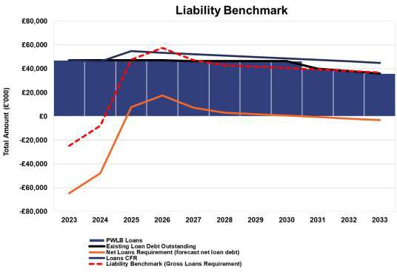
PCC will pay for capital assets through revenue each year. The PCC is also allowed to make additional voluntary payments (voluntary revenue provision - VRP).

Regulations have been issued which require the PCC to approve an MRP Statement in advance of each year. A variety of options are provided, so long as there is a prudent provision.
2.4 Minimum revenue provision (MRP) policy statement

The PCC is required to pay off an element of the accumulated capital spend each year (the CFR) and make a statutory charge to revenue for the repayment of debt, known as the minimum revenue provision (MRP). The MRP policy sets out how the
The PCC is recommended to approve the following MRP Statement:

- For capital expenditure incurred before 1 April 2008, MRP will be based on the Regulatory Method of 4% reducing. MRP will be written down over a fixed 50 year period
- For capital expenditure incurred from 1 April 2008, the MRP will be based on the ‘Asset Life Method’, whereby MRP will be based on the estimated life of the assets in accordance with the regulations.
- For finance leases, an ‘MRP equivalent’ sum will be paid off each year.

Capital expenditure incurred during a financial year will not be subject to an MRP charge until the following year, or the year after the asset becomes operational if later.

2.5 Core funds and expected investment balances

Investments will be made with reference to the core balances, future cash flow requirements and the outlook for short-term interest rates (i.e. rates for investments up to 12 months).

Table 4 below provides an estimate of the year-end balances for each resource and anticipated day-to-day cash flow balances.

Table 4  Year End Resources | 2022/23  Actual  £m | 2023/24  Revised Estimate  £m | 2024/25  Estimate  £m | 2025/26  Estimate  £m | 2026/27  Estimate  £m | 2027/28  Estimate  £m
General balances | 17.931 | 15.512 | 15.772 | 15.772 | 15.772 | 15.772
Earmarked revenue reserves | 54.506 | 56.703 | 28.626 | 25.243 | 27.106 | 30.910
Capital grants and reserves | 40.981 | 30.063 | 0.000 | 0.000 | 0.000 | 0.000
Insurance provision | 7.910 | 7.000 | 5.710 | 5.710 | 5.710 | 5.710
Total core funds | 121.328 | 109.279 | 50.108 | 46.725 | 48.588 | 52.391
Working capital* | 19.400 | 19.400 | 19.400 | 19.400 | 19.400 | 19.400
Expected investments | 140.728 | 128.679 | 69.508 | 66.125 | 67.988 | 71.791
* The working capital balance is the average difference between cash investments and core cash balances from the last 5 financial years. The actual figure will obviously vary from day to day according to circumstances.

BORROWING

The capital expenditure plans set out in Section 2 provide details of the service activities of the PCC. The treasury management function ensures that the PCC’s cash is organised in accordance with the relevant professional codes so that sufficient cash is available to meet this service activity. This will involve both the organisation of the cash flow and, where capital plans require, the organisation of
appropriate borrowing facilities. The strategy covers the relevant treasury / prudential indicators, the current and projected debt positions and the annual investment strategy.

Current portfolio position

The PCC’s borrowing portfolio position at 31 March 2023, with forward projections, is summarised below. The table shows the actual external debt (the treasury management operations), against the underlying capital borrowing need (the Capital Financing Requirement or CFR), highlighting any over or under borrowing.

Table 5  PCC Borrowing Portfolio | 2022/23  Actual  £m | 2023/24  Revised Estimate  £m | 2024/25  Estimate  £m | 2025/26  Estimate  £m | 2026/27  Estimate  £m
External Debt
Debt at 1 April | 47.178 | 47.178 | 47.178 | 56.341 | 56.341
Expected change in Debt | 0.00 | 0.00 | 9.163 | 0 | 0
Other long-term liabilities (OLTL) at 1st April | 8.102 | 5.622 | 6.000 | 6.000 | 6.000
Expected change in OLTL | (2,480) | 0.378 | 0 | 0 | 0
Actual gross debt at 31 March | 52.800 | 53.178 | 62.341 | 62.341 | 62.341
The CFR | 62,709 | 59,624 | 66,564 | 64,822 | 63,081
Under / (over) borrowing | 9.909 | 6.446 | 4.223 | 2.481 | 0.740

Within the prudential indicators there are a number of key indicators to ensure that the PCC operates their activities within well-defined limits. One of these is that the PCC needs to ensure that gross debt does not, except in the short term, exceed the total of the CFR in the preceding year plus the estimates of any additional CFR for the current and the following two financial years. This allows some flexibility for limited early borrowing for future years, but ensures that borrowing is not undertaken for revenue purposes.

The Chief Finance Officer reports that the PCC has complied with this prudential indicator in the current year and does not envisage difficulties for the future. This view takes into account current commitments, existing plans, and the proposals in this budget report.

Treasury Indicators: limits to borrowing activity

The operational boundary for external debt is based on ‘probable’ debt during the year and is a benchmark guide, not a limit. Actual debt could vary around this boundary for short periods during the year. It should act as a monitoring indicator to initiate timely action to ensure the statutory mandatory indicator (the ‘Authorised Limit’, per Table 7 below) is not breached inadvertently.

Table 6  Operational boundary | 2023/24  Estimate  £m | 2024/25  Estimate  £m | 2025/26  Estimate  £m | 2026/27  Estimate  £m | 2027/28  Estimate  £m
Debt | 47.178 | 47.178 | 56.341 | 56.341 | 56.341
Other long term liabilities | 5.622 | 6.000 | 6.000 | 6.000 | 6.000
Short Term liabilities | 20.000 | 20.000 | 20.000 | 20.000 | 20.000
Total | 72.800 | 73.178 | 82.341 | 82.341 | 82.341

The authorised limit for external debt is a key prudential indicator which provides control on the overall level of affordable borrowing. It represents a limit beyond which external debt is prohibited and needs to be set and/or revised by the PCC. It reflects the level of external debt which, whilst not necessarily desired, could be afforded in the short term, but is not sustainable in the longer term. This is the statutory limit determined under section 3 (1) of the Local Government Act 2003. The Government retains an option to control either the total of all local authority plans, or those of a specific authority (or PCC), although this power has not yet been exercised.

The PCC is asked to approve the following authorised limit:

Table 7 Authorised limit | 2023/24  Estimate  £m | 2024/25  Estimate  £m | 2025/26  Estimate  £m | 2026/27  Estimate  £m | 2027/28  Estimate  £m
Debt | 67.178 | 67.178 | 76.341 | 76.341 | 76.341
Other long term liabilities | 5.622 | 6.000 | 6.000 | 6.000 | 6.000
Short Term liabilities | 20.000 | 20.000 | 20.000 | 20.000 | 20.000
Total | 92.800 | 93.178 | 102.341 | 102.341 | 102.341

Prospects for interest rates

The PCC has appointed Link Treasury Services as his treasury advisor and part of their service is to assist the PCC to formulate a view on borrowing interest rates. The following table and subsequent paragraphs give the Link forecast view.

Table 8 | Bank Rate | PWLB Borrowing Rates (including certainty rate adjustment)
 |  | 5 year | 25 year | 50 year
 | % | % | % | %
Mar 2024 | 5.25 | 4.50 | 5.20 | 5.00
Jun 2024 | 5.25 | 4.40 | 5.10 | 4.90
Sep 2024 | 4.75 | 4.30 | 4.90 | 4.70
Dec 2024 | 4.25 | 4.20 | 4.80 | 4.60
Mar 2025 | 3.75 | 4.10 | 4.60 | 4.40
Jun 2025 | 3.25 | 4.00 | 4.40 | 4.20
Sep 2025 | 3.00 | 3.80 | 4.30 | 4.10
Dec 2025 | 3.00 | 3.70 | 4.20 | 4.00
Mar 2026 | 3.00 | 3.60 | 4.20 | 4.00
Jun 2026 | 3.00 | 3.60 | 4.10 | 3.90
Sep 2026 | 3.00 | 3.50 | 4.10 | 3.90
Dec 2026 | 3.00 | 3.50 | 4.10 | 3.90
Mar 2027 | 3.00 | 3.50 | 4.10 | 3.90

Our central forecast for interest rates was previously updated on 7th November and reflected a view that the MPC would be keen to underpin its anti-inflation credentials by keeping Bank Rate at 5.25% until at least H2 2024. We expect rate cuts to start when both the CPI inflation and wage/employment data are unequivocally supportive of such a move, and that there is a strong likelihood of the overall economy enduring tepid growth (at best) or a mild recession (at worst) over the coming months.
Naturally, timing on this matter will remain one of fine judgment: cut too soon, and inflationary pressures may well build up further; cut too late and any downturn or recession may be prolonged.
In the upcoming months, our forecasts will be guided not only by economic data releases and clarifications from the MPC over its monetary policies and the Government over its fiscal policies, but also international factors such as policy development in the US and Europe, the provision of fresh support packages to support the faltering recovery in China as well as the on-going conflict between Russia and Ukraine, and Gaza and Israel.
On the positive side, consumers are still anticipated to be sitting on some excess savings left over from the pandemic, which could cushion some of the impact of the above challenges and may be the reason why the economy is performing a little better at this stage of the economic cycle than may have been expected. Nonetheless, with approximately 400,000 households per quarter facing a mortgage interest reset at higher levels than their current rate, the economy will face on-going headwinds from that source, in addition to lower income households having to spend disproportionately on essentials such as food, energy and rent payments.

The balance of risks to the UK economy: -
The overall balance of risks to economic growth in the UK is to the downside
Borrowing advice: The 50-year PWLB Certainty Rate target for new long-term borrowing started 2023/24 at 3.50% (the lowest forecast rate within a two-year time horizon), increasing to a peak of 4.00% in November. With rates elevated across the whole of the curve, it is advised to not borrow long-term unless the Authority wants certainty of rate and judges the cost to be affordable.

Borrowing strategy

The PCC is currently maintaining an under-borrowed position. This means the capital borrowing need (the Capital Financing Requirement) has not been fully funded with loan debt as cash supporting the PCC’s reserves, balances and cash flow has been used as a temporary measure. This strategy is prudent - medium and longer dated borrowing rates are expected to fall from their current levels once prevailing inflation concerns are addressed by tighter near-term monetary policy. That is, Bank Rate remains elevated through to the second half of 2024.

Against this background and the risks within the economic forecast, caution will be adopted with the 2024/25 treasury operations. The CFO will monitor interest rates in financial markets and adopt a pragmatic approach to changing circumstances:

If it was felt that there was a significant risk of a sharp FALL in borrowing rates, then longer term borrowing will be postponed. If it was felt that there was a significant risk of a much sharper RISE in borrowing rates than that currently forecast, fixed rate funding will be drawn whilst interest rates are lower than they are projected to be in the next few years.

Any decisions will be reported to the appropriate decision-making body at the next available opportunity.

Treasury management limits on activity

There are three debt related treasury activity limits. The purpose of these are to restrain the activity of the treasury function within certain limits, thereby managing risk and reducing the impact of any adverse movement in interest rates. However, if these are set to be too restrictive they will impair the opportunities to reduce costs / improve performance. The indicators are:

63
13
- Upper limits on variable interest rate exposure. This identifies the maximum limit for variable interest rates for both borrowing and investments.
- Upper limits on fixed interest rate exposure. This is similar to the previous indicator and covers a maximum limit on fixed interest rates;
- Maturity structure of borrowing. These gross limits are set to reduce the PCC’s exposure to large fixed rate sums falling due for refinancing, and are required for upper and lower limits.

The PCC is asked to approve the following treasury indicators and limits:

Table 9
Indicator | Limit
Variable interest rate debt | No more than 50% of all debt
Debt maturing within 10 years | No more than 50% of all debt

Policy on borrowing in advance of need

The PCC will not borrow more than or in advance of its needs purely in order to profit from the investment of the extra sums borrowed. Any decision to borrow in advance will be within forward approved Capital Financing Requirement estimates, and will be considered carefully to ensure that value for money can be demonstrated and that the PCC can ensure the security of such funds.

Debt rescheduling

Rescheduling of current borrowing in our debt portfolio would be considered in the event premature redemption rates providing an opportunity.

The reasons for any rescheduling to take place will include:
- the generation of cash savings and / or discounted cash flow savings;
- helping to fulfil the treasury strategy;
- enhance the balance of the portfolio (amend the maturity profile and/or the balance of volatility).

Any rescheduling undertaken will be reported formally to the PCC in the next quarterly performance update.

ANNUAL INVESTMENT STRATEGY

Investment policy

The Department of Levelling Up, Housing and Communities (DLUHC) and CIPFA have extended the meaning of ‘investments’ to include both financial and non-financial investments. This report deals solely with financial investments, (as managed by the
treasury management team). Non-financial investments, if required, are covered in the separate Annual Capital Strategy.

The PCC’s investment policy has regard to the following: -

- DLUHC’s Guidance on Local Government Investments (“the Guidance”)
- CIPFA Treasury Management in Public Services Code of Practice and Cross Sectoral Guidance Notes 2021 (“the Code”)
- CIPFA Treasury Management Guidance Notes 2021

The PCC’s investment priorities will be security first, liquidity second, then return.

In the current economic climate, it is considered appropriate to maintain a degree of liquidity to cover cash flow needs but to also consider “laddering” investments for periods up to a year with high credit rated financial institutions, whilst investment rates remain elevated, as well as wider range fund options.

In accordance with the above guidance from the DLUHC and CIPFA, and in order to minimise the risk to investments, the PCC applies minimum acceptable credit criteria in order to generate a list of highly creditworthy counterparties which also enables diversification and thus avoidance of concentration risk. The key ratings used to monitor counterparties are the Short Term and Long Term ratings.

Ratings will not be the sole determinant of the quality of an institution; it is important to continually assess and monitor the financial sector on both a micro and macro basis and in relation to the economic and political environments in which institutions operate. The assessment will also take account of information that reflects the opinion of the markets. To this end the PCC will engage with its advisors to maintain a monitor on market pricing such as “credit default swaps” and overlay that information on top of the credit ratings.

Other information sources used will include the financial press, share price and other such information pertaining to the banking sector in order to establish the most robust scrutiny process on the suitability of potential investment counterparties.

Investment instruments identified for use in the financial year are listed in appendix 5.2 under the ‘specified’ and ‘non-specified’ investments categories. Counterparty limits will be as set through the Council’s treasury management practices – schedules.

As a result of the change in accounting standards for 2023/24 under IFRS 9, this Authority will consider the implications of investment instruments which could result in an adverse movement in the value of the amount invested and resultant charges at the end of the year to the General Fund. (In November 2018, the MHCLG, concluded a consultation for a temporary override to allow English local authorities time to adjust their portfolio of all pooled investments by announcing a statutory override to delay implementation of IFRS 9 for five years ending 31.3.23. More recently, a further extension to the over-ride to 31.3.25 has been agreed by Government.

Creditworthiness policy

The PCC applies the creditworthiness service provided by Link Treasury Services. This service employs a sophisticated modelling approach utilising credit ratings from the three main credit rating agencies - Fitch, Moody’s and Standard and Poor’s. The credit ratings of counterparties are supplemented with the following overlays:

- credit watches and credit outlooks from credit rating agencies;
- CDS spreads to give early warning of likely changes in credit ratings;
- sovereign ratings to select counterparties from only the most creditworthy countries.

This modelling approach combines credit ratings, credit Watches and credit Outlooks in a weighted scoring system which is then combined with an overlay of CDS spreads for which the end product is a series of colour coded bands which indicate the relative creditworthiness of counterparties. These colour codes are used by the PCC to determine the suggested duration for investments. The PCC will therefore use counterparties within the following durational bands.

- Yellow 5 years
- Purple 2 years
- Blue 1 year (only applies to nationalised or semi nationalised UK Banks)
- Orange 1 year
- Red 6 months
- Green 100 days
- No colour not to be used

Y Pi1 Pi2 P B O R G N/C
1 | 1.25 | 1.5 | 2 | 3 | 4 | 5 | 6 | 7
Up to 5yrs Up to 5yrs Up to 5yrs Up to 2yrs Up to 1yr Up to 1yr Up to 6mths Up to 100days No Colour

The Link Asset Services’ creditworthiness service uses a wider array of information than just primary ratings. Furthermore, by using a risk weighted scoring system, it does not give undue preponderance to just one agency’s ratings.

Typically the minimum credit ratings criteria the PCC uses will be a Short Term rating (Fitch or equivalents) of F1 and a Long Term rating of A-. There may be occasions when the counterparty ratings from one rating agency are marginally lower than these ratings but may still be used. In these instances consideration will be given to the whole range of ratings available, or other topical market information, to support their use.

All credit ratings will be monitored weekly. The PCC is alerted to changes to ratings of all three agencies through its use of the Link Asset Services’ creditworthiness service:

- if a downgrade results in the counterparty / investment scheme no longer meeting the PCC’s minimum criteria, its further use as a new investment will be withdrawn immediately.

- in addition to the use of credit ratings the PCC will be advised of information in movements in credit default swap spreads against the iTraxx benchmark and other market data on a daily basis via its Passport website, provided exclusively to it by Link Asset Services. Extreme market movements may result in downgrade of an institution or removal from the PCC’s lending list.

Sole reliance will not be placed on the use of this external service. In addition the PCC will also use market data and market information, information on any external support for banks to help support its decision making process.

Creditworthiness.

Significant levels of downgrades to short and Long-Term credit ratings have not materialised since the crisis in March 2020. In the main, where they did change, any
alterations were limited to Outlooks. Nonetheless, when setting minimum sovereign debt ratings, this Authority will not set a minimum rating for the UK.

Although bank CDS prices, (these are market indicators of credit risk), spiked upwards during the days of the Truss/Kwarteng government in the autumn of 2022, they have returned to more average levels since then. However, sentiment can easily shift, so it will remain important to undertake continual monitoring of all aspects of risk and return in the current circumstances. Link monitor CDS prices as part of their creditworthiness service to local authorities and the Authority has access to this information via its Link-provided Passport portal.

Country limits

The PCC has determined that it will only use approved counterparties from countries with a minimum sovereign credit rating of AA- from Fitch (or equivalent). The list of countries that qualify using this credit criteria as at the date of this report are shown in Appendix
5.3. This list will be added to, or deducted from, by officers should ratings change in accordance with this policy.

The UK is excluded from any stipulated minimum sovereign rating requirement.

Investment strategy

Investments will be made with reference to the core balance and cash flow requirements and the outlook for short-term interest rates (i.e., rates for investments up to 12 months).

Greater returns are usually obtainable by investing for longer periods. The current shape of the yield curve suggests that is the case at present, but there is the prospect of Bank Rate having peaked in the second half of 2023 and possibly reducing as early as the second half of 2024 so an agile investment strategy would be appropriate to optimise returns.

The current forecast shown in paragraph 3.3, includes a forecast for Bank Rate to have peaked at 5.25%.

Investments of up to 2 years will also be allowed with the Royal Bank of Scotland Group. No material change in Government ownership is expected during that period. This policy will potentially enable the PCC to lock in investment returns whilst continuing to adopt a low risk approach.

The suggested budgeted investment earnings rates for returns on investments placed for periods up to about three months during each financial year are as follows: -

Average earnings in each year
2023/24 (residual) | 5.30%
2024/25 | 4.55%
2025/26 | 3.10%
2026/27 | 3.00%

2027/28 | 3.25%
Years 6 to 10 | 3.25%
Years 10+ | 3.25%

As there are so many variables at this time, caution must be exercised in respect of all interest rate forecasts

Environmental, Social & Governance (ESG) Considerations
The CIPFA Treasury Management Code of Practice 1.13 states that “Environmental, social and governance (ESG) issues are increasingly significant for investors and investment managers. This is better developed in equity and bond markets than for short-term cash deposits, and there is a diversity of market approaches to ESG classification and analysis. This means that a consistent and developed approach to ESG for public service organisations is currently difficult. Organisations are therefore recommended to consider their credit and counterparty policies in light of ESG information and develop their own ESG investment policies and treasury management practices consistent with their organisation’s own relevant policies, such as environmental and climate change policies. It is not expected that the organisation’s ESG policy will currently include ESG scoring or other real-time ESG criteria at individual investment level.”

The PCC invests in short-term cash deposits. In line with the expectations of the Code it is not proposed to include additional ESG criteria at individual investment level. ESG risks are considered primarily for their potential financial impact. The credit and counterparty policies outlined in this document include a proportionate consideration of the ESG risks, since credit rating agencies incorporate ESG considerations into their evaluations. Further restrictions would risk narrowing available counterparties and reducing Yield obtainable without benefitting Security or Liquidity, and therefore would be inconsistent with the treasury management principles.

Changes in Investment Strategy
There are now several alternative types of investment opportunity which could, potentially, yield greater returns than cash deposits:

- Ultra-short dated bond Funds
- Corporate Bonds - direct, passive and active external management (including Short-Dated Bond Funds)
- Multi Asset Funds
- Property Funds
- Equity Funds

However investing in these types of instruments would be a fundamental change of investment strategy. The PCC wishes to maintain the prudent approach of security of funds in the first instance.

Investment treasury indicator and limit - total principal funds invested for greater than one year. These limits are set with regard to the PCC’s liquidity requirements and to reduce the need for early sale of an investment, and are based on the availability of funds after each year-end. A limit of £20m is recommended in order to provide officers with flexibility to take advantage of time and cash limited offers, which sometimes exceed a
year when initially offered, or to place deposits for up to 2 years in order to lock in investments returns whilst continuing to adopt a low risk approach.

The PCC is asked to approve the treasury indicator and limit:

Table 10
Indicator | Limit
Principal sums invested over one year | £20m

Investment risk benchmarking

The PCC has approved benchmarks for investment Security, Liquidity and Yield.

These benchmarks are simple guideline targets (not limits) and so may be breached from time to time, depending on movements in interest rates and counterparty criteria. The purpose of the benchmark is that officers will monitor the current and trend position, and amend the operational strategy depending on any changes.

The proposed benchmarking targets for 2024/25 are set out below:

- Security - the PCC’s maximum security risk benchmark for the current portfolio, when compared to historic default tables, is:
  - 0.25% historic risk of default when compared to the whole portfolio.

- Liquidity – in respect of this area the OPCC seeks to maintain:
  - Bank overdraft limit - £0.1m
  - Liquid short-term deposits - including the receipt of government grants, council tax precept income and use of short-term borrowing - of at least
£5m available within one week.
  - ‘Weighted Average Life’ benchmark - 9 months (270 days), with a maximum of 2 years.

- Yield – performance target is to achieve:
  - An average return above SONIA compounded rates (i.e. the bespoke TVP benchmark).

Any breach of the indicators or limits will be reported to the PCC, with supporting reasons, in the quarterly performance monitoring reports. Members of the Joint Independent Audit Committee will also be notified.

End of year investment report

At the end of the financial year the Chief Finance Officer will report on the investment activity as part of his Annual Treasury Report.

Appendices

  - Economic background (as provided by Link on 17.01.2024)

69
19

The UK Manufacturing PMI fell to 46.2 in December, down from 47.2 in the prior month and missing market expectations of 47.5. The latest reading pointed to a reduction in manufacturing output for the tenth consecutive month and at a notably faster pace than in November. Production sustained its decline due to reports of reduced demand both at home and abroad amidst challenging economic conditions, as well as destocking activities and tighter inventory policies at plants.

Conversely, the UK Services PMI rose to 53.7 in December of from 50.9 in the previous month, above expectations of 51, marking the second consecutive expansion in the UK’s services sector and outperforming the contractions in Eurozone members. Consequently, the Composite PMI rose to 51.7 in December, up from 50.7 in the previous month and surpassing the market consensus of 50.9. Meanwhile, the UK Construction PMI edged down to 45.5 in November, barely shifting from October’s value of 45.6 and falling short of market expectations set at
46.3. This latest reading marks the second-lowest point since May 2020.

The UK economy shrank 0.3% m/m in October, reversing the growth from the previous two months, and worse than market forecasts of a flat reading. The services sector shrank 0.2% and was the largest contributor to the fall. Meanwhile, output in consumer-facing services fell by 0.1%. Also, production declined 0.8% driven by widespread drops in manufacturing output, namely computer, electronic and optical products, and machinery and equipment while construction output went down 0.5% partly due to the poor weather.

Considering the three months to October, UK GDP stalled. Elsewhere, the UK's trade deficit widened to £4.480 billion in October, the largest in five months, as imports jumped 4.6% to a four-month high and exports rebounded 0.6% from an over one-year low.

The UK registered an increase of 50,000 jobs in the three months to September, slightly lower than a downwardly revised 52,000 gain in the previous reading. Meanwhile, average weekly earnings, including bonuses in the UK increased 7.2% y/y in the three months to October, the lowest in five months and below market forecasts of a 7.4% rise. The adjusted “experimental” unemployment rate in the UK remained unchanged at 4.2% in the three months leading up to October. The adjusted “experimental” employment rate stood at 75.7%, and the economic inactivity rate remained unchanged at 20.9%.

Regarding inflation, the annual consumer price measure in the UK declined to 3.9% in November, the lowest since September 2021, from 4.6% in October and well below forecasts of 4.4%. The largest downward contribution came from transport, mainly downward effects from motor fuels and, to a lesser extent, second-hand cars,maintenance and repairs, and air fares. Other downward pressure came from prices for recreation and culture, namely computer games and admission fees to theatres and live music events; and food and non-alcoholic beverages, mostly bread and cereals. Prices also rose less for alcoholic beverages and tobacco, clothing and footwear andhealth and continued to fall for housing and utilities. On the other hand, inflation was steady for communication, education and restaurants and hotels.

Annual core inflation also declined, with its 5.1% reading the lowest since January 2022.

In the retail sector, November witnessed a 1.3% m/m increase in sales, a stark contrast to October's stagnant growth and beating market forecasts of a 0.4% rise. It was the strongest growth in retail activity since January. Additionally, the GfK
Consumer Confidence indicator rose to -22 in December from -24 in November as Britons became less pessimistic about their future financial situation amid easing inflationary pressures. Analysts noted that wages have begun to rise faster than inflation while mortgage rates eased from their summer peak.

Elsewhere, Public sector net debt excluding public sector banks was £2,671.4 billion at the end of November and was provisionally estimated at around 97.5% of the UK's annual gross domestic product (GDP); this is 1.8 percentage points higher than in November 2022 and remains at levels last seen in the early 1960s.
  - Credit and Counterparty Risk Management Specified and Non-Specified Investments and Limits Specified Investments
‘Specified’ investments are sterling investments of not more than one-year maturity made with any institution meeting the minimum ‘high’ quality criteria where applicable.

Non-Specified Investments

These are any investments which do not meet the specified investment criteria which may include more complex instruments which require greater consideration before being authorised for use. A maximum of 50% will be held in aggregate in non-specified investment.

A variety of investment instruments will be used, subject to the credit quality of the institution, and depending on the type of investment made it will fall into one of the above categories.

Investments of up to 2 years will continue to be allowed with the Royal Bank of Scotland (RBS) Group, since no material change in Government ownership is expected during that period. This policy will potentially enable the PCC to lock in investment returns whilst continuing to adopt a low risk approach.

The proposed criteria for (a) Specified and (b) Non-Specified investments are presented below for approval.

Specified Investments

These investments are sterling investments of not more than one-year maturity, or those which could be for a longer period but where the PCC has the right to be repaid within 12 months if it wishes.
.
 | Minimum credit criteria / colour band | Maximum investment per institution | Maximum maturity period

The PCC’s own banker if it fails to meet the basic credit criteria. In  this instance balances will be minimised as far as is possible. |  | Minimal
DMADF – UK Government | N/A | No limit | 6 months
Money Market Funds (MMF) – (Low Volatility Net Asset Value) & (Constant Net Asset Value) | AAA rating and minimum asset base of £500m | £25m or 1% of total asset base per fund whichever is the  lower figure | Liquid (instant access)
Money Market Funds (MMF) – (Variable Net Asset Value) | AA- rating and minimum asset base of £500m | £10m or 1% of total asset base per fund whichever is the lower figure | Repayment within 1 year
Ultra- and Short-Dated Bond Funds (Variable Net Asset Value) | AA- rating and minimum asset base of £500m | £10m or 1% of total asset base per fund whichever is the  lower figure | Repayment within 1 year
Local authorities | N/A | £20m | 1 year
Term deposits with banks and building societies | Blue Orange Red Green | £20m  £20m  £20m  £15m | Up to 1 year Up to 1 year Up to 6 months Up to 100 days
CDs or corporate bonds with banks and building societies | Blue Orange Red Green | £20m  £20m  £20m  £15m | Up to 1 year Up to 1 year Up to 6 months Up to 100 days
Housing Associations | A- | £5m | Up to 1 year

Non-Specified Investments

Non-specified investments are any other type of investment (i.e. not defined as ‘specified’ above). The identification and rationale supporting the selection of these other investments, and the maximum limits to be applied, are set out below.

Non-specified investments would include any sterling investments with:

 | Minimum credit criteria / colour  band | Maximum investment per  institution | Maximum maturity period
Local authorities | N/A | £20m | 5 years
Term deposits with banks and building societies | Purple Blue (RBS) | £20m  £20m | Up to 2 years Up to 2 years
CDs or corporate bonds with banks and building societies | Purple Blue (RBS) | £20m  £20m | Up to 2 years Up to 2 years
Housing Association | A- | £5m | Up to 2 years

Investments of up to 370 days will be treated as 1 year investments. This simplifies investment timings, for example where the maturity date is over a long weekend.

  - Approved Countries for investments

Link show the lowest rating from Fitch, Moody’s and S&P (the 3 main ratings agencies) including banks operating in sterling markets which have credit ratings of green or above in the Link creditworthiness service.

AAA
Australia Denmark Germany Netherlands Norway Singapore Sweden Switzerland

AA+
Canada Finland U.S.A.

AA
Abu Dhabi (UAE)

AA-
Belgium
France (downgraded by Fitch on 9th May 2023) Qatar
U.K.

THIS LIST IS AS AT 31.12.23
AGENDA ITEM 6

73

OPCC Financial Delegations – from 1 April 2024

These processes cover the main financial activity within the OPCC. In general, the OPCC follows the same principles as the Force for consistency, to avoid duplication and reduce the risk of confusion.
Purchases

Purchase Value | Supplier Selection | T&Cs | Purchase  Approval | Publish  Decision | Finance  Team
<£10k | Consider VfM | CFO  approval for non- standard T&Cs | Cost Centre Approver* | Not required | Check approvals and raise PO
£10k - £50k | Three written quotes
£50k - £200k | Tender process with Procurement support | CFO  approval for non- standard T&Cs | CFO | Reported to  PAM | Check approvals and raise PO
£200k - £1m
>£1m | Tender process with Procurement support | CFO  approval for non- standard T&Cs | CFO + CoS + PCC | PCC Website | Check approvals and raise PO

Grants Commissioning

Grant Value | Provider Selection | T&Cs | Grant Approval | Publish  Decision | Finance  Team
<£10k | Consider VfM | CFO  approval for non- standard T&Cs | Cost Centre Approver* | Simple awards list on PCC Website | Check approvals and raise PO
£10k - £50k | Request three bids
£50k - £200k | Tender process with Procurement support | CFO  approval for non- standard T&Cs | CFO | Simple awards list on PCC Website | Check approvals and raise PO
£200k - £1m
>£1m | Tender process with Procurement support | CFO  approval for non- standard T&Cs | CFO + CoS + PCC | PCC Website | Check approvals and raise PO

*Cost Centre Approvers

Budget | Delegated  Authority | Cost Centre Approver | Deputy (if absent)
All OPCC held budgets | £1m | Chief Finance Officer | Corporate Accountant
All OPCC held budgets | £50k | Chief of Staff | N/A
Externally Funded: Victims | £50k | Head of Victims Services | Deputy Head of Victims  Services
Externally Funded: Victims | £10k | Deputy Head of Victims  Services | N/A
Externally Funded: Partnerships  Crime Prevention Fund & Partnership Fund | £50k | Head of Partnerships & Community Safety | N/A
Externally Funded: Partnerships Crime Prevention Fund & Partnership Fund  (On codes where approver is Project Manager) | £10k | Partnerships Delivery Manager & Project Manager | N/A
Crime Prevention Fund  (Comms spend – SQY/PA) | £10k | Comms & Engagement  Manager | N/A
Externally Funded: VRU  Refer to note below | £50k | Head of Violence  Reduction Unit | N/A
OPCC office budget (SQR) | £ 1k | Any SMG Member | N/A

Purchasing / Commissioning Notes

Standard Terms & Conditions are found on the website: Contracts and tenders - Thames Valley PCC (thamesvalley-pcc.gov.uk). Any variation to these requires approval from the CFO.

In exceptional circumstances regarding Provider Selection, contact the Head of Procurement for advice (in line with Force procurement process), and obtain CFO approval for exceptions. For example, a competition would not be required where an external funder specifies the provider (“Flow Down” grants). Note that a competition is not required where grants are made to other public sector organisations.
If a change to a contract causes the total value to move to a higher level, then the change must be approved at the new higher level.

Accepting Grants

Grant Value | Decision  to Bid | T&Cs | Acceptance | Publish  Decision | Finance  Team
<£10k | CFO + CoS | CFO | CFO | Not required (unless public interest) | Create APTOS  budget
£10k - £50k
£50k - £200k
£200k - £1m
>£1m | CFO + CoS | CFO | CFO + CoS + PCC | Not required (unless public interest) | Create APTOS  budget

Staffing

Changes to establishment must be approved by the Chief of Staff and CFO.
Reward payments under the rewards scheme (up to £500) are approved by SMG meetings. Reward payments for other SMG members are approved by the Chief of Staff and CFO.
All severance payments (including settlement of industrial tribunals) and payments to staff over
£10k must be approved by Chief of Staff, CFO and the PCC.
Other staff payments (including overtime) under £10k can be approved by the Chief of Staff or CFO – note that approval must be sought in advance of working the overtime (except in an emergency).
Recruitment to existing posts is approved by CFO in ECRIS.

Financial Planning & Monitoring

Quarterly reviews are held in detail with each budget manager Quarterly reports to SMG summarise the financial position Independent Panels
The Executive Assistant approves Allowances and Expenses for JIAC, PESP and ISOB up to £10k

Credit Cards

Credit Cards are held by the Corporate Accountant and Executive Assistant to facilitate low value spend which is either urgent or unduly burdensome to set up via Purchase Order. This should not be used to circumvent the official process. The process will follow the force Credit Card guidance.

Violence Reduction Unit (VRU)

As the VRU transitions, delegated authorities came under the OPCC from 1 April 2023. Most processes are not amended: existing contracts will not be novated to the PCC, staff will continue to be formally employed by the CC (with the exception of the new Head of VRU), and Force Finance will continue to provide business partnering and process administration. Where expenditure does come directly under the PCC (eg Crime Prevention Fund spend) then OPCC Finance processes will apply.
The CFO will attend VRU quarterly financial reviews.

Martin Thornley, CFO Approved: Matthew Barber, PCC, 22 March 2024


OFFICE OF THE POLICE & CRIME COMMISSIONER FOR THAMES VALLEY

Date
Signature
Police and Crime Commissioner

I hereby approve the recommendation above
Report for Information – PAM Meeting
Title: Income Charging Rates 2024/25
Executive Summary:

There are a limited range of activities where it is appropriate for the Force to make charges to individuals or organisations to recover costs of policing services provided. To ensure consistency across the services requested these rates have become standardised nationally for 2024/25 and are set in accordance with National Police Chiefs Council (NPCC) guidelines for charging for police services. This report sets out the Fees and Chargeable rates applicable for 2024/25.

Recommendation:

The PCC is invited to note the current fees and chargeable rates for 2024/25.

PART I – NOT CONFIDENTIAL

- Introduction and background Fees and Charges
  - The police service is generally provided out of public funds for the benefit of the public at large. However there is a limited range of activities where it is appropriate for the force to make charges to individuals and/or organisations to recover costs. Ensuring that charges are levied effectively in such circumstances protects the public police provision and contributes to the overall funding of the service.

  - The ability to charge for police services is determined by statutory provision. To provide consistency across the service, the National Police Chiefs Council (NPCC) agree fee levels and charging methodologies.

  - Since the guidance was last published Blue light Commercial BLC have undertaken a national review of SPS rates. Standard National Rates have now been introduced for Intellectual property and a rate for the escorting of abnormal loads. A review on Firearms licensing rates has also begun and is currently awaiting decision prior to the publication of the new statutory instrument in early 2024.

  - The proposed rates for policing services provided to third parties have been set in accordance with the officer’s region (rates adapted for regional allowances) and whom the services are being provided to.

Issues for consideration Fees and Charges
  - TVP follows NPCC national guidance in respect of all fees and charges. Appendix 1 provides details of the current fees and chargeable rates. These include:

    - Statutory Charges – Such as firearms licence fees which are set nationally and are monitored on an individual basis by the relevant department.
    - Other Fees and Charges – Such as the provision of copy statements and accident reports, alarms, illegal immigrants etc.
    - Income for the Provision of Policing Services - from third parties, Special Services Income.

Financial Comments

  - The Force’s annual revenue budget and medium term financial plan both include full estimates of all funding streams including chargeable activities.

Legal comments

  - All charges are made in accordance with the various statutory provisions.

Equality comments

5.1 No specific implications arising from this report

Conclusion

  - The Force is actively pursuing income streams and receives funding and support from a number of sources. TVP follow NPCC and APCC national guidance in respect of all fees and charges.

Background papers

    - TVP Prop Fees Charges Excl. S25 2024-25
Is there a Part 2 form? No
Public access to information
Information in this form is subject to the Freedom of Information Act 2000 (FOIA) and other legislation. Part 1 of this form will be made available on the website within 1 working day of approval. Any facts and advice that should not be automatically available on request should not be included in Part 1 but instead on a separate Part 2 form. Deferment of publication is only applicable where release before that date would compromise the implementation of the decision being approved.

Name & Role | Officer
Head of Unit  National Police Chiefs’ Council National charging policies are followed when applying charges and fees. | Director of Finance
Legal Advice  Charges are calculated in accordance with national guidelines | Chief Executive
Financial Advice  Charges are appropriately applied in accordance with legislation. | PCC Chief  Financial Officer
Equalities & Diversity  No specific implications arising from this report | Director of Finance

STATUTORY OFFICERS’ APPROVAL
We have been consulted about the proposal and confirm that financial and legal advice have been taken into account in the preparation of this report.

We are satisfied that this is an appropriate request to be submitted to the Police and Crime Commissioner.
Director of Finance
Date:
Chief Finance Officer
Date:



Proposed Fees & Chargeable Rates 2024/25



Thames Valley Police uses the National Police Chiefs’ Council (NPCC) National Policing Guidelines on Charging for Police Services. The current version is applicable from 1 April 2024.

CONTENTS

Description Page

- Accident / Collision Reports 3
- Civil Courts/Tribunals 4
- Photographs & Recordings 4
- Digital Data 5
- Multimedia 5
- Witness Statements 5
- Other Reports / Fee 6
- ACRO Services 7
- Requests for Disclosure of information 7
- Cancellation Charges 8
- Firearms 8
- Intellectual Property and Copyright 9
- Special Police Services (Incl. Football) – Commercial Events 10
- Special Police Services (Incl. Football) – Non-commercial events 11
- Special Police Services (Incl. Football) – Government Bodies 12
- Specialist Units 13
- Notes 13
- ACCIDENT / COLLISION REPORTS

CHARGE FOR: | 2024-25 RATE (£)
Copy of Collision Report Book | 123.30 | per report  per page per report  per video/DVD per page  per report  per report per plan  per report per report per page per item  per item per report  per report
(Includes sketches and statements therein up to 30 pages)
Additional pages (in relation to the same collision) | 5.50
Fatals – Copy of Collision Investigation Report | 529.00
(Include report, statements, plans, photos, vehicle examination,
reconstruction)
Fatals – Reconstruction video / DVD | 105.50
Unprocessed electronic data obtained at the scene of a collision (Rough | 35.20
Data)
Limited Particulars (RTAs) (Names & addresses of drivers & registered | 43.80
keepers, insurance companies, date and location of collision, name and
number of officer dealing – unless provided as part of a full report
Copy of Self Reporting Form | 43.80
Copy of Scale Plan (other than in collision book) | 53.00
Forensic Collision Investigator / Forensic Vehicle Examiner – Vehicle | 87.90
Examination Report (unless provided as full extract)
Forensic Collision Investigator / Forensic Vehicle Examiner – Vehicle | 5.50
Reconstruction Report (unless provided in full report)
Additional pages (unless part of full extract) – Maximum £50.00 | 5.50
Forensic Collision Investigator – adhoc requested services | per hour +
 | 65.60
Specialist Report – (CCTV/Tachograph/ Vehicle download) if separate | 92.10
External Expert Report – Requested by Force | 82.10
External Expert Report – Requested by External Party | cost of
 | report +
 | 82.10

Information / Record Search | 30.40 | per item

- CIVIL COURTS / TRIBUNALS

CHARGE FOR: | 2024-25 RATE (£)
Interview with a Police Officer in a civil case (First two hours) | 177.70 | per officer
Interview with a Police Officer in a civil case (subsequent hours) | 88.85 | per hour
Request for statement written by Police Officer in a civil case | 177.70 | per statement
Court Attendance by Police Officer in a civil case (Minimum 4 hours) | 355.40 | per officer
Court Attendance by Police Officer in a civil case (subsequent hours) | 88.85 | per hour
Notes:
Where the police officer is of a rank other than Police Constable the
appropriate hourly rate shown in section 10 (Special Police Services)
should be used.
In Civil cases any additional expenses such as travel, subsistence,
accommodation and vehicle hire will be recharged at cost.

- COPIES OF PHOTOGRAPHS & RECORDINGS

CHARGE FOR: | 2024-25 RATE (£)
From Digital Camera | 36.30 | per disc or contact sheet
Curated Photo Sets | 71.60 | per 10 photos or part thereof
Video Footage – Police (handheld, drone, vehicle mounted or body warn video) | per hour +  36.30 | per hour rate for reviewing & redaction
3D Virtual World – Simulations / Fly Throughs – Already Prepared | 35.70 | per item
3D Virtual World – Simulations / Fly Throughs – Requested | per hour +  35.70 | per item
Dashcam, Drone & CCTV footage – Public/Private | 36.30 | per item

- DIGITAL DATA

CHARGE FOR: | 2024-25 RATE (£)
Laser Scan Data – Raw/ Registered Point Cloud | 75.20 | per item
Skid test & survey data – Raw/ Registered | 31.70 | per item
Skid test & survey data – Digital Mapping | 75.20 | per item
Video recording aligned to digital mapping/ survey data | 75.20 | per item
Vehicle digital data download –IDR/Blackbox/Tachograph/ Infotainment | 75.20 | per item

- COPIES OF MULTIMEDIA ITEMS

CHARGE FOR: | 2024-25 RATE (£)
Additional Audio Tapes (provision for CJS) | 105.80 | per tape
Additional Video Tapes (provision for CJS) | 105.50 | per tape
DVDs from Digital Video | 105.80 | per DVD
Copies of CDs/DVDs | 34.00 | per CD/DVD

- COPIES OF WITNESS STATEMENTS

CHARGE FOR: | 2024-25 RATE (£)
Copy of a Statement (other than in booklets) per statement – up to 3 pages | 45.30 | per statement
Additional pages | 5.50 | per page
Copy of witness statement where witness agrees to disclose personal details | 53.00 | per statement

Copy of witness statement where witness does not agree to disclosure of personal details | 70.00 | per statement

- OTHER REPORTS / FEES

CHARGE FOR: | 2024-25 RATE (£)
Disclosure of Information - initial fees for up to 2 hours work | 111.70 | per request per interview  per report  per set per set  per record per certificate  per request per request per request per request  per request per request per request  per request per request per request  per request
Organisations wanting to Interview a Police Officer | 177.70
Copies of Custody Records (PIC Records)  (over & above those legally provided free of charge) | 22.50
Fingerprinting Fees – One Set | 99.30
Fingerprinting Fees – Additional sets thereafter (each) | 49.70
PLEASE NOTE THERE IS NO CHARGE FOR PRINTS FOR CRB
Copy of interview record (where prepared during investigative process) | 70.50
Pedlars Certificate | 12.25
Data Protection Act 1998 Fees*
(SI 2000/191)
DPA 1998 – Section 7 Subject Access Request | N/A
DPA 1998 – Section 68 Health Records (Copy) | N/A
DPA 1998 – Section 68 Health Records (View) | N/A
DPA 1998 – Section 68 Health Records (View & then Copy) | N/A
Alarm Registration & Lone worker URN Fees
(Set by NPCC Security Systems Group)
Alarm Registration (Intruder) | 55.60
Alarm Registration (Hold Up Alarm) | 55.60
Reduced combined Intruder / Personal Attack/Hold Up Alarm | 79.34
Registration Fee
Lone Worker Devices URN (Under 10,000) | 67.10
Lone Worker Devices URN (10,000 – 50,000) | 100.70
Lone Worker Devices URN (Above 50,000) | 134.30
CAT 5 Vehicle Tracking SOCs | 64.10

*Disclosure of any documents, images or data held by a Police Force is subject to any such disclosure being lawful, in accordance with legal professional privilege and being in compliance with the General Data Protection Regulation 2016/679 data protection and privacy (as amended).

- ACRO Services

CHARGE FOR: | 2024-25 RATE (£)
PNC Names Enquires | 16.00 | per request
PNC Record Creation | 97.80 | per record
International Criminal Convictions | 33.00 | per request
Police Certificates – Standard Service | 65.00 | per certificate
Police Certificates – Premium Service | 115.00 | per certificate
International Child Protection Certificates | 90.00 | per certificate

*provided only to authorised agencies with a lawful basis to information.

- REQUESTS FOR THE DISCLOSURE OF INFORMATION

CHARGE FOR: | 2024-25 RATE (£)
Request for information (up to 2 hours work) | 111.70 | per request
Hourly rate for work above 2 hours (including redaction) | 37.50 | per request
ABI / Lloyds Disclosure of Information (ABI/Lloyds MOU)
Request (Crime/lost property number, etc.) – MOU App D(a) | 35.80 | per request
Request (In response to specific questions) – MOU App D(b) | 152.50 | per request
Interview with Police Officer (per Officer) – MOU Para 4.5 | 169.90 | per request
Other common items
Crime Report | 112.00 | per report
MG5 | 44.70 | per copy
MG3 | 44.70 | per copy
Incident Log | 45.50 | per copy
Domestic Violence Report | 67.30 | per report

Occurrence Summary | 22.60 | per copy
Custody Record | 22.50 | per copy

- CANCELLATION CHARGES

Cancellation of requests may incur a charge, if received after work has started on any service. If received before any work has commenced, no charge should be made. If received immediately prior to despatch of requested item(s), full charge should be made. Cancellation requests received where the request is part complete should be charged accordingly.

- FIREARMS

CHARGE FOR | 2024-25 RATE (£)
Firearms Certificate (FAC)
Grant (Form 201) | 88.00 | Per certificate
Renewal (Form 201) | 62.00 | Per certificate
Variation – one for one (Form 202) | 0.00 | Per certificate
Variation – not like-for-like (Form 202) | 20.00 | Per certificate
Replacement | 4.00 | Per certificate
Visitors Permit (single) (Form 107) | 20.00 | Per certificate
Visitors Permit (6+) (Form 107) | 100.00 | Per certificate
Shotgun Certificate (SGC)
Grant (Form 201) | 79.50 | Per certificate
Renewal (Form 201) | 49.00 | Per certificate
Replacement | 4.00 | Per certificate
Co-Terminus with FAC Grant (Form 201) | 90.00 | Per certificate
Co-Terminus with FAC Renewal (Form 201) | 65.00 | Per Certificate
Registered Firearms Dealer
Grant (Form 116) | 200.00 | Per certificate
Renewal (Form 116) | 200.00 | Per certificate
Temporary Transfer In – Games Fairs | 13.00 | Per certificate
Museum License
Grant | 200.00 | Per licence
Extension to additional premises | 0.00 | Per licence

Home Office Club Approval | 84.00 | Per licence

- Intellectual Property Right and Copyright

CHARGE FOR | 2024-25 RATE (£)
Usage | Region/Type | Time Limited  Used | In Perpetuity
Still Images £ per image
Books | UK | 100 | 200
 | Europe | 110 | 220
 | Worldwide | 120 | 240
Newspapers & Magazines | Single Use | 110 | N/A
Internet | Non-Commercial | 65 | N/A
 | Commercial | 175 | N/A
TV/Film | UK | 120 | 275
 | Europe | 175 | 350
 | Worldwide | 275 | 550
Footage £ per 15 Seconds
TV/Film | UK | 120 | 245
 | Europe | 175 | 370
 | Worldwide | 275 | 585
Internet | Non-Commercial | 65 | N/A
 | Commercial | 175 | N/A

  - SPECIAL POLICE SERVICES RATES - Services provided at commercial events

 | 2024-25 COST PER HOUR (£)
Rank / Grade | Normal Hourly Rate | Short Notice/Public Holiday Premium | Enhanced Hourly Rate
Police Special | 42.53 | Refer Below | Refer Below
Police Constable | 85.06 | Refer Below | Refer Below
Police Sergeant | 105.36 | Refer Below | Refer Below
Police Insp | 102.50 | - | 102.50
Police C/Insp | 108.84 | - | 108.84
Police Supt | 134.71 | - | 134.71
CCTV Operator | 33.54 | 5.20 | 38.74
Mounted Section Groom | 36.78 | 7.09 | 43.87
PCSO** | 60.82 | 8.65 | 69.47
CRED Operator | 39.40 | 8.47 | 47.87
CRED Team Leader | 43.30 | 10.92 | 54.22
Custody Manager | 43.30 | 10.92 | 54.22
Custody Officer | 39.40 | 8.47 | 47.87
ANPR Operator | 43.30 | 10.92 | 54.22
Logistics Officer (Police Staff) | 43.30 | 10.92 | 54.22
Traffic Management (Police Staff) | 52.68 | 16.26 | 68.94
ELO - Emergency Liaison Officer | 43.30 | 10.92 | 54.22

**Includes an apportionment for uniform & call handling

Public Holiday/Short notice enhancements only apply to the Police ranks of PC and Sgt and Police Staff equivalents because only these ranks are eligible for overtime payments
Special Services Rates-Enhancements

Short Notice Public Holiday Additional Premium
Less than 8 Days’ Notice – Bank Holiday

Rank / Grade | Normal Hourly Rate | Additional Premium | Enhanced Hourly Rate
Police Special | 42.53 | 42.53 | 85.06
Police Constable | 85.06 | 85.06 | 170.12
Police Sergeant | 105.36 | 105.36 | 210.72

Public Holiday Rate

Rank / Grade | Normal Hourly Rate | Additional Premium | Enhanced Hourly Rate
Police Special | 42.53 | 13.52 | 56.06
Police Constable | 85.06 | 28.36 | 113.42
Police Sergeant | 105.36 | 35.12 | 140.48

  - SPECIAL POLICE SERVICES RATES - Services provided at non-commercial events

 | 2023-24 COST PER HOUR (£)
Rank / Grade | Normal Hourly Rate | Short Notice/Public Holiday Premium | Enhanced Hourly Rate
Police Special | 28.47 | Refer Below | Refer Below
Police Constable | 56.93 | Refer Below | Refer Below
Police Sergeant | 73.47 | Refer Below | Refer Below
Police Insp | 67.20 | - | 67.20
Police C/Insp | 72.07 | - | 72.07
Police Supt | 91.98 | - | 91.98
CCTV Operator | 33.54 | 5.20 | 38.74
Mounted Section Groom | 36.78 | 7.09 | 43.87
PCSO** | 60.82 | 8.65 | 69.47
CRED Operator | 39.40 | 8.47 | 47.87
CRED Team Leader | 43.30 | 10.92 | 54.22
Custody Manager | 43.30 | 10.92 | 54.22
Custody Officer | 39.40 | 8.47 | 47.87
ANPR Operator | 43.30 | 10.92 | 54.22
Logistics Officer (Police Staff) | 43.30 | 10.92 | 54.22
Traffic Management (Police Staff) | 52.68 | 16.26 | 68.94
ELO - Emergency Liaison Officer | 43.30 | 10.92 | 54.22

**Includes an apportionment for uniform & call handling

Public Holiday/Short notice enhancements only apply to the Police ranks of PC and Sgt and Police Staff equivalents payments
Special Services Rates-Enhancements

Short Notice Public Holiday Additional Premium
Less than 8 Days’ Notice – Bank Holiday

Rank / Grade | Normal Hourly Rate | Additional Premium | Enhanced Hourly Rate
Police Special | 28.47 | 28.47 | 56.93
Police Constable | 56.93 | 56.93 | 113.85
Police Sergeant | 73.47 | 73.47 | 146.93

Public Holiday Rate

Rank / Grade | Normal Hourly Rate | Additional Premium | Enhanced Hourly Rate
Police Special | 28.47 | 9.48 | 37.95
Police Constable | 56.93 | 18.97 | 75.90
Police Sergeant | 73.47 | 24.49 | 97.96

  - SPECIAL POLICE SERVICES RATES - Services provided to quasi commercial activities

 | 2023-24 COST PER HOUR (£)
Rank / Grade | Normal Hourly Rate | Short Notice/Public Holiday Premium | Enhanced Hourly Rate
Police Special | 34.29 | Refer Below | Refer Below
Police Constable | 68.57 | Refer Below | Refer Below
Police Sergeant | 85.11 | Refer Below | Refer Below
Police Insp | 78.84 | - | 78.84
Police C/Insp | 83.72 | - | 83.72
Police Supt | 103.63 | - | 103.63
CCTV Operator | 33.54 | 5.20 | 38.74
Mounted Section Groom | 36.78 | 7.09 | 43.87
PCSO** | 60.82 | 8.65 | 69.47
CRED Operator | 39.40 | 8.47 | 47.87
CRED Team Leader | 43.30 | 10.92 | 54.22
Custody Manager | 43.30 | 10.92 | 54.22
Custody Officer | 39.40 | 8.47 | 47.87
ANPR Operator | 43.30 | 10.92 | 54.22
Logistics Officer (Police Staff) | 43.30 | 10.92 | 54.22
Traffic Management (Police Staff) | 52.68 | 16.26 | 68.94
ELO - Emergency Liaison Officer | 43.30 | 10.92 | 54.22

**Includes an apportionment for uniform & call handling

Public Holiday/Short notice enhancements only apply to the Police ranks of PC and Sgt and Police Staff equivalents payments
Special Services Rates-Enhancements

Short Notice Public Holiday Additional Premium
Less than 8 Days’ Notice – Bank Holiday

Rank / Grade | Normal Hourly Rate | Additional Premium | Enhanced Hourly Rate
Police Special | 34.29 | 34.29 | 68.57
Police Constable | 68.57 | 68.57 | 137.15
Police Sergeant | 85.11 | 85.11 | 170.23

Public Holiday Rate

Rank / Grade | Normal Hourly Rate | Additional Premium | Enhanced Hourly Rate
Police Special | 34.29 | 11.43 | 45.72
Police Constable | 68.57 | 22.86 | 91.43
Police Sergeant | 85.11 | 28.37 | 113.48

  - SPECIALIST POLICE UNITS

Specialist Unit | Normal Hourly Rate | Additional Premium | Enhanced Hourly Rate
Police Horse | 130.82 | - | 130.82
Police Dog | 94.23 | - | 94.23

NOTES:

    - Special Services charges should only be charged for the above stated ranks and positions, all other roles and positions are covered by these inclusive rates.

    - If the force incurs additional costs such as travel, subsistence, equipment, and vehicle hire purely for the benefit of the event then these should be recharged alongside the policing costs.

    - The above rates are for both uniformed and CID Officers.

    - Enhanced Rates are to be used for short day notice requirements (less than 15 days’ notice) only.

    - Public Holiday Rates are to be used for Public Holidays only.

    - Specialist Units charges are only for the categories above. Any Officer costs should be separately added.

    - Different VAT rates are applicable dependent upon the recipient of the service. Full advice should be sort from the Corporate Finance department before quoting for Special Police Services..


Report for Information
Title: Decisions Under the Scheme of Governance
Executive Summary:

This report details the decisions that have been taken in accordance with the Scheme of Governance in the period 1st January 2024 to 29th February 2024.

Recommendation:

The PCC is asked to NOTE the decisions taken by Chief Officers during the period 1st January 2024 to 29th February 2024.

Police and Crime Commissioner

I hereby approve the recommendation above.
Signature Date

PART 1 – NON-CONFIDENTIAL

- Introduction and background

  - The Scheme of Corporate Governance sets out the formal delegations made by the Police and Crime Commissioner (PCC) and the Chief Constable to senior officers to facilitate the efficient running of the business, hence avoiding unnecessary delays in decision making. The PCC has given consent for the Chief Constable to enter into contracts and to acquire or dispose of property, other than land, subject to the requirements of Financial Regulations.

  - The Scheme of Governance includes a requirement for all decisions statutory officers make under the powers given to them by the PCC and Chief Constable to be recorded and be available for inspection.

Issues for consideration

- Financial Regulations

Approval of Tenders/Contracts

Financial Regulations delegate decisions for the acceptance of tenders/award of contract for goods and services.
    - Up to £200,000: to the appropriate chief officer (Director of Finance)
    - From £200,000 up to £1m: the appropriate chief officer from the PCC’s office and the Force (PCC’s Chief Finance Officer or Chief Executive and the Force Director of Finance)

Appendix A details the decisions taken following a full tender exercise:
    - £50,000 to the £200,000, authorised by the Director of Finance/Head of Procurement, 3 tender/contract decisions totalling £339,212.
    - between £200,000 and £1m, authorised by the Director of Finance and PCC’s Chief Finance Officer 3 tender/contract decisions totalling
£1,826,602.

Single Quotation/Proprietary Article or Service

Financial Regulations also provide for exceptional circumstance where it is in the interests of Thames Valley Police (TVP) not to seek competitive tenders. This covers those circumstances where it has been established that:
    - there is only one source of supply, or
    - the works, goods or services required are of such a special nature that no advantage would accrue by inviting competitive tenders where only one supplier can provide the service or
    - the works, goods or services are urgently required and loss, injury or damage could occur through a delay in advertising.

Appendix A details 5 instances totalling £620,000 where this delegation has been utilised.

Disposal of Assets

In accordance with the Asset Management Strategy, the Chief Constable is responsible for disposing of police houses with an estimated sale value of less than £0.2m. Properties with an estimated sale value of more than £0.2m require the approval of the PCC. No houses were identified for sale in the period 1st January 2024 – 29th February 2024.

People Service Functions

The Scheme of Governance includes a number of delegations from the Chief Constable to the Director of People to facilitate effective day-to-day management. During the period, there were 6 compassionate applications granted on behalf of members of police staff to extend occupational sick pay.

Legal Functions

The scheme of governance authorises the Head of Legal Services to approve the settlement of any claim (including Employment Tribunal claims) brought against the Chief Constable or the PCC, or the making of any ex gratia payment:
- Ex Gratia and Damages payments up to £10,000: Head of Legal Services.
- Damages - £10,000 - £30,000: Head of Legal Services with the PCC’s Chief Executive or Chief Finance Officer.
- All other settlements must be approved by the PCC.
- Employment Tribunal settlements – 1 payment has been made of
£8,000.

During the period 1st January – 29th February 2024 the following payments have been made:
- Under Public Liability 14 payments under £10,000 have been made totalling £14,802.
- Under Employers Liability 0 payments have been made during this period.
- Ex-gratia payments 2 payments have been made, all for less than
£10,000, totalling £516.

Financial comments

  - All financial commitments as a result of the above delegations were within the current revenue budgets.

Legal comments

  - The scheme of delegation has been complied with in all cases.

Equality comments

  - No specific implications arising from this report

Background papers

Public access to information
Information in this form is subject to the Freedom of Information Act 2000 (FOIA) and other legislation. Part 1 of this form will be made available on the website within 1 working day of approval. Any facts and advice that should not be automatically available on request should not be included in Part 1 but instead on a separate Part 2 form. Deferment of publication is only applicable where release before that date would compromise the implementation of the decision being approved.
Is there a Part 2 form? No

Name & Role | Officer
Head of Unit  The report lists all actions taken under delegated powers during the period 1st January to 29th February 2024. | Director of Finance Director of People
Legal Advice  Relevant delegations are set out in the agreed Framework of Corporate Governance as approved by the PCC and Chief Constable on 1st April 2014 | Chief Executive
Financial Advice  All awards and payments have been contained within existing budgetary provisions | PCC Chief Finance Officer
Equalities & Diversity  No specific implications arising from this report | Chief Executive

STATUTORY CHIEF OFFICERS’ APPROVAL
We have been consulted about the proposal and confirm that financial and legal advice have been taken into account in the preparation of this report.

We are satisfied that this is an appropriate request to be submitted to the Police and Crime Commissioner.
Chief of Staff OPCC
Date: 5th April 2024
Chief Finance Officer PCC
Date: 5th April 2024
97 Appendix A

Financial Regulation - Delegated Authorities
Financial & Contractual Decisions under the scheme of Governance 1st January - 29th February 2024
Contracts/Approval of tenders | Awarded to | Date | Cost/Value | Duration
£50,000 to £200,000
Banbury Cold Water System | Barker & Evans | 01/11/2023 | 112,232 | 2 months
Bicester Traffic base | Jet Construction | 26/01/2024 | 141,980 | 12 months
RAAC emergency propping up | Morgan Sindall | 12/02/2024 | 85,000 | 12 months
Total Value |  |  | 339,212
£200,000 to £1m
CSI Refurbishment- St. Aldates | Thames Valley Maintenance | 09/02/2024 | 284,403 | 4 months
 |  |  |  | 24 + 12 months
Legal Services Contract | Sintons/Capsticks | 14/02/2024 | 625,250
DEVA Network (Data Extraction Viewing Analysis) | BT | 09/02/2024 | 916,949 | 36 months
Total Value |  |  | 1,826,602
Single /Proprietary/Concession/CCN £50k and above |  |  |  |  | Rationale
SSA - Virtual Platform for Op Maple | MD5 | 23/01/2024 | 50,000 | 9 months | Embedded costs
SSA - ROSA Software | FSP Consulting Services | 07/02/2024 | 50,000 | 12 months | Only Whitehall appointed supplier
SSA - End point Assessment Emergency Services Contact Handler | SFJ | 09/02/2024 | 100,000 | 24 months | Single Provider
CCN - Increase in guest Wi-Fi | BT | 12/02/2024 | 320,000 | 12 months | Part of original contract award value
SSA - Kennelling | redacted | 28/02/2024 | 100,000 | 12 months | Legislative changes
 |  | Total Value | 620,000

