 | OFFICE OF THE POLICE & CRIME COMMISSIONER  FOR THAMES VALLEY

PCC DECISION REPORT - SECTION A - SUMMARY

Report for Decision / Information (delete as appropriate)

Report Reference Number: | PCC 2024-009

Report Title:
Complaint Models

Background
Following extensive consultation, a package of reforms to the police complaints and misconduct system was developed by the Home Office and the Independent Office for Police Conduct (IOPC). The spirit behind these reforms, amongst other things, was to enhance public confidence and police accountability, to provide independence that police were not marking their own homework and to provide a greater emphasis of complaints being handled in a reasonable and proportionate way.
The reforms form part of a process of overhaul of the complaints and discipline system that were outlined in the 2017 Policing and Crime Act which came into effect on 1 February 2020. As part of this work PCCs had a statutory obligation to have a stronger role in the complaints system, with an option of taking on one of 3 different levels of complaints (Models) against the police. Model 1 (which must be adopted as a minimum standard), involves oversight of complaints and purely means that the PCC deals with reviews (formerly appeals dealt with by the Force only). Model 2 is an informal resolution role and takes over a large part of the complaints from the Force which are subject to service recovery, therefore outside of Schedule 3 of the Police Reform Act 2002. Model 3, is where the PCC deals with all statutory duties and responsibilities for complaints in relation to service recovery and is also responsible for keeping the complainant updated. Please see Appendix A.
When the reforms were implemented, the vast majority of PCCs undertook Model 1 due to its convenience and minimal disruption to both the Force and the PCC’s office. However, as these have bedded in and matured, more PCCs are exploring the possibility to consider Models 2 or 3 which not only provides better oversight for the PCC but also in turn, arguably boosts public confidence in that the police are not holding themselves to account.
The purpose of this briefing paper is to present an understanding of potential advantages for moving to an upgraded Model versus the risks involved and challenges for consideration by the PCC. As alluded to above, the vast majority of PCCs opted for Model 1, at the outset and this may have been due to a lack of understanding or resource concerns regarding the greater power bestowed upon PCCs following implementation of the legislation.

It must be borne in mind that, even with Model 3, PCCs do not have the power to investigate complaints recorded under Schedule 3 of the Police Reform Act 2002. The biggest impact to upgrading to Model 2 or 3 would be the low level complaints and it is also important to understand that this role does not in any way impinge on the role or remit of the IOPC.

Model 1

This is the Model that Thames Valley OPCC currently use. This Model is the least disruptive of all three models and allows the OPCC to receive appeals – now known as reviews, for lower level complaints from members of the public. The criteria is to consider whether the Force took appropriate action when dealing with the complaint – was the outcome reasonable and proportionate?

Where it is considered that the complaint was not handled appropriately or that the outcome was not reasonable and proportionate, the OPCC can issue formal recommendations to the Force and write to the complainant explaining this. However, whilst PCCs have the power to make recommendations, they have no authority to enforce them. As such, if the Force refuses, the PCC remains powerless. This is systemic throughout all three Models.

Advantages

- As this is the statutory minimum, there is no choice and it provides reassurance to the public that Police are not marking their own homework.
- It keeps the complaints process first tier separate which avoids the risk of perceived bias when a review is conducted.
- This Model creates the least disruption of the OPCC and PSD and maintains the status quo whilst complying with reform.
Disadvantages

- Limited oversight of complaints.
- Unless the PCC does dip checks (and currently there is little capacity), there is no way of monitoring what is going on with complaints unless they are passed for review to the OPCC. At a time when public confidence is so low, this may appear ‘weak’.
Model 2

Model 2 incorporates Model 1 but goes some way further in dealing with complaints from the outset. It includes additional elements of dealing with complaints, contacting complainants and the ability to record the matter formally under Police Reform Act 2002 (but not investigate) or otherwise attempting to resolve under the service recovery system.
Process

- Receive initial complaint
- Log complaint
- Deal only outside of Schedule 3 so strictly ‘service recovery’.
- If complaint needs recording (criteria applied) then choice as to whether:-
- OPCC records or
- PSD record (preferred option is OPCC record)
- PSD will deal with as appropriate.
OPCC will have no further involvement in this process save for as follows:

- Every so often (for example monthly) check files to look for:-
- Outcome
- Learning
- Raise challenges where appropriate.
Advantages

- OPCC Deals with all of the service recovery; as such the PCC has direct influence on the issues;
- PCC is able to hold the Chief Constable to account more effectively.
Disadvantages

- TUPE and/or recruitment.
- Consultation and preferably agreement with the Force.
- Public perception- public do not necessarily understand that the OPCC is different to the Force so the electorate could lose confidence in the value of the OPCC if they simply see the OPCC ever increasing.
- Clear understanding and analysis of resourcing to be considered – this could skew the plans for re-structure currently underway?
- Would need a clear understanding of what the OPCC are doing and what PSD are doing.
- If this is not handled carefully in a pragmatic manner, there is a danger that further bureaucracy could be created and an extra level of delay ensued.
- Would need to consider phased implementation – this could be done by area to begin with. Would have to create a change of culture for complaint handling.
Further considerations:-

- A good triage system is critical for effective implementation.
- Need to streamline process with good working templates.
- Staff training.
- Need good templates – extensive planning.
- Members of the public might get confused, as they would probably think that the OPCC could provide updates, which under Model 2 –it cannot, so nuances in the regulations could create friction.

- Ensuring that the OPCC do not pass information to the complainant that they are not entitled to – OPCC staff would need better access to Force information (probably Niche). Good GDPR awareness.
- The complainant gets ‘2 bites of the cherry’ i.e. complain to OPCC outside of Schedule 3 and then get the matter recorded at the OPCC to be passed to PSD under Schedule 3 thereby creating an extra layer of bureaucracy.
- Issues with collaborated functions – terms of reference would have to be clearly understood and implemented to ensure that the Model ran smoothly.
- A clear message about the functions and service would need to be delivered to the public.

- Could blur the boundaries between the OPCC and the Force’s operational discretion. However, this Model is within the remit of the law, so it is a public perception issue rather than a legal one.
- It could be perceived to undermine PSD if this function is taken away from them, internally and externally.
Model 3

This is an extension of Model 2 but in addition gives the OPCC responsibility for keeping the complainant updated and providing an outcome letter. The OPCC would require a ‘SPOC’ (single point of contact).

Advantages

- No confusion of functions with Force and OPCC as OPCC would do everything (as far as regulations permit). Conversely, the Force would still have to ‘investigate’ so this may be difficult for the public to understand.
- The OPCC would be holding the Force to account at the highest level possible giving complete oversight of the complaints system to the PCC. This could provide a greater focus on key issues in terms of holding the Chief Constable to account.
- Free up PSD’s time and resources.
Disadvantages

- More resources required by OPCC.
- Potential lack of impartiality of public perception as OPCC would receive the initial complaint and deal with the review. No perceived separation of powers anywhere throughout the process.
- Staffing issues with PSD. Potential redeployment or redundancies.
- Potential perception of undermining of PSD in terms of taking the process away from them in its entirety – potential mistrust.
- If the IOs do not update the complaints log every 28 days then this would fall at the door of the OPCC. This could result in more complaints against the OPCC/PCC. Consultation with the PCP would be advisable about ensuring that the complaints protocol and processes are fit for purpose due to the higher demand. This could lead to reputational issues.
- Additional bureaucracy in terms of a ‘middle man’ providing but not controlling updates to the complainant.
Resourcing

It is accepted that any change in Model from 1 would mean an increase in staff count for the PCC. At the time of writing this report, it is impossible to say what that would look like but there is no doubt that sizeable investment would need to be made in order to procure a level of service that would comply with the legislative requirements and promote a good level of service to the public and provide meaningful data to the PCC.

Recommendation

To give context, Thames Valley PSD service recovered 57% of complaints in 2022/23 which is consistent with figures so far for 2023/24. The OPCC would, on Model 2 undertake just over half of all of PSD’s complaints.

In terms of timeliness, even at Model 3, complaints would still have to be investigated by IOs. The difference would be that the OPCC would be responsible for updating the complainant.

However, for the reasons set out above, it is recommended that the PCC does enhance its oversight in terms of complaint data and thereby be better placed to hold the Chief Constable to account and boost public confidence. However, this can be done in various ways, for example, consistent and regular dip checking of files under Model 1 for quality assurance or by upgrading to Model 2 or 3 and make additional oversight a matter of statutory process. As such it is recommended that the PCC explore all options as further as outlined in this paper and commence additional explorative research and embark on a period of consultation in order to reach a definitive decision. It is envisaged that if the PCC were to move to Model 2 or 3 that this would commence from 2025/26.

Decision of Police and Crime Commissioner
I hereby approve the recommendation(s) above.
Signature:  Date: 20/03/2024

PCC DECISION REPORT - SECTION B - INFORMATION

PART 1:

NON-CONFIDENTIAL INFORMATION

- Introduction and background

  - Aa (Reason for report, e.g. new legislation/local policy change, etc.)
  - Bb
  - Cc

- Issues for consideration

  - Dd (e.g. service implications and issues)
  - Ee (e.g. links to PCC strategic priorities and objectives per Police and Criminal Justice Plan)
  - Ff (e.g. costs, benefits and risks)
  - Gg (e.g. staffing implications)
  - Hh (e.g. legal and/or governance implications)

- Financial comments

  - Ii (e.g. revenue or capital spending implications
  - Jj (e.g. one-off costs and ongoing annual costs)
  - Kk (e.g. budget / funding availability)

- Legal comments

  - Ll (e.g. legislative power or duty relevant to decision)
  - Mm (e.g. GDPR implications)

- Equality comments

  - Nn (e.g. service implications for individual communities – inclusivity and diversity issues)
  - Oo (e.g. staff implications)

6. Background papers

- Jj (Papers relevant to the decision-making, as appropriate)
PUBLIC ACCESS TO INFORMATION
Information contained in this Decision Report is subject to potential disclosure under the Freedom of Information Act 2000 (FOIA) and other legislation.

Part 1 of this Section (information to be disclosed) will be made available on the website within 1 working day of approval of the Decision Report. Any facts and advice that should not be automatically available on request should not be included in Part 1 but instead in the separate Part 2 (‘Exempt Information’) section.

Deferment of publication of this Decision Report is only applicable where release of information contained within it before a specified date would compromise the implementation of the decision being approved.
Is there a Part 2 ‘Exempt Information’ section? | No
Is the publication of this Decision Report to be deferred? | No
If ‘Yes’, please state specified earliest date for publication and reasons for deferment:

GOVERNANCE CHECKS (Name & Role) | Officer Signature
Originating Officer / Head of Unit
Vicki Waskett
Legal Advice
Vicki Waskett
Financial Advice  Martin Thornley | 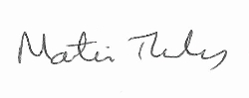
Equalities and Diversity
Vicki Waskett

PCC’s STATUTORY CHIEF OFFICERS’ APPROVAL

We have been consulted about the proposal(s) contained in this Decision Report and confirm that financial and legal advice have been taken into account in the preparation of this report.

We are satisfied that this is an appropriate request to be submitted to the Police and Crime Commissioner for decision.

Chief of Staff (Monitoring Officer) 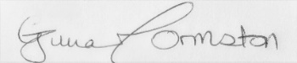 Date: 20/03/2024
Chief Finance Officer Date: 20/03/2024

Appendix A

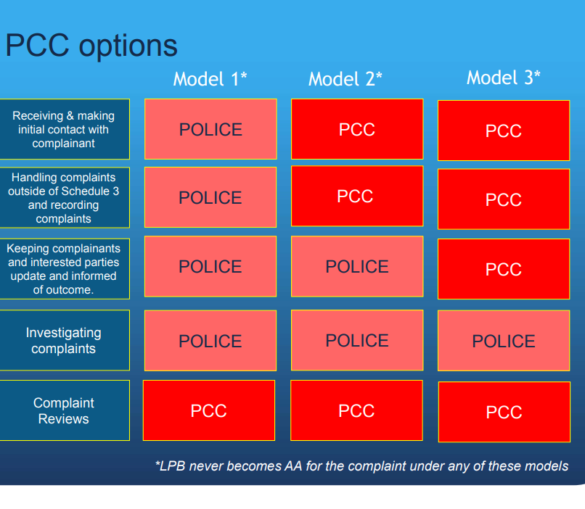

PART 2:

ADDITIONAL CONFIDENTIAL / RESTRICTED INFORMATION EXEMPT FROM DISCLOSURE

- Introduction and background

1.1 Aa (Reason for report, e.g. new legislation/local policy change, etc)
1.2 Bb
1.3 Cc

- Issues for consideration

2.1 Dd (e.g. service implications and issues)
2.2 Ee (e.g. links to PCC strategic priorities and objectives per Police and Criminal Justice Plan)
2.3 Ff (e.g. costs, benefits and risks)
2.4 Gg (e.g. staffing implications)
2.5 Hh (e.g. legal and/or governance implications)

- Financial comments

3.1 Ii (e.g. revenue or capital spending implications
3.2 Jj (e.g. one-off costs and ongoing annual costs)
3.3 Kk (e.g. budget / funding availability)

- Legal comments

4.1 Ll (e.g. legislative power or duty relevant to decision)
4.2 Mm (e.g. GDPR implications)

- Equality comments

5.1 Nn (e.g. service implications for individual communities – inclusivity and diversity issues)
5.2 Oo (e.g. staff implications)

6. Background papers

- Jj (Papers relevant to the decision-making, as appropriate)

